Proposal for Rolsa technologies
by Tyler Hooley
centre number: 37710
[my student id]

Table of Contents
Organisation overview 3
Functional and non-functional requirements 4
functional 4
non-functional 4
Key performance indicators (KPI) 4
Website 4
publicity/reputation 4
Problem overview 5
decomposition 5
Laws, guidance & legislation 6
Promotion of the Use of Energy from Renewable Sources Regulations 2011 6
Planning Act 2008 & National Policy Statement EN-3 6
UK GDPR (General Data Protection Regulation) 6
Key Requirements: 6
Data Protection Act 2018 7
Equality act 7
Protected Characteristics 7
Accessibility Requirements 7
Public Sector Equality Duty (Section 149) 8
Permits and Consents 8
Integration with National Grid and Local Energy Networks 8
Consultation and Consumer Protection 8
Smart Metering and Energy Management 8
risks 9
inputs 9
targetted malicious attacks 9
accidental miss inputs 9
Scope 9
User groups 9
Customers 10
consultants 10
builders 10
admin 10
User acceptance criteria 11
Empathy maps 11
Customers 11
consultants 12
builders 13
admin 14
User stories 15
Alternative systems 17
ACL 17
clear vue 18
grid point 19
Description of proposed solution 20
key features and benefits 20

Organisation overview
Rolsa Technologies is a local green technology company that provides essential green energy electrical appliances to its customer base, who strive to reduce their carbon footprint and maintain negative carbon emissions in their local areas.
They offer a wide range of services, including solar panel installation and maintenance, to help reduce carbon emissions and encourage energy self-sufficiency, minimising reliance on large energy providers who consume gas and output large amounts of carbon in waste.

Rolsa also installs electric vehicle (EV) charging stations to promote the use of EVs in the community, as EVs produce fewer carbon emissions than gas-powered cars. Additionally, they offer smart home energy management systems that enable customers to monitor their energy consumption, identify areas of waste, and reduce both costs and environmental impact on their local environment.

While I am unsure whether the company’s systems include automated energy features—such as switching to green energy when available—I believe they likely do, given their commitment to sustainability.

With a growing customer base, Rolsa has been facing challenges in managing the scheduling of consultations and installations. They believe that integrating a carbon footprint calculator into their system would be an effective way to influence more customers to purchase Rolsa products and services.

Such a system would reduce the burden of handling consultations and installations via phone calls, allowing more time to focus on customer engagement and sales. It would also give customers greater control over managing their appointments and installations.

Functional and non-functional requirements

functional
- A tool for calculating carbon footprint
- schedule consultations and installations
- allow users to login/register to the system
- allow users to manage their data e.g. see what the company has stored about them
- an accessible navigation system
- tool for calculating and tracking energy usage

non-functional
- inform users about green energy products currently on the market
- inform users of methods or products that can help in reducing their carbon footprint
- a back-end database to manage user information details and booked consultations and installations
- follows wcag guidelines for accessibility

Key performance indicators (KPI)

Website
- Web traffic: can be judged by how long page takes to load
- traffic from all sources: e.g. includes over calls

publicity/reputation
- Improved reviews from popular web association’s such as trust pilot
- number of repeat customers
- customer satisfaction rate

Problem overview
The main issue Rolsa Technologies faces is the lack of a consultation and installation management system that allows customers to book, view, and manage their appointments. To support this functionality, a database will be required to store user credentials and manage relationships between users, consultations, and installations. A login system must be implemented to enable users to access their accounts, view scheduled appointments, and book new consultations or installations.
Because the system will store sensitive information such as customer addresses, it must comply with GDPR regulations. This includes enforcing strong password requirements, hashing passwords before storing them, and cleansing user inputs to prevent SQL injection attacks, especially since SQL will be used for back-end database management.
Additionally, a navigation system is needed to ensure users can easily access all available features. These features include booking consultations and installations, registering and logging in or out, requesting personal data, calculating carbon footprint, and managing energy usage. The system should be intuitive and secure to support a wide range of users and provide a seamless experience.

decomposition
Register→ enter details→ check password strength→hash password→ add new user to database
login→ enter details→ checks details matches the ones stored after hashing password
(login)→ book consultations→ enter details→ adds a consultation to database for the logged in user
(login)→book installations→ enter details→ confirm payment→ add installation for logged user→ assign builders for installations
(login)→ view consultations→ get data about user from database→ display for user
(login)→ view installations→ get data about user from database→ display for user
(login consultant)→ view consultations→ get data about users assigned to consultant from database→ display for consultant
(login builder)→ view installations→ get data about installations assigned to builder from database→ display for builder

Laws, guidance & legislation
This will only include laws around green energy systems and not about web design I will be doing that on the design plan

Promotion of the Use of Energy from Renewable Sources Regulations 2011
This regulation underpins the UK's renewable energy policy, defining terms like "renewable energy" and setting out obligations for energy providers and installers.

Planning Act 2008 & National Policy Statement EN-3

EN-3 outlines the planning framework for renewable energy infrastructure in England and Wales. It emphasises the urgent need for new electricity generation capacity and supports the development of systems that help meet carbon budget targets.

UK GDPR (General Data Protection Regulation)
The UK GDPR is retained from the EU GDPR post-Brexit and governs how personal data is collected, stored, and processed

Key Requirements:
- Lawful Processing: Must have a valid legal basis (e.g., consent, contract) for collecting and using personal data.
- Transparency: Users must be informed about what data is collected, why, how it’s used, and who it’s shared with — typically via a privacy notice.
- Data Minimisation: Only collect data that is necessary for the booking and installation process.
- Security Measures: Implement technical and organisational safeguards (e.g., encryption, access controls) to protect data.
- User Rights: Users have rights to access, correct, delete, and restrict processing of their data.
- Data Breach Protocols: Must notify the ICO (Information Commissioner's Office) and affected individuals in case of serious breaches.

Data Protection Act 2018
Supplements the UK GDPR by providing additional rules and enforcement mechanisms.

Equality act

Protected Characteristics
The Act prohibits discrimination based on:
- Age
- Disability
- Gender reassignment
- Marriage and civil partnership
- Pregnancy and maternity
- Race
- Religion or belief
- Sex
- Sexual orientation
Your booking system must not treat users unfairly or exclude them based on any of these characteristics.

Accessibility Requirements
Under the Act, service providers must make reasonable adjustments to ensure disabled users can access and use their services. For a booking system, this includes:
- Screen reader compatibility
- Keyboard navigation
- Clear visual design and contrast
- Alternative formats for communication (e.g., voice support, large text)
Failure to implement these features could be considered indirect discrimination.

Public Sector Equality Duty (Section 149)
If your system is used by or developed for public sector bodies (e.g., local councils or government-funded energy schemes), you must:
- Eliminate discrimination
- Advance equality of opportunity
- Foster good relations between different groups
This duty applies to both the design and delivery of services, including consultation and installation processes.

Permits and Consents
Installers must obtain necessary planning permissions and environmental consents, especially for solar panels, EV charging stations, and other infrastructure. Local councils often have additional requirements.

Integration with National Grid and Local Energy Networks

Installations must be compatible with grid standards and may require coordination with energy suppliers or local authorities.

Consultation and Consumer Protection
Booking systems must comply with consumer rights laws, including:
- Clear communication of services and pricing
- Data protection under GDPR
- Fair cancellation and refund policies

Smart Metering and Energy Management
Systems that include smart energy features must align with the UK’s smart metering policy framework, which is evolving post-2025 to support net-zero goals

risks

inputs
Inputs can pose a risk for sql injection since we will be using sql to manage the back end database to remove this risk we will cleanse the input to remove anything that could cause unwanted outputs we will also limit the amount they can enter data where possible such as using drop down boxes if its a limited choice for the input

targetted malicious attacks
Targetted attacks to either slow or crash the web page by overloading the web server with requests to prevent other users from accessing it or crashing it which may take a while for it to recover/restart which could cost the company money/time and reputation with local community we cant fully protect against this and I have limited knowledge at this time on how to prevent against such attacks and don’t have enough time to learn while adding the other features so I will not worry about it but in a real scenario I would add a preventative measure before deploying this system

accidental miss inputs

This is easy to fix by using good error handling to catch users if they make an error while typing e.g. putting a number in a box which needs string good robust code with great error handling will remove the issue of handling incorrect input errors

Scope

For my scope I am focusing on local people looking to reduce their carbon footprint with little to no knowledge about how to reduce their carbon footprint

User groups
Who will be using my system and who it will be designed for

Customers
Most customers will be people who own homes and are wanting to invest in it so will probably be aged 35-85 as buying a house will take many years of saving so will be around mid 30’s and the average life expectancy is around mid 80’s for people in the uk so the upper end would be around the age of 85 as they are older they may have less experience with technology as it was not around during their generation
- wants to see their booked consultations/installations
-wants to cancel/reschedule consultations/installations
-wants to book consultations/installations

consultants
Catering for Experienced consultants between the ages 20-70 because consultants will be people who have just left college and often retire around the ages of 70 as it is not a labour intensive job so often do not retire early so will probably have some experience with tech
-wants to see who has booked a consultation with them

builders
Built for builders age 16-55 because builder will be people with strong body’s such as late teens who just finished gcse’s but is very labour intensive so most retire early around early to late 50’s
so will have a harder time with working tech
- want to see who has booked an installation and where its to be installed at what time

admin
Designed for it personnel between 25-65 as a senior it techs will most likely be the ones with admin accounts as juniors may not be trusted with admin privileges and most senior technicians retire around 65
-want to add/delete and alter details for other accounts
-wants to add/delete and alter bookings for consultations and installations

User acceptance criteria
Clear and obvious navigations
accessible colour scheme little to no red and green’s
fast loading times- efficient code
clear and obvious instructions for website

Empathy maps

Customers
says | thinks
- “I want to see how much energy I’m saving.”  - “Booking a consultation was straightforward.”  - “I like that I can track my carbon footprint.”  - “It would be great to get more personalised tips.”  - “The interface is clean, but I wish it loaded faster.” | - “Am I doing enough to reduce my carbon footprint?”  - “Is this the best setup for my home?”  - “I hope this system integrates with my other smart devices.”  - “I want to stay ahead with the latest green tech.”  - “I need this to be accessible for everyone in my household.”
does | feels
- Registers an account to manage appointments and data  - Uses the carbon footprint calculator regularly  - Schedules installations or consultations through the platform  - Checks energy usage trends and product updates  - Explores green energy product recommendations | - Empowered by having control over their energy impact  - Curious about new ways to improve sustainability  - Occasionally frustrated by technical limitations or lack of depth  - Reassured by the transparency and data tracking  - Motivated to continue making eco-friendly choices

consultants
says | thinks
- “I need quick access to customer details and schedules.”  - “It helps when customers understand their energy options before the consultation.”  - “The system should be easy to update on the go.”  - “I wish the platform gave me insights into customer preferences.”  - “Clear communication tools would make my job smoother.” | - “How can I make this consultation more impactful?”  - “Is the customer ready to adopt these technologies?”  - “I need reliable tools to stay organized and efficient.”  - “The system should support me in educating customers.”  - “I want to feel confident that the data I input is secure and accurate.”
does | feels
- Logs into the system to view and manage appointments  - Reviews customer profiles and energy usage before consultations  - Updates installation status and notes after visits  - Uses the platform to recommend products or services  - Communicates with customers through built-in messaging or scheduling tools | Responsible for delivering a great customer experience  - Frustrated when digital tools are slow or unintuitive  - Valued when their feedback is considered in system updates  - Motivated by helping customers transition to green energy  - Confident when the system supports their workflow seamlessly

builders
says | thinks
- “Where’s my next job site?”  - “I need clear instructions and access details.”  - “The system should work offline or in low-signal areas.”  - “It’d be helpful to upload photos or notes after the job.”  - “I want to spend less time figuring out logistics and more time doing the work.” | - “Is everything I need already at the site?”  - “Will the customer be ready when I arrive?”  - “I hope the instructions are clear and up to date.”  - “I need to finish this job on time to stay on schedule.”  - “If something goes wrong, I want fast support from HQ.”
does | feels
- Logs into the system daily to check assigned installations  - Uses maps or integrated navigation to reach customer locations  - Reviews installation details, equipment lists, and safety notes  - Updates job status (e.g., completed, delayed, in progress)  - Uploads photos or comments post-installation for documentation | - Confident when the system is reliable and intuitive  - Frustrated by unclear directions or missing job details  - Pressured by tight schedules and multiple appointments  - Proud of contributing to sustainable energy solutions  - Relieved when communication with the team is smooth

admin
says | thinks
- “I need full visibility into all user activity and system performance.”  - “The platform must be secure, scalable, and easy to maintain.”  - “I want to quickly resolve issues and support users.”  - “We need analytics to track usage and identify trends.”  - “The system should allow me to manage roles and permissions easily.” | - “Is the system secure and compliant with data regulations?”  - “Are users getting the most value from our platform?”  - “How can I improve operational efficiency?”  - “What features are underused or causing friction?”  - “We need to stay ahead of customer expectations and tech trends.”
does | feels
- Monitors system health, uptime, and performance metrics  - Manages user accounts, roles, and access levels  - Reviews consultation schedules and installation workflows  - Tracks energy usage data and customer engagement  - Responds to support requests and resolves technical issues  - Updates content and product listings on the platform | - Responsible for keeping everything running smoothly  - Pressured to meet performance, security, and user satisfaction goals  - Empowered when tools are intuitive and responsive  - Frustrated by bugs, bottlenecks, or lack of control  - Proud when the system supports sustainability and customer success

User stories
As a [user] | I want... | So that...
As a customer | I want to register an account | so that I can manage my consultations and track my energy data.
As a customer | I want to calculate my carbon footprint | so that I can understand and reduce my environmental impact.
As a customer | I want to schedule consultations and installations | so that I can plan my transition to green energy.
As a customer | I want to access information about green energy products | , so that I can make informed purchasing decisions.
As a customer | I want accessibility features | so that I can use the system comfortably regardless of my abilities.
As a customer | I want to track my energy usage over time | so that I can monitor progress and adjust my habits.
As a consultant | I want to view customer profiles and energy data | so that I can tailor my advice during consultations.
As a consultant | I want to manage my appointment schedule | so that I can stay organised and efficient.
As a consultant | I want to communicate with customers through the system | so that I can confirm details and provide updates.
As a consultant | I want to access product information and recommendations | so that I can guide customers effectively.
As a consultant | I want to log consultation outcomes | so that the system reflects accurate customer progress.
As a builder | I want to see my daily installation schedule | so that I know where to go and what to install.
As a builder | I want access to site details and instructions | so that I can complete installations correctly and safely.
As a builder | I want to update job status in the system | so that admins and customers are informed in real time.
As a builder | I want to upload photos and notes after installations | so that documentation is complete and traceable.
As a builder | I want offline access to key job info | so that I can work even in low-signal areas.
As an admin | I want to manage user accounts and permissions | so that each role has appropriate access.
As an admin | I want to monitor system performance and usage | so that I can ensure reliability and scalability.
As an admin | I want to track consultations and installations | so that I can oversee operations and resource allocation.
As an admin | I want to respond to support requests | so that users receive timely help.
As an admin | I want to update product listings and content | so that customers always see current and relevant information.
As an admin | I want to generate reports on energy usage and customer engagement | so that I can inform strategic decisions.

Alternative systems

ACL
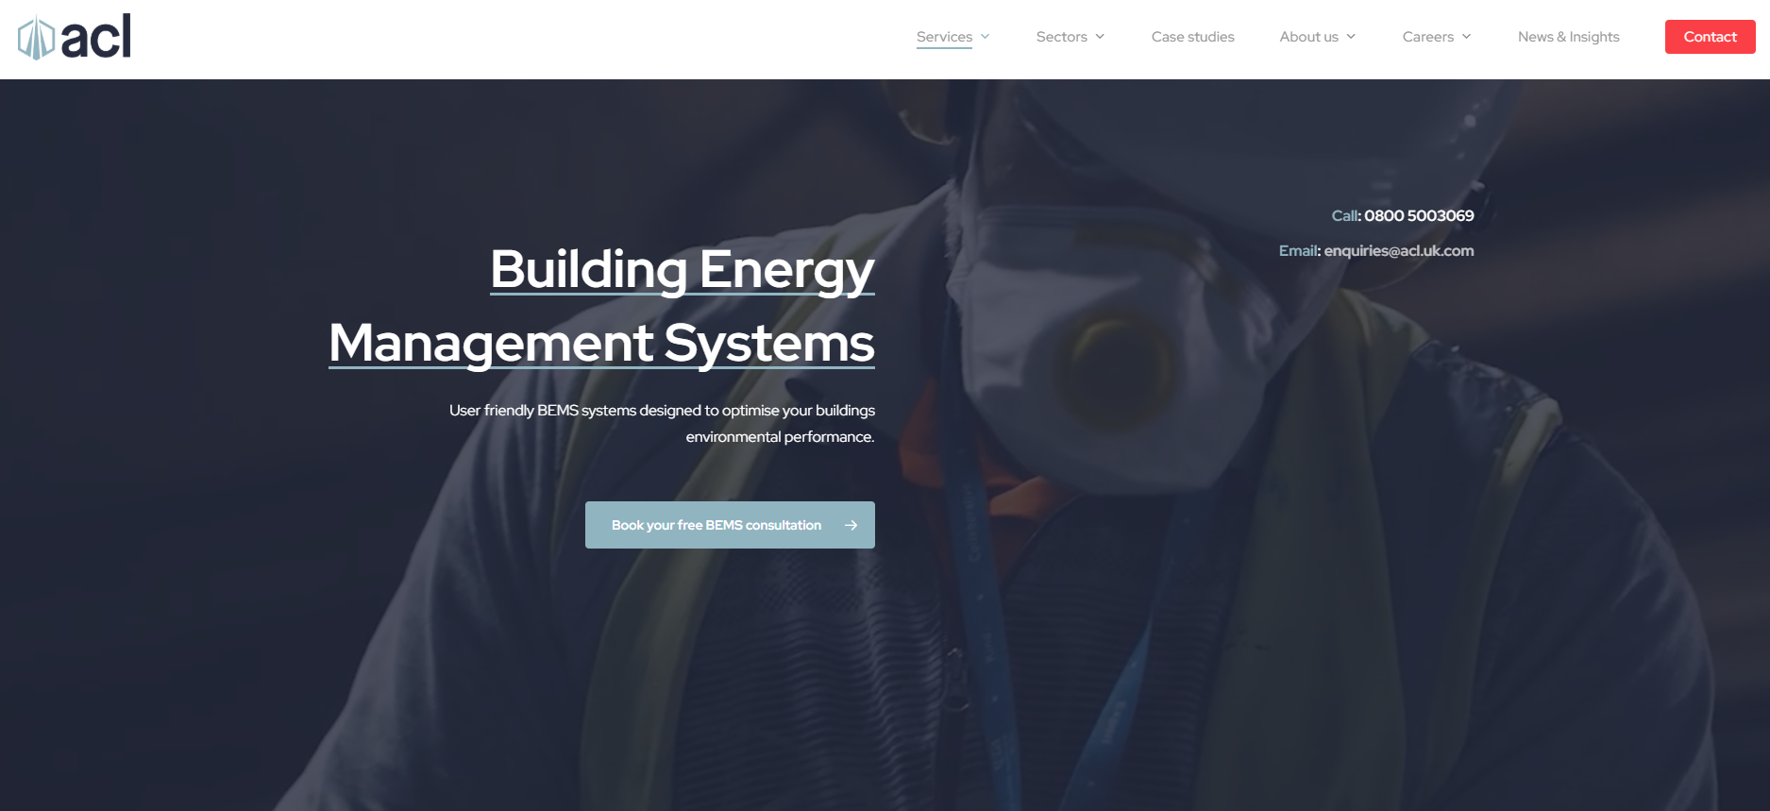
Has a simple design with mellow colours that don’t really pop out to show professionalism it has clean nav bar with a logo
the simple design does make it harder to navigate since no directions are given to the user except the orange contact button which pops out amongst the other colours
I will use the mellow white and blue colour scheme and use of orange to direct the user but will stray away from being too simple that it becomes hard to navigate

clear vue
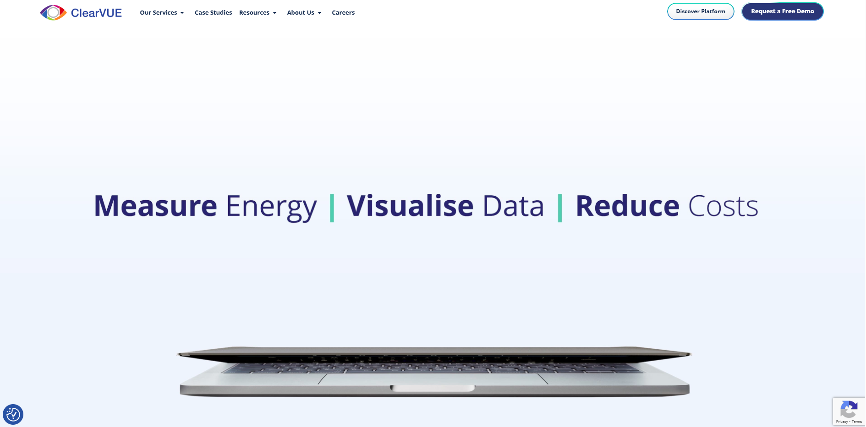

Uses big bold letters and simple words that explain a lot of what their business is about
clear nav bar with logo have highlighted rounded borders on important buttons
the images are bland and have left a lot to be desired could have better image choice
I will take the bold letters and simple words into my design and highlighted borders to highlight important
I will make sure not to have bad imagery as it ruined the quality of the other well designed aspects of the system

grid point
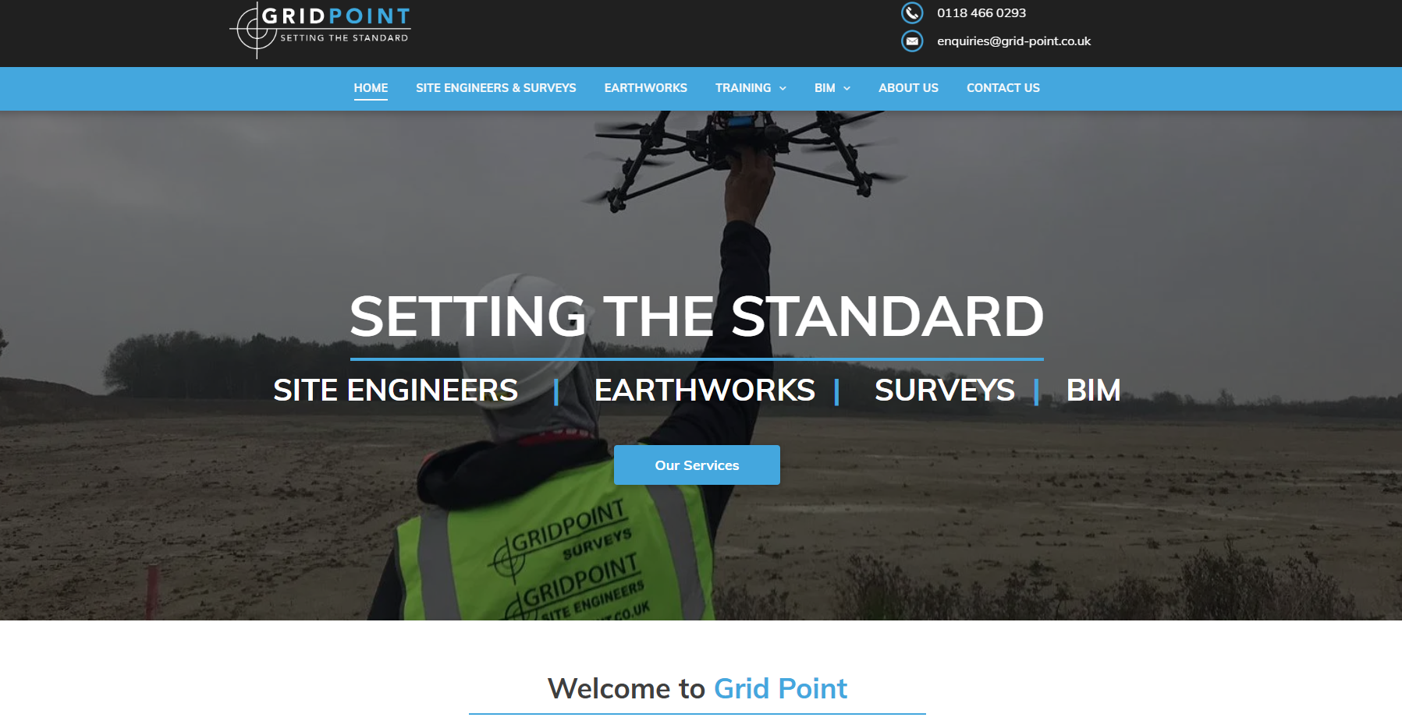

I do like the calming blue with white letters they used for the nav bar it makes it look easy going I will be using that in my end design for buttons and things I deem need to be easy on the eyes
using | to make words stand alone makes them have more power ill combine it with the bold simple letters in my end design
I do like the top bar of a logo and contact details and use of symbols to make it more accessible as not everyone will understand words so a phone symbol instead of the words phone number is simpler if I have extra time I will implement that into my end design as it would make it look more streamlined.

Description of proposed solution
In the above paragraphs I was decomposing, analysing, and setting the requirements for the new booking system. In this section I will be summarising the proposal and its main benefits to the clients – Rolsa technologies
the final proposal is a navigable website that will include the following:

key features and benefits
- accessible
  - the website is going to be accessible to most users allowing users to navigate through all its functionalities with little to no issues.
  - It should be formatted in an appropriate colour scheme that allows for all users to read it contents- if given the time I would integrate a text to speech for blind users but due to the limited amount of time I will not.
- Informative
  - display information about available green energy options for the user
- easy registration
  - allows customers to easily register or login
  - it should have separate options for logging in consultants and builders(admins will be the only one who can add consultants and builders)
- admins
  - admins will be able to add consultants and builders using a webpage separate from the main system
- simple booking management
  - allow the customers to manage which consultations and installations they have and cancel, refund and reschedule them if they need to.
- simple booking
  - the website will allow the customer to easily book consultations and installations without the need of support from individuals.

