Table of Contents
User acceptance criteria 1
Description of proposed solution 2
key features and benefits 2
REPORT 1 3
Nav bar 3
Index page 3
login page 3
register page 3
Logout page 3
css styling 3
common 3
dbconn 3
database 4
images 4
REPORT 2 4
database 4
register builder, consultant 4
book installations 4
book consultations 4
login builder consultant 5
viewing installations, consultations 5
Carbon footprint calculator 5
Robustness 5
improvements upon base design to note 5
Things to add 5
Report 3 5
design 6
expected 6
Actual outcome 7
Well commented 7
Database 7
version 4 update 7
final notes 7
Password strength checker 7
try and catches 8
Carbon footprint calculator, payment & admin 8

Here is a repeat of my user acceptance criteria lifted from my proposal document

User acceptance criteria
Clear and obvious navigations
accessible colour scheme little to no red and green’s
fast loading times- efficient code
clear and obvious instructions for website

Here is a repeat of my expected outcome from this project lifted from my proposal document

Description of proposed solution
In the above paragraphs I was decomposing, analysing, and setting the requirements for the new booking system. In this section I will be summarising the proposal and its main benefits to the clients – Rolsa technologies
the final proposal is a navigable website that will include the following:

key features and benefits
- accessible
  - the website is going to be accessible to most users allowing users to navigate through all its functionalities with little to no issues.
  - It should be formatted in an appropriate colour scheme that allows for all users to read it contents- if given the time I would integrate a text to speech for blind users but due to the limited amount of time I will not.
- Informative
  - display information about available green energy options for the user
- easy registration
  - allows customers to easily register or login
  - it should have separate options for logging in consultants and builders(admins will be the only one who can add consultants and builders)
- admins
  - admins will be able to add consultants and builders using a webpage separate from the main system
- simple booking management
  - allow the customers to manage which consultations and installations they have and cancel, refund and reschedule them if they need to.
- simple booking
  - the website will allow the customer to easily book consultations and installations without the need of support from individuals.

REPORT 1
A write up describing what I created and what each page does for the user

Nav bar
The nav bar is frequently accessed to redirect the users to different pages

Index page
Currently an empty page I don’t plan on adding nothing to this page as of now as it doesn’t really matter until version 3 when I start implementing design features

login page
Accesses the database to allow a registered user to login
- matches expectation from expected solution for easy logging in of users

register page
The register page allows users to make new account and add it to the database contains a password strength checker to ensure users enter a strong unique password
- matches expectation from expected solution for easy registration of users

Logout page
Logout itself is a page that the user doesn’t really see it is only accessed to redirect the user and to terminate the current session of the user and log them out

css styling
The styling currently only somewhat resembles what I designed prior I don’t plan on making adjustments to this until version 3 when I attempt to make it look like what I designed after implementing all the features I can as I am more focused on making a functioning design than a good looking design I have planned out enough time for me to add in styling but if any major issues occur I will focus more on functions than design

common
Putting all frequently called functions into one centralised area to be called at a later date
currently contains all the functions for registering users ,logging users , the user password checking

dbconn
Connects the system to the database I have saved an export of the current structure of the database called rolsa_tech.sql in the same folder as this report

database
Currently only contains the users table the bare minimum for a login and register system
I will be adding many more tables in version 2 and 3 for auditing and for other user groups

images
The only image I plan to add is a logo I have put it inside the image folder but wont add it till version 3 when I do design and final touches

REPORT 2
Report for version 2 of development

database
During development I realised I had failed to realise the need to instruct builders on what type of installation during the design so I added a new field called installation type to installations I also updated it to contain all the tables minus the ones required for auditing which I will add in version 3

register builder, consultant
I added the ability to register consultants and builders it is not part of the main system and can only be accessed by launching the php itself this is intended to only be accessible by the admin but because of my lack of ability I don’t know how to lock it away from the main system I have done this as consultants and builder will be people hired by the company and adding them should have a more thorough process than just registering
- from my design proposal for admins i have separated the register of consultant and builder from the main system I would have not put them in the same document if it weren’t for me versioning for this mock ideally these registering systems would only be accessible on a separate location only accessible to admin to avoid html manipulation

book installations
I have added the ability to book an installation I have only added smart meters and solar panels as I do not know enough about the company to put all the installations they offer this would also need a payment processing function that would deal with the users financial records and bank details but because I have not learnt enough to build a secure banking system for the users I will leave it as a poorly constructed payment system would be more dangerous than no payment rosla will need to hire someone else to add the banking system

book consultations
Added the ability to book consultations with consultants that have been registered with system
I don’t know if rolsa will charge for this consultations as well but if they do I didn’t add it for the prior reason i allowed the changing and cancelling of installations, consultations
- matches expectation from expected solution with allowing users to reschedule cancel and change details for installations and consultations

login builder consultant
Despite not having anything added yet I added the ability for the registered consultants and builders to login to the system more features for them will be added in version 3

viewing installations, consultations
I added the ability to view a users consultations and installations I will add the ability for builders and consultants to view theirs in version 3 as it is not a mandatory part of the system as it mostly meant to be a user booking system than a system for consultant and builders.

Carbon footprint calculator
I intended to add a carbon footprint calculator during this phase but due to my lack of experience and knowledge in this area so I have decided against wasting development time attempting to create a footprint calculator that I know itll be redesigned because it wont match the companys standards.

Robustness
As of now I havent implemented any robustness except for ensuring a user is logged in to access certain pages a strengh checker for user passwords when registering and hashing password with a inbuilt php hasher which isnt very secure a better option would have been 256sha but it isnt available in our programming enviroment during v3 I intend to add try and excepts around anything that takes in a user input or when a function is called

improvements upon base design to note
After looking at the design ive realised that my nav bar requires more login options than previously intended at this point in time I have an idea on fixing it to be 1 php page but as to not interfere with the current system operations I will be implementing this idea in version 4 as i may not finish production.

Things to add
I intend to add an auditing log in version 3 and give builders and consultants their features I also intend to implement robustness and try to match the design I intended at the star and I also want to attempt adding the slogan I created in my design for the main page.

Report 3
Report for version 3 of development

design
I am quite pleased at how well I matched what I had designed using other green energy websites to my advantage I managed to make a website that looks quite modern I made a sleek eye catching slogan that draws your attention I also added customer support email and number which I have put wrong information into since I don’t know rolsa’s actual contact information I placed the company logo in a visible location that isn’t too off-putting and shoved into the users face I matched the design I made very well but I did fail to realise the need of designing the input slides
so I am quiet disappointed in my poor oversight which resulted in bad looking input menu pages which should have been much better than they actually turned out

expected


Actual outcome
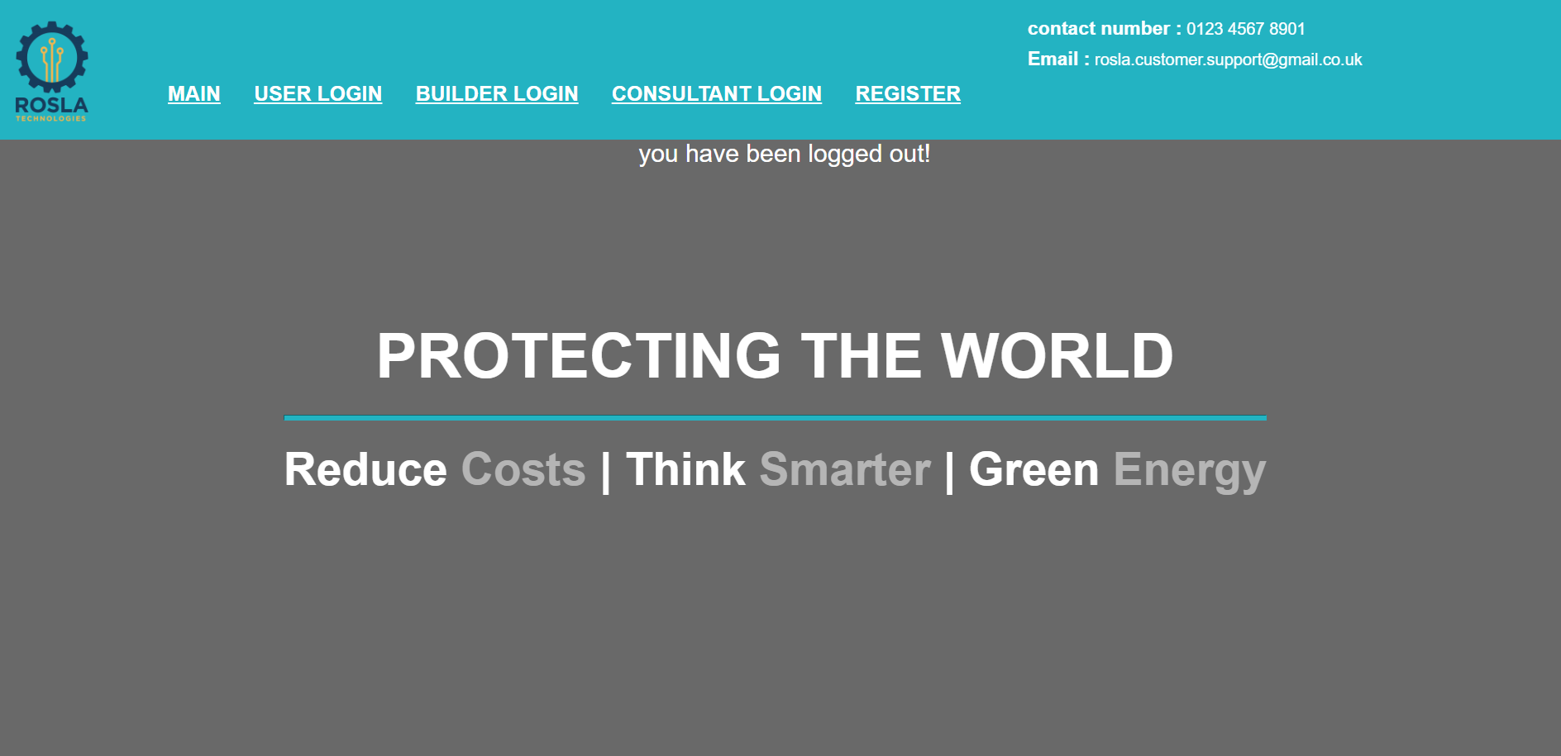

Well commented
I didn’t mention this in prior version but for maintainability purposes I have been commenting everything in some detail but for version 3 I went through and completely commented it as it is the version I intend over developers to work off of.

Database
Added audit logs for each user and a functioning audit system which logs their actions while using the system I decided against logging whenever they view their installations/consultations as I will assume that they have viewed them if they log into the system as its the main feature of the system

version 4 update
I have decided against the production of a version 4 due to lack of time I have decided to polish version 3 instead of a poorly made version 4

final notes

Password strength checker
I didn’t thoroughly test the password strength checker as I have already thoroughly tested it when integrating it into many other systems and has never posed an issue prior so I decided against full testing it to save on time just note that It has been fully tested before to work correctly and be easily integrated within my system

try and catches
I didn’t place any try and catches around the system to make any errors during testing very obvious and easier for me to fix for the final release rolsa will need to place try and catches around user inputs and when calling functions that process information as these could pose errors which may crash the system making the system lack robustness.

Carbon footprint calculator, payment & admin
These are failed concepts that I cant implement due to lack of current ability and lack of knowledge around the area I couldn’t implement the footprint calculator due to my lack of knowledge around carbon footprints and how to calculate it ,payment and admin I could not implement due to lack of ability and not wanting to make an unsecure version which may cause real issues for the company so I am leaving it someone more capable who will give a better solution to this issue than I could at this current moment in time.

Conclusion
Overall I matched what I expected for my outcome from this solution I did much better than I thought I would during making the design for the system but I did fail to realise the need for designing the input pages as well which I would fix given another chance but overall I matched what I expected I could produce for this system I am sad I couldn’t implement the feature for logging in using 1 web page and 1 link instead of 3 separate which I will research and implement if I make a similar system in the future overall im quite happy with my solution I did miss some parts of the system which rolsa wanted such as the carbon footprint calculator,admin and payment but im glad I didn’t do those as it would have made the rest of t he system worse if I tried to implement something I do not know or have a knowledge around so im quite happy with how my solution turned out.

