The word “polymorphism” means having many forms. In simple words, we can define polymorphism as the ability of a message to be displayed in more than one form. A real-life example of polymorphism is a person who at the same time can have different characteristics. A man at the same time is a father, a husband, and an employee. So the same person exhibits different behavior in different situations. This is called polymorphism. Polymorphism is considered one of the important features of Object-Oriented Programming.
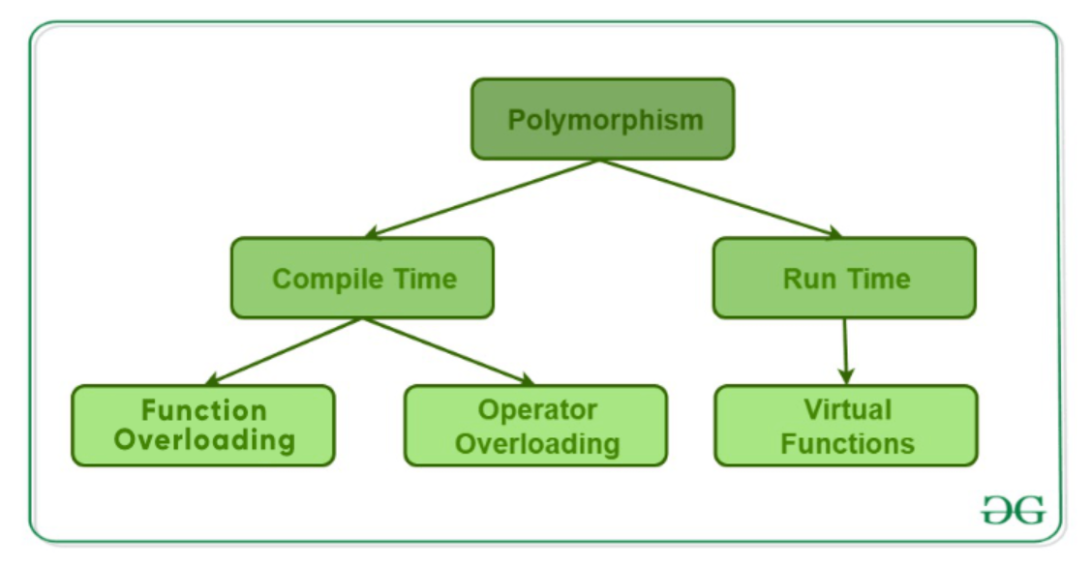
Compile Time Polymorphism: This type of polymorphism is achieved by function overloading or operator overloading.
Function Overloading:
When there are multiple functions with the same name but different parameters, then the functions are said to be overloaded, hence this is known as Function Overloading. Functions can be overloaded by changing the number of arguments or/and changing the type of arguments.
Operator Overloading:
C++ has the ability to provide the operators with a special meaning for a data type, this ability is known as operator overloading. For example,complex number addition.

Runtime Polymorphism
This type of polymorphism is achieved by Function Overriding.

Function Overriding
Function Overriding occurs when a derived class has a definition for one of the member functions of the base class. That base function is said to be overridden.

