Course Name: **Object Oriented Analysis and Design**

Name of the Assignment: **Bank Management System**

Group Number: **32**

|  |  |  |
| --- | --- | --- |
| Group Member’s Name | ID | Section |
| Shifat, Shadril Hassan | 20-42451-1 | D |
| Debnath, Pritom | 20-42414-1 | D |

**Brief Description of the system:**

In a bank management system, only an admin can hire employees. To hire employees, the admin needs to check the eligibility of an employee. Then employees are provided username and password. A user can create a new account. For this, the user must select which kind of account the user wants to create. A user can create either a savings account or a fixed account. To create an account, the user must submit an application and provide all details to the employees of the bank. Employee sends all the documents of the user to the admin for further verification. If the admin grants the new user, only then the user can create an account. After creating the account, the bank will provide a username and a password to the user. A user can do transactions. For this operation, a user has to decide which kind of transaction the user wants to do. A user can deposit or withdraw or transfer money. For the transaction, the bank needs to verify the user. After the verification, a user does the transaction. A user can also take a loan from the bank. For this, the user must apply for a loan. Then admin will verify the user’s information, check due loan. After approval, the user can get loan from the bank.

**Sequence Diagram:**

1. **Sequence diagram for opening an account:**

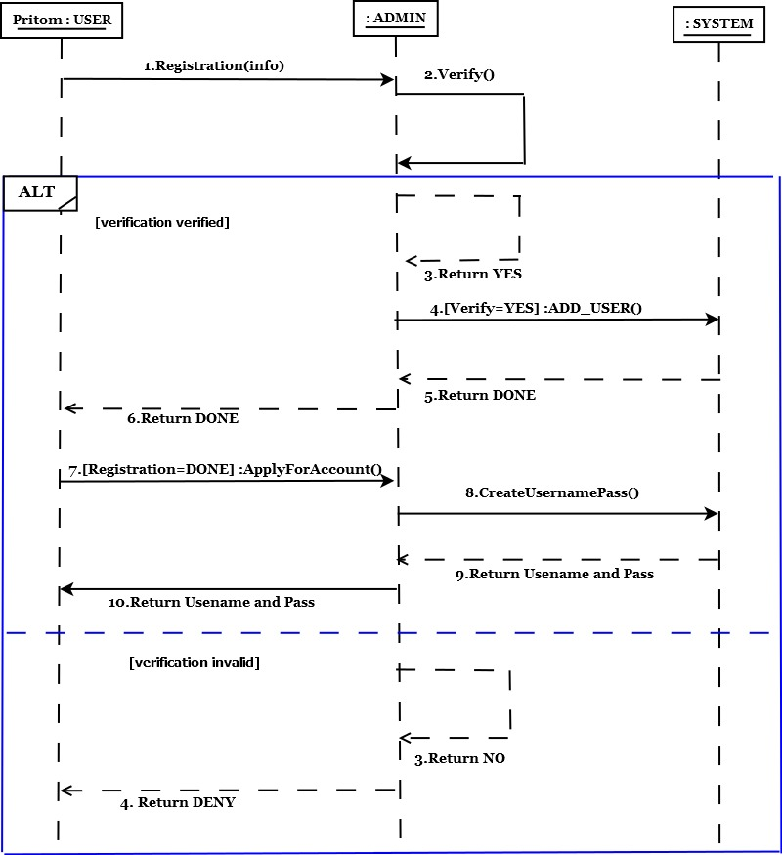

1. **Sequence diagram for applying loan:**

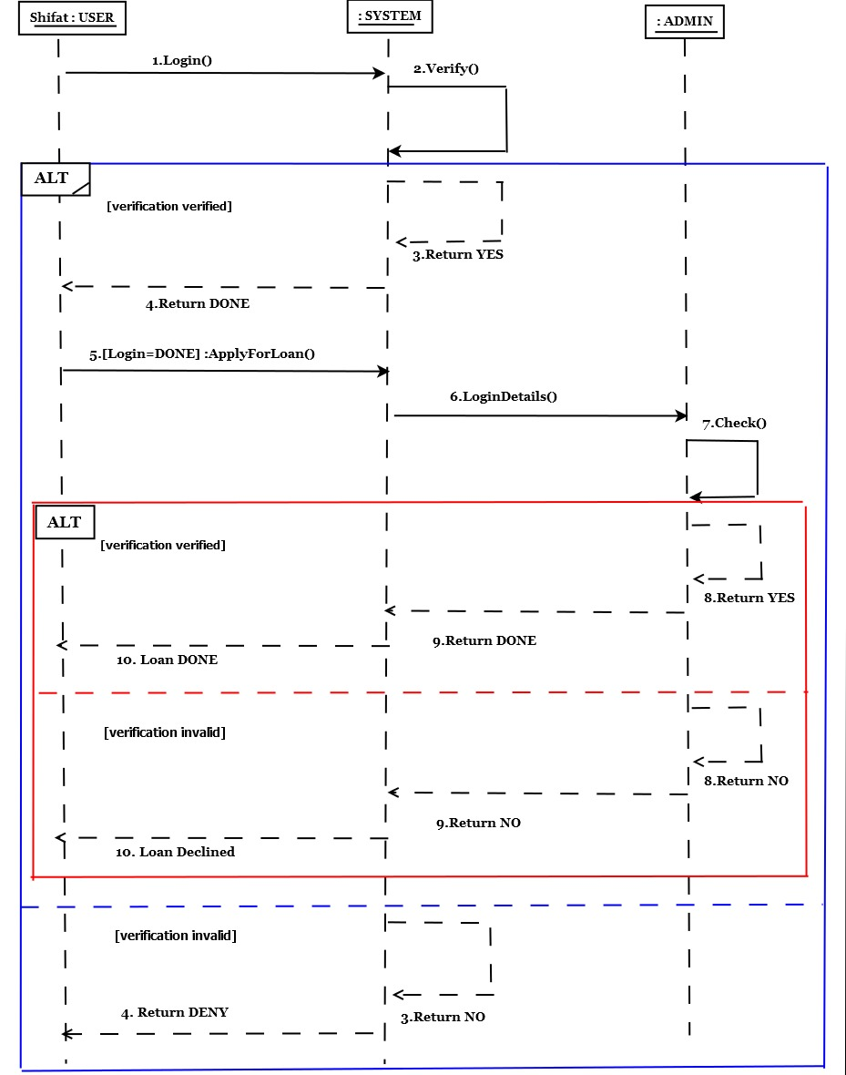

**Activity Diagram:**

**1.Activity diagram for applying loan:**

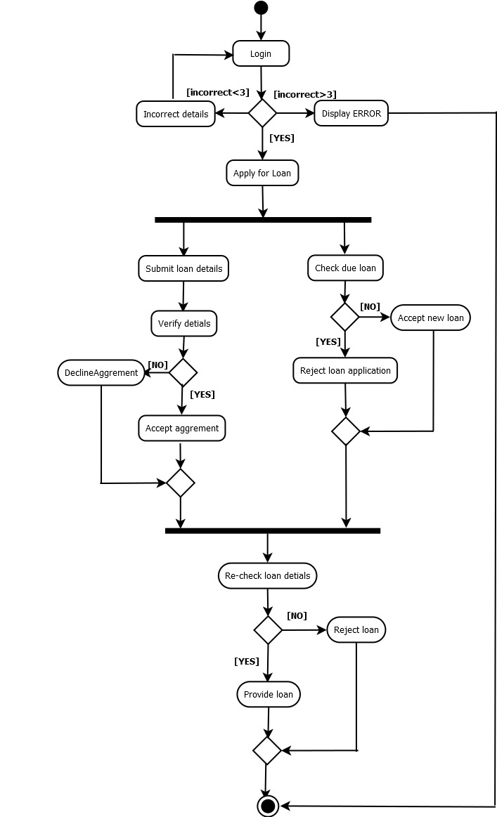

1. **Activity diagram for deposit and withdraw:**

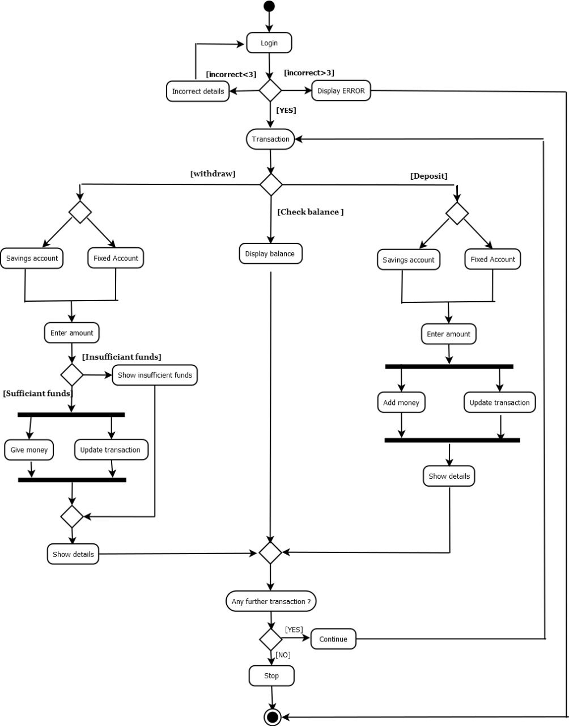

**Statechart Diagram:**

**1.Statechart diagram for ‘TransferMoney’:**

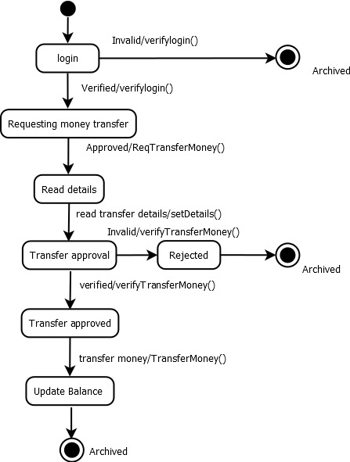

**2.Statechart diagram for ‘Loan’:**

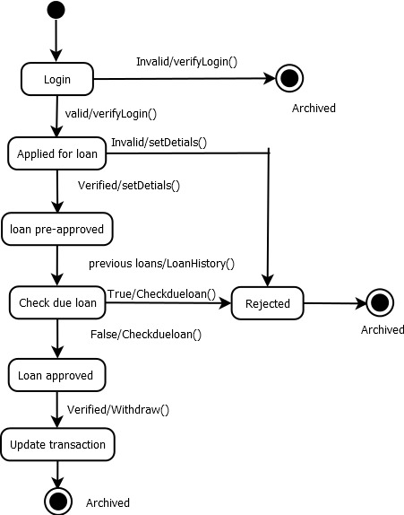

**Calculation of the LCOM value:**

**1.**

|  |
| --- |
| <<user>>  User  {Last updated 25-04-21} |
| -name: String  -accNo:String  -accType: String  -mailAddress:String  -userId:String  -password:String  -address:String  -amount: Integer |
| +registration(name : String, mailAddress : String, address : String, accType : String) : Boolean  +applyForAccount(name : String, accNo : String, mailAddress : String, address : String) : String  +logIn(userId : String, mailAddress : String, password : String) : Boolean  +reqForLoan(accNo : String, amount : Integer)  +depositMoney(accNo : String, amountToDeposit : Integer)  +withdrawMoney(accNo : String, amountToWithdraw : Integer) |

**Calculating LCOM value for User class:**

**Pairs:**

**Cohesive Pairs:**

(registration, applyForAccount) , (registration, logIn), (applyForAccount, logIn),(applyForAccount, reqForLoan), (applyForAccount, depositMoney), (applyForAccount, withdrawMoney), (reqForLoan, depositMoney), (reqForLoan, withdrawMoney), (depositMoney, withdrawMoney)

So, Q= 9

**Non-Cohesive Pairs:**

(registration, reqForLoan), (registration, depositMoney), (registration, withdrawMoney), (logIn, reqForLoan), (logIn, depositMoney), (logIn, withDrawMoney)

So, P= 6

Here, Q>P

So, **LCOM= 0**

**Comment:** The LCOM value of the **User** class indicates that the methods of the class are **cohesive**, and it is a **desirable design**.

**2.**

|  |
| --- |
| << >>  Admin  {Last Updated 25-04-21} |
| -name: String  -accNo : User  -loanNo : Loan  -userDetails: User  -loanType: Loan |
| +verifyUser(name: String, accNo: User, userDetails: User): Boolean  +verifyLoan(accNo : User, loanNo: Loan, loanType: Loan): Boolean  +addUser(name : String, userDetails: User)  +createUsernamePass( accNo: User, UserDetails: User): String |

**Calculating LCOM value for Admin class:**

**Pairs:**

**Cohesive Pairs:**

(verifyUser, verifyLoan), (verifyUser, addUser), (verifyUser, createUsernamePass), (verifyLoan, createUsernamePass),

(addUser, createUsernamePass)

So, Q= 5

**Non-Cohesive Pairs:**

(verifyLoan, addUser)

So, P=1

Here, Q>P

So, **LCOM= 0**

**Comment:** The LCOM value of the **Admin** class indicates that the methods of the class are **cohesive**, and it is a **desirable design**.