Course Name: **Object Oriented Analysis and Design**

Name of the Assignment: **Bank Management System**

Group Number: **32**

|  |  |  |
| --- | --- | --- |
| Group Member’s Name | ID | Section |
| Shifat, Shadril Hassan | 20-42451-1 | D |
| Debnath, Pritom | 20-42414-1 | D |

**Brief Description of the system:**

In a bank management system, only an admin can hire employees. To hire employees, the admin needs to check the eligibility of an employee. Then employees are provided username and password. A user can create a new account. For this, the user must select which kind of account the user wants to create. A user can create either a savings account or a fixed account. To create an account, the user must submit an application and provide all details to the employees of the bank. Employee sends all the documents of the user to the admin for further verification. If the admin grants the new user, only then the user can create an account. After creating the account, the bank will provide a username and a password to the user. A user can do transactions. For this operation, a user has to decide which kind of transaction the user wants to do. A user can deposit or withdraw or transfer money. For the transaction, the bank needs to verify the user. After the verification, a user does the transaction with the help of an employee. A user can also take a loan from the bank. For this, the user must apply for a loan to an employee. Then admin will verify the user’s information.

**Use Case Diagram:**

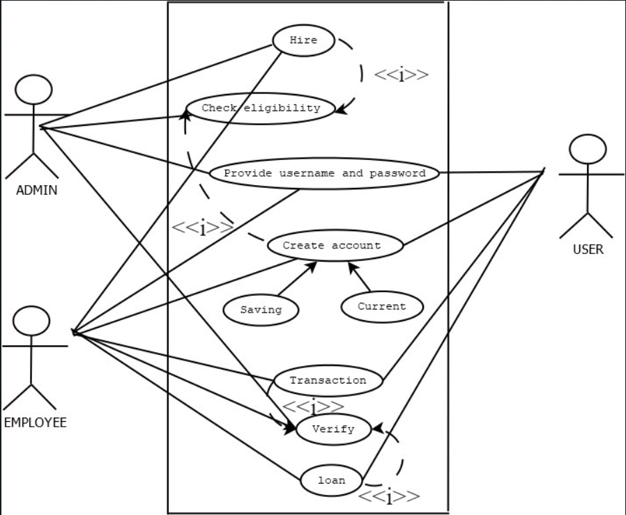

**Class Diagram:**

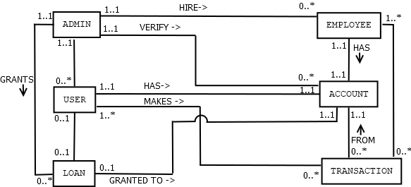

**Detail design (name, attributes, operations) of 3 classes:**

|  |
| --- |
| <<user>>  Admin  {Last updated 13-03-20} |
| -name: String =blank  -id:String=blank  -mailaddress:String=blank |
| +getName():String  +setName(Name :String)  +getId(): String  +setId(id :String)  +getMailaddress():String  +setMailaddress(MailAddress : String)  +getEmployeeDetaiils():String  +setEmployeeDetails(EmployeeDetails : String)  +getUserdetails():String  +setUserdetails(UserDetails :String) |

|  |
| --- |
| << entity class >>  Loan  {Last Updated 13-03-20} |
| -amount:double=0  -loanType :String =balnk  -loanNo :String=blank |
| +getAmount():double  +setAmount(Amount :double)  +getLoantype():String  +setLoantype(loantype :String)  +getLoanNo():String  +setLoanNo(LoanNo : String) |

|  |
| --- |
| <<entity class>>  Account  {Last updated 12-03-20} |
| -username : String=blank  -password :String= blank{minimum 8 digit}  -type : String=blank  -amount : double=0 |
| +getUsername():String  +setUsername(Username : String)  +getPassword():String  +setPassword(Password : String)  +getType():String  +setType(Type :String)  +getAmount():double  +setAmount(Amount :double) |

**Design 3 CRC Card for 3 classes:**

|  |  |
| --- | --- |
| **Class name** | Admin |
| **Description** | Maintains employee, verifies details of user, employee and transaction |
| **Superclass** |  |
| **Subclass** |  |
| **Responsibilities** | **Collaborators** |
| Maintains employee | Employee |
| Verifying details and update database | Database |
| Keep track of transaction | transaction |

|  |  |
| --- | --- |
| **Class name** | User |
| **Description** | Create account, do transactions, takes loan |
| **Superclass** |  |
| **Subclass** |  |
| **Responsibilities** | **Collaborators** |
| Create account | Account |
| Withdraw or deposit money | transaction |
| Take loan | Admin |

|  |  |
| --- | --- |
| **Class name** | Account |
| **Description** | Holds username, passwords of both user and employees, keep track of balance and transaction |
| **Superclass** |  |
| **Subclass** | Current account, savings account |
| **Responsibilities** | **Collaborators** |
| Holds username, passwords | User and Employee |
| Keep track of balance | transaction |