KMEANS :-

- For kmeans please open the code and change parameters here :-

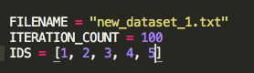

- Run the code using bash “python2.7 kmeans.py”

HAC Algorithm :

- For HAC Algorithm, please open the code and change parameters here :-

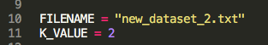

- Run the code using bash command “python2.7 hac.py”

DBSCAN algorithm :

- For DBCAN, please open the code and change parameters here :-
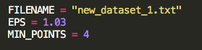
- Run the code using bash “python2.7 dbscan.py”

For MAPREDUCE HADOOP :-

- Please copy the mapper, reducer and bash files into the same folder where Hadoop is located.

- Please run the bash file using “python2.7 bash.py”

