1. To run a query please change the keywords at the bottom of the code file and run the code using “python2.7 code.py” in the command line. The code requires plotly and numpy 1.12.



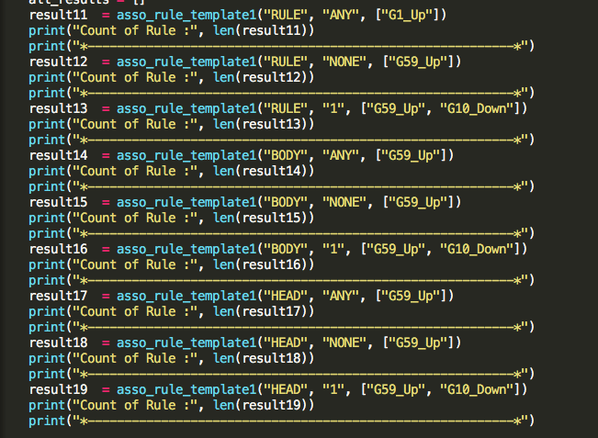

1. The support and confidence values can be changed at the top :

