1. To run the code on a particular text file kindly change the file name at the end of the code file.

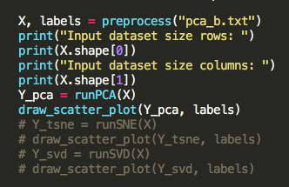

1. To run the PCA implementation kindly uncomment the Y_pca and draw function.



1. To run the SVD implementation, kindly uncomment the SVD and comment the rest.

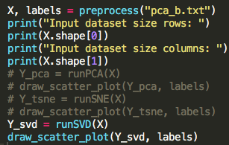

1. To run the TSNE implementation, kindly uncomment the t-SNE function and comment the rest.

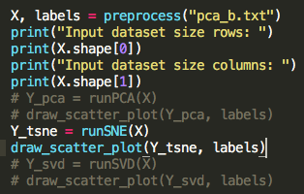

1. To run the code please type “python2.7 code.py”. The code requires numpy 1.12.