- 使用匈牙利法求解下述指派问题
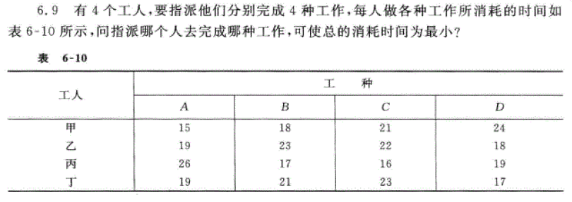
- 利用动态规划的思路，计算A到B、C、D的最短路径
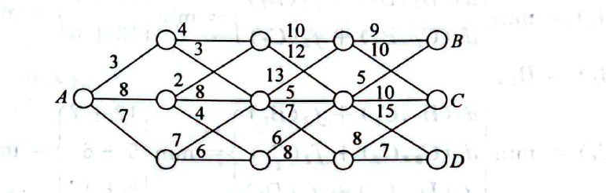
- 利用动态规划的思路，求解下述问题：
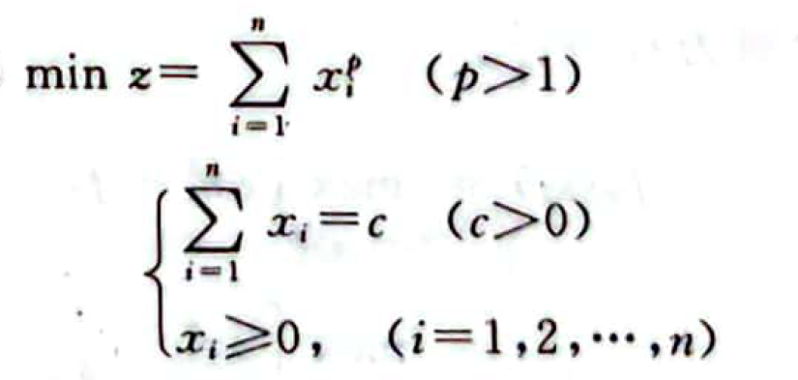
提示：划分为n个阶段$S_{1},S_{2},…,S_{n}$,状态为$s_{n}=x_{n},s_{n-1}=x_{n-1}+x_{n}, …s_{1}=x_{1}+x_{2}+…+x_{n}$.首先证明
$$f\left(s_{n-1}\right)=\min_{{0≤s}_{n}≤s_{n-1}}{{\left(s_{n-1}-s_{n}\right)}^{p}+f\left(s_{n}\right)}=\min_{{0≤s}_{n}≤s_{n-1}}{{\left(s_{n-1}-s_{n}\right)}^{p}+s_{n}^{p}}=\frac{2s_{n-1}^{p}}{2^{p}}$$
且$s_{n}^{*}=\frac{s_{n-1}}{2}$
$$f\left(s_{n-2}\right)=\min_{{0≤s}_{n-1}≤s_{n-2}}{{\left(s_{n-2}-s_{n-1}\right)}^{p}+f\left(s_{n-1}\right)}=\min_{{0≤s}_{n-1}≤s_{n-2}}{{\left(s_{n-2}-s_{n-1}\right)}^{p}+\frac{2s_{n-1}^{p}}{2^{p}}}=\frac{3×s_{n-1}^{p}}{3^{p}}$$
且$s_{n-1}^{*}=\frac{2s_{n-2}}{3}$
以此类推，证明$f\left(s_{n-k}\right)=\frac{(k+1)×s_{n-k}^{p}}{{(k+1)}^{p}}$.

