After the Deposit — Journey Plan
Oct 14, 2026 · @Shady
A readable version of the proposal in docs/post-deposit-journey-design.md. It describes what RehletShifaa does once a patient has paid the coordination deposit, what is missing, the rules that apply in Egypt, and the recommended way to run the rest of the journey: arrival, treatment, discharge and follow-up.

1. Summary
The platform handles the deposit correctly and then goes quiet: after the money is confirmed, the rest of the journey is a set of staff forms with no payments, no required proof and nothing for the patient to follow. We recommend five additions, none of which replaces what already works.
- An evidence ledger. Each stage opens only when its proof is on file: the hospital's admission letter, the patient's arrival, the balance receipt, the consent, the discharge pack, the reconciled hospital bill.
- A clear money model with three legs. The deposit (built), a disclosed platform fee, and the hospital package. In the first release the hospital package is paid at the hospital against a voucher the platform issues, so the platform never holds hospital money. Treatment cannot start until the balance is proven ("pay to admit").
- One new stage, "Cleared for admission". Everything else is recorded as milestones inside the existing stages.
- An audit of the doctors' own hospital agreements. Declared affiliations, price confirmation from the hospital itself, separate doctor and hospital lines, a reconciliation at discharge, scorecards and sample audits.
- Clear duties with deadlines for the Consultant, Operations and Finance from arrival to follow-up.
One legal point changes the business model: Egypt's medical ethics regulation forbids a doctor from sharing fees with, or working through, an intermediary. A 15% markup hidden inside the doctor's fee reads as exactly that. The same 15% should be charged to the patient as a visible platform fee on the platform's own invoice, with the doctor's and hospital's prices passed through untouched.
Nine decisions are needed from the owner (section 12). The most urgent are the fee restructuring, the voucher model, and starting the data-protection licence and the medical-liability fund subscription now.

2. Where the journey stands today
After Finance confirms the deposit, the case moves itself into treatment coordination and the following steps exist. They are correct, but each is a form that staff fill in; nothing checks that the step was done with proof.
Step | Who | What exists today
Deposit confirmed | Finance, system | Finance's item closes; the coordinator gets "Start treatment coordination"; the patient is told; the case moves on once the profile, consents and onboarding are complete. Audited and safe to repeat.
Assign Operations | Coordinator | One action; refused until the patient's own steps are done.
Travel plan | Operations | Planned and confirmed arrival, visa, flights, airport reception, hotel, transport, companions, hospital (from the registry), exceptions. Confirming travel needs full readiness. Recording the arrival moves the case to "Arrival confirmed".
Final assessment and final quote | Consultant, coordinator | In-person assessment with price lines (doctor's catalogue, hospital packages, manual lines); final quote with the locked margin; secure link; patient accepts, asks for changes or declines.
Consent | Consultant | Procedure-specific consent in the patient's language with evidence, or an audited emergency override.
Treatment | Consultant | One record per episode: hospital, dates, planned and actual procedures, milestones and complications as free text, discharge-ready flag, discharge document.
Follow-up | Consultant | A plan with a date, mode (video, phone, in person), tests and instructions; then the case closes.
Patient view | Patient | Four calm messages: "We are arranging your treatment", "Your arrival is confirmed", "Your treatment is under way", "You are in follow-up". No dates, no money, no documents.
Money | Finance | The deposit only: 15% of the marked-up medical total, between USD 200 and USD 1,500, by bank transfer or cash through an agent, verified against the patient's reference. Refunds and waivers can be recorded. Nothing after that: no balance, no invoice, no receipt, no payment to the hospital or the doctor.

3. What is missing
Eight gaps, in order of consequence.
# | Gap | Why it matters
1 | No money after the deposit. Treatment can begin with 15% paid. The balance is never collected, recorded or reconciled; nobody is paid. | The platform cannot prove what the patient paid, refund correctly, or pay the Consultant. Revenue is unproven.
2 | No admission record. No reservation with the hospital, no admission letter, no hospital invoice, no comparison of quoted price against charged price. | The price the patient saw and the price the hospital charges are never compared.
3 | The Consultant's hospital deal is invisible. The doctor picks a hospital package; the real arrangement happens off the platform. | Inflated bills, side payments or kickbacks cannot be detected or disproved.
4 | Treatment is a form, not a process. No milestones (admitted, procedure done, ward, stable), no control over extra charges after the final quote, no incident handling, no deadlines on the doctor's updates. | The family hears nothing for days; extras appear on the bill; adverse events are not managed.
5 | Discharge is just a document. No discharge pack (summary, medicines, implant details, fit-to-fly letter, follow-up dates), no departure logistics. | The patient flies home without what their home doctor needs; a complication within 30 days has no owner.
6 | Follow-up is not executed. A plan is written; nothing schedules the call, records the outcome, closes the 30-day window or hands over to a home doctor. | No aftercare, no outcomes, no word of mouth.
7 | No proof required to move a stage. Stages change on a staff click. | The audit trail is a log of clicks, not of evidence.
8 | The legal shape of the 15%. The markup sits inside the doctor's fee. | Under Egypt's ethics regulation this reads as fee-sharing through an intermediary (section 4).

4. Rules we must follow in Egypt
Every item below needs confirmation by Egyptian counsel before launch. The ethics text comes from a public copy of the regulation; the Syndicate's own page could not be reached.
Rule | What it says | What it changes for us
Medical ethics regulation (Ministerial Decree 238/2003), public copy | Article 8: a doctor may not use intermediaries, paid or unpaid; may not take a reward for sending patients to a hospital; may not share fees with anyone who did not take part in the treatment; may not act as an intermediary for another doctor or a hospital. Article 10: no self-advertising. | The platform must not be the doctor's intermediary and must not take a share of the doctor's fee. The patient is our client; we charge the patient a visible coordination fee; the doctor and hospital are paid their own prices in full. Consultant public profiles stay factual: no promotion, ratings or testimonials.
Medical Liability and Patient Safety Law 13/2025, summary | In force since 29 October 2025. Every practitioner and facility must subscribe to the national liability fund; complaints go to technical committees (30 days) and conciliation committees. | Record each Consultant's fund subscription as a credential with an expiry. Give every incident after arrival a record and a route to the committee. Keep consent, operative notes and discharge documents retrievable.
Private medical establishments Law 51/1981, guide | Facilities must be licensed and registered with the Syndicate and post their prices. | Store the licence number and accreditation on each hospital record; keep the hospital's own price confirmation for every admission.
Personal Data Protection Law 151/2020 and its regulations (Decree 816/2025), analysis | Compliance deadline reported as 31 October to 1 November 2026. A licence is needed to process health data; breaches reported within 72 hours; cross-border transfers need a licence and explicit consent. | The licence application is a launch blocker. The WhatsApp (Meta) transfer and any foreign hosting need the transfer licence. Hospital documents must stay inside the platform's scanned, encrypted document pipeline.
Central Bank payment rules (June 2025), summary | A business that receives a customer's money and forwards it to the merchant is a payment facilitator and needs a licence or a licensed partner. | In the first release the platform collects only what it is owed itself (the deposit, as a payment for its own services credited to the patient, and its fee). Collecting the hospital package through the platform comes later, behind a licensed payment provider.
VAT Law 67/2016 and e-invoicing, overview | Healthcare is VAT-exempt; a coordination service is most likely taxed at 14% and must be issued as a tax-authority e-invoice or e-receipt. | Our fee is a separate taxable line on our own e-invoice; the medical lines are the providers' exempt invoices. The patient statement is designed this way from day one.
Consumer Protection Law 181/2018, summary | Services must be announced with an all-inclusive price; remote contracts carry a 14-day withdrawal right. | The proposal shows the all-inclusive price with our fee visible. Our refund rule (deposit refundable until 10 days before the first appointment) already exceeds the statutory right.
National Medical Tourism Council (2025) and GAHAR, news | The council is defining criteria for providers on a national health-tourism platform; GAHAR accredits facilities. | Prefer GAHAR- or JCI-accredited hospitals; register the platform with the council once the criteria are published.

5. What successful operators do
Operator | Practice | What we copy
Bookimed | The deposit is legally a payment for Bookimed's own services; the clinic reduces its bill by that amount. The patient pays the clinic directly. Bookimed never holds treatment money and adds no markup to the clinic price. | The same legal construction for our deposit and fee. The patient pays the hospital package at the hospital in the first release.
Bumrungrad (Thailand) | A written, itemised estimate with explicit exclusions. The full deposit of the estimate is paid before any procedure. Staff never handle a patient's money. Any excess is refunded after the procedure, to the original payment method. | "Pay to admit" before treatment; exclusions on the final quote; refund to the original method.
Apollo, Vaidam, HOSMAT (India) | The full surgical amount, or 90 to 100% of the estimate, is paid at admission. Interim bills are issued during the stay and settled within hours. Excess is refunded at discharge. | Interim bills recorded during the stay; a running balance; a tolerance band for extras.
Acibadem (Türkiye) | A discharge pack: summary, medication list, operative note, implant details, warning signs in plain language, dated follow-up plan. The fit-to-fly letter is a separate document from the treating doctor. A support line after discharge. | The discharge pack and the fit-to-fly rule before the return flight is booked.
USHAŞ regulation (Türkiye, 2025) | Facilitators are certified; the certificate depends on performance: patient complaints, response time, waiting time, reviewed yearly. A 24/7 call centre in two languages is required. | Our own service levels and complaint channel; a performance scorecard per Consultant and hospital.
JCI and GHA | Cost information at admission; consent in a language the patient understands; no abbreviations on documents patients take home; care from first contact to follow-up at home. | The evidence ledger in section 10 mirrors this continuum.

6. The journey after the deposit, stage by stage
The existing stages stay. One stage is added, "Cleared for admission", because "arrived" and "cleared to be admitted" are different moments for the patient, for the money and for liability. Everything else is recorded as milestones inside a stage.
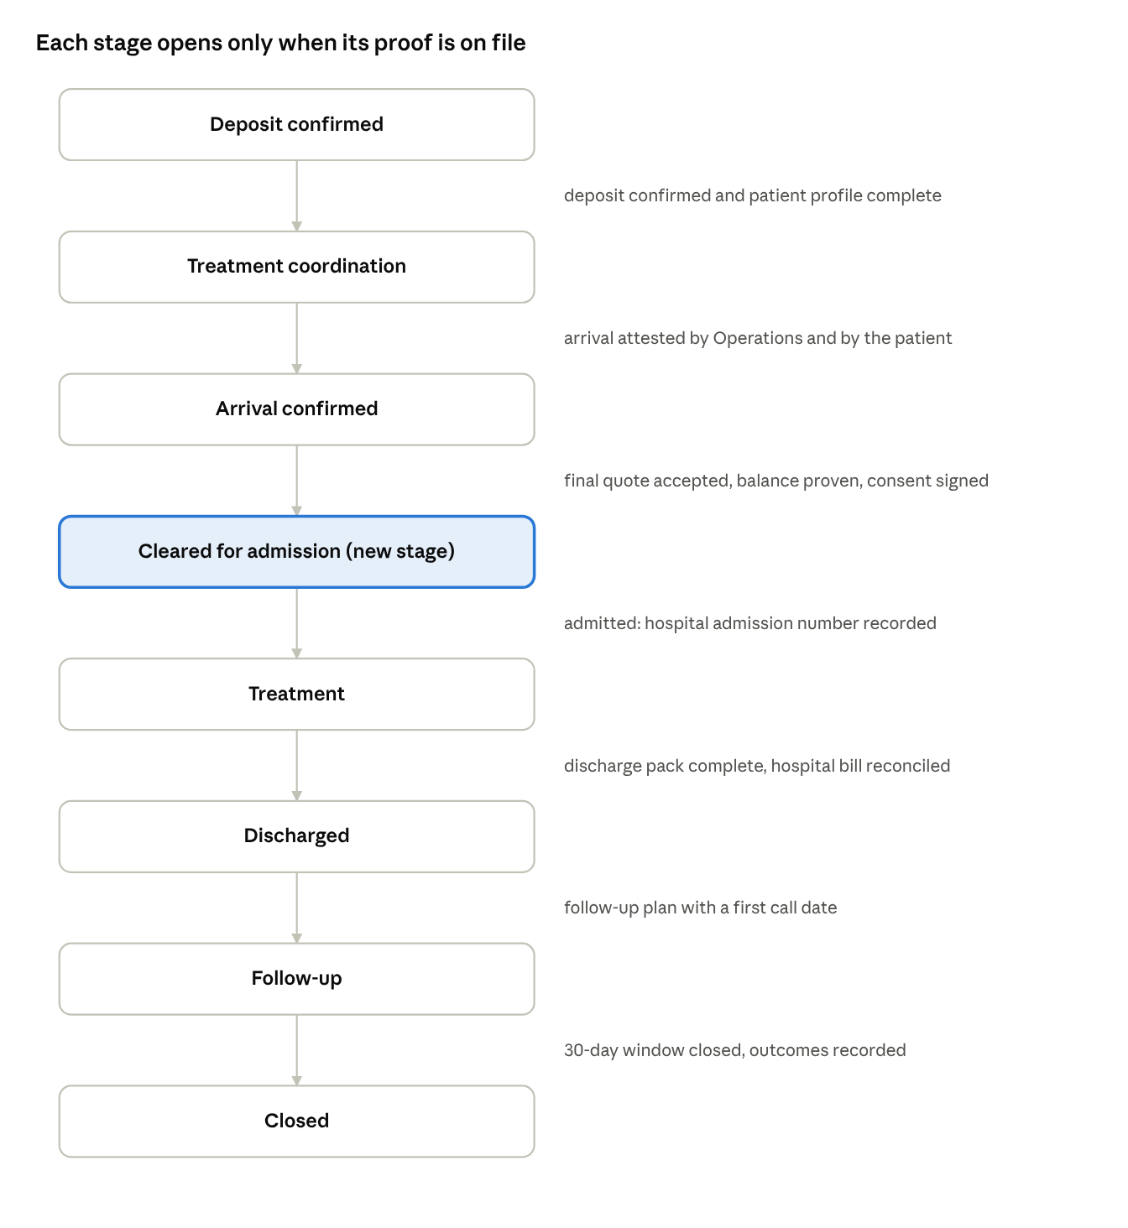
journey after the deposit · 8 stages, one new
On the left, the stage. On the right, the proof that must be on file before the next stage opens.
Stage | Who does what | What the patient sees
Treatment coordination | Coordinator assigns Operations and agrees the admission week with the Consultant. Consultant confirms availability and the hospital, and declares any affiliation with it. Operations reserves the admission and uploads the hospital's own admission letter or pro-forma with the package price. Finance checks that price against the approved package and the estimate; a variance is resolved before travel is confirmed. | "Your dates": admission week, hospital and city, Consultant, what to bring, travel items, and a money line: deposit paid, balance due at admission, fee breakdown.
Arrival confirmed | Operations records the arrival; the patient confirms "I have arrived"; identity is checked against the passport. Consultant does the in-person assessment within 1 to 2 days. Coordinator issues the final quote; Finance handles exceptions. | An arrival card (hotel, hospital, first appointment, coordinator's number), then the final quote with "what changed and why" and the balance due before admission.
Cleared for admission (new) | Operations confirms the admission date and records the hospital admission number. Consultant confirms the surgical plan and expected length of stay. | "You are cleared for admission on …".
Treatment | Consultant records milestones within 24 hours of each: admitted, procedure started, procedure completed, intensive care, ward, complication, stable, discharge planned. Any extra procedure or night outside the final quote is a change order: clinical reason from the Consultant, price from Finance, acceptance by the patient above a tolerance band. Operations uploads interim bills. | A treatment timeline in plain language, who to call, visiting information. The family representative sees the same.
Discharged | Consultant completes the discharge pack: summary, medication list, operative note, implant record, fit-to-fly letter, follow-up plan. Finance reconciles the hospital's final invoice against the quote and change orders and issues the patient's statement. Operations arranges the return only after the fit-to-fly letter. | "Going home": the documents to download, the statement, the follow-up date, the 30-day support line.
Follow-up | Consultant holds the planned calls and records outcomes at day 30 and day 90. Coordinator checks in on days 3 and 14 and owns the 30-day complication window with a named escalation route. The platform generates the home-doctor handover letter and asks for a review at closure. | Follow-up dates, the handover letter, how to reach us if something is wrong.

7. Money: who pays what, when, and through whom
Every case has three money legs, each with its own payee, invoice and proof, all shown on one patient statement in the patient's currency at the frozen rate and in EGP.
Payment | Paid to | What | When | Through the platform? | Proof
A. Coordination deposit | Platform, credited to the patient's bill | 15% of the medical total, USD 200 to 1,500 (built) | At acknowledgement of the estimate | Yes: bank transfer or cash through an agent; card later | Patient's reference, confirmed by Finance (built)
B. Platform fee | Platform | The disclosed coordination and guarantee fee (today's 15%, restructured per section 4), plus 14% VAT, on our own e-invoice | Due at the final quote; the deposit covers it first | Yes | Platform e-invoice and receipt
C. Medical package | Hospital (including the Consultant's fee when the hospital bills it) or Consultant | The accepted final quote minus the deposit credit and the platform fee | Before admission ("pay to admit") | First release: no. Paid at the hospital cashier against the platform's admission voucher; the hospital returns the receipt. Later: yes, through a licensed payment provider into a segregated account, settled to providers on their terms. | Hospital receipt uploaded by Operations; provider webhook later
D. Change orders | Hospital | Approved extras during the stay | After approval | As C | Change-order record and interim bill
E. Travel services | Platform, then suppliers | Visa, hotel, transfers, flights | At travel confirmation; refundable until the point of no return | Yes | Supplier confirmations
F. Refunds | Patient | Deposit under the 10-day rule; travel until the point of no return; overpayment at discharge | On the rule's trigger | Yes, to the original method | Refund entry in the ledger (built)
G. Payouts | Hospital, Consultant, suppliers | The deposit credit settled to the hospital; platform-collected amounts later | On each hospital's settlement terms (already stored, unused) | Yes | Settlement statement, "mark paid" with reference
The admission voucher. When the final quote is accepted, the platform issues the hospital a voucher: case number, patient, package reference and price, inclusions, the deposit credit the platform will settle, the amount the patient pays at the cashier, and the frozen exchange rate. The hospital confirms the admission against it and returns the cashier receipt. The platform never touches the hospital's money, yet the price is fixed by a document both sides hold, and the reconciliation at discharge has a baseline.
Pay to admit. No treatment can be recorded without proof of the balance on file, exactly as consent gates it today. Emergency exception: the Consultant overrides with a reason and Finance reviews afterwards.
Extras. Below a tolerance band, Finance approval is enough; above it, the patient accepts in My Care. Extras that were never approved are disputed with the hospital, never charged to the patient silently.
Statements. At the final quote, at discharge and at closure, Finance issues a statement in English and Arabic: lines, payments, credits, refunds, balance, with the platform's e-invoice attached. A government or employer payer receives the same.

8. Auditing the doctor's own agreements with hospitals
We cannot and should not stop Consultants from having their own arrangements with hospitals; that is how private medicine works in Egypt. We can make every case provable and make hidden arrangements visible through their effects.
- Only registered hospitals with Finance-approved packages (built). Add the licence number, the hospital's international-patient contact and the signed hospital agreement: package validity, price guarantee, cancellation terms, invoice format, no extra charges without a change order, data handling.
- Declared affiliations. At onboarding and every year, each Consultant declares privileges at, employment by, or any financial interest in the hospitals they use. A case using an undeclared hospital is flagged to Compliance; an undeclared financial interest breaches the Consultant agreement.
- Price confirmed by the hospital itself. The admission letter or pro-forma must come from the hospital's named contact to the platform, not through the Consultant, and must sit inside the approved package range. Operations records who sent it.
- Separate lines, no blending. The final quote shows the Consultant's fee and the hospital package separately, even when the hospital collects both, so a blended "surgeon package" cannot hide a markup.
- Reconciliation at discharge with variance codes: within band, change order, unapproved extra, billing error. A hospital with unapproved extras twice in a quarter has its packages suspended pending review.
- A scorecard per Consultant, reviewed by Compliance and Consultant Operations: final quote against the preliminary maximum, change-order rate, unapproved extras, complication and reopen rate, discharge-pack completeness, follow-up completion, patient rating. Thresholds feed availability for new cases.
- Non-circumvention and no-kickback clauses in the Consultant and hospital agreements, and a line on every proposal: "No doctor or hospital pays us for sending you; our fee is shown here." This is also our defence under the ethics regulation.
- Sample audits. Compliance samples closed cases every month and compares the hospital invoice, the patient's receipt, the statement and the Consultant's fee record. Findings become incidents.
- A concern channel the patient can reach without the Consultant. The coordinator thread (built) plus a "raise a concern" action in My Care that creates an incident visible to Compliance.

9. Who does what after the deposit
Role | Must do | Deadline | Must not
Coordinator | Stay the one voice to the patient; assign Operations; agree dates with the Consultant; welcome at arrival; issue the final quote; check in on days 3, 14 and 30; close the case | Final quote within 1 day of the assessment | Touch money, consent or clinical fields
Consultant | Confirm dates and hospital; declare affiliations; in-person assessment and final quote inputs; consent; milestones; change-order reasons; discharge pack; fit-to-fly letter; follow-up calls; outcomes at day 30 and 90 | Assessment within 2 days of arrival; each milestone within 24 hours; pack before discharge | Collect money in the platform's name; use an unregistered hospital; blend their fee into the hospital's
Operations | Reserve the admission and get the hospital's letter; travel items; attest arrival and identity; record the admission number; upload interim bills and the final invoice; arrange departure after the fit-to-fly letter | Reservation within 3 days; final invoice within 2 days of discharge | Confirm travel before readiness; change prices
Finance | Check the hospital's pro-forma; final-quote exceptions; record balance proof; price change orders; track interim bills; reconcile the invoice; issue statements and e-invoices; settle and pay out; refund under the rule | Pro-forma check within 1 day; change order within 4 hours; reconciliation within 2 days | Approve their own entries above a threshold (maker/checker)
Compliance | Affiliation checks; sample audits; incident oversight; scorecards | Monthly | Change cases
Patient or representative | Confirm arrival; accept the final quote and change orders; pay the balance; receive the pack; answer outcome questions
Missed deadlines raise the existing reminders and escalate to the team lead, as the current work-item engine already does for earlier stages.

10. How every step is audited
One new record type, the evidence ledger, replaces "a staff member clicked" with "this proof was filed". Every entry is permanent and records the stage, the kind of proof, the document or reference, who recorded it and their role, who countersigned it (required for money, and for anything Operations records on the Consultant's behalf), and when.
Stage | Proof kinds recorded
Treatment coordination | Hospital admission letter or pro-forma; Finance price check; travel confirmations
Arrival confirmed | Arrival attested; identity seen; final assessment; final quote accepted; balance receipt; consent
Cleared for admission | Admission number; surgical plan
Treatment | Each milestone; change orders; interim bills; incidents
Discharged | Discharge summary; medication list; operative note; implant record; fit-to-fly letter; final invoice; reconciliation with variance codes; statement
Follow-up | Each call done; outcomes at day 30 and 90; handover letter; closure review
How it is used:
- Stage gates read the ledger. A stage will not open until its required proof is there; the screen shows the missing items as a checklist, the way readiness blockers are shown today.
- One source for everything shown. The patient's timeline, the staff's current action and "At a glance" are all derived from the same entries, so they can never disagree.
- Every money entry points to proof. Nothing is marked paid without a receipt or provider confirmation, and nothing is settled without a reconciliation entry countersigned by Finance.
- Reports for Compliance. Per case: the full evidence trail in order. Per Consultant and hospital: the scorecard. Per month: the reconciliation summary and the settlement register, exportable with correlation ids for an external auditor.

11. Build order
The work fits the existing implementation plan as five new phases (2 to 6 below) after the commercial-truth phase already planned, each one to two sessions, plus a later phase once a licensed payment partner exists.
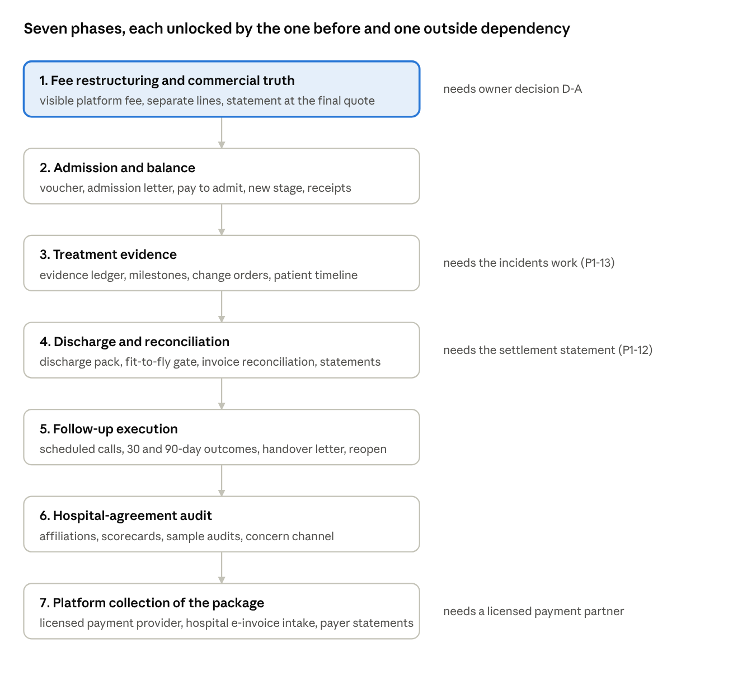
build order · 7 phases
Each phase is unlocked by the one above it; the note on the right names the one outside dependency where there is one.

12. Decisions for the owner
# | Decision | Recommendation
D-A | Restructure the 15% as a visible platform fee charged to the patient, with the Consultant and hospital at their own prices? | Yes, before launch. Required by the ethics regulation reading in section 4 and by consumer-protection price disclosure; it also makes VAT and e-invoicing clean. Counsel to confirm the reading and the VAT rate on the fee.
D-B | First release: the hospital package is paid at the hospital against a platform voucher, and the platform never holds hospital money? | Yes. Avoids Central Bank payment licensing at launch; price control comes from the voucher and the reconciliation. Move to platform collection with a licensed provider later.
D-C | "Pay to admit": the balance must be proven before treatment is recorded? | Yes, with the same emergency override pattern as consent. This is what Bumrungrad and Apollo do; it protects the hospital relationship and the refund logic.
D-D | Add the stage "Cleared for admission"? | Yes, one well-defined stage; everything else as milestones.
D-E | Tolerance band for extras during the stay | 10% of the hospital package or EGP 15,000, whichever is lower. Finance alone below it, the patient's acceptance above it, emergency override with review.
D-F | How long a fit-to-fly letter is valid | 72 hours before the flight; Operations cannot confirm the return without it.
D-G | Free follow-up window | 30 days of calls included in the package; paid teleconsultation after that.
D-H | Declared hospital affiliations as a condition of a Consultant's eligibility | Yes, yearly, reviewed by Compliance.
D-I | Start the data-protection licence application and the medical-liability fund subscription now | Start now. Both are launch blockers in time, not in effort.
What this does not change: the case lifecycle, the one-voice rule, the readiness gate, the deposit mechanics, the frozen commercial snapshot, the hospital and package registry, and the work-item engine. Everything above is layered on them.

