RehletShifaa Users Roles and Access Guide
A plain language operating manual for platform owners provider organizations clinics staff and testers
Edition 1 Target operating model 25 September 2026
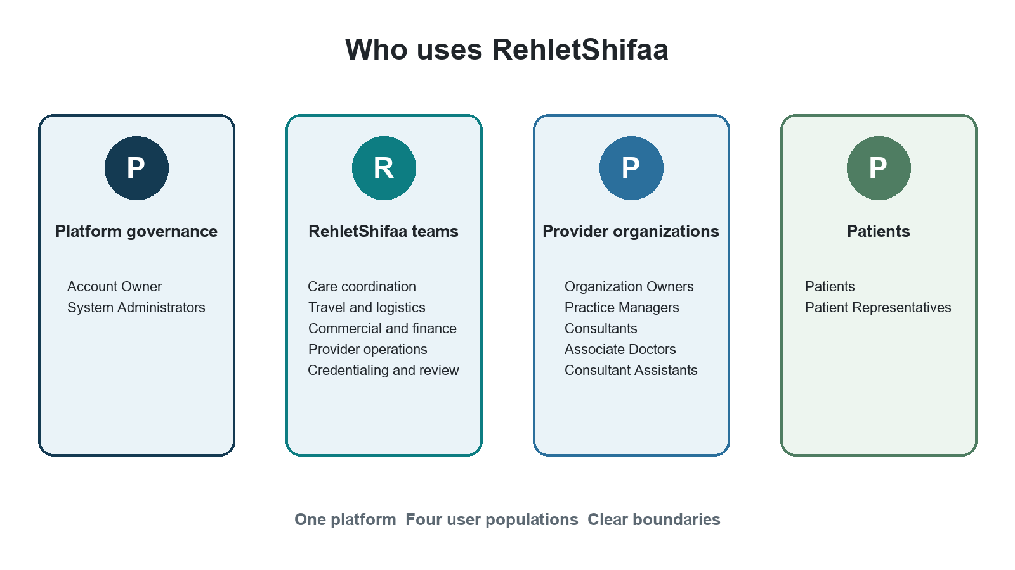
This guide explains who each user is, where each role applies, what that person may do, what remains prohibited, and how to test the boundaries. It is suitable for a provider owner evaluating the platform and for delivery teams building or validating it.
Document owner RehletShifaa

1 How to use this guide
The agreed model is simple. A role states what a person may do. A scope states where that role applies. Access is granted only when the person, membership, organization, facility, assignment, and any professional eligibility are all active.
This document describes the approved target operating model. It is the behavior to build and test for the first production release. It should not be treated as proof that every feature is already available in the current development environment.

Reader paths
Reader | Start here | Then use
Provider owner or buyer | Sections 2 through 5 | Worked example and quick reference
Clinic manager | Provider organization roles | Access scopes and lifecycle
RehletShifaa manager | Platform governance and internal roles | Role combinations and handovers
Tester | Core model and scope rules | Tester handbook and worked example
Implementation team | All role profiles | Control rules and acceptance checks

Contents
1. The model in one page
2. Platform governance roles
3. RehletShifaa internal staff roles
4. Provider organizations clinics and roles
5. Patients representatives and non business identities
6. Scopes role combinations and professional eligibility
7. Invitations activation suspension and removal
8. Services prices schedules cases and routing
9. Tester handbook
10. Worked example
11. Quick reference and glossary

2 The model in one page

Four user populations
RehletShifaa separates platform governance, internal operations, provider organizations, and patients. The boundaries prevent a provider manager from becoming a platform administrator and prevent an administrator from reading clinical information merely because they manage access.
Figure 1 The four user populations

Seven facts every reader should know
1. One human has one sign in identity across the platform.
2. A provider organization is the legal or contracting tenant.
3. A clinic branch hospital or virtual site is a facility inside one provider organization.
4. A person may belong to several provider organizations and several facilities.
5. The same person may hold different compatible roles in different organizations or facilities.
6. Ending one local role membership or facility affiliation does not disable access elsewhere.
7. A global identity disable is reserved for compromise or an authorized platform wide action.

The provider hierarchy
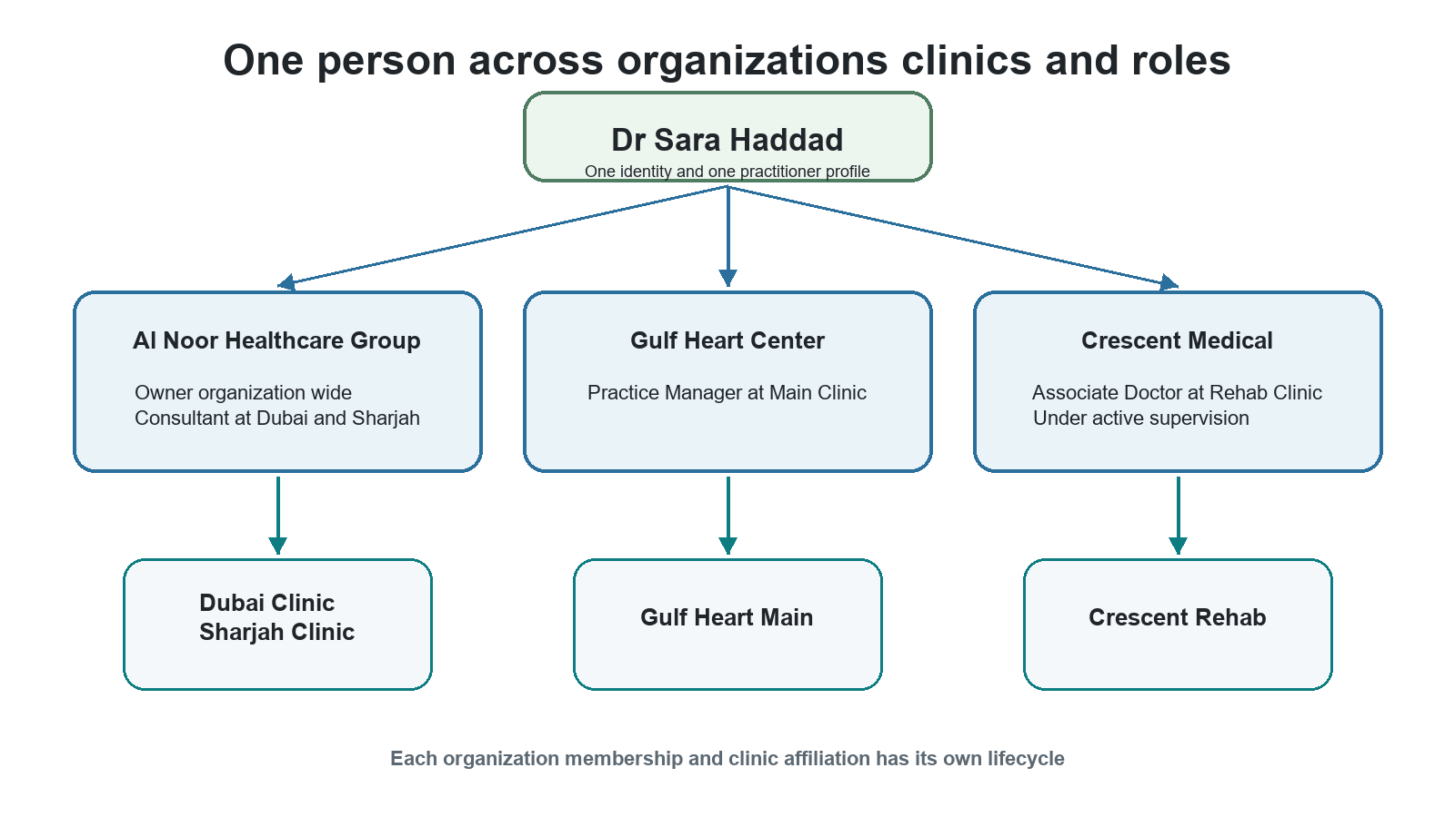
Figure 2 One person can work across organizations and clinics
- The identity and practitioner profile are shared across the platform.
- Each organization membership can start suspend or end independently.
- Each clinic affiliation and role assignment names the context where it applies.

3 Platform governance roles
These roles govern the RehletShifaa platform account. They are separate from daily care delivery and from ownership of a provider organization.
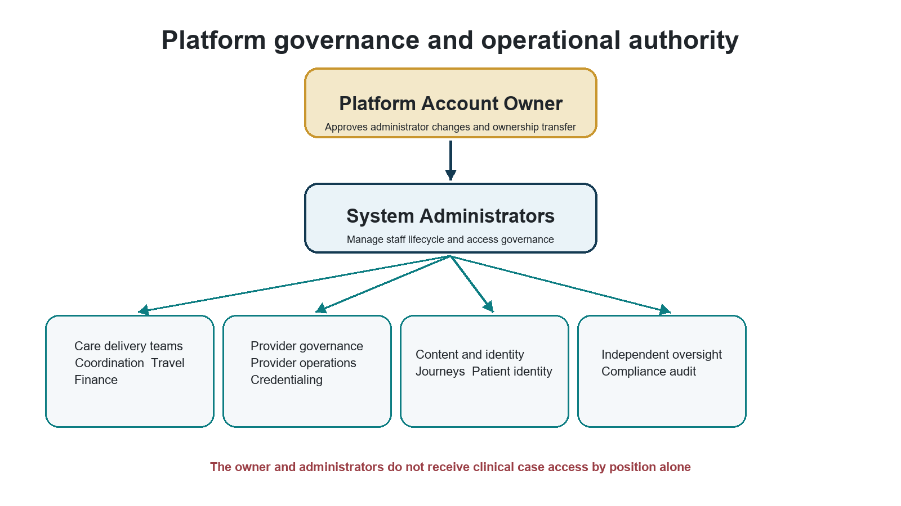
Figure 3 Governance and operational authority are separate

Platform Account Owner
The Platform Account Owner is the contractual root of trust for the RehletShifaa platform account. Ownership is a protected relationship, not a normal grantable role.
Role fact | Plain language meaning
Population and scope | Platform governance. Platform governance actions only
May do | Approve or reject System Administrator changes; transfer ownership; authorize handover administrators; restore administration if no administrator remains; emergency remove an administrator; review a governance summary.
Must not do | Read clinical cases or documents; manage finance or provider operations; grant normal staff roles; act as the owner of a provider organization merely because they own the platform account.
Strong sign in | Required for every owner action. Sensitive actions also require a recent sign in within five minutes.
Typical handoff | The owner approves administrator changes. System Administrators perform day to day staff and access administration.
Tester focus | Verify that ownership alone grants no clinical operational financial provider or patient access. Verify transfer and emergency actions are audited.

System Administrator
System Administrators manage people access and staff lifecycle without becoming clinical superusers. Two active holders are recommended.
Role fact | Plain language meaning
Population and scope | Platform governance and internal staff. Platform access governance and staff administration
May do | Invite and manage internal staff; change jobs; grant compatible supplemental responsibilities; manage access assignments and relationships; view effective access and access audit; request or approve another administrator appointment or removal.
Must not do | Approve their own request; grant or revoke their own authority; read unrelated clinical cases; make finance credential identity provider or journey decisions; bypass role conflicts; remove the last administrator through the normal flow.
Strong sign in | Required on every request. Privileged actions require a recent sign in within five minutes.
Typical handoff | Hands operational work to the correct staff profile. Another administrator or the Platform Account Owner approves privileged administrator changes.
Tester focus | Test no self service escalation no clinical bypass last administrator protection and owner controlled recovery when zero administrators remain.

Administrator appointment rules
Situation | Who starts it | Who approves it | Expected protection
Two or more administrators | Any administrator | Another administrator or the Platform Account Owner | Requester approver and target must be different where required
Exactly one administrator | That administrator | Platform Account Owner | Last administrator remains until replacement is active
No administrator after handover | Platform Account Owner | No second approval | Strong sign in recent authentication reason and critical audit
Emergency removal | Platform Account Owner | No second approval | Explicit warning may temporarily leave zero administrators
Owner also becomes administrator | Another administrator | Another administrator | The owner never self requests or self approves

4 RehletShifaa internal staff roles
Internal staff remain RehletShifaa employees even when they cover a provider organization or clinic. They never appear as provider employees and cannot be invited into a provider organization by a provider manager.

Internal role structure
- Each internal staff member has one primary job or no primary job only when they are administration only.
- A person may also hold compatible supplemental responsibilities from the approved supplemental set.
- Operational jobs in coordination travel finance and provider operations are primary jobs because they control work queues reporting lines and case ownership.
- Access is governed by assignments and scope. The displayed job label does not create authority by itself.

Care Coordination Manager
Leads the coordination team and supervises the flow of patient cases through assigned provider organizations.
Role fact | Plain language meaning
Population and scope | RehletShifaa internal staff. Platform role with the organizations the manager serves
May do | Supervise coordination work; view team queues; transfer work; configure coordination pools and routing rules for covered organizations; perform coordination casework.
Must not do | Act outside covered organizations; perform finance travel credential provider administration or platform access governance unless separately and compatibly assigned.
Strong sign in | Required as internal staff.
Typical handoff | Receives staff setup from a System Administrator and hands cases to Care Coordinators or other operational teams.
Tester focus | Verify team visibility transfer permissions and organization boundaries. A promotion from Coordinator keeps coordination authority and should not be blocked by owned cases.

Care Coordinator
Owns and progresses assigned coordination cases and connects patients providers and internal teams.
Role fact | Plain language meaning
Population and scope | RehletShifaa internal staff. Assigned cases and the organizations served
May do | Take ownership of eligible cases; work assigned coordination tasks; route or hand work to the appropriate next team under the workflow.
Must not do | Supervise the full coordination team; configure pools; access unrelated cases; perform travel finance credential or platform administration work.
Strong sign in | Required as internal staff.
Typical handoff | Escalates or transfers work to the Care Coordination Manager and hands approved work to travel finance or provider teams.
Tester focus | Verify assigned case access and denial for unrelated cases organizations and facilities.

Travel and Logistics Manager
Supervises travel and logistics work connected to assigned patient journeys.
Role fact | Plain language meaning
Population and scope | RehletShifaa internal staff. Platform travel casework with supervisory authority
May do | Supervise travel cases; review team work; use lead level travel visibility; manage handoffs within the travel function.
Must not do | Change clinical decisions; manage finance policy; administer provider membership; access unrelated case data beyond the minimum travel workspace.
Strong sign in | Required as internal staff.
Typical handoff | Receives approved travel needs from coordination and hands completed arrangements back to the care workflow.
Tester focus | Verify lead visibility is limited to travel work and that sensitive clinical fields are minimized.

Travel and Logistics Specialist
Plans and records travel arrangements for assigned cases.
Role fact | Plain language meaning
Population and scope | RehletShifaa internal staff. Assigned travel cases
May do | Build travel plans; record arrival and logistics milestones; complete assigned operations steps.
Must not do | Supervise the travel team; open unrelated cases; approve finance or clinical decisions.
Strong sign in | Required as internal staff.
Typical handoff | Works from coordination requirements and sends completed arrangements to the next workflow step.
Tester focus | Verify access is limited to assigned travel cases and necessary information.

Commercial and Finance Manager
Owns commercial policy and supervises financial execution for patient cases.
Role fact | Plain language meaning
Population and scope | RehletShifaa internal staff. Platform finance casework and commercial policy
May do | Manage margin and deposit policy; manage foreign exchange rates and service templates; supervise finance casework; perform finance work when needed.
Must not do | Read unrelated clinical material; grant platform roles; make credential decisions; approve a decision when separation of duty requires another person.
Strong sign in | Required as internal staff.
Typical handoff | Sets policy used by Finance Officers and receives escalations or exceptions.
Tester focus | Verify manager only capabilities for policy foreign exchange and templates and verify clinical data minimization.

Finance Officer
Executes the financial steps of assigned cases under approved commercial policy.
Role fact | Plain language meaning
Population and scope | RehletShifaa internal staff. Assigned finance cases
May do | Record deposits and payments; review and approve commercial terms within delegated authority; complete assigned finance tasks.
Must not do | Change margin deposit foreign exchange or service template policy; access unrelated cases; administer users.
Strong sign in | Required as internal staff.
Typical handoff | Receives approved terms and hands financial completion back to the patient journey.
Tester focus | Verify assigned case limits and denial for policy administration.

Provider Operations Manager
Leads setup and operational governance of provider organizations covered by RehletShifaa.
Role fact | Plain language meaning
Population and scope | RehletShifaa internal staff. Platform provider creation plus assigned organizations or facilities
May do | Create provider organizations; activate or suspend providers; manage provider setup; invite provider members and clinicians for covered organizations; manage direct provider setup where applicable.
Must not do | Decide credentials for a clinician they invited or manage; become a provider employee; access patient clinical cases merely because they manage a provider.
Strong sign in | Required as internal staff.
Typical handoff | Creates and prepares providers then hands credential decisions to an independent Credentialing Specialist.
Tester focus | Verify assigned organization boundaries and the independent review rule between provider operations and credentialing.

Provider Operations Specialist
Performs provider and clinician setup for assigned organizations under manager oversight.
Role fact | Plain language meaning
Population and scope | RehletShifaa internal staff. Assigned organizations or facilities
May do | View and update covered providers; invite provider members and clinicians; perform approved direct setup tasks.
Must not do | Activate or suspend providers when the manager capability is required; decide credentials for clinicians they invited or manage; act outside assigned coverage.
Strong sign in | Required as internal staff.
Typical handoff | Prepares the organization and clinicians for independent credential review and manager activation.
Tester focus | Verify no provider activation authority and no credential decision for managed clinicians.

Credentialing Specialist
Provides independent review of clinician credentials for assigned organizations or facilities.
Role fact | Plain language meaning
Population and scope | RehletShifaa internal staff. Assigned organizations or facilities
May do | View credential dossiers; review evidence; request more information; verify reject or suspend credentials; decide direct clinician credentials where applicable.
Must not do | Review their own credentials; decide a clinician they invited or manage as Provider Operations; receive a Provider Operations role on the same person.
Strong sign in | Required as internal staff.
Typical handoff | Receives a complete dossier from provider operations or the clinician and returns an independent decision.
Tester focus | Verify self review denial inviter reviewer separation facility scope and person level conflict with Provider Operations.

Patient Identity Reviewer
Reviews patient legal identity evidence and records an identity decision.
Role fact | Plain language meaning
Population and scope | RehletShifaa internal staff. Platform identity review function
May do | Open the identity review queue; inspect necessary identity evidence; approve reject or request further information according to policy.
Must not do | Read clinical documents or case details unrelated to identity evidence; perform staff administration or credential decisions.
Strong sign in | Required as internal staff.
Typical handoff | Receives an identity review task and returns the outcome to the patient workflow.
Tester focus | Verify the role sees only identity review information and no general clinical documents.

Care Journey Manager
Authors and prepares reusable care journey definitions.
Role fact | Plain language meaning
Population and scope | RehletShifaa internal staff. Platform journey design
May do | View create and edit draft journeys; validate and simulate them; submit them for independent approval.
Must not do | Approve publish or retire their own journey; combine with Care Journey Approver on the same person.
Strong sign in | Required as internal staff.
Typical handoff | Submits a completed draft to a Care Journey Approver.
Tester focus | Verify author and approver separation and that authoring grants no patient case access.

Care Journey Approver
Independently approves and publishes care journey definitions.
Role fact | Plain language meaning
Population and scope | RehletShifaa internal staff. Platform journey approval
May do | View submitted journeys; approve publish or retire journey versions.
Must not do | Author the journey they approve; combine with Care Journey Manager on the same person; access patient cases because of this role.
Strong sign in | Required as internal staff.
Typical handoff | Receives a submitted journey from the Care Journey Manager and publishes or rejects it.
Tester focus | Verify maker checker separation and no clinical case access.

Compliance Auditor
Independently reviews access roles assignments and effective access.
Role fact | Plain language meaning
Population and scope | RehletShifaa internal staff. Platform access audit
May do | View role definitions; view effective access; review access audit history.
Must not do | Read clinical cases or documents; administer staff; change roles; combine with System Administrator on the same person.
Strong sign in | Required as internal staff.
Typical handoff | Reviews evidence produced by Access Governance without changing it.
Tester focus | Verify read only access audit capability no clinical bypass and conflict with System Administrator.

5 Provider organizations clinics and roles
A Provider Organization is the legal or contracting tenant. A Provider Facility is one operating site inside that organization. The user interface calls facilities Clinics and branches. Each facility belongs to exactly one organization.

Organization and facility rules
- An organization may own any number of clinics hospitals medical centers diagnostic centers rehabilitation centers and virtual care facilities.
- A legally independent site with its own contract is a separate Provider Organization rather than a branch.
- Each organization has one default facility for configuration and backfill. The default facility does not grant access.
- An organization cannot be active without at least one active facility.
- Suspending one facility blocks that facility but does not suspend sibling facilities.

Organization Owner
Owns the provider tenant and governs its provider members and operations. This role is different from the Platform Account Owner.
Role fact | Plain language meaning
Population and scope | Provider organization. Organization wide including all current and future facilities
May do | Manage provider members and organization level settings; govern clinics and branches; receive authority across all facilities within the organization; hold compatible provider roles when separation rules still apply.
Must not do | Grant platform or internal staff roles; create central RehletShifaa coverage; bypass self approval rules; see another organization; assume clinical eligibility from ownership.
Strong sign in | Required at launch.
Typical handoff | Delegates day to day work to Practice Managers and clinical work to eligible clinicians.
Tester focus | Verify all facility inheritance including a newly created facility and denial for every platform staff and access governance action.

Practice Manager
Runs provider operations for one several or all facilities in an organization.
Role fact | Plain language meaning
Population and scope | Provider organization. Organization wide or an explicit set of assigned facilities
May do | Manage provider operations and assigned clinicians within scope; manage schedules services or prices when granted by the provider role; work across all facilities only when organization wide.
Must not do | Act at an unassigned sibling facility; grant platform authority; independently approve a price they authored; bypass professional eligibility or affiliation rules.
Strong sign in | Required at launch.
Typical handoff | Receives authority from the Organization Owner and coordinates provider staff clinicians and clinic operations.
Tester focus | Test both organization wide and facility scoped variants. Confirm a facility scoped manager is denied at siblings and organization defaults.

Consultant
Provides consultant level clinical services in the organization and facilities where the assignment applies.
Role fact | Plain language meaning
Population and scope | Provider organization clinical role. Assigned facilities organization scope when explicitly granted and self or managed relationships
May do | Deliver consultant services; manage their own professional workspace schedules and eligible services; supervise Associate Doctors through an active relationship when authorized.
Must not do | Consult without a Consultant declaration and Consultant level credential verification in that organization; act at a facility without active affiliation; approve their own credentials.
Strong sign in | Required no later than first executable clinical capability and recommended at launch.
Typical handoff | Receives an accepted membership offer and independent credential decision before clinical authority becomes usable.
Tester focus | Verify declared level organization credential level active facility affiliation and assignment scope are all required.

Associate Doctor
Provides clinical services under required supervision within the local engagement.
Role fact | Plain language meaning
Population and scope | Provider organization clinical role. Assigned facilities and self or supervised relationships
May do | Work as an Associate Doctor at assigned active facilities; maintain their own provider workspace; receive supervision from an eligible Consultant in the same organization.
Must not do | Work without an active supervising Consultant; act as a Consultant without local Consultant verification; act at another facility or organization without the matching assignment and affiliation.
Strong sign in | Required no later than first executable clinical capability and recommended at launch.
Typical handoff | Works under an active Consultant supervision relationship and follows the organization credential decision.
Tester focus | Verify Associate or Consultant credential level is accepted for Associate engagement and active supervision is mandatory.

Consultant Assistant
Supports selected clinicians and clinic operations without becoming a clinician.
Role fact | Plain language meaning
Population and scope | Provider organization support role. Assigned facilities plus explicit assisting relationships where used
May do | Support the clinicians and facilities explicitly assigned; perform allowed administrative provider tasks within that scope.
Must not do | Hold Consultant or Associate Doctor in the same facility; receive clinical authority from the assistant role; act for unassigned clinicians or facilities.
Strong sign in | Required if the account also holds a manager role and otherwise follows provider authentication policy.
Typical handoff | Works for selected clinicians and escalates clinical decisions to the responsible clinician.
Tester focus | Verify same facility clinical role conflict and denial outside assigned clinicians and facilities.

No Branch Manager role
The agreed model does not create a separate Branch Manager role. A Practice Manager covers one branch, several branches, or the entire organization through scope. This avoids duplicate roles with identical duties and makes facility access explicit.
Figure 4 Provider roles are contextual

6 Patients representatives and non business identities

Patient
Uses the patient experience for their own identity care requests documents communications and journey steps according to the existing patient policy.
Role fact | Plain language meaning
Population and scope | Patient population. Self and the patient own care context
May do | Use the patient portal; maintain permitted profile information; access the patient own authorized care information and actions; retain patient access if a separate provider membership is later accepted.
Must not do | Receive provider staff platform administration or internal staff authority from the Patient role.
Strong sign in | Follows patient authentication policy. Provider manager or clinical access requires the stronger rules of that accepted context.
Typical handoff | Interacts with care coordination providers travel and finance through the patient journey.
Tester focus | Verify provider offer acceptance does not remove Patient access and that provider authority does not activate before consent.

Patient Representative
Acts for a patient only through an authorized representation relationship.
Role fact | Plain language meaning
Population and scope | Patient population. The represented patient and the permissions of that relationship
May do | Use the patient portal for permitted representative actions linked to the represented patient.
Must not do | Act for unrelated patients; receive provider internal staff or platform governance authority from the representative label.
Strong sign in | Follows patient authentication policy and any stronger policy required by a separate context.
Typical handoff | Communicates with the patient care team within the authorized representation.
Tester focus | Verify every action is bound to an active representation relationship and does not leak another patient information.

Items that are not business roles
Item | What it means | Why it must not be treated as a role
MFA REQUIRED | An authentication policy classifier that forces a strong sign in | It never grants business authority
Vendor operator | The installer or recovery operator used during controlled setup or recovery | It is not a normal ongoing platform user role and leaves after handover
Provider user | A population label | Real authority comes from Organization Owner Practice Manager Consultant Associate Doctor or Consultant Assistant assignments
Internal staff | A population label | Real authority comes from the selected internal staff profile and its scope

Items not in the launch catalogue
- Support Specialist and Support Manager are deferred.
- Credentialing Manager is not a separate role.
- Journey Specialist roles are not included.
- Platform Administrator Access Governance Manager and Support Agent are retired concepts.
- Legacy staff realm roles are not a source of production business authority.

7 Scopes role combinations and professional eligibility

Role and scope work together
A role without the correct scope cannot reach the resource. The platform resolves the organization and facility from stored data rather than trusting a facility identifier supplied by the browser.
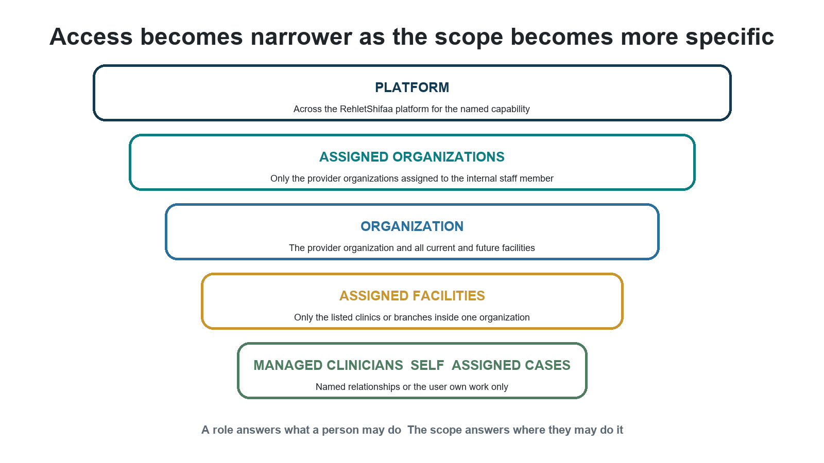
Figure 5 The role says what and the scope says where
Scope | Plain meaning | Typical holders
PLATFORM | The named capability applies across RehletShifaa | System Administrator and selected internal roles
ASSIGNED ORGANIZATIONS | Only the provider organizations assigned to the internal staff member | Provider Operations Credentialing and other central coverage
ORGANIZATION | The provider organization and all current and future facilities | Organization Owner and organization wide Practice Manager
ASSIGNED FACILITIES | Only the listed clinics or branches inside one organization | Facility scoped Practice Manager clinicians assistants and central staff
MANAGED CLINICIANS | Only clinicians linked through an active management relationship | Practice Manager or provider support roles
SELF | Only the user own profile workspace or professional records | Consultants Associate Doctors and assistants
ASSIGNED CASES | Only casework assigned to the staff member or team | Coordination travel and finance roles

Internal staff combinations
Combination rule | Result
One primary job | Required for normal internal staff. Administration only System Administrators may have no primary job.
Supplemental responsibilities | Credentialing Specialist Patient Identity Reviewer Care Journey Manager Care Journey Approver Compliance Auditor and System Administrator may be supplemental when compatible.
Credentialing plus Provider Operations | Refused because the person who invites or manages clinicians cannot be their independent credential decision maker.
Care Journey Manager plus Care Journey Approver | Refused because the author cannot approve the same control family.
Compliance Auditor plus System Administrator | Refused because the auditor cannot audit their own administration.

Provider role combinations
Roles held together | Allowed result and control
Organization Owner and Practice Manager | Allowed.
Owner or Practice Manager and Consultant | Allowed only when clinical eligibility is satisfied. No self credential or self approval bypass.
Owner or Practice Manager and Associate Doctor | Allowed only when clinical eligibility and supervision are satisfied.
Consultant and Associate Doctor | Allowed only at different facilities when the person is Consultant qualified and the Associate engagement has active supervision.
Consultant Assistant and Consultant | Refused at the same facility.
Consultant Assistant and Associate Doctor | Refused at the same facility.
Any provider role and RehletShifaa internal staff | Refused. Internal staff are never provider members under this model.

Four facts required for a clinical role
1. The person declares a global professional level such as Consultant or Associate Doctor.
2. Each provider organization independently verifies the professional level for that organization.
3. The organization grants a local Consultant or Associate Doctor engagement role.
4. The person has an active affiliation with every facility named by the assignment.
A local role cannot upgrade a person declared or verified professional level. A Consultant role requires a Consultant declaration and Consultant level verification in that organization. An Associate Doctor role accepts Associate or Consultant level verification but also requires active supervision by an eligible Consultant in the same organization.

8 Invitations activation suspension and removal

Provider membership offers
Typing an email does not silently attach a person to an organization. The organization sends an offer. The invitee sees the organization facilities proposed roles and dates and then accepts or declines.
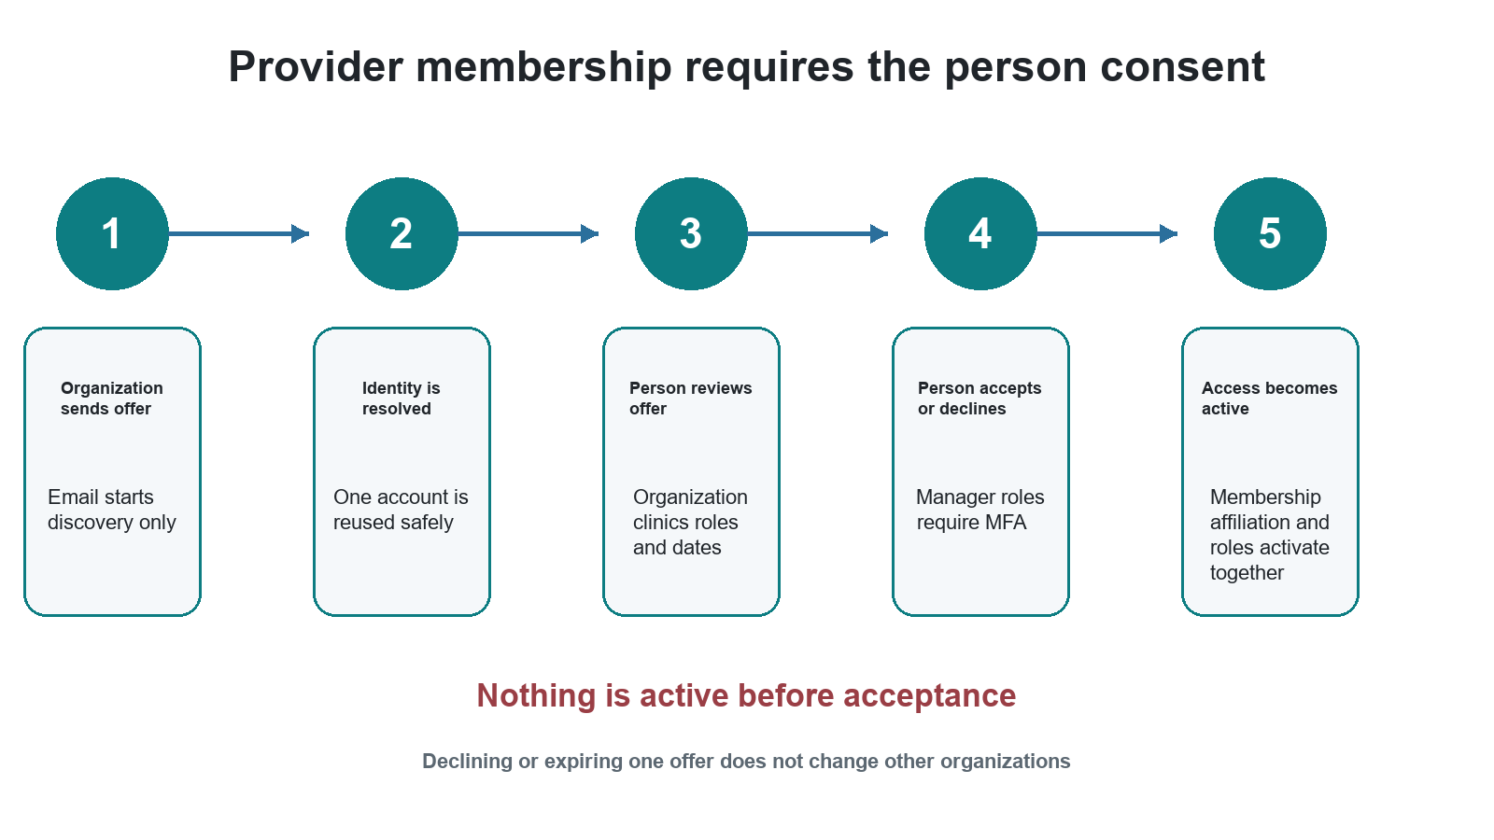
Figure 6 Provider access starts only after consent
Offer state | Meaning
Awaiting identity | The platform is safely resolving or creating one identity for the email.
Pending | The person may review and accept or decline. Nothing is active yet.
Accepted | Membership facility affiliations and compatible role assignments activate together.
Declined | This offer ends. Other organizations are untouched.
Expired | The offer expires after the configured period. The agreed default is 14 days.
Cancelled | The inviter cancels this offer before acceptance.
Review required | An identity conflict incompatible role or internal staff collision requires governance review.

Internal staff activation
1. A System Administrator creates the invitation with one primary job compatible supplementals and operational setup.
2. The invitee verifies email sets a password enrolls strong authentication and signs in.
3. The first successful strong authenticated request activates the staff lifecycle once.
4. Assignments remain unusable while the staff record is still invited.

Local and global lifecycle
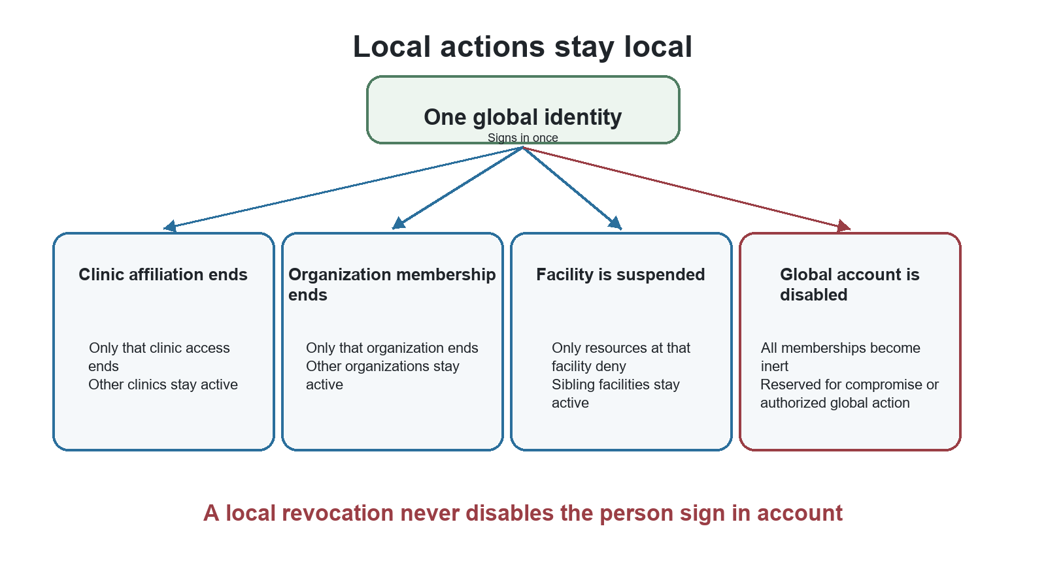
Figure 7 Local actions do not cascade globally
Action | What ends | What remains
End one facility affiliation | That facility access and any assignment left with no facility | Other facilities organizations memberships and central coverage
Revoke one provider membership | Provider roles affiliations and relationships in that organization | Other organizations the global identity and central coverage
End central coverage | The internal assignment for that organization or facility | Provider memberships and affiliations
Suspend one facility | Facility scoped actions at that site | Organization and sibling facilities
Suspend one organization | Its facilities become unavailable | Other organizations
Disable global identity | All memberships become inert | History remains for audit

Internal staff offboarding
Offboarding first removes the staff member from new work and identifies blockers such as owned cases open tasks active assignments direct reports or last administrator status. Authorized leads transfer the work. Final offboarding revokes assignments and central memberships, disables sign in, revokes sessions, and keeps history. Urgent security cases may disable sign in immediately while the handover is completed.

9 Services prices schedules cases and routing

Service and price selection
The organization owns the default service catalogue. A facility must explicitly offer a service before it can be priced scheduled or booked there. The platform then chooses the most specific active price.
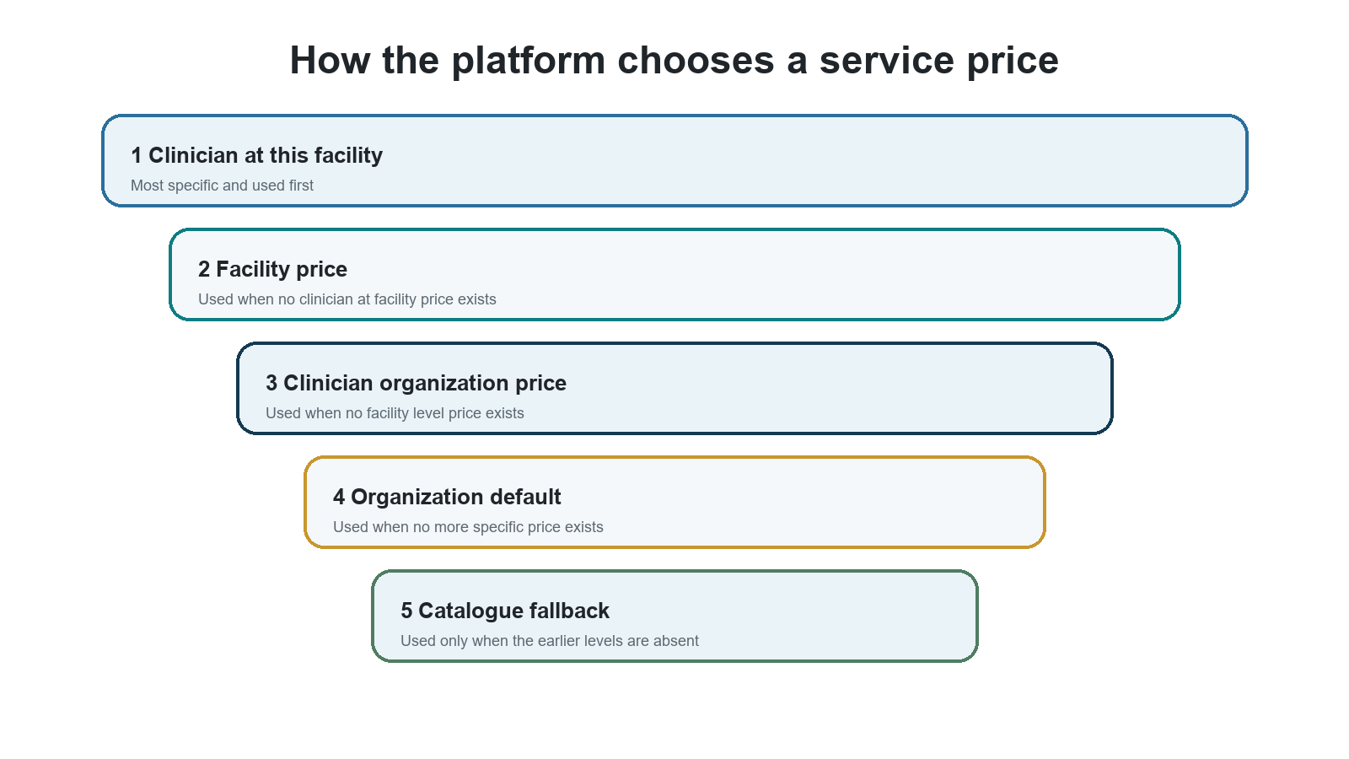
Figure 8 Price precedence from most specific to fallback

Schedules and virtual care
- Every availability slot and exception names a facility.
- Virtual care uses a Virtual Care facility rather than an empty facility value.
- In person slots cannot overlap across facilities.
- In person and virtual slots cannot overlap.
- Concurrent virtual slots are denied by default and require an explicit facility setting to allow them.
- A clinician is never duplicated to represent another schedule price or clinic.

Cases appointments and routing
Decision point | Required context
A provider Consultant is selected | The case must store the provider organization.
An in person appointment is made | The case must store the facility.
Travel is finalized | The facility must be known for location specific travel.
A location specific service is delivered | The facility must be known and active.
Care is virtual | The delivery mode is Virtual and the organization Virtual Care facility is used.
A clinician is assigned | The clinician must be active and eligible in the organization and affiliated with the chosen facility.
Routing selects a destination | Routing is organization level at launch and facility is an eligibility filter.

10 Tester handbook
A role test is incomplete if it checks only a successful action. Every important permission needs a positive test in the correct context and negative tests for the wrong organization facility role lifecycle authentication strength and professional eligibility.
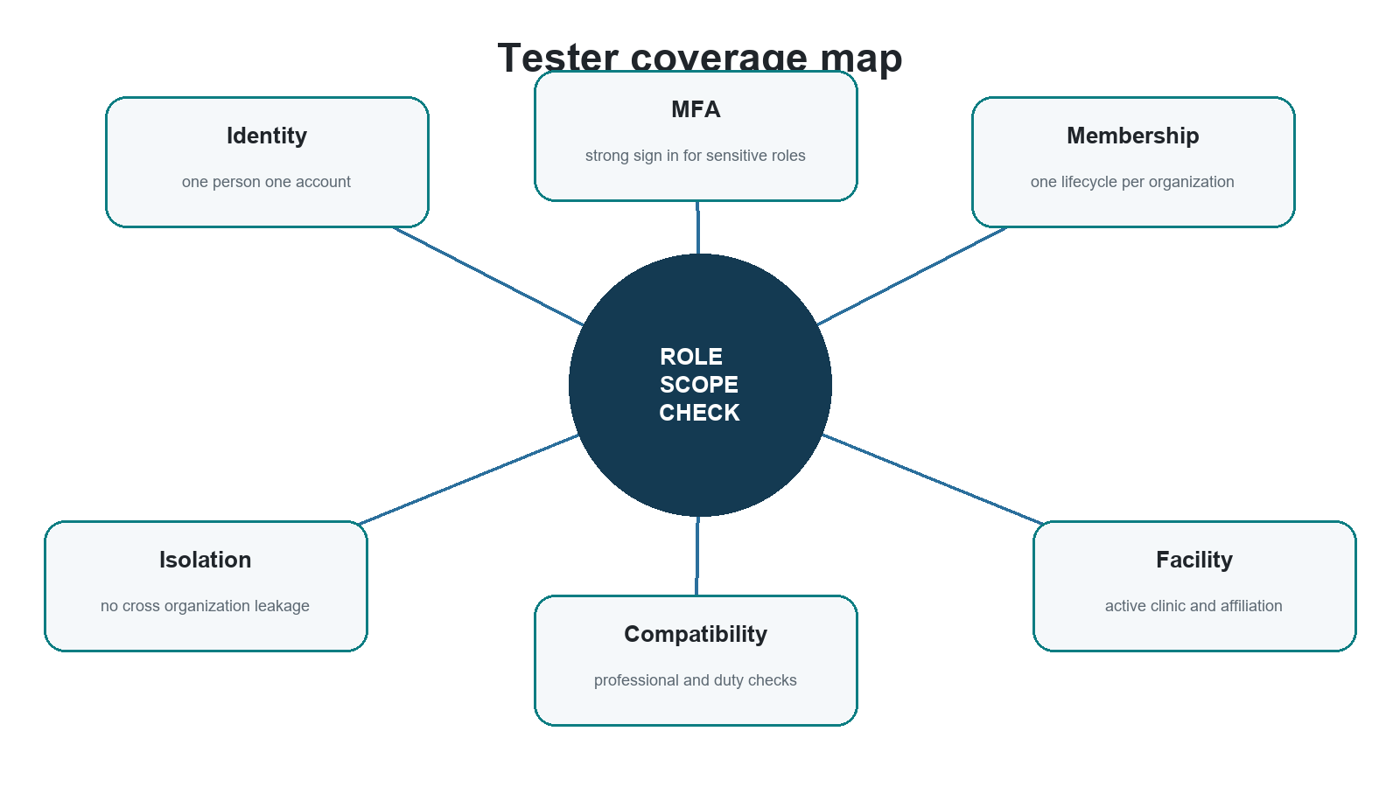
Figure 9 Every access decision has several independent conditions

Minimum test personas
Persona | Required setup | Primary purpose
Platform Account Owner | Active ownership strong sign in | Approve administrator changes and prove no business access
System Administrator A | Active staff and administrator assignment | Create staff and request privileged changes
System Administrator B | Separate active administrator | Approve changes and prove maker checker
Care Coordinator | Assigned case and organization | Positive and negative case access
Provider Operations Specialist | Coverage for one organization and one facility | Provider setup boundary
Credentialing Specialist | Independent coverage for the same organization | Credential separation
Organization Owner | Organization wide provider membership | All facility inheritance and no platform access
Facility Practice Manager | Assignment to one of two sibling facilities | Cross facility denial
Consultant | Declared and verified Consultant active affiliations | Clinical eligibility
Associate Doctor | Verified level and active supervisor | Supervision requirement
Consultant Assistant | Assigned facility and clinician | Relationship and same facility conflict
Patient | Patient account with own case | Self only access
Patient Representative | One active patient relationship | Relationship bound access

Identity and invitation tests
Test | Action | Expected result
ID 01 | Two organizations invite the same email at the same time | One identity and one practitioner profile are created or reused. Two independent pending offers exist.
ID 02 | Invite an existing provider identity | A pending offer is created. No membership role or affiliation becomes active before acceptance.
ID 03 | Invite an internal staff email from a provider | No provider offer activates. The case moves to governance review and is refused by default.
ID 04 | Invite a patient only identity | A normal offer is created. On acceptance the practitioner profile is created when needed and Patient access remains.
ID 05 | Accept the same offer twice | The result is idempotent. The second request does not duplicate memberships affiliations roles or profiles.
ID 06 | Decline or expire one offer | Only that offer ends. Other pending offers and active memberships remain.

Organization and facility tests
Test | Action | Expected result
SC 01 | Use an Organization Owner at a newly created facility | The owner is allowed because organization scope includes current and future facilities.
SC 02 | Use a facility Practice Manager at a sibling facility | Access is denied.
SC 03 | Use a facility Practice Manager on organization defaults | Access is denied because organization level resources require organization scope.
SC 04 | Suspend one facility | Both provider and central facility scoped actions deny at that site. Sibling facilities remain available.
SC 05 | End one clinician affiliation | That clinic is removed from facility assignments. Other clinics and organizations remain active.
SC 06 | Submit a facility identifier that conflicts with the stored resource | The server uses the stored facility and denies the mismatched context.

Role and professional eligibility tests
Test | Action | Expected result
RL 01 | Grant Consultant to a declared Associate Doctor | The grant is refused for insufficient professional level.
RL 02 | Grant Consultant before Consultant verification in that organization | The grant is refused even if another organization has verified the person.
RL 03 | Grant Associate Doctor without an active supervisor | The grant is refused with supervision required.
RL 04 | Give Consultant and Associate Doctor roles at different facilities | Allowed only for a Consultant qualified person with valid organization eligibility and supervision for the Associate facility.
RL 05 | Give Consultant Assistant and Consultant at the same facility | The combination is refused.
RL 06 | Revoke one role from a multi role person | Only the named assignment ends. Other compatible roles remain.

Separation and administration tests
Test | Action | Expected result
AD 01 | System Administrator opens an unrelated clinical document | Access is denied.
AD 02 | Compliance Auditor opens a clinical case | Access is denied. Audit authority is not clinical authority.
AD 03 | System Administrator grants a role to themselves | The request is refused.
AD 04 | Only active administrator resigns through normal flow | The request is blocked until a replacement is active.
AD 05 | Provider Operations inviter decides that clinician credentials | The decision is refused and requires an independent reviewer.
AD 06 | Care Journey Manager also receives Care Journey Approver | The combination is refused.
AD 07 | Compliance Auditor also receives System Administrator | The combination is refused.
AD 08 | Practice Manager approves a price version they authored | The approval is refused.

Authentication and lifecycle tests
Test | Action | Expected result
AU 01 | Owner or administrator uses password only | The request requires strong authentication.
AU 02 | A manager accepts an offer without strong authentication | The platform requests step up before acceptance.
AU 03 | Invited staff signs in without the required strong authentication | The staff record does not activate and no authority is usable.
AU 04 | Two first requests arrive for an invited staff member | Exactly one activation event is recorded.
AU 05 | One provider manager role is removed while another qualifying role remains | Strong authentication remains required.
AU 06 | A local provider membership is revoked | The global sign in remains enabled and other memberships continue.

Services prices and schedules tests
Test | Action | Expected result
OP 01 | Request a price with every override level present | The clinician at facility price wins.
OP 02 | Remove the clinician at facility price | The active facility price becomes effective.
OP 03 | Price or schedule a service not offered by the facility | The action is denied.
OP 04 | Create overlapping in person slots at two facilities | The second slot is denied.
OP 05 | Create overlapping in person and virtual slots | The second slot is denied.
OP 06 | Create an in person appointment without a facility | The action is denied until an eligible active facility is selected.

Evidence to keep for every test
- The signed in subject and authentication strength.
- The organization facility role and scope used by the decision.
- Membership affiliation assignment and eligibility status at the time of the request.
- The response and the explainable reason for allow or deny.
- The audit event with actor subject organization facility previous and new state reason and correlation identifiers.
- Proof that unrelated organizations facilities roles and identities did not change.

11 Worked example

Meet Dr Sara
Dr Sara Haddad has one sign in identity and one practitioner profile. Her global declared professional level is Consultant. Each provider organization still makes its own credential decision and grants its own local role.
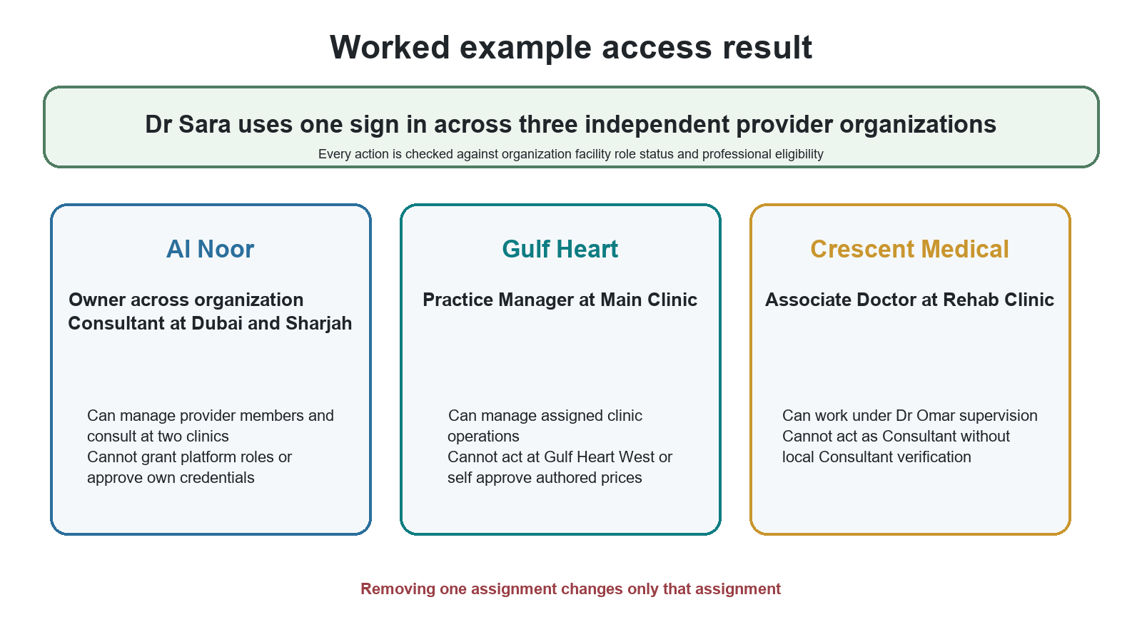
Figure 10 One person with different roles in different contexts

Dr Sara access records
Organization | Facilities | Roles | Why access works
Al Noor Healthcare Group | Dubai Clinic and Sharjah Clinic | Organization Owner across the organization and Consultant at the two clinics | Active membership active affiliations Consultant declaration and Al Noor Consultant verification
Gulf Heart Center | Gulf Heart Main | Practice Manager at one assigned facility | Active membership active affiliation and facility scoped manager assignment
Crescent Medical | Crescent Rehab | Associate Doctor | Active membership and affiliation credential level accepted for Associate engagement plus supervision by Dr Omar

What Dr Sara may and may not do
Question | Answer | Reason
Can she manage Al Noor Sharjah as owner | Yes | Organization Owner reaches all Al Noor facilities.
Can she consult at Al Noor Abu Dhabi if it is newly created | No until assigned and affiliated | Owner scope reaches it for management but the Consultant role names only Dubai and Sharjah.
Can she manage Gulf Heart West | No | Her Practice Manager assignment names only Gulf Heart Main.
Can she work as a Consultant at Crescent Rehab | No | Her local Crescent role is Associate Doctor. A local role does not upgrade itself.
Can she approve her own credentials because she is an owner | No | Self review is always prohibited.
Can she grant a RehletShifaa System Administrator role | No | Provider authority never reaches platform governance.

Change scenarios
1. If Gulf Heart removes the Practice Manager role, only that assignment ends. Al Noor and Crescent access remain.
2. If Al Noor ends the Sharjah affiliation, Dr Sara retains Al Noor ownership and Dubai Consultant access. Sharjah Consultant access ends.
3. If Crescent ends the supervision relationship, Associate Doctor work becomes unusable until valid supervision exists. Her other organizations remain unchanged.
4. If Gulf Heart suspends Main Clinic, actions at Main deny for all scoped users. Al Noor and Crescent remain available.
5. If the platform disables Dr Sara global identity for a verified compromise, every membership becomes inert until the global action is resolved.

Example test script
Step | Action | Expected result
1 | Sign in as Dr Sara with strong authentication | All three accepted organization contexts appear without duplicate identities.
2 | Select Al Noor and Dubai Clinic | Owner and Consultant actions allowed according to their separate permissions.
3 | Switch to Al Noor and Sharjah Clinic | Same identity works. Consultant access is allowed through the second affiliation.
4 | Switch to Gulf Heart Main | Practice Manager actions are allowed. Clinical Consultant actions are not granted by this role.
5 | Attempt Gulf Heart West | Access is denied because the manager scope does not include it.
6 | Switch to Crescent Rehab | Associate Doctor actions are allowed only while supervision and eligibility remain active.
7 | Remove the Gulf Heart manager assignment | Only Gulf Heart management access ends. Recheck Al Noor and Crescent successfully.

12 Quick reference and glossary

Role catalogue at a glance
Population | Roles
Platform governance | Platform Account Owner and System Administrator
RehletShifaa internal staff | Care Coordination Manager Care Coordinator Travel and Logistics Manager Travel and Logistics Specialist Commercial and Finance Manager Finance Officer Provider Operations Manager Provider Operations Specialist Credentialing Specialist Patient Identity Reviewer Care Journey Manager Care Journey Approver Compliance Auditor
Provider organization | Organization Owner Practice Manager Consultant Associate Doctor Consultant Assistant
Patients | Patient and Patient Representative

Naming distinctions
Term | Meaning
Platform Account Owner | Owns the RehletShifaa platform account governance relationship.
Organization Owner | Owns one provider organization tenant. This role has no platform governance authority.
Provider Organization | The legal or contracting provider tenant.
Provider Facility | A clinic branch hospital center rehabilitation site or virtual care site inside one organization.
Membership | The person relationship with one organization and its local lifecycle.
Facility affiliation | Where a provider member works. It does not grant authority by itself.
Role assignment | What the person may do in the stated context.
Scope | Where the role applies such as one organization or selected facilities.
Central coverage | A RehletShifaa internal assignment to serve an organization or facility without becoming provider staff.
Professional declaration | The practitioner global statement of professional level.
Organization credential level | The professional level independently verified by one provider organization.
Local engagement role | The Consultant or Associate Doctor work role granted in an organization or facility.
Strong authentication | A sign in that includes the required second factor and recorded authentication level.

Decision checklist
Before allowing any role protected action the platform should be able to answer every applicable question below with Yes.
1. Is the global identity active
2. Is the person lifecycle active for this population
3. Is the membership active in the correct organization
4. Is the organization active
5. Is the facility active when the resource is facility scoped
6. Is the facility affiliation active for a provider facility assignment
7. Is the role assignment active and does its scope cover this resource
8. Is strong authentication present when required
9. Are professional credentials and supervision valid for a clinical action
10. Are separation of duty and self approval rules satisfied

Final rule
A person can have several legitimate relationships without receiving broad or accidental access. RehletShifaa keeps one identity, records every organization and clinic relationship separately, evaluates the role in its exact context, and changes only the relationship named by an authorized action.
Source basis Customer Governance Target Architecture Reviewed revision 3 and decisions D1 through D35. This guide presents the target behavior in plain language and omits internal implementation detail that owners and testers do not need for daily use.

