CertaRig Phase 3

Wave 1 Wiring and Circuit Guide
Raspberry Pi 3 Model A+ dry hardware-in-the-loop bench
Prepared for controlled assembly, commissioning evidence, and the 20 September Phase 3 submission

CONTROL STATUS ANALOGUE INPUT PATH VERIFIED
Pi boot, SSH, I2C, ADS1115 address 0x48, and both 0-3.3 V potentiometer acquisition paths have measured evidence. E-stop contacts, transistor pinout, relay logic, fused output supply, and indicator polarity remain gated until measured and recorded.

Field | Value
Project | CertaRig
Scope | Wave 1 dry low-voltage bench only
Controller | Raspberry Pi 3 Model A+
Analogue interface | ADS1115 at 3.3 V, I2C address 0x48
Safety concept | NC E-stop sense loop plus independent NC relay-power inhibit
Output | Low-voltage green/yellow indicators through relay channel 1
Excluded | Mains, pump, solenoid valve, pressurised plumbing, water loop

1. Purpose and non-negotiable boundaries
This document is the single wiring reference for the CertaRig Wave 1 dry bench. It translates the received inventory and the current repository configuration into a labelled circuit, a staged assembly method, and evidence gates. It does not claim that the hardware is already electrically verified.
SAFE SCOPE
Use only SELV low-voltage sources: the official Raspberry Pi supply and a separate regulated 5 V supply for the relay and indicators. Do not connect mains voltage, a pump, a solenoid valve, or any water-bearing equipment during Wave 1.

STOP CONDITIONS
Stop immediately for heat, smell, smoke, unstable Pi power, an unexpected voltage, unclear terminal labels, a non-latching E-stop, an indicator that does not match the state, or any software state that disagrees with the physical state.

What Wave 1 can prove
- Real Pi deployment, I2C acquisition, analogue scaling, deterministic safety logic, dashboard/API behaviour, event logs, and repeatable test evidence.
- Healthy, warning, threshold-trip, E-stop, broken-wire, restart, and output-indication behaviours on a low-voltage dry bench.
- A controlled substitution boundary: potentiometers emulate sensor voltages and indicators emulate an actuator command.

What Wave 1 cannot prove
- Pressure or flow accuracy, leaks, priming, cavitation, surge, pump inrush, hydraulic dynamics, EMI in a field installation, or long-duration wet operation.
- Formal TRL certification. The defensible wording is evidence consistent with laboratory breadboard readiness.

2. System architecture and power domains
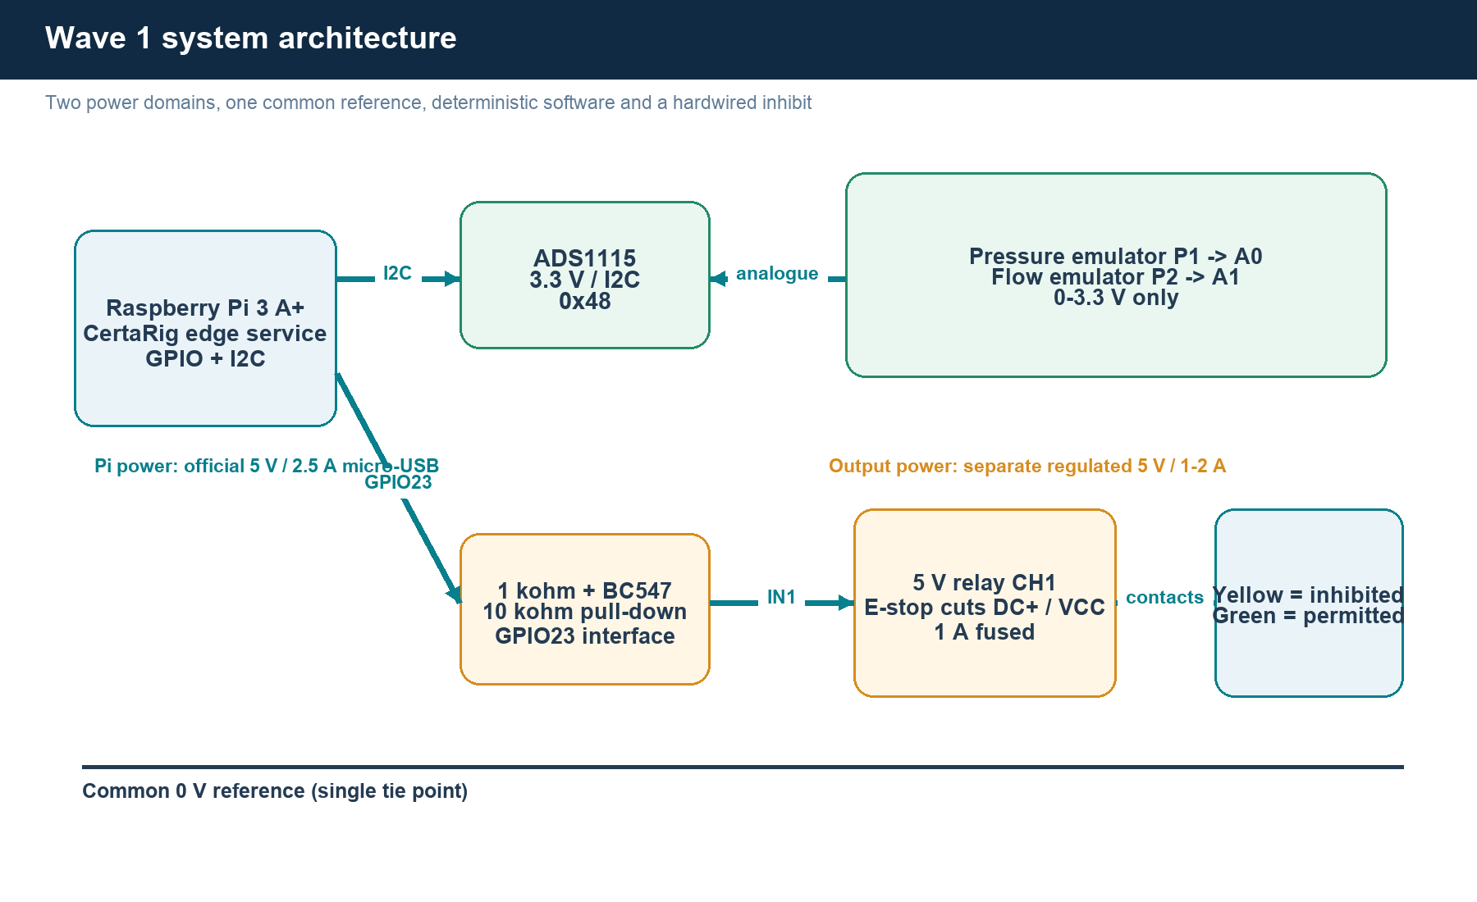
Figure 1. Wave 1 architecture. The Pi and output circuit use separate supplies; only the reference ground is shared for the transistor interface.
Domain | Source | Loads | Rule
Pi / logic | Official 5 V, 2.5 A micro-USB supply into PWR IN | Pi, ADS1115, two potentiometers | ADS uses physical pin 1; pots use physical pin 17 via the verified splitter
Output | Separate regulated 5 V, 1-2 A supply | Relay module and two 3-9 V indicators | Pass +5 V through the 1 A fuse and E-stop power loop
Common reference | One controlled ground tie | Pi GND, transistor emitter, relay/external GND | Never join the external +5 V rail to Pi 5 V pins
Why two supplies
The relay board can draw far more current and create switching noise. A separate supply keeps that load away from the Pi rail, while a single ground tie gives the BC547 interface a defined reference.

3. Raspberry Pi GPIO naming
Every connection in this guide uses both the physical header pin and the BCM GPIO number. Physical pin 16 and BCM GPIO23 are the same conductor; they are not two different pins. Never wire by BCM number alone while the Pi is unpowered.
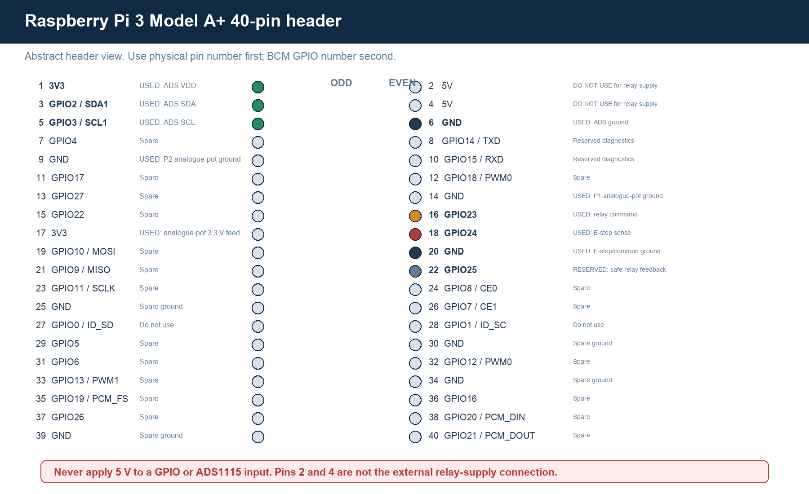
Figure 2. Abstract 40-pin header map. Confirm orientation from the square pin-1 pad and later with the Raspberry Pi pinout command.
Used pins
Pin 1 = 3V3; pin 3 = GPIO2/SDA1; pin 5 = GPIO3/SCL1; pin 6 = GND; pin 16 = GPIO23 relay command; pin 18 = GPIO24 E-stop input; pin 20 = GND. Pin 22/GPIO25 is reserved but left unconnected for the first build.

4. Complete 40-pin allocation table
Phys | Odd pin | Type | CertaRig use | Phys | Even pin | Type | CertaRig use
1 | 3V3 | POWER | USED: ADS VDD | 2 | 5V | POWER | DO NOT USE for relay supply
3 | GPIO2 / SDA1 | I2C | USED: ADS SDA | 4 | 5V | POWER | DO NOT USE for relay supply
5 | GPIO3 / SCL1 | I2C | USED: ADS SCL | 6 | GND | GROUND | USED: ADS ground
7 | GPIO4 | GPIO | Spare | 8 | GPIO14 / TXD | UART | Reserved diagnostics
9 | GND | GROUND | USED: P2 analogue-pot ground | 10 | GPIO15 / RXD | UART | Reserved diagnostics
11 | GPIO17 | GPIO | Spare | 12 | GPIO18 / PWM0 | GPIO | Spare
13 | GPIO27 | GPIO | Spare | 14 | GND | GROUND | USED: P1 analogue-pot ground
15 | GPIO22 | GPIO | Spare | 16 | GPIO23 | OUTPUT | USED: relay command
17 | 3V3 | POWER | USED: analogue-pot 3.3 V feed | 18 | GPIO24 | INPUT | USED: E-stop sense
19 | GPIO10 / MOSI | SPI | Spare | 20 | GND | GROUND | USED: E-stop/common ground
21 | GPIO9 / MISO | SPI | Spare | 22 | GPIO25 | INPUT | RESERVED: safe relay feedback
23 | GPIO11 / SCLK | SPI | Spare | 24 | GPIO8 / CE0 | SPI | Spare
25 | GND | GROUND | Spare ground | 26 | GPIO7 / CE1 | SPI | Spare
27 | GPIO0 / ID_SD | HAT ID | Do not use | 28 | GPIO1 / ID_SC | HAT ID | Do not use
29 | GPIO5 | GPIO | Spare | 30 | GND | GROUND | Spare ground
31 | GPIO6 | GPIO | Spare | 32 | GPIO12 / PWM0 | GPIO | Spare
33 | GPIO13 / PWM1 | GPIO | Spare | 34 | GND | GROUND | Spare ground
35 | GPIO19 / PCM_FS | GPIO | Spare | 36 | GPIO16 | GPIO | Spare
37 | GPIO26 | GPIO | Spare | 38 | GPIO20 / PCM_DIN | GPIO | Spare
39 | GND | GROUND | Spare ground | 40 | GPIO21 / PCM_DOUT | GPIO | Spare
GPIO electrical rule: Raspberry Pi GPIO operates at 3.3 V. GPIO pins and ADS inputs must never receive 5 V. Power pins 2 and 4 are 5 V rails, not general outputs and not the external relay supply connection.

5. Circuit A: ADS1115 and sensor-emulation inputs
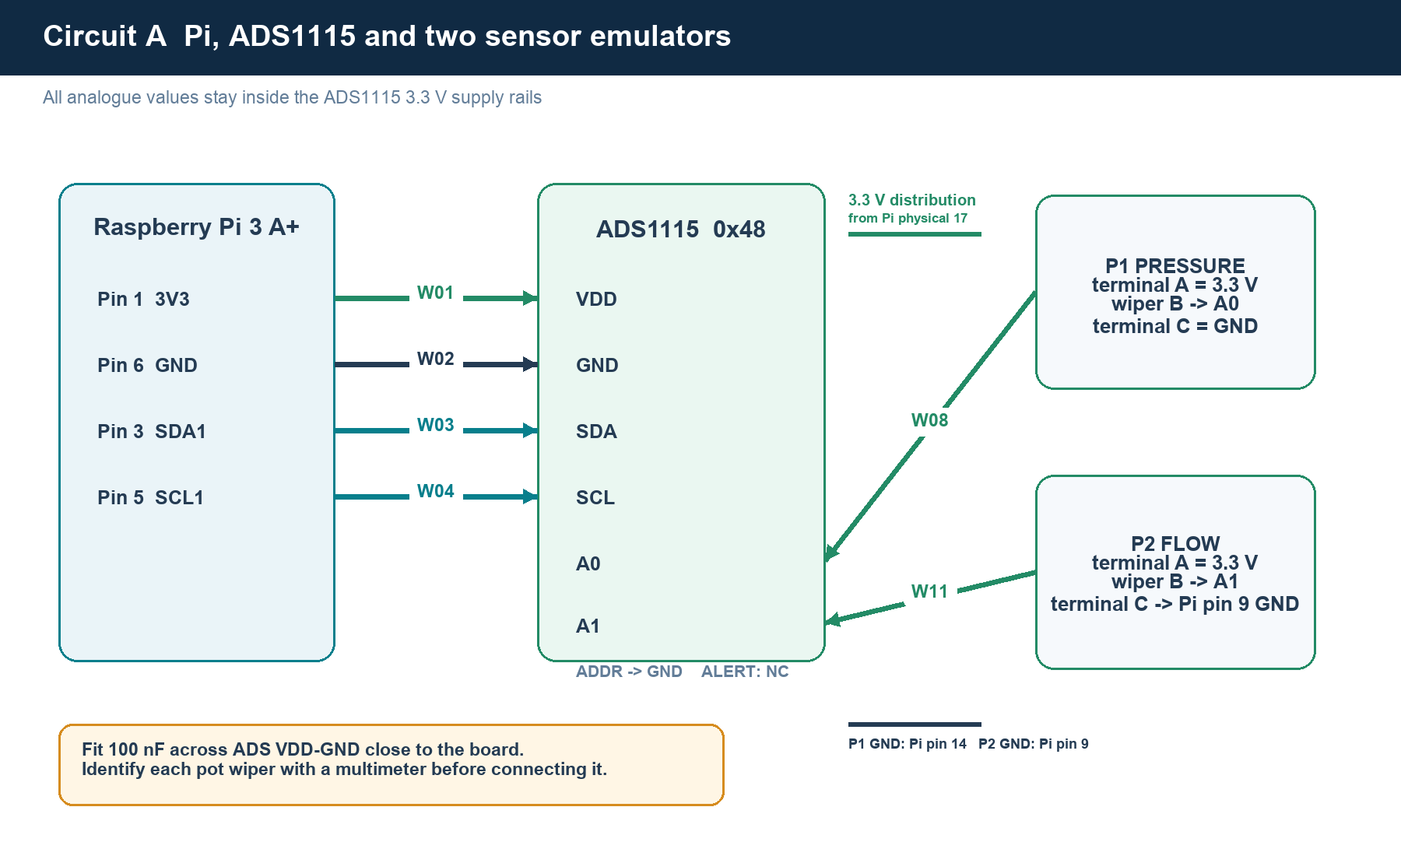
Figure 3. Pi-to-ADS1115 I2C wiring and two 10 kohm potentiometer sensor emulators.

Connection intent
- Power the ADS1115 from 3.3 V so its input range is naturally bounded to the Pi logic domain.
- Tie ADDR to GND for decimal address 72, hexadecimal 0x48. Leave ALERT/RDY unconnected during initial commissioning.
- Use A0 for pressure and A1 for flow. Reserve A2/A3 until the two-channel baseline is stable.
- Place one 100 nF ceramic capacitor directly across ADS VDD and GND.
- Characterise each potentiometer separately. In the measured CertaRig convention, A is the high track end, B is the wiper, and C is the low track end; manufacturer markings and measurements override this illustration.
WAVE 1 CONFIGURATION
Use the dedicated Wave 1 configuration with measured endpoints near 0-3.3 V. The original 0.5-4.5 V example is retained only as a future sensor-interface reference and must not be used for the present potentiometer bench.

5.1 ADS1115 physical placement on the MB102 breadboard
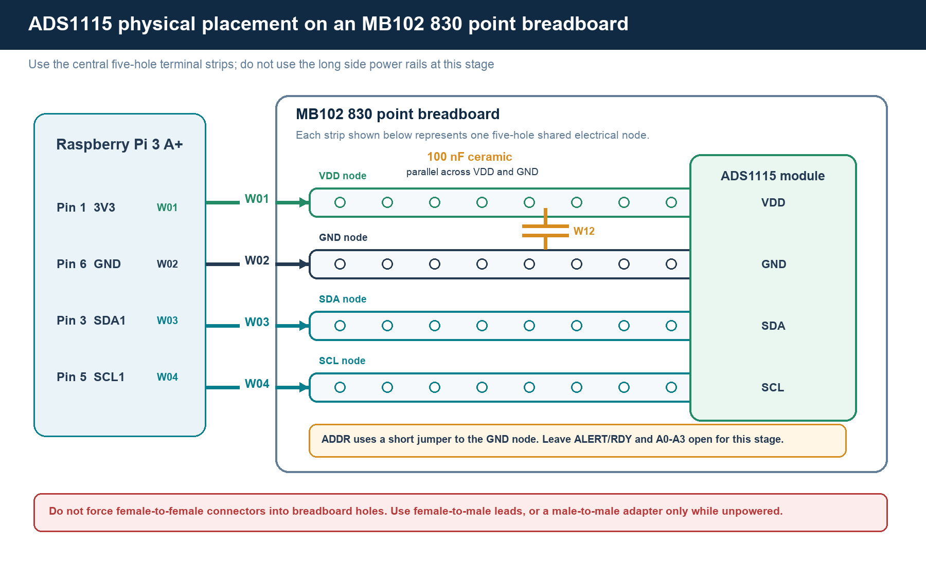
Figure 3A. Physical node layout for the ADS-only commissioning stage on an MB102 830 point breadboard.

How to assemble this stage
- Use the MB102 central terminal area, not the long red and blue side rails. On a typical MB102, holes A-E in one numbered row form one five-hole node, and holes F-J form a separate node across the centre channel. Verify this pattern with the multimeter because board variants differ and the long power rails may be split.
- Insert the ADS1115 male header along one terminal-strip bank so every labelled module pin occupies a different numbered five-hole row. Never place two ADS pins in the same connected row. Follow the ADS board silkscreen because breakout-board pin order varies.
- Use female-to-male jumper leads: the female end fits the Raspberry Pi GPIO header and the male end enters the breadboard strip shared with the matching ADS1115 pin.
- Place one leg of the 100 nF ceramic capacitor in the same strip as ADS VDD and the other leg in the same strip as ADS GND. The capacitor is parallel with the supply, not inserted in series with either wire, and it has no polarity.
- Connect ADS ADDR to the same ground strip with a short male-to-male jumper to select address 0x48.
- Leave ALERT/RDY and analogue inputs A0-A3 open. Do not connect the potentiometers until ADS-only detection has passed.
Direct female-to-female alternative. The four Pi-to-ADS connections can be made directly only if the external capacitor is omitted or attached through a purpose-built splitter. Do not twist the capacitor around exposed header pins. For this controlled build, use the breadboard arrangement above.

6. Circuit B: E-stop, relay interface, fuse and indicators
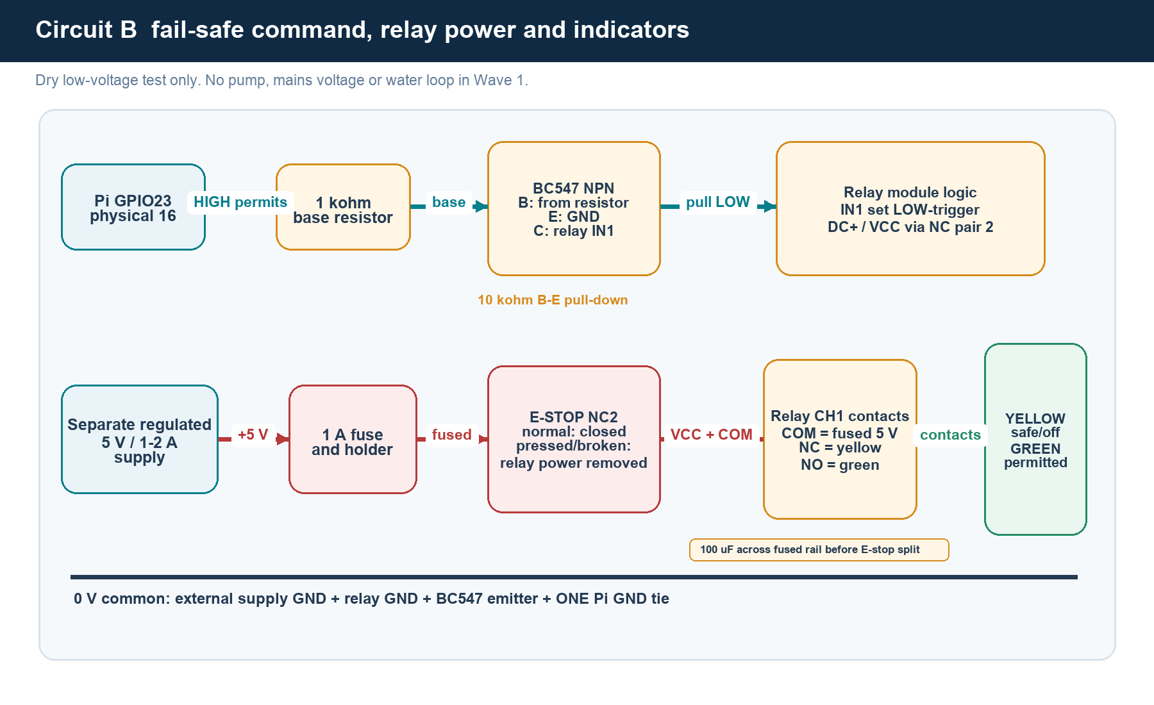
Figure 4. Intended fail-safe low-voltage output path. Exact module terminal order remains a measurement gate.

Dual-contact E-stop allocation
Contact set | Circuit | Normal condition | Pressed or broken wire | Purpose
Measured NC pair 1 | GPIO24 to GND sense loop | Closed; input LOW | Open; input HIGH | Software detects E-stop and wiring break
Measured NC pair 2 | Fused +5 V to relay DC+ or VCC | Closed; relay can energize | Open; relay power removed | Independent hardware inhibit
FAIL-SAFE POLARITY CONTRACT
The Wave 1 adapter uses a pull-up input with explicit active-high fault interpretation. The measured NC loop therefore has this electrical truth: normal/closed is LOW and healthy; pressed, open, or broken-wire is HIGH and active. Automated tests must pass before connecting the E-stop or enabling any output.

Relay and indicator behaviour
- GPIO23 HIGH drives the BC547 through 1 kohm. The transistor pulls IN1 LOW, so the relay board must be configured for low-level trigger.
- A 10 kohm base-to-emitter resistor keeps the transistor off while GPIO23 floats during boot.
- Relay de-energized: COM1 connects to NC1 and the yellow safe/inhibited indicator is on. Relay energized: COM1 connects to NO1 and the green permitted indicator is on.
- Install the 100 uF electrolytic across the fused 5 V rail before the E-stop branch split. Observe polarity. Do not put it after NC2 because stored energy could delay relay drop-out.
- Leave relay channel 2 unused in the first build.

7. Wire identification schedule
Label both ends with the W-number. Colour is a convenience, never proof of function. The schedule becomes the continuity checklist and the final as-built record.
ID | From | To | Signal | Colour | Control note
W01 | Pi physical 1 (3V3) | ADS1115 VDD | 3.3 V | Red | ADC supply
W02 | Pi physical 6 (GND) | ADS1115 GND | 0 V | Black | ADC return
W03 | Pi physical 3 (GPIO2/SDA1) | ADS1115 SDA | I2C data | Green | No pull-up added initially
W04 | Pi physical 5 (GPIO3/SCL1) | ADS1115 SCL | I2C clock | Yellow/blue | No pull-up added initially
W05 | ADS1115 ADDR | ADS1115 GND | Address strap | Black | Selects address 0x48
W06 | Pi physical 17 (3V3) via distribution node | Pressure pot measured high track end A | 3.3 V | Red | Terminal must be measured
W07 | Pi physical 14 (GND) | Pressure pot measured low track end C | 0 V | Black/orange | Dedicated P1 ground; terminal measured
W08 | Pressure pot measured wiper B | ADS1115 A0 | 0-3.3 V analogue | Yellow/green | Pressure emulator
W09 | Same physical-17 3V3 distribution node | Flow pot measured high track end A | 3.3 V | Red | Characterise this pot separately
W10 | Pi physical 9 (GND) | Flow pot measured low track end C | 0 V | Black/orange | Dedicated P2 ground; characterise this pot separately
W11 | Flow pot measured wiper B | ADS1115 A1 | 0-3.3 V analogue | Blue/yellow | Flow emulator
W12 | 100 nF capacitor | ADS VDD to GND | Decoupling | N/A | Fit close to ADS module
W13 | Pi physical 18 (GPIO24) | E-stop measured NC pair 1 terminal A | 3.3 V logic | Yellow | NC fail-safe sense loop
W14 | E-stop measured NC pair 1 terminal B | Pi physical 20 (GND) | 0 V | Black | Normal closed = LOW
W15 | Pi physical 16 (GPIO23) | 1 kohm resistor | 3.3 V command | Green | Resistor then transistor base
W16 | 1 kohm resistor | BC547 base | Base drive | Green | Verify E-B-C pinout
W17 | BC547 base | 10 kohm resistor to emitter | Pull-down | N/A | Keeps command off at boot
W18 | BC547 emitter | Common ground point | 0 V | Black | Logic/external supply reference
W19 | BC547 collector | Relay IN1 | Low-side input | Green | Relay must be set for LOW trigger
W20 | External regulated +5 V | 1 A fuse holder input | +5 V | Red | Separate supply, not Pi 5 V pin
W21 | Fuse holder output | Fused +5 V rail | +5 V fused | Red | Install 1 A fast fuse
W22 | Fused +5 V rail | E-stop measured NC pair 2 terminal A | +5 V | Red | Hardwired output inhibit
W23 | E-stop measured NC pair 2 terminal B | Relay module DC+ or VCC terminal as marked | +5 V switched | Red | Relay loses power on E-stop
W24 | External 5 V ground | Relay module GND | 0 V | Black | External supply return
W25 | External 5 V ground | Pi ground at one point | 0 V reference | Black | Required for transistor interface
W26 | Fused +5 V rail | Relay contact COM1 | +5 V | Red | Indicator source
W27 | Relay contact NC1 | Yellow indicator + | +5 V when safe/off | Yellow | Default inhibited indication
W28 | Relay contact NO1 | Green indicator + | +5 V when permitted | Green | Energized indication
W29 | Both indicator negative leads | External 5 V ground | 0 V | Black | Verify polarity first
W30 | 100 uF capacitor + / - | Fused +5 V rail / ground | Bulk decoupling | N/A | Before E-stop split; observe polarity

8. Terminal verification register
Item | Do not assume | Multimeter or visual test | Record before wiring
E-stop | Printed NC claim or terminal position | Continuity in released and latched states for both independent pairs | NC1-A/B and NC2-A/B labels; released/pressed resistance
TE / ALPS pots | Centre terminal is always the wiper | End-to-end resistance and wiper-to-end sweep | A, B, C labels and rotation direction
BC547 | Flat-face lead order across vendors | Part marking, datasheet package, diode-mode junction check | E, B, C on the actual pieces
Relay module | VCC/GND/IN order, trigger jumper, COM/NC/NO order | Read silkscreen; unpowered contact continuity; powered coil test only after supply check | Connector map and low-trigger setting
Indicators | Wire colour means polarity; internal resistor value | Current-limited 3-5 V polarity test | +/- wire and observed current/brightness
Fuse path | Holder clips make reliable contact | Continuity through installed 1 A fuse | Resistance and fuse identity
Breadboard | Power rails are continuous end-to-end | Continuity map, including any centre rail splits | Rail split drawing
External supply | Label voltage equals measured voltage | Measure unloaded and with relay load | Voltage, polarity, current rating
Before wiring each remaining stage
Use the available multimeter to identify terminals and record the result before connecting them to the Pi. Do not assemble or energize the E-stop, transistor, relay, indicator, or fused external-supply circuit until its specific acceptance gate has passed.

9. Step-by-step assembly and commissioning SOP
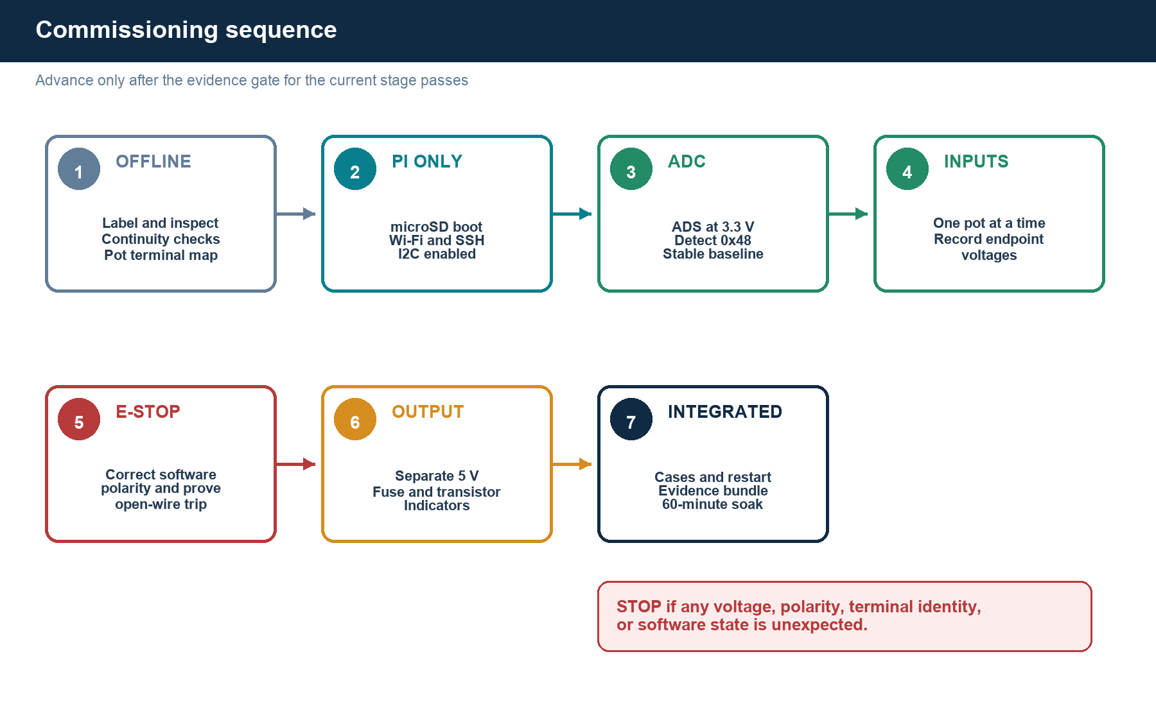
Figure 5. Controlled commissioning sequence. Each stage creates evidence before the next stage is allowed.
Gate | Action and acceptance
Stage 0 Work area | Both supplies disconnected; remove jewellery; dry non-conductive surface; label W01-W30; photograph the empty board.
Stage 1 Component acceptance | Map breadboard rails, pot terminals, E-stop pairs, relay terminals, transistor leads, indicator polarity, fuse continuity, and external supply voltage.
Stage 2 Pi-only boot | Flash Raspberry Pi OS, boot from PWR IN, join Wi-Fi, enable SSH and I2C, update hostname/time, and record OS plus software commit.
Stage 3 ADS-only | Power down. Wire W01-W05 and W12. Inspect. Power the Pi. Confirm I2C address 0x48 and stable open-channel behaviour. Power down.
Stage 4 One analogue channel | Wire pressure pot W06-W08. Check 0 V and 3.3 V rails before inserting ADS. Sweep slowly; record minimum/mid/maximum. Repeat for flow W09-W11.
Stage 5 Software safety | Implement NC-loop polarity and tests. Set relay_feedback_gpio to null initially. Create measured 0-3.3 V Wave 1 calibration. Prove output defaults safe after service start/restart.
Stage 6 E-stop input | Power down. Wire W13-W14 only. Validate released, pressed, and one-wire-disconnected states. All pressed/broken states must block the command.
Stage 7 Relay logic interface | With external supply still off, wire W15-W19 and W25. Confirm GPIO23 is LOW at boot and transistor is off. Verify no 5 V reaches the GPIO side.
Stage 8 Fused output circuit | Wire W20-W24 and W26-W30. Inspect polarity. Energize the external 5 V supply with Pi command forced safe. Yellow must be on, green off.
Stage 9 Integrated cases | Run normal, warning, trip, E-stop, broken loop, process restart, command rejection and 60-minute soak. Save logs, screenshots, wiring photos and measured results.

10. Software-to-wire contract
Software field | Current value | Physical meaning | Required action before bench
i2c_bus | 1 | GPIO2/SDA1 and GPIO3/SCL1 | Keep
ads1115_address | 72 / 0x48 | ADDR tied to GND | Keep; confirm with I2C scan
valve_output_gpio | 23 | Pi physical pin 16 to BC547 interface | Keep; Wave 1 load is indicators only
emergency_stop_gpio | 24 | Pi physical pin 18 NC loop to ground | Keep; validated in automated polarity tests
emergency_stop_active_high | true | LOW = healthy; HIGH/open = active | Keep for the measured fail-safe NC loop
relay_feedback_gpio | null | Pi physical pin 22 remains disconnected | Keep disabled for the initial Wave 1 bench
output_active_high | true | GPIO23 HIGH commands transistor/low-trigger relay | Keep only after measured truth-table test
pressure raw range | Wave 1: 0.0-3.3 V | A0 pot is limited to the 3.3 V rail | Use rig.wave1.json; preserve raw voltage evidence
flow raw range | Wave 1: 0.0-3.3 V | A1 pot is limited to the 3.3 V rail | Use rig.wave1.json; preserve raw voltage evidence
Why GPIO25 stays disconnected
A relay contact may carry the external 5 V rail. Directly connecting that voltage to GPIO25 would damage the Pi. Feedback can be added later only as a 3.3 V dry-contact circuit or through an appropriately isolated/translated interface.

Current repository evidence
The adapter initializes its output safe and reads ADS1115 A0/A1. The Wave 1 configuration uses GPIO23 for output command, GPIO24 for the fail-safe NC E-stop loop, no GPIO25 feedback, and 0-3.3 V analogue scaling. Automated tests verify that LOW means healthy and HIGH/open means E-stop active before physical input commissioning.

11. Acceptance tests and evidence
ID | Test | Pass condition | Evidence
T01 | Pi boot | Pi powered only through PWR IN; stable power; SSH reachable | Boot log + photo
T02 | I2C | ADS1115 appears at 0x48 repeatedly | Command output + photo
T03 | Pressure input | A0 sweep monotonic; min/mid/max recorded; no value above VDD | CSV + screenshot
T04 | Flow input | A1 sweep monotonic; min/mid/max recorded; no value above VDD | CSV + screenshot
T05 | Normal state | E-stop released; yellow on until a valid permit; no unsolicited relay action | Video + event log
T06 | E-stop | Pressing E-stop removes relay power and software reports active | Video + timestamps
T07 | Broken sense wire | Opening either NC1 conductor creates the same inhibited software state | Video + event log
T08 | Threshold trip | Pressure above 4.2 bar equivalent rejects/de-energizes permit | CSV + decision record
T09 | Invalid input | Out-of-range/stale input prevents output | Test result + event log
T10 | Restart | After service/Pi restart the relay is de-energized and yellow is on | Video + boot log
T11 | Indicator truth | NC/off = yellow; NO/on = green; states match dashboard | Photo/video matrix
T12 | Soak | 60 min with no unexplained reset, overheating, or state divergence | CSV summary + photos

Minimum evidence pack
- One labelled overhead wiring photograph and close-ups of Pi header, ADS, E-stop, transistor, fuse, relay, and indicator terminals.
- Multimeter acceptance sheet, measured supply voltages, potentiometer endpoint readings, and E-stop contact truth table.
- Exact configuration file, software commit hash, automated test output, I2C scan, CSV logs, screenshots, and short demo clips.
- A limitations statement preserving the dry-bench versus hydraulic boundary.

12. Troubleshooting by symptom
Symptom | Most likely checks | Do not do
Pi red LED only / no network | Confirm bootable microSD, correct PWR IN cable/supply, OS image, Wi-Fi config, router client list | Do not expect USB-A host cable to make the Pi a normal USB peripheral
ADS not at 0x48 | Power off; check W01-W05, common ground, I2C enabled, ADDR strap, solder joints | Do not move wires while powered
ADC value jumps | Check breadboard rail continuity, 100 nF decoupling, short signal leads, secure pot wiper | Do not add random capacitors before a baseline log
Pot direction reversed | Swap only its two end terminals after power-off; keep wiper on A0/A1 | Do not alter software sign to hide a wiring ambiguity
Relay always on | Disconnect external supply; verify LOW-trigger selection, 10 kohm pull-down, transistor E-B-C, GPIO boot state | Do not connect load until the input truth table passes
Pi resets when relay switches | Stop output; verify separate supply, common tie, supply voltage, wiring, decoupling and shorts | Do not power relay from Pi 3.3 V
E-stop reads backwards | Stop commissioning; correct NC-loop software polarity and rerun unit tests | Do not rewire to non-fail-safe semantics just to match current code
Green/yellow reversed | Power off; verify COM/NC/NO and indicator polarity | Do not assume relay terminal order from appearance

13. Build checklist and as-built sign-off
ID | Control | Result / measured value | Evidence filename
C01 | All parts labelled and photographed
C02 | Breadboard rails mapped
C03 | Each pot high end / wiper / low end recorded
C04 | E-stop NC1/NC2 truth table recorded
C05 | BC547 E/B/C verified
C06 | Relay VCC/GND/IN and COM/NC/NO verified
C07 | External 5 V voltage/polarity/load rating verified
C08 | 1 A fuse path continuity verified
C09 | NC E-stop polarity software change tested
C10 | Wave 1 0-3.3 V config frozen
C11 | W01-W30 point-to-point inspection complete
C12 | T01-T12 evidence archived

As-built declaration
The circuit was assembled to this revision, all deviations were recorded, and all required gates were passed before integrated testing.
Role | Name | Date | Signature / review note
Builder | Chintan Dedhia
Advisor review | Prof. Raj Kumar

Revision history
Revision | Date | Status | Change
0.4 | 10 Sep 2026 | Dual input verified | Recorded 4,457 paired samples; A0 reached 0-3.302 V and A1 reached 0-3.300 V; updated software and E-stop gates
0.3 | 10 Sep 2026 | P2 ground allocation | P1 low terminal uses physical 14 GND; P2 low terminal uses physical 9 GND; both share the Pi ground plane
0.2 | 09 Sep 2026 | As-built analogue correction | Use physical 17 for pot 3.3 V distribution and measured terminal convention A = high, B = wiper, C = ground
0.1 | 07 Sep 2026 | Pre-commissioning | Initial controlled wiring design based on current inventory and repository contract

14. References
- Raspberry Pi documentation, GPIO and 40-pin header: https://www.raspberrypi.com/documentation/computers/raspberry-pi.html
- Raspberry Pi configuration documentation, enabling I2C: https://www.raspberrypi.com/documentation/computers/configuration.html
- Raspberry Pi 3 Model A+ product page: https://www.raspberrypi.com/products/raspberry-pi-3-model-a-plus/
- Texas Instruments ADS1115 data sheet: https://www.ti.com/lit/ds/symlink/ads1115.pdf
- onsemi BC546/BC547/BC548/BC549/BC550 data sheet: https://www.onsemi.com/pdf/datasheet/bc550-d.pdf
- Local project source: work/certarig-poc/certarig_edge/hardware/raspberry_pi.py
- Local project configuration: work/certarig-poc/config/rig.example.json
- CertaRig Phase 3 hardware inventory register, baseline 06 Sep 2026.
Document control note
Manufacturer data sheets and measured terminal identities override illustrative diagrams. Update this document to an as-built revision after component acceptance and before Phase 3 submission.

