TERMWORK 1
NAME: CHINMAY HEBBALE
USN: 2GI20CS032
DATE: 30/05/2022
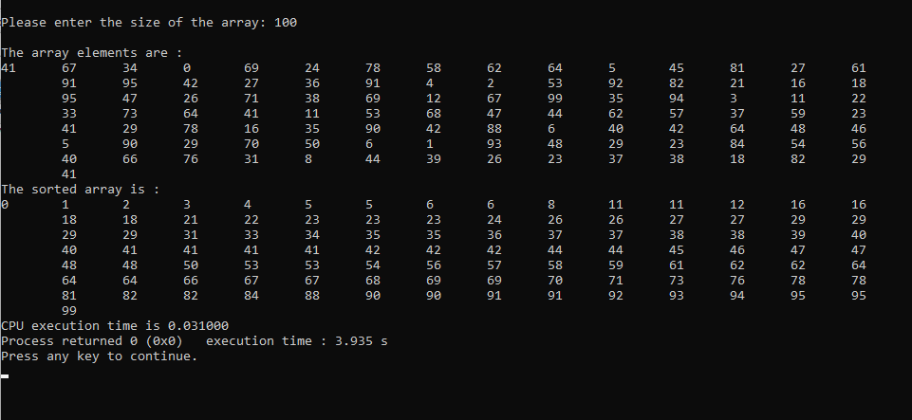
n | t
100 | 0.031
200 | 0.063
300 | 0.109
400 | 0.156
500 | 0.188

TERMWORK 2
NAME: CHINMAY HEBBALE
USN: 2GI20CS032
DATE: 06/06/2022
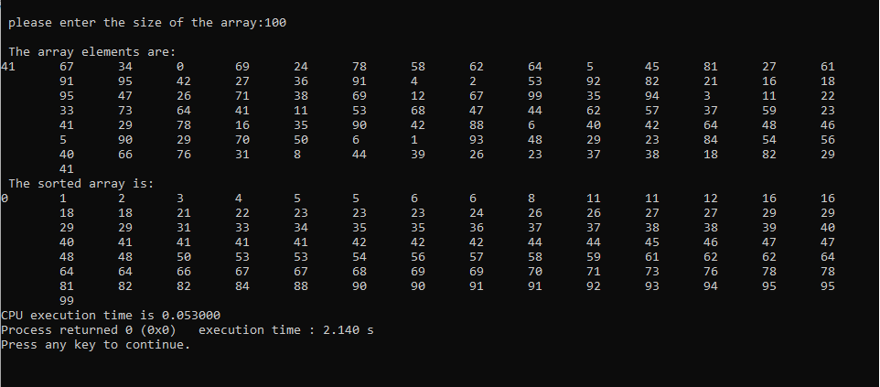
n | t
100 | 0.053
200 | 0.656
300 | 0.985
400 | 1.066
500 | 1.4

TERMWORK 3
NAME: CHINMAY HEBBALE
USN: 2GI20CS032
DATE: 13/06/2022
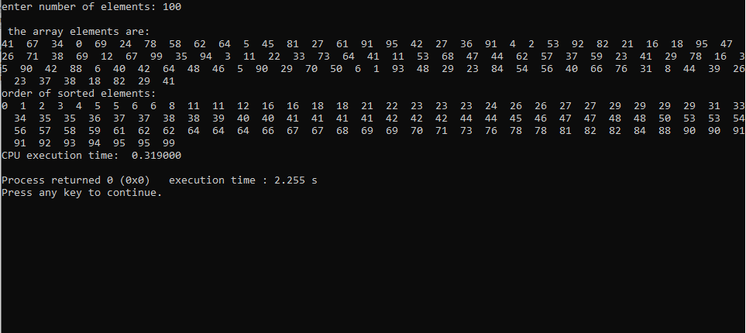

n | t
100 | 0.315
200 | 0.951
300 | 1.691
400 | 2.79
500 | 3.918
600 | 5.273

