Program(4a):

import java.io.\*;

import java.util.\*;

public class TW4a{

public static void main(String[] args) {

Scanner s = new Scanner(System.in);

int flag = 1;

while(flag == 1){

System.out.println("1. print characters on console - ");

System.out.println("2: print the entire file: ");

System.out.println("3: print contents to another file: ");

System.out.println("Choice: ");

int c = s.nextInt();

switch(c){

case 1: System.out.println("print characters on the console");

try{

FileInputStream fip = new FileInputStream("input1.txt");

int ch = fip.read();

while(ch != -1){

System.out.println((char)ch);

ch = fip.read();

}

fip.close();

}

catch(Exception e){

System.out.println(e);

}

break;

case 2: System.out.println("print the entire file");

try{

FileInputStream fip = new FileInputStream("input1.txt");

int ch = fip.read();

while(ch != -1){

System.out.print((char)ch);

ch = fip.read();

}

fip.close();

}

catch(Exception e){

System.out.println(e);

}

break;

case 3: System.out.println("print contents onto other file");

try{

FileInputStream fip = new FileInputStream("input1.txt");

FileOutputStream fop = new FileOutputStream("output.txt");

byte[] buf = new byte[100];

fip.read(buf);

fop.write(buf);

System.out.println("copied to another file: output.txt");

fip.close();

fop.close();

}

catch(Exception e){

System.out.println(e);

}

break;

}

System.out.println("do you wish to continue?(1/0)");

flag=s.nextInt();

}

s.close();

}

}

Output:

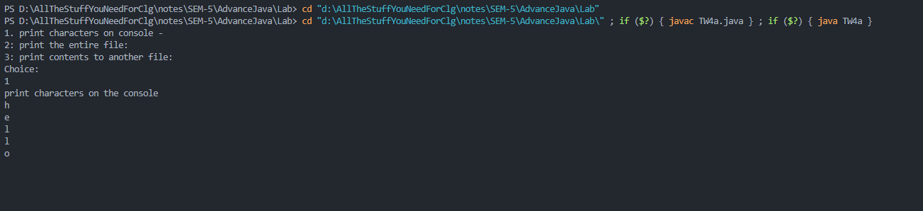

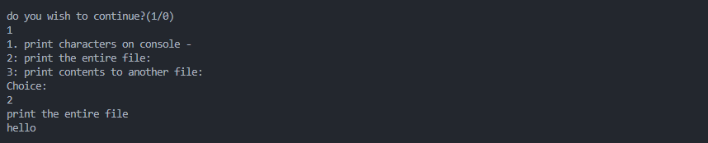

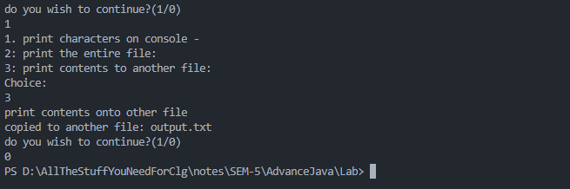

Output file:

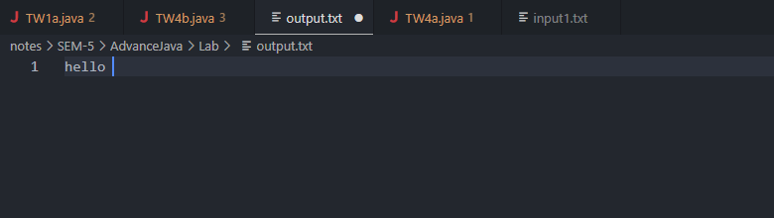

Input file:

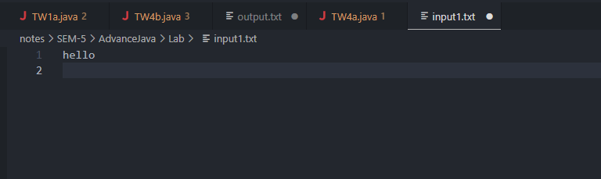

Program(4b):

import java.io.\*;

public class TW4b {

public static void main(String[] args) {

String f1 = args[0];

String f2 = args[1];

System.out.println("File name 1 is: "+ f1);

System.out.println("File nmae 2 is: "+f2);

FileInputStream in1,in2;

try{

in1 = new FileInputStream(f1);

byte b[] = new byte[(int)f1.length()];

int nob = in1.read(b);

String f3 = args[2];

FileOutputStream ou = new FileOutputStream(f3,true);

ou.write(b);

System.out.println("Data file from input1.txt to output.txt was successful...");

in2 = new FileInputStream(f2);

byte b1[] = new byte[(int)f2.length()];

int nob1 = in2.read(b1);

ou.write(b1);

System.out.println("Data file from input2.txt to output.txt was successful...");

ou.close();

in1.close();

in2.close();

File fob = new File(f3);

System.out.println("Absolute path: "+fob.getAbsolutePath());

System.out.println("Path of the file: "+fob);

System.out.println("Parent: "+fob.getParent());

if(fob.exists()){

System.out.println("Is file Readable? : "+fob.canRead());

System.out.println("Is file writable? : "+fob.canWrite());

System.out.println("Is a directory? : "+fob.isDirectory());

System.out.println("Length of the file : "+fob.length());

}

}

catch(Exception e){

System.out.println(e);

}

}

}

Output:

