import java.io.\*;

public class TW1a {

public static void main(String[] args) {

File f1 = new File("input1.txt");

File fi2 = new File("outputV.txt");

File fi3 = new File("outputC.txt");

if(f1.exists()){

try{

byte b[] = new byte[(int)f1.length()];

FileInputStream f = new FileInputStream(f1);

FileOutputStream f2 = new FileOutputStream(fi2);

FileOutputStream f3 = new FileOutputStream(fi3);

f.read(b);

ByteArrayOutputStream bo1 = new ByteArrayOutputStream();

ByteArrayOutputStream bo2 = new ByteArrayOutputStream();

for(int i = 0 ; i<b.length ; i++){

if(b[i] == 97 || b[i] == 101 || b[i] == 105 || b[i] == 111 || b[i] == 117)

bo1.write(b[i]);

else

bo2.write(b[i]);

}

bo1.writeTo(f2);

bo2.writeTo(f3);

f.close();

}

catch(Exception e){

System.out.println(e);

}

}

else

System.out.println("File Does Not Exists...");

}

}

TERMWORK -01

NAME-Kavya Tigadi

USN -2GI20CS048

Output: 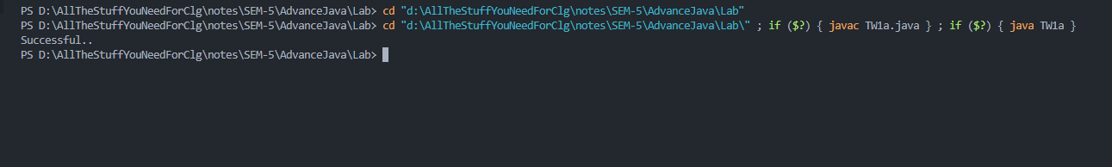

Contents in input1.txt:

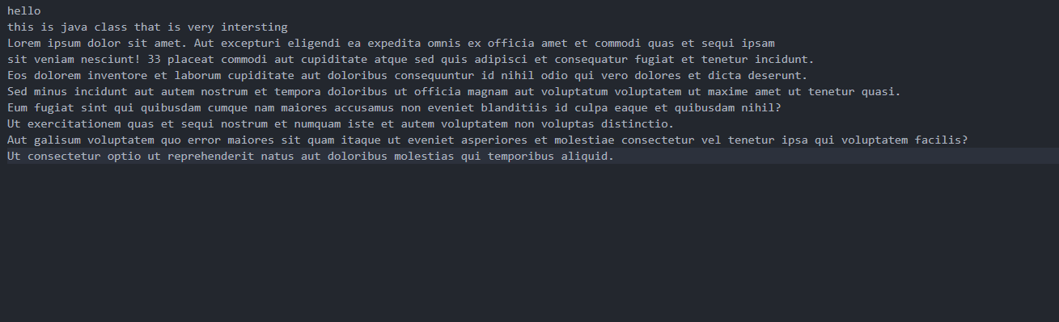

Generated output files containing vowels and consonants:

File containing vowels:

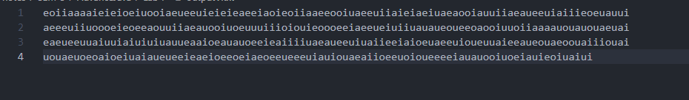

File containing consonants:

