Termwork 1

Name: name

USN: 2GI20CSXXX

Date:

**Path Found Example:**

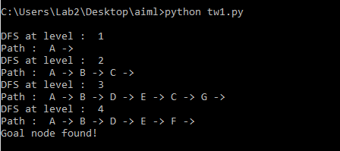

**Path Not Found Example:**

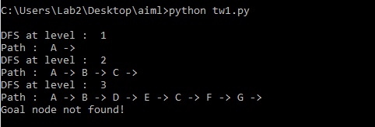

Termwork 2

Name: name

USN: 2GI20CSXXX

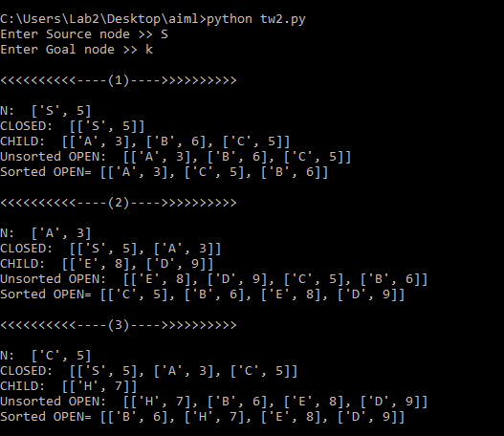Date:

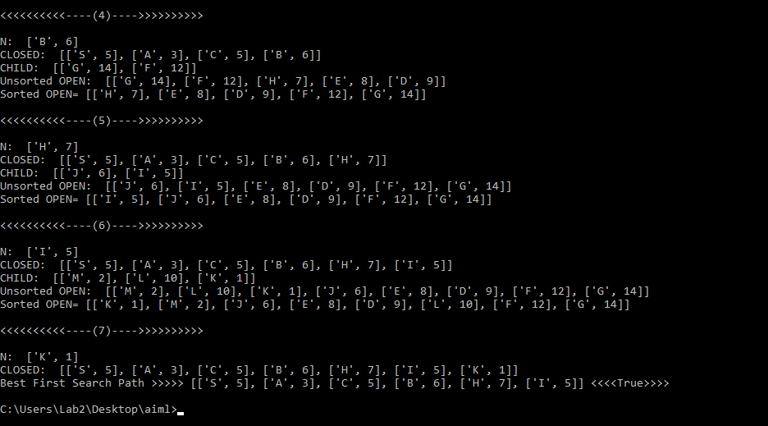

Termwork 3

Name: name

USN: 2GI20CSXXX

Date:

**OR Gate:**

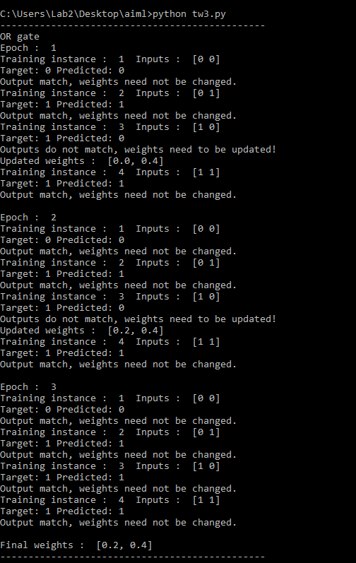

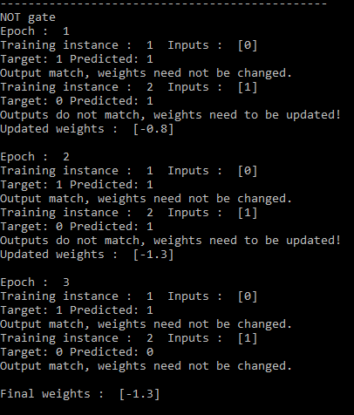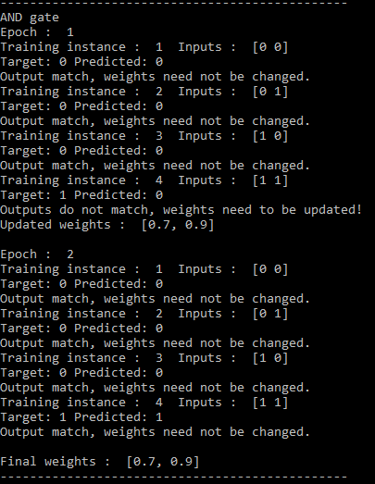

**NOT Gate:**

**AND Gate:**

Termwork 4

Name: name

USN: 2GI20CSXXX

Date:

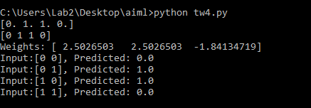

Termwork 5

Name: name

USN: 2GI20CSXXX

Date:

