Termwork 6

Name: name

USN: 2GI20CSxxx

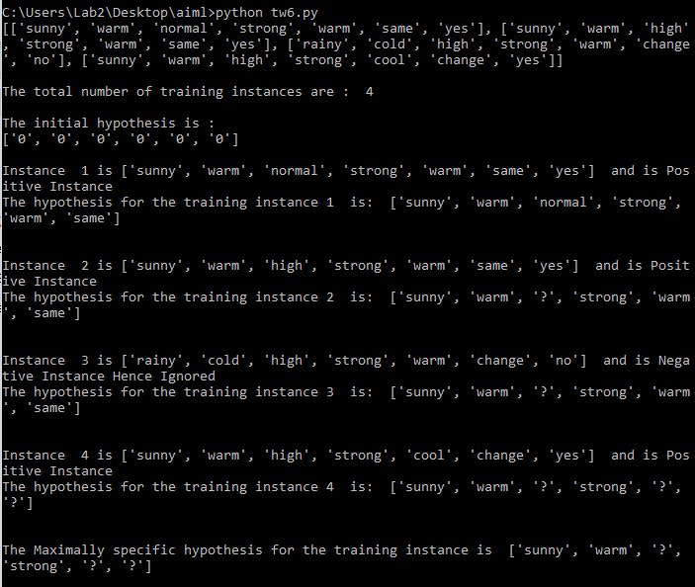Date: