Termwork 6

Name: name

USN: 2GI20CSXXX

Date:

[['sunny', 'warm', 'normal', 'strong', 'warm', 'same', 'yes'], ['sunny', 'warm', 'high', 'strong', 'warm', 'same', 'yes'], ['rainy', 'cold', 'high', 'strong', 'warm', 'change', 'no'], ['sunny', 'warm', 'high', 'strong', 'cool', 'change', 'yes']]

The total number of training instances are : 4

The initial hypothesis is :

['0', '0', '0', '0', '0', '0']

Instance 1 is ['sunny', 'warm', 'normal', 'strong', 'warm', 'same', 'yes'] and is Positive Instance

The hypothesis for the training instance 1 is: ['sunny', 'warm', 'normal', 'strong', 'warm', 'same']

Instance 2 is ['sunny', 'warm', 'high', 'strong', 'warm', 'same', 'yes'] and is Positive Instance

The hypothesis for the training instance 2 is: ['sunny', 'warm', '?', 'strong', 'warm', 'same']

Instance 3 is ['rainy', 'cold', 'high', 'strong', 'warm', 'change', 'no'] and is Negative Instance Hence Ignored

The hypothesis for the training instance 3 is: ['sunny', 'warm', '?', 'strong', 'warm', 'same']

Instance 4 is ['sunny', 'warm', 'high', 'strong', 'cool', 'change', 'yes'] and is Positive Instance

The hypothesis for the training instance 4 is: ['sunny', 'warm', '?', 'strong', '?', '?']

The Maximally specific hypothesis for the training instance is ['sunny', 'warm', '?', 'strong', '?', '?']

Termwork 7

Name: name

USN: 2GI20CSXXX

Date:

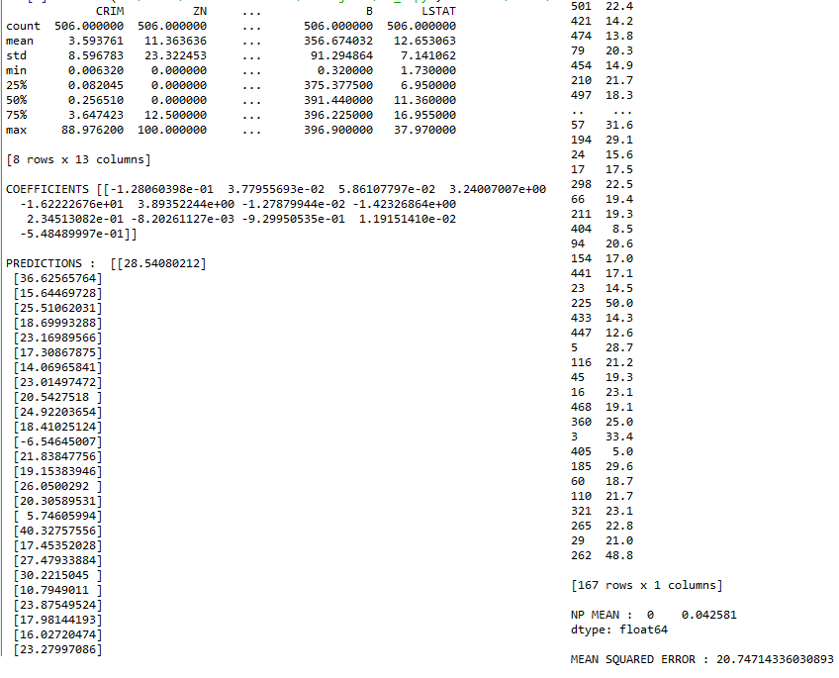

Termwork 8

Name: name

USN: 2GI20CSXXX

Date:

Number of emails: 5728

Number of spam emails: 1368

Probability of spam: 0.2388268156424581

Prediction using Bayes for word sale 0.48148148148148145

Prediction using Bayes for word lottery 0.9

Prediction using NaiveBayes for word lottery sale 0.9638144992048691

Prediction using NaiveBayes for word asdfgh 0.2388268156424581

Prediction using NaiveBayes 0.12554358867164464