**Termwork 6**

NAME: XXX DATE: 25/05/2023

USN: 2GI20CSXXX

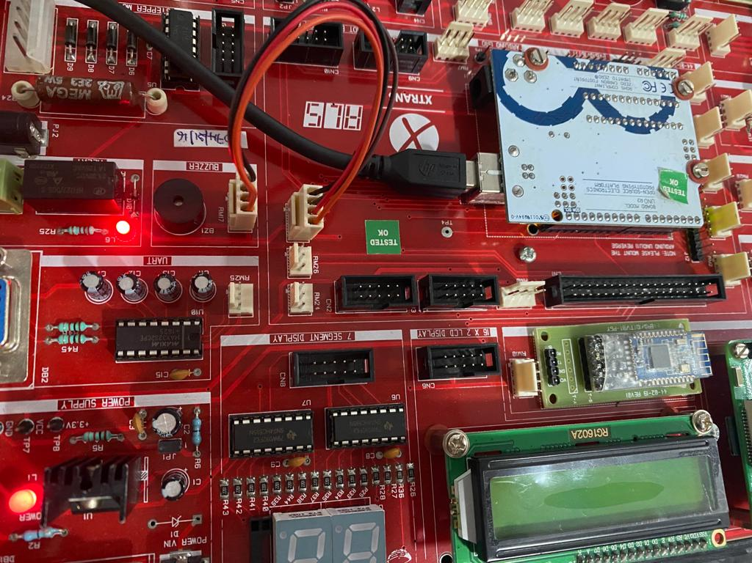Relay ON :

Relay OFF :

