**Term work 9**

NAME: XXX DATE: 1/06/2023

USN: 2GI20CSXXX

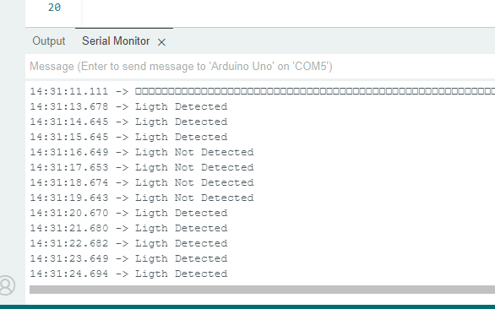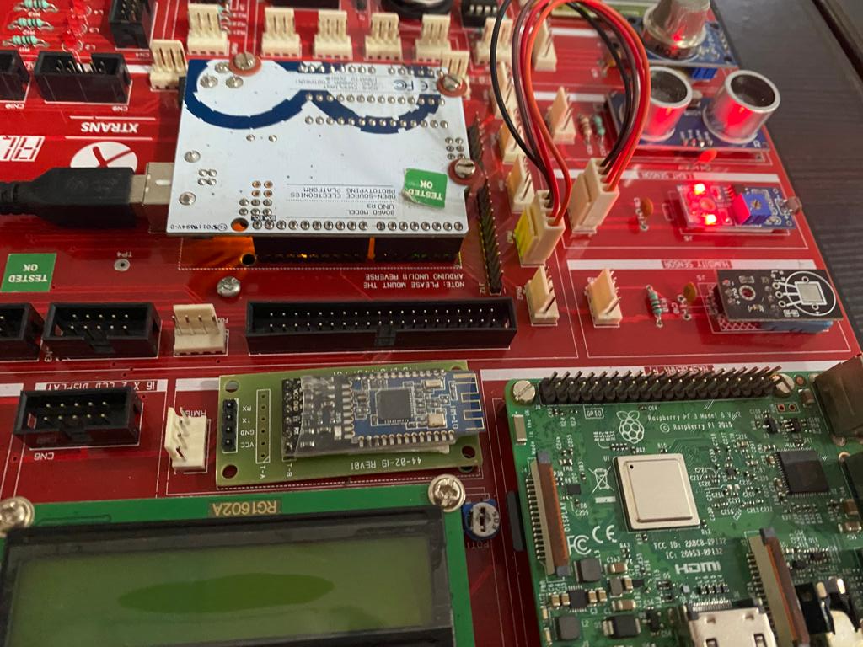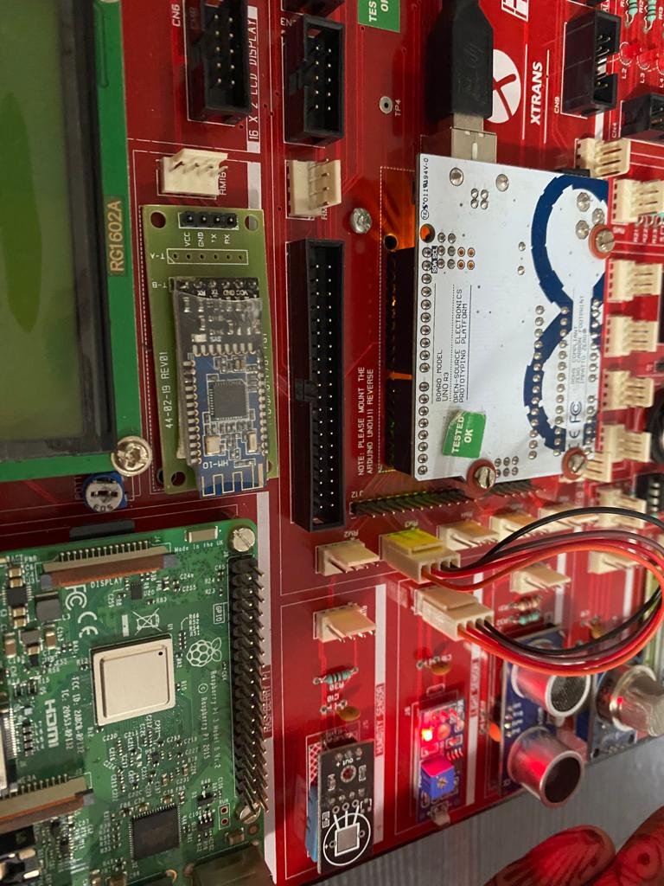

Light detected : Light not detected :