**Term work 9**

**Server**

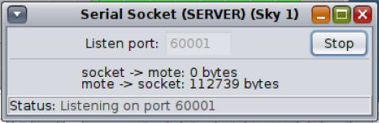

**Client**

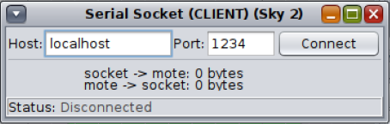

**Connection established**

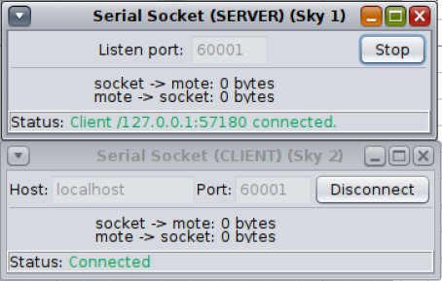

**Connection details**

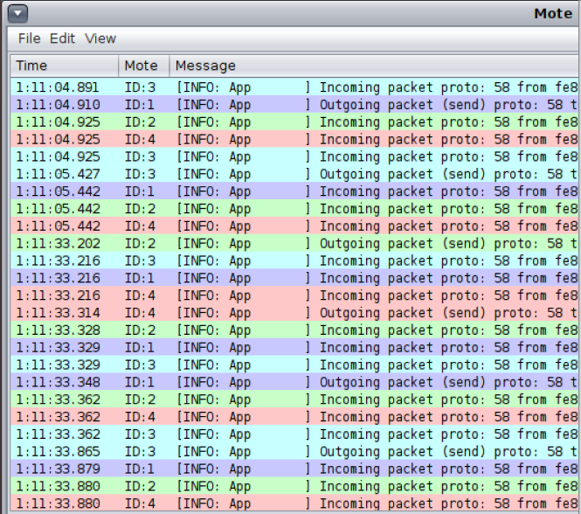

**Graphical visualization of nodes**

