**1. Install Apache HTTP server**

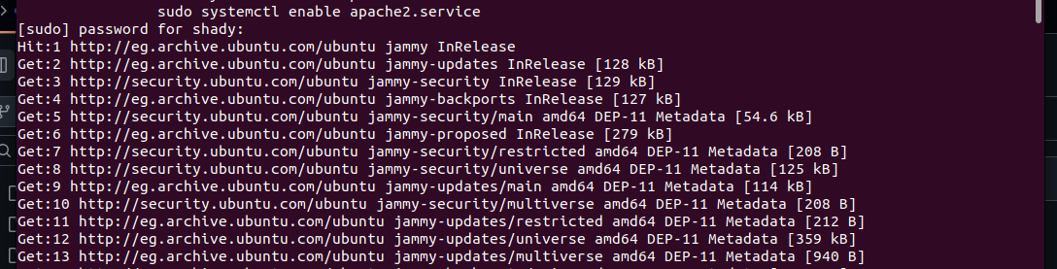

**2. Create two simple html pages named “page1.html, page2.html” then use the suitable**

**directive to automatically redirect from localhost/page1.html to**

**localhost/page2.html.**



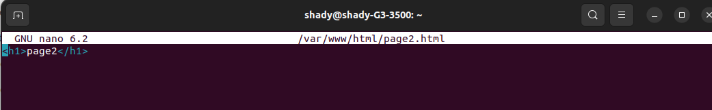

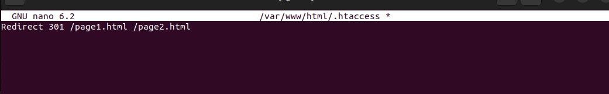

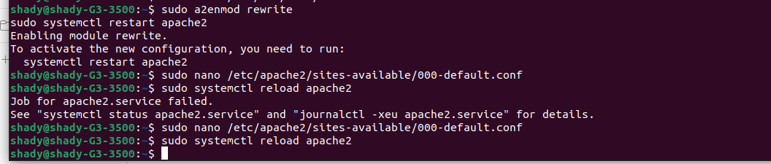

**<Directory /var/www/html>**

**Options Indexes FollowSymLinks**

**AllowOverride All**

**Require all granted**

**</Directory>**

**3. Ask for user name and password when accessing a directory**

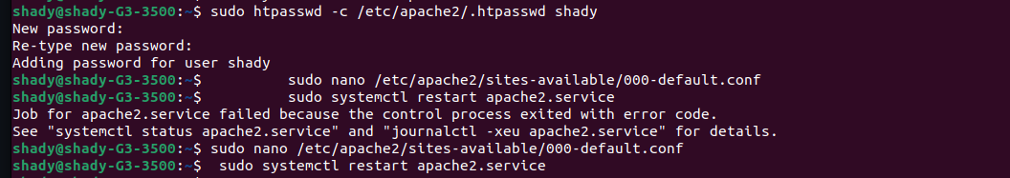

**4. Apply authentication before downloading PDF files.**





**5. Create a directory then allow access to one of your classmates only.**



**<Directory /var/www/html/classmate>**

**AuthType Basic**

**AuthName "ClassmateAccess"**

**AuthUserFile /etc/apache2/.htpasswd**

**Require user classmate_username**

**</Directory>**

**6. Disable listing the directory content (hint use indexs)  
**



**7. Change the default index page to be default.html instead of index.html (use**

**DirectoryIndex)**



