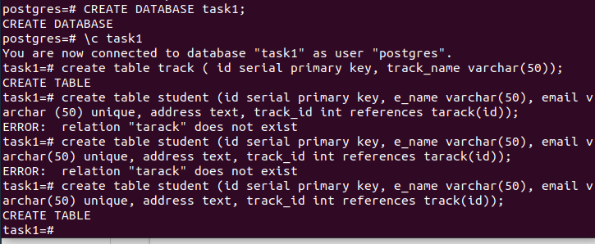

2. Insert at minimum 3 Rows at each table.

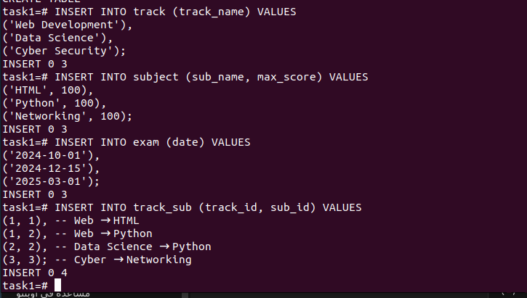

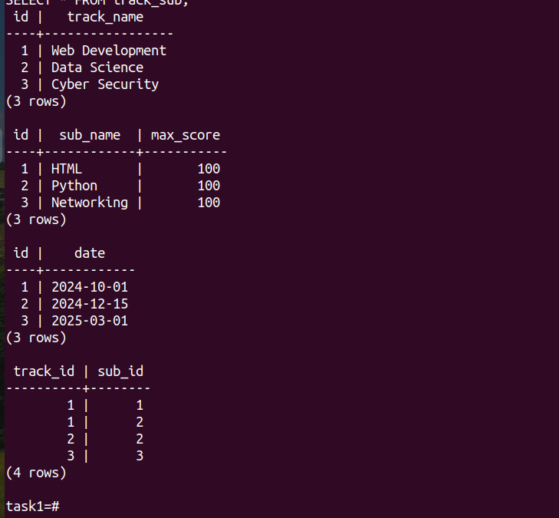

3. Add birth date column for the student table.

ALTER TABLE student ADD COLUMN birth_date DATE;

4. Add gender column which hold only 2 values (Male or

Female).



6. Display male students who are born before 1991-10-01.

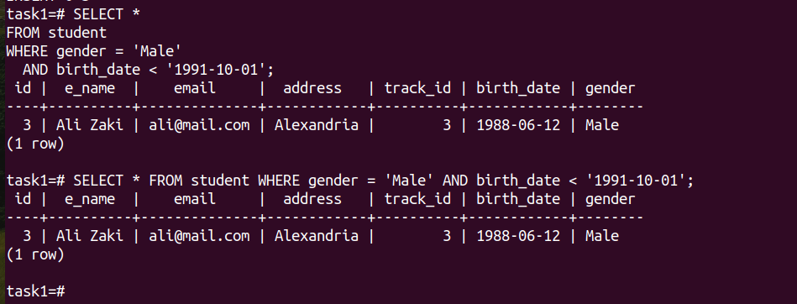

7. Display students’ names that begin with A.

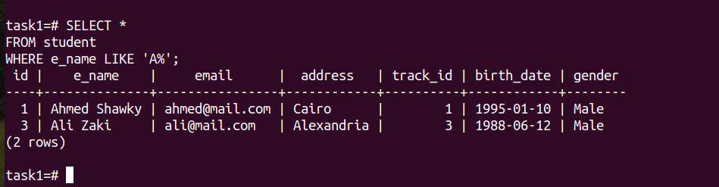

8. Display subjects and their max score sorted by max score.



9. Display the subject with highest max score



lab2

1. Display the number of students their name is “Mohammed”



2. Display the number of males and females.

