Day0: Introduction to Deep Learning: d2l.ai course

Machine learning is the study of powerful techniques that can learn from experience.
As an machine learning algorithm accumulates more experience, typically in the form of observational data or interactions with an environment, its performance improves. Contrast this with our deterministic e-commerce platform, which performs according to the same business logic, no matter how much experience accrues, until the developers themselves learn and decide that it is time to update the software.

Here is the trick. Often, even when we do not know how to tell a computer explicitly how to map from inputs to outputs, we are nonetheless capable of performing the cognitive feat ourselves. In other words, even if you do not know how to program a computer to recognize the word “Alexa”, you yourself are able to recognize it. Armed with this ability, we can collect a huge dataset containing examples of audio and label those that do and that do not contain the wake word. In the machine learning approach, we do not attempt to design a system explicitly to recognize wake words. Instead, we define a flexible program whose behavior is determined by a number of parameters. Then we use the dataset to determine the best possible set of parameters, those that improve the performance of our program with respect to some measure of performance on the task of interest.

You can think of the parameters as knobs that we can turn, manipulating the behavior of the program. Fixing the parameters, we call the program a model. The set of all distinct programs (input-output mappings) that we can produce just by manipulating the parameters is called a family of models. And the meta-program that uses our dataset to choose the parameters is called a learning algorithm.

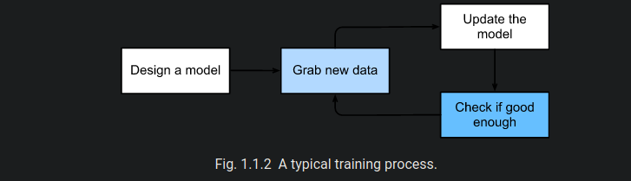
To summarize, rather than code up a wake word recognizer, we code up a program that can learn to recognize wake words, if we present it with a large labeled dataset.

DATA
In order to work with data usefully, we typically need to come up with a suitable numerical representation. Each example (or data point, data instance, sample) typically consists of a set of attributes called features (or covariates), from which the model must make its predictions. In the supervised learning problems above, the thing to predict is a special attribute that is designated as the label (or target).
When every example is characterized by the same number of numerical values, we say that the data consist of fixed-length vectors and we describe the constant length of the vectors as the dimensionality of the data.

