Day 0:
Credits to Cybersecurity Meg on Youtube
-------------------------------------------------------------------------------------------
Comptia Sec+ --> really informational and for getting into a good cybersec related job
ClassCentral --> offer tons of cybersec courses(mainly for bolstering knowledge)
Azure --> Cloud computing for students.(100$)
TryHackMe --> wide range of topics(linux, research, pentesting)
Content creators... twitch, youtube
Professor Messers ----> Super large range of videos
Twitter.... for news

📌Links To Resources Discussed In The Video: • Infragard Application: https://www.infragard.org/Application...​ • Meetup Website To Find Local Cybersecurity Groups: https://www.meetup.com​ • CompTIA Security+ Information: https://www.comptia.org/certification...​ • Class Central Cybersecurity Course Offerings: https://www.classcentral.com/subject/...​ • $100 Azure Credit For Students: https://azure.microsoft.com/en-us/fre...​ • Try Hack Me: https://tryhackme.com/​ • Tib3rius' Twitch Stream (you can find many other amazing Twitch streamers!) https://www.twitch.tv/0xTib3rius/videos​ • Professor Messer's CompTIA Security+ Video Series: https://www.youtube.com/watch?v=UbxRf...​ • Twitter (for staying apprised of what is going on in the Cybersecurity world): Https://Twitter.com/​ • Certification Station Discord: https://discord.gg/rTR7uszGmN​ • InfoSec Prep Discord: https://discord.gg/mn8aX4HWME​ • Do's & Don'ts Of Writing Cybersecurity Resumes Article: https://securityintelligence.com/arti...​

--------------------------------------------------------------------------------------

Certifications
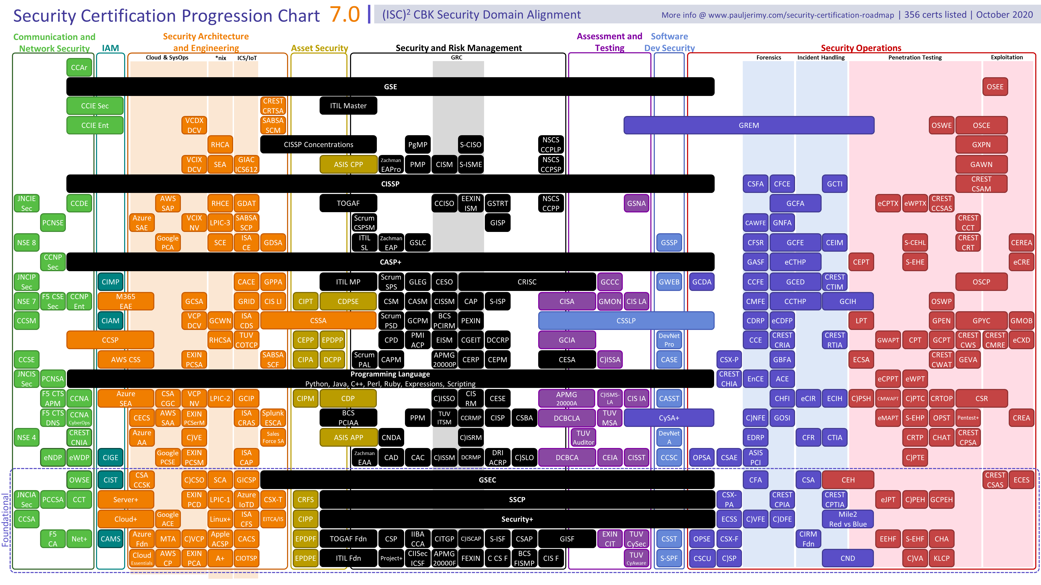
https://pauljerimy.com/security-certification-roadmap/ --> interactive roadmap

Master List: I Compiled and Ranked Every Major Studying Resource for A+, Network+, and Security+ Here!
https://www.reddit.com/r/CompTIA/comments/i7hx4t/master_list_i_compiled_and_ranked_every_major/

Getting into cybersec and what domain to choose
https://noxcyber.co.uk/

