# Setup Flask Server to Run the GoPiGo3

## Connect to the GoPiGo3

|  |  |  |
| --- | --- | --- |
| **Step** | **Action** | **Expected Result** |
| 1 | Use these instructions to install Raspbian for Robots on your GoPiGO3: <https://www.dexterindustries.com/howto/install-raspbian-for-robots-image-on-an-sd-card/> | The Raspbian for Robots OS is installed on the GoPiGo3 |
| 2 | Use these instructions to setup the wifi on your GoPiGo3: <https://www.dexterindustries.com/GoPiGo/get-started-with-the-gopigo3-raspberry-pi-robot/2-connect-to-the-gopigo-3/raspbian-for-robots-operating-system/> | The GoPiGo is setup to connect over wifi |
| 3 | Open a browser and enter <http://dex.local> | The Raspbian for Robots webpage is displayed |
| 4 | Click **Launch VNC** | The browser connects to the GoPiGo GUI |

## Setup Python Virtual Environment

1. Open file manager and create a new folder

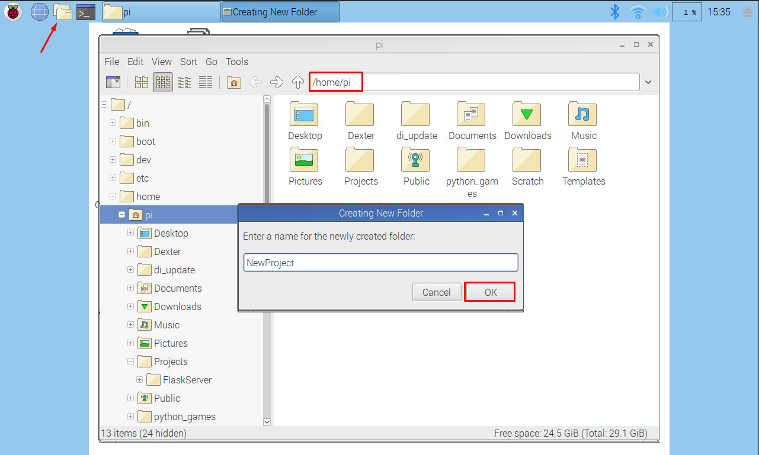

1. Open a terminal and navigate to the new folder

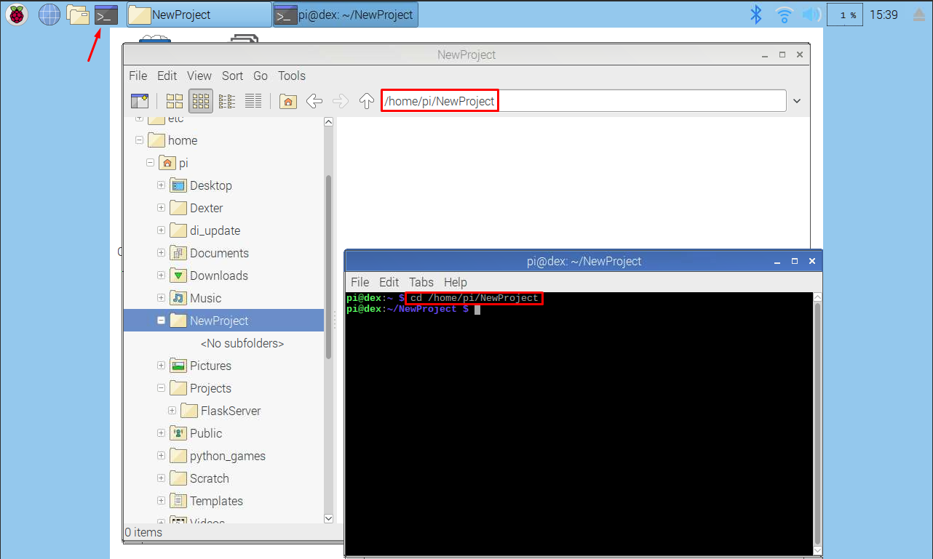

1. Create a new python virtual environment with the command “python3 -m venv venv”

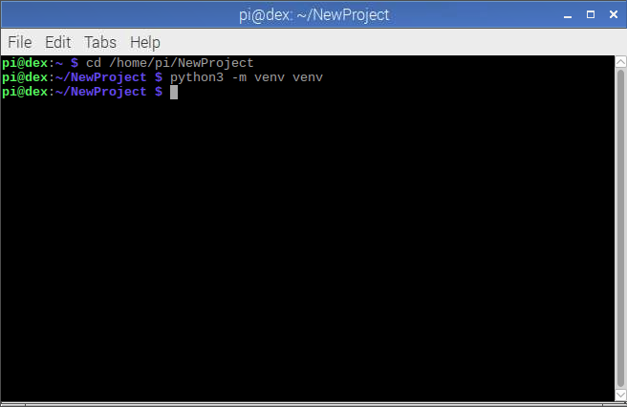

1. Activate the virtual environment with “. venv/bin/activate”

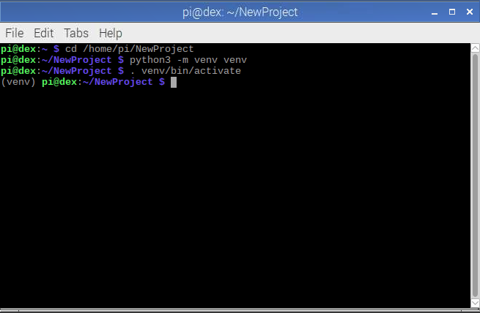

1. Upgrade pip with “pip install --upgrade pip”

Note: If pip displays SSL errors use this command to ignore:

$ pip install --trusted-host pypi.org --trusted-host files.pythonhosted.org pip setuptools

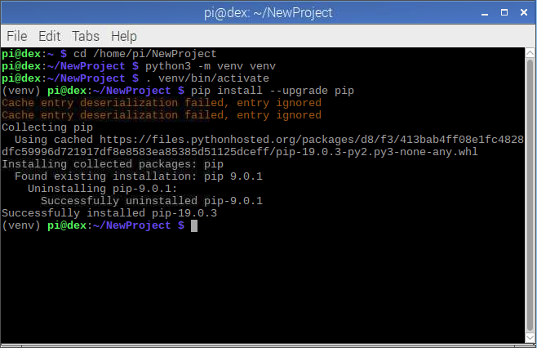

1. Use pip to install these packages:
   1. pip install Flask
   2. pip install opencv-python
   3. pip install gopigo3

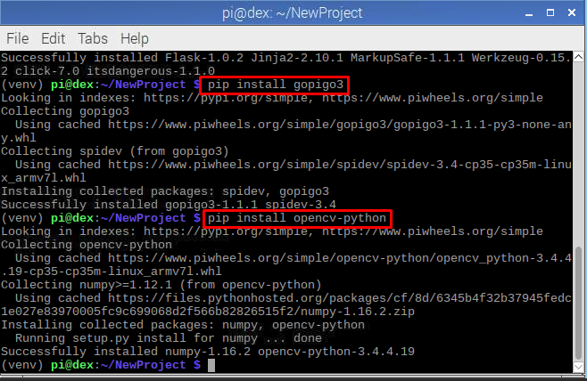

1. download the project files from the gitLab repository

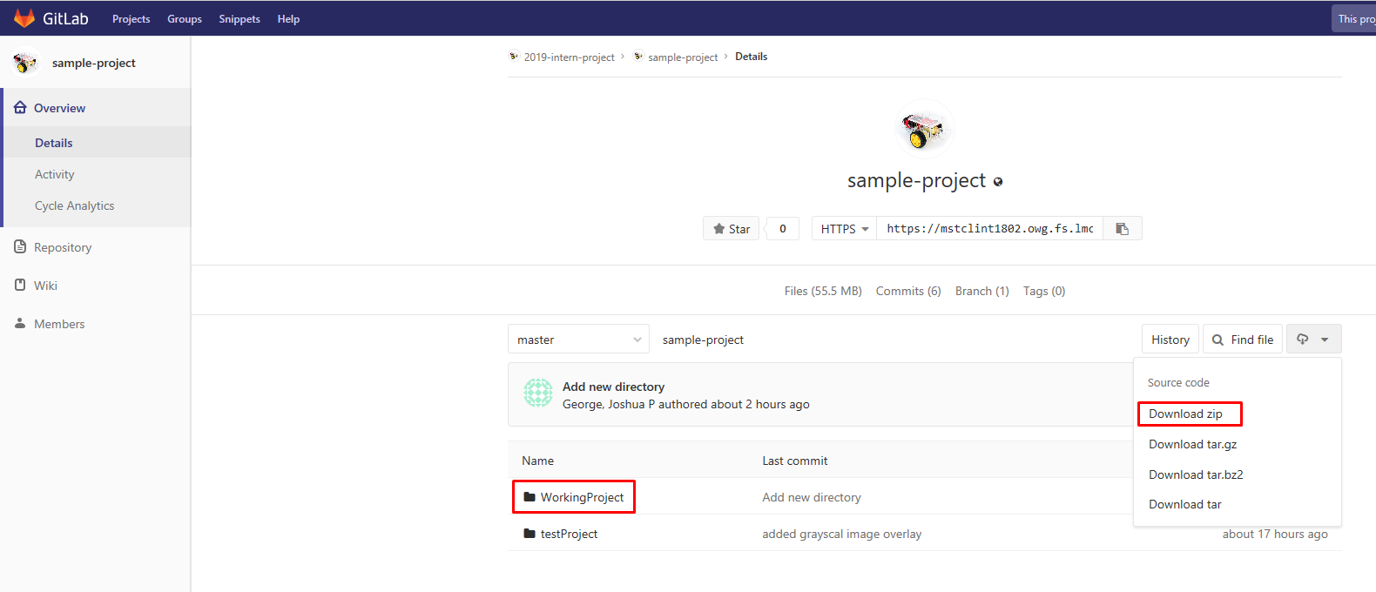

1. Copy all of the files from the “WorkingProject” folder into the folder where your virtual environment is setup on you GoPiGo3. This can be done with a USB drive or using the scp command
   1. To use the scp command open a terminal on your computer and enter:

scp –r <source > <destination>

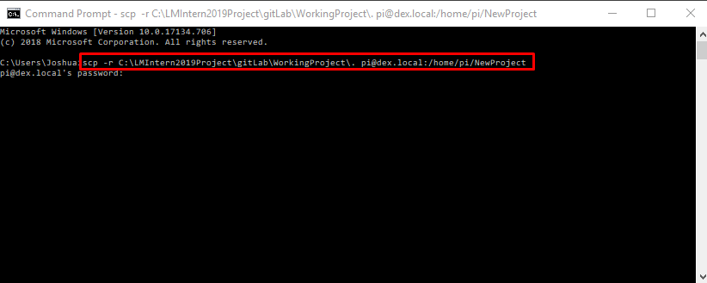

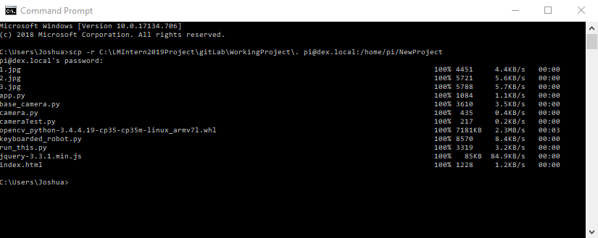

* 1. The files should now be copied to the “NewProject” folder on your GoPiGo3

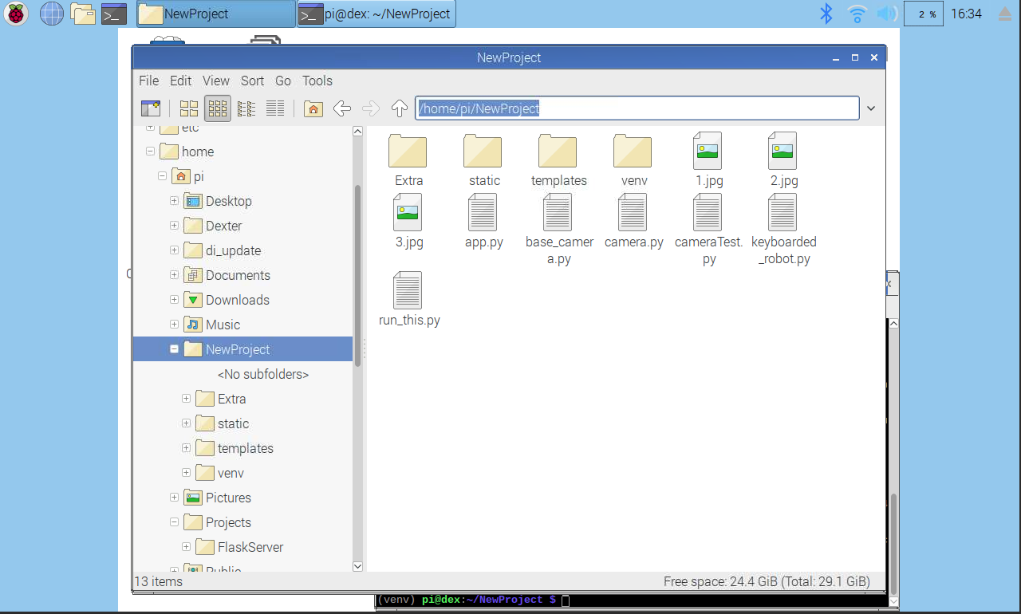

1. Start the Flask server by entering “python app.py”

Note: If a libcblas.os.3 cannot open shared object error is thrown, run these command:

pip3 install opencv-python

sudo apt-get install libcblas-dev

sudo apt-get install libhdf5-dev

sudo apt-get install libhdf5-serial-dev

sudo apt-get install libatlas-base-dev

sudo apt-get install libjasper-dev

sudo apt-get install libqtgui4

sudo apt-get install libqt4-test

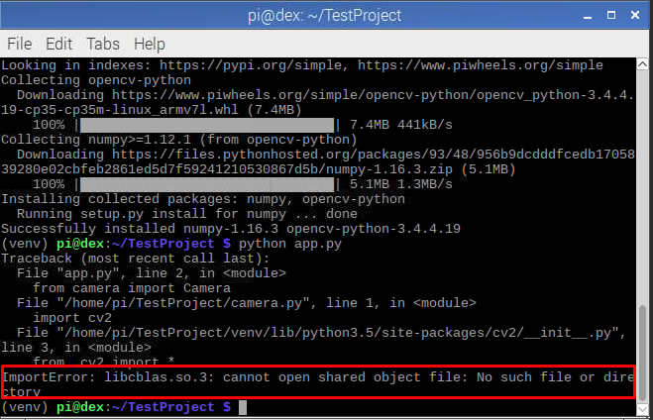

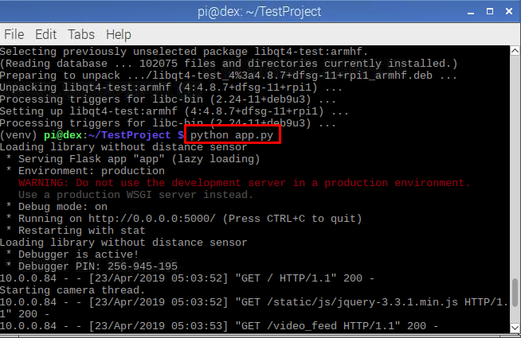

1. On your computer open a browser and navigate to <http://dex:5000> or http://<gopigo IP>:5000

