

**SECJ2013 DATA STRUCTURE AND ALGORITHM**

# SESSION 2021/2022/1

MINI PROJECT

“E-RECRUITMENT SYSTEM”

**GROUP 5**

# GROUP MEMBERS:

G M SHAHEEN SHAH SHIMON (A20EC0266)

TOYA LAZMIN KHAN (A20EC0284)

RAHIM REHNUMA TAHSIN (A20EC5001)

**SECTION:** 09

**LECTURER’S NAME:**

DR. SIM HIEW MOI

**Table of Contents**

**Contents Pages**

1. INTRODUCTION ---------------------------------------------------------------------- 3
   1. Synopsis of the Mini Project ---------------------------------------------- 3
   2. Objectives of the Project ---------------------------------------------------3
2. SYSTEM ANALYSIS AND DESIGN -------------------------------------------------- 4
   1. System Requirements ------------------------------------------------------ 4
   2. System Design ---------------------------------------------------------------- 6
3. SYSTEM PROTOTYPE ­---------------------------------------------------------------- 8
4. DEVELOPMENT ACTIVITIES ------------------------------------------------------- 17
5. APPENDIX ----------------------------------------------------------------------------- 19
6. **INTRODUCTION**

**1.1.** **Synopsis of the Mini Project**

For this semester’s final project of the course Data Structure & Algorithm, we were required to develop a medium to complex sized program by applying several data structure concepts in C++ programming language. We have chosen to develop a program on E-recruitment system by applying data structures like stack and queue.

In this project, we have digitized the hiring system of an applicant . The applicant applies through a job portal and then the hiring panel receives the applications. They check the resumes and documents and select the applicants that can be sent to the HR manager.

This project is based on a system in which a Hiring Panel can add Applicants’ information into an Applicant list that is created by the system and can also display and delete Applicants’ information from the list. The HR manager can access and check the list of all applicants, then add applicants they want to hire into another list that is for hired applicants.

Stack is used to add applicants’ information to the Applicant file and/or to delete them in Last in First Out movement and also to display the list of Applicants. while queue data structure is used to create a new list for shortlisted applicants in queue once the HR manager chooses whether and who to hire or not and also to display the full list of applicants if the HR manager wants to see the list.

**1.2.** **Objectives of the Project**

The objectives of this project are:

* Implementing the concept of Data Structure and Algorithm into a real-world situation.
* Developing a medium to complex size program on E-recruitment system by applying data structure concepts such as, stack and queue, in C++ programming language.
* Improving the skills of solving a problem in a group

**2.0.** **SYSTEM ANALYSIS AND DESIGN (USE CASE, FLOWCHART AND CLASS DIAGRAM)**

**2.1. System Requirements**

**Use Case Diagram**

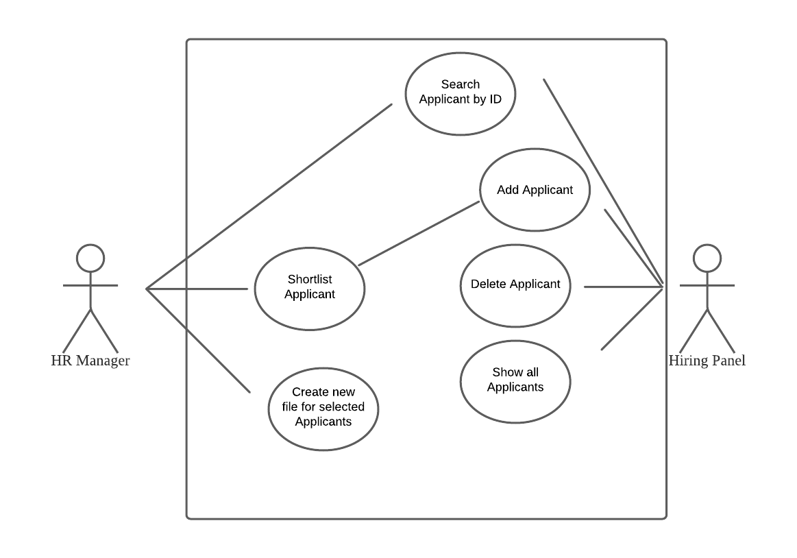

**Use Case Description for E-recruitment System**

The system users are Hiring Panel and HR Manager.

|  |  |
| --- | --- |
| **Actor** | **Task** |
| Hiring Panel | Hiring Panel can add Applicant’s information into Applicant file or delete the information from the file and also can display Applicant’s information and can check if new Applicants have been added. |
| HR Manager | HR Manager will shortlist applicants and display the list of all Applicants. |

**Detail Description for Each Use Cases**

The system has 6 main use cases.

|  |  |
| --- | --- |
| **Use Case** | **Task** |
| Add Applicant | Hiring Panel inserts information of Applicant that is then added into the Applicant file created by the system. |
| Delete Applicant | Hiring Panel deletes information of Applicant from Applicant file. |
| Show all Applicants | The system displays the list of Applicants from Applicant file to Hiring Panel |
| Search Applicant by ID | Both Hiring Panel and HR Manager can search for an Applicant from the Applicant list by inputting the specific Applicant’s ID. |
| Shortlist Applicant | Once Hiring Panel adds Applicant information to the list of Applicants, HR Manager decides whether to shortlist them or not. |
| Check new file for selected Applicants | Once an Applicant is shortlisted, the system creates a new file for those selected Applicants. |

**Class Diagram**

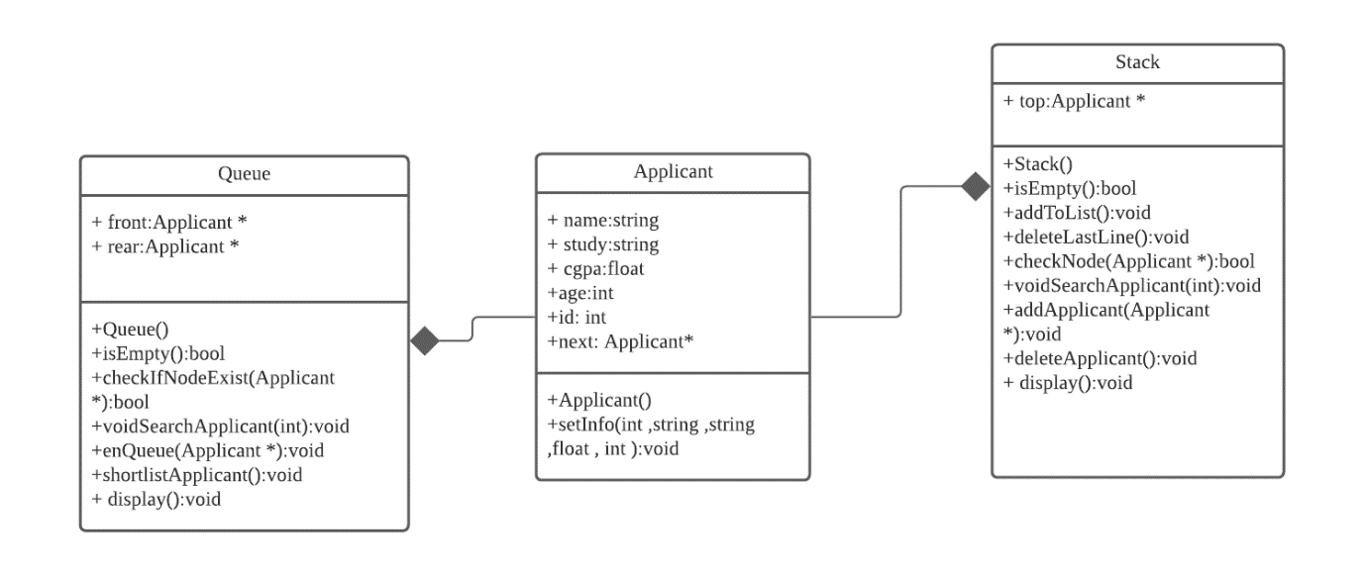

There are 3 classes in the program:

* Queue - Checking if there are any applicants in the system for their resume to be checked and adding selected applicant into the file by HR manager
* Applicant – Applicant’s name and other information is inserted into system my hiring panel for HR manager to check them
* Stack – Hiring panel adds applicants into the file and can also delete file from the system. Can display the inputted applicant data

**2.2. System Design**

**Overall Flowchart**

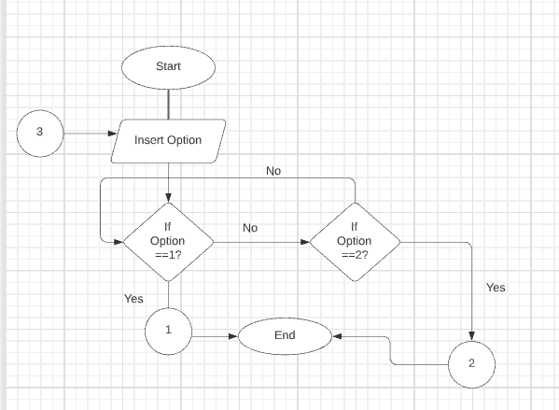

The menu appears. If option 1 is selected it goes through the process 1 and if option 2 is pressed , the process 2 functionality is showcased in the code.

**Flowchart 2**

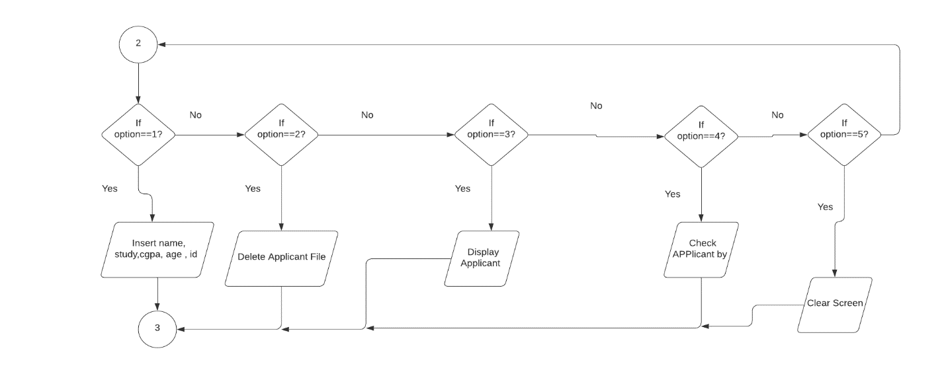

Process 2 is described here. If the user presses option 1 , it lets the users key in the applicant names and other information. If option 2 is pressed , the user can delete the latest keyed in Applicant file. If option 3 is pressed , user can check all applicant information . If option 4 is pressed , applicant can be searched by their ID, option 5 lets the user clear the screen.

**Flowchart 1**

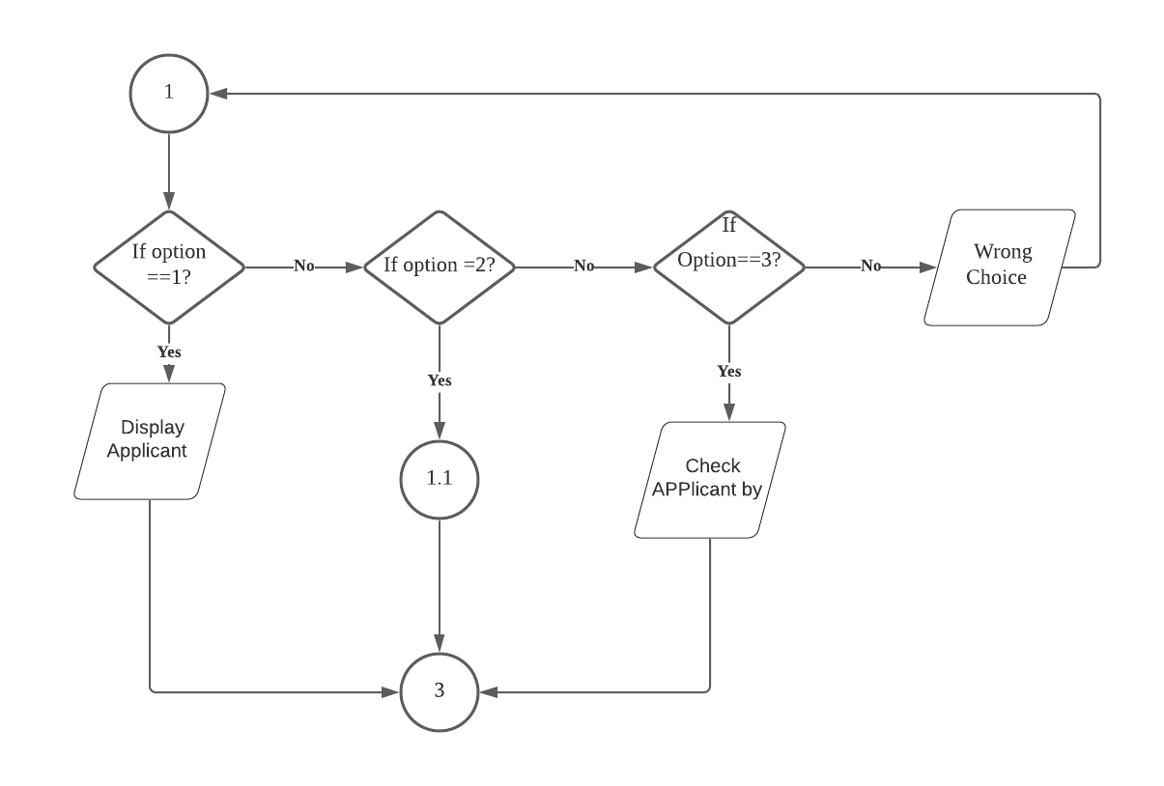

Search applicant by ID

In flowchart 1, If aoption 1 is selected , all the applicants he hiring panel added is showcased, if option 2 is pressed it goes through process 1.1 , which is described later and if option 3 is pressed , applicant information can be search by their Id, if any other key is pressed , it shows wrong choice , and every process after finishing returns back to the process 3.

**Flowchart 1.1**

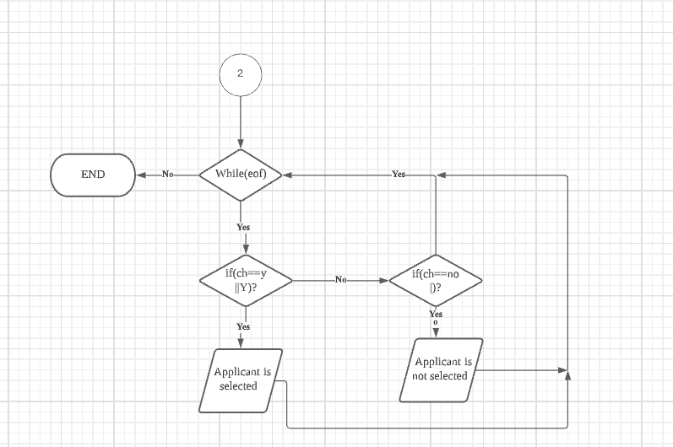

Process 1.1 involves HR manager selecting Applicants one by one, first they review on applicant, select or reject them, then move on to the next applicant until the list of Applicant is over in the file. If user presses Y, the applicant is selected, if user presses no, the user is not selected. The selected users’ information is saved in a new file.

**3.0. SYSTEM PROTOTYPE**

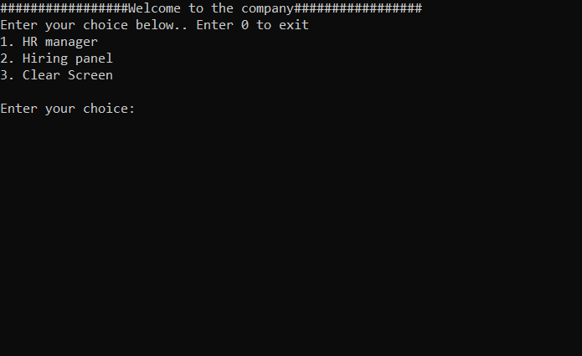

This screen shows the main menu of the system. Users must choose whether they are HR manager or a Hiring Panel. If the user is a Hiring Panel, they will have to type 2 to input or delete Applicant details and if the user is a HR Manager, they will have to type 1 for either displaying the list of applicants or shortlisting applicants into a new file created by the system. If the user enters an integer other than 0-3 , the program will display an error message and the screen will be displayed again. Then, users are allowed to enter their input again. They can also enter 0 if they want to stop running the program.

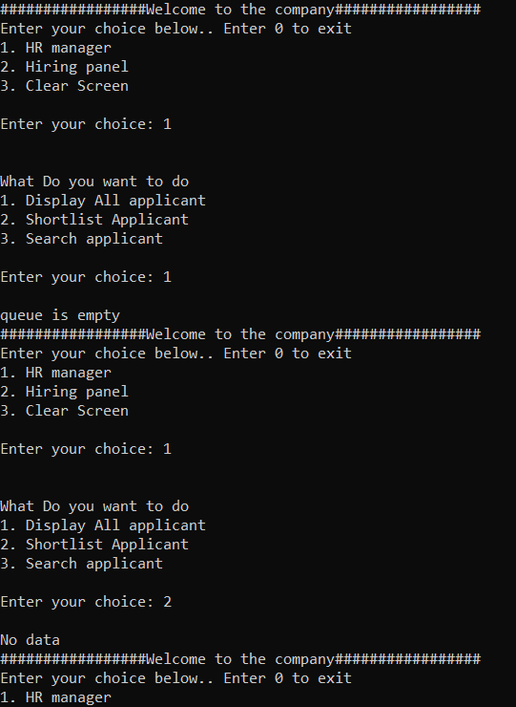

This screen shows that if there is no Applicant information in the list file then appropriate error messages will be displayed. If the HR Manager inputs 1 to display the list of all applicants when the file doesn’t contain any Applicant information, the system will display the error message ‘queue is empty’. If the HR Manager inputs 2 to shortlist applicant when the file doesn’t contain any Applicant information, the system will display the error message ‘No data’.

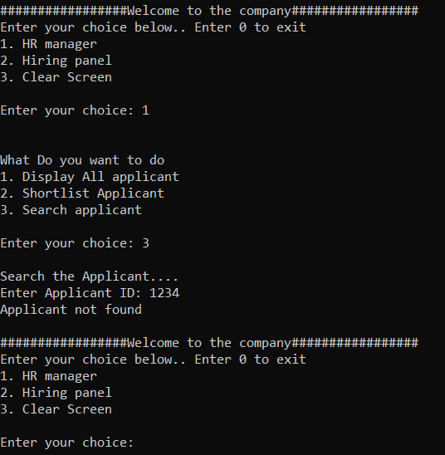

This screen shows that if the HR Manager inputs 3 to search for Applicant information from the list of Applicants when the file doesn’t contain any Applicant information or if the Applicant ID inputted is not in the file, the system will display the error message ‘Applicant not found’.

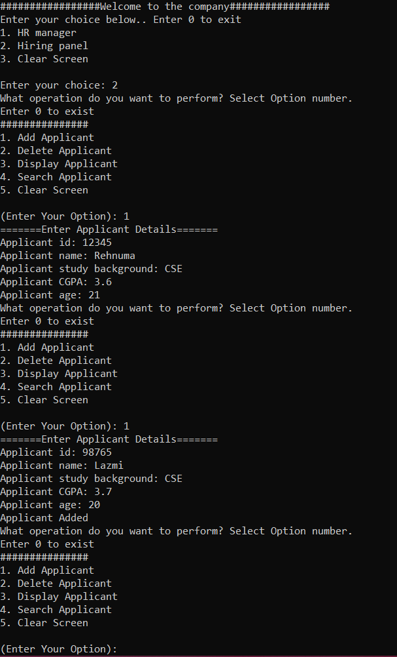

This screen shows the menu for Hiring Panel and how an Applicant’s information is added into the Applicant file.

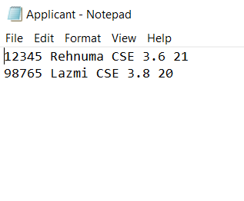

This is the file with list of Applicants that is created by the system automatically once the Hiring Panel adds Applicant information and this is how the information inputted by Hiring Panel should be stored in the file by the system.

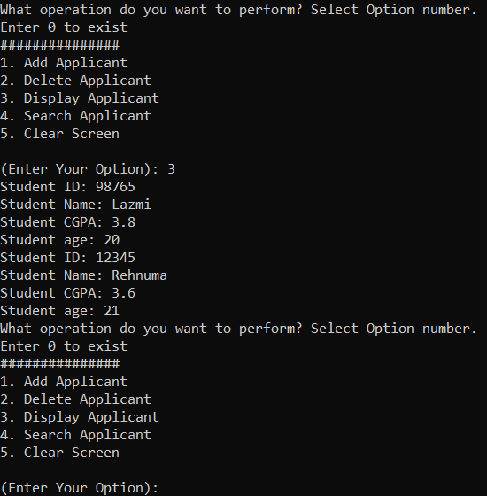

If the Hiring Panel wants to display the list of Applicants from the file then they need to input 3 and this is how the information of Applicants will be displayed.

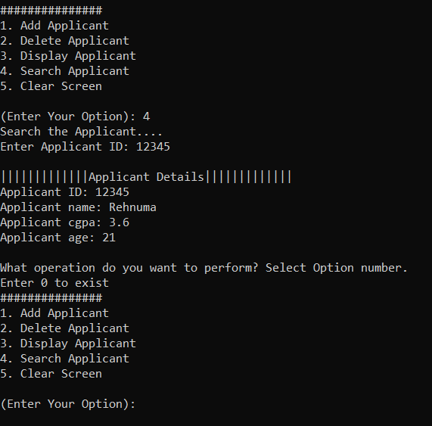

If the Hiring Panel wants to Search for a particular Applicant’s information, they will have to input 4 and then input the Applicant’s ID and this is how the information of that particular Applicant will be displayed.

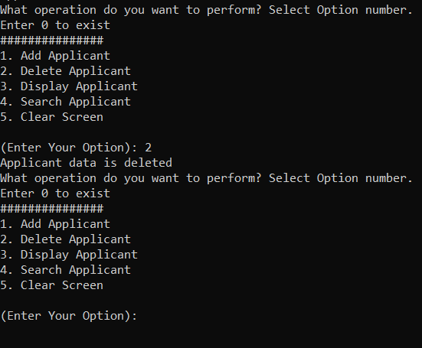

This screen shows that id the Hiring Panel inputs 2 then the system will delete the information of Applicant from the list in Last in First out movement.

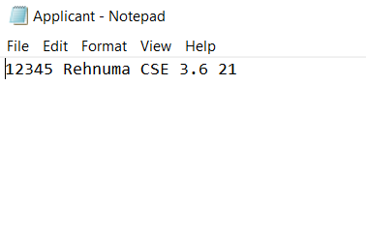

As shown in the picture above, information of the last applicant in the list is deleted.

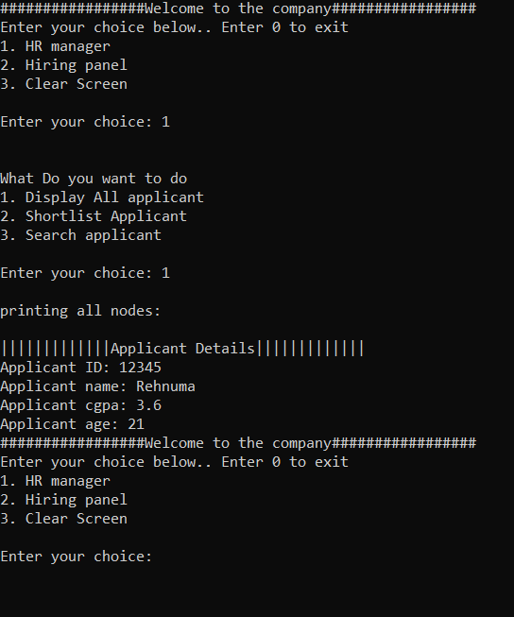

This screen shows that after the Hiring Panel adds Applicants’ information and an applicant file is created by the system, the HR Manager can access the list from the main menu. The HR Manager first has to input 1 in the main menu to access the HR Manager’s menu and then they can input 1 if they want to display the information of Applicants that are in the Applicant File and all the information that are in the file will be displayed.

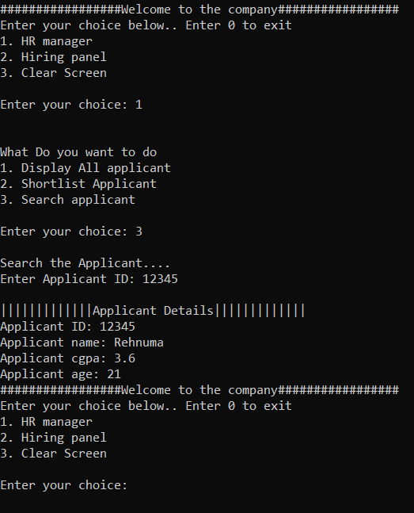

This screen shows that a HR Manager can also search for a particular Applicant from the list to be displayed if they want to, by inputting 3 in the HR Manager menu first and then inputting that particular Applicant’s ID.

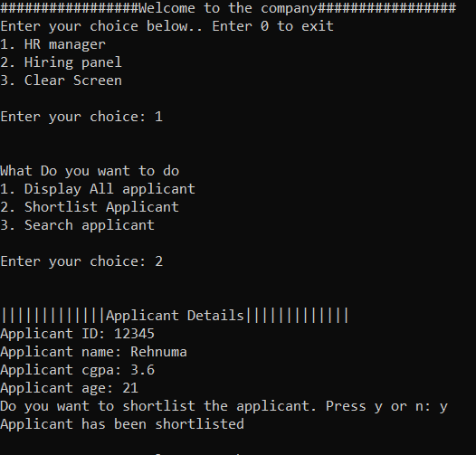

If a HR Manager wants to shortlist an applicant they will have to first input 2 in the HR Manager menu and the information of each Applicant in the list will appear in the screen and then the system will ask the HR Manager, ‘Do you want to shortlist the applicant. Press y or n’. If the HR Manager inputs y to shortlist that applicant then the system will create a new file for shortlisted Applicants where all the information of shortlisted applicants will be stored. The screen shows that the HR Manager keyed in y so the applicant in from the Applicant file was shortlisted.

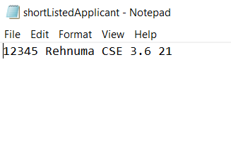

This is the system-created file of shortlisted Applicants that has the information of the Applicant which was shortlisted by the HR Manager.

**Explanation Prepared By:** Rahim Rehnuma Tahsin.

**Code Prepared By:** G M Shaheen Shah Shimon & Toya Lazmi Khan.

**4.0. DEVELOPMENT ACTIVITIES**

|  |  |  |  |  |
| --- | --- | --- | --- | --- |
| **Online Meeting Date** | **Members Participated in the meeting** | **Activity** | **Task for each member** | **Task Achieved**  **(Yes/No)** |
| 22/1/2022  10:00 PM | Lazmi  Shimon  Rehnuma | -Brainstorming  about the project and deciding what to be done  -Trying to decide on how to implement  queue and stack in the program. | **Rehnuma**  -Initiate the meeting and  suggest few concepts.  **Lazmi**  -Relating  things from previous assignments with  the project  **Shimon**  -Planning how to implement the concept. | Yes |
| 1/1/2022  10:00 PM | Lazmi  Shimon  Rehnuma | -Implementing the concept in Dev C++ | **Shimon**  -Initiate the meeting and start writing the code.  **Lazmi**  **-** Suggest ways of implementation and write some of the code  **Rehnuma**  **-** Suggest ways of implementation and write some of the code | Yes |
| 3/1/2022 | Lazmi  Shimon  Rehnuma | -Final touch up on project report documentation, presentation slides,  and source code. | **Lazmi**  **-** Initiate the meeting, create class diagram and flow charts for the report  **Shimon**  -Finalize code and create Use Case diagram.  **Rehnuma**  -Finishing up the rest of the report and compile.  - Create presentation slide | Yes |

**5.0. APPENDIX**

**Source Code**

// MINI PROJECT : "E-RECRUITMENT SYSTEM" //

// SECJ2013 DATA STRUCTURE AND ALGORITHM //

// SESSION 2021/2022/1 //

// SECTION - 09, LECTURER: DR. SIM HIEW MOI //

// GROUP - 05 //

/* MEMBERS:

G M SHAHEEN SHAH SHIMON (A20EC0266)

TOYA LAZMIN KHAN (A20EC0284)

RAHIM REHNUMA TAHSIN (A20EC5001) */

#include<iostream>

#include<fstream>

#include<vector>

using namespace std;

class Applicant{

public:

string name;

string study;

float cgpa;

int age;

int id;

Applicant* next;

Applicant(){

name=" ";

study=" ";

cgpa=0.0;

age=0;

next=NULL;

}

void setInfo(int ID,string n,string s,float c, int a){

name=n;

study=s;

cgpa=c;

age=a;

id=ID;

}

};

class Stack{

public:

Applicant* top;

Stack(){

top=NULL;

}

//checking the stack is empty or not

bool isEmpty(){

if(top==NULL){

return true;

}

else{

return false;

}

}

//add to file

void addToList(Applicant *s){

ofstream file_out("Applicant.txt",ios::app);

file_out<<s->id<<" "<<s->name<<" "<<s->study<<" "<<s->cgpa<<" "<<s->age<<endl;

}

//delete the last line of the file

void deleteLastLine(){

string line; // To read each line from code

int count=0; // Variable to keep count of each line

ifstream mFile ("Applicant.txt");

//get the number of line in a file

if(mFile.is_open())

{

while(mFile.peek()!=EOF)

{

getline(mFile, line);

count++;

}

mFile.close();

// cout<<"Number of lines in the file are: "<<count<<endl;

}

else

cout<<"Couldn't open the file\n";

//remove the last line of the line

string line2;

vector<string> lines;

ifstream inputStream("Applicant.txt");

while (getline(inputStream,line2)) {

lines.push_back(line2);

}

inputStream.close();

fstream outputStream("example.txt", ios::out | ios::trunc);

if (outputStream.is_open())

{

for (int i=0; i < lines.size()-1; i++)

{

outputStream << lines[i] << "\n";

}

outputStream.close();

}

remove("Applicant.txt");

rename("example.txt", "Applicant.txt");

}

//check the node

bool checkNode(Applicant* s){

Applicant* temp=top;

bool exist = false;

while(temp!=NULL){

if(temp->id==s->id){

exist=true;

break;

}

temp=temp->next;

}

return exist;

}

//Search an applicant

void searchApplicant(int searchID){

string name;

string study;

float cgpa;

int age;

int id;

int found=0;

fstream infile("Applicant.txt",ios::in);

infile>>id>>name>>study>>cgpa>>age;

while(!infile.eof()){

if(id==searchID){

cout<<endl<<"|||||||||||||Applicant Details|||||||||||||"<<endl;

cout<<"Applicant ID: "<<id<<endl;

cout<<"Applicant name: "<<name<<endl;

cout<<"Applicant cgpa: "<<cgpa<<endl;

cout<<"Applicant age: "<<age<<endl;

cout<<endl;

found=1;

}

infile>>id>>name>>study>>cgpa>>age;

}

if(found==0){

cout<<"Applicant not found"<<endl<<endl;

}

}

//push the node

void addApplicant(Applicant *s) {

if(top==NULL){

addToList(s);

top=s;

}

else if(checkNode(s)){

cout<<"xxxxxxx(ERROR : Same ID exists)xxxxxxx"<<endl;

}

else{

addToList(s);

Applicant* temp=top;

top=s;

s->next=temp;

cout<<"Applicant Added"<<endl;

}

}

//pop operation

void deleteApplicant(){

Applicant *temp=NULL;

if(isEmpty()){

cout<<"Stack is empty"<<endl;

}

else{

deleteLastLine();

temp=top;

top=top->next;

delete temp;

cout<<"Applicant data is deleted"<<endl;

}

}

//print the all elements

void display(){

Applicant *temp;

temp=top;

if(isEmpty()){

cout<<"Stack is empty"<<endl;

}

else{

while(temp!=NULL){

cout<<"Student ID: "<<temp->id<<endl;

cout<<"Student Name: "<<temp->name<<endl;

cout<<"Student CGPA: "<<temp->cgpa<<endl;

cout<<"Student age: "<<temp->age<<endl;

temp=temp->next;

}

}

}

};//end of stack class

class Queue{

public:

Applicant*front,*rear;

Queue(){

front=NULL;

rear=NULL;

}

//checking wheather list is empty or not

bool isEmpty(){

if(front==NULL&&rear==NULL){

return true;

}

else{

return false;

}

}

//Search an applicant

void searchApplicant(int id){

int found=0;

Applicant*temp=front;

while(temp!=NULL){

if(temp->id==id){

cout<<endl<<"|||||||||||||Applicant Details|||||||||||||"<<endl;

cout<<"Applicant ID: "<<temp->id<<endl;

cout<<"Applicant name: "<<temp->name<<endl;

cout<<"Applicant cgpa: "<<temp->cgpa<<endl;

cout<<"Applicant age: "<<temp->age<<endl;

found=1;

break;

}

temp=temp->next;

}

if(found==0){

cout<<"Applicant not found"<<endl<<endl;

}

}

//enQueue function

void enQueue(Applicant*s){

if(isEmpty()){

front=s;

rear=s;

}

else{

rear->next=s;

rear=s;

}

}

//shortlist the applicant

void shortlistApplicant(){

if(isEmpty()){

cout<<"No data"<<endl;

}

else{

ofstream sl_out("shortListedApplicant.txt",ios::app);

string ch;

Applicant* temp=front;

while(temp!=NULL){

cout<<endl<<"|||||||||||||Applicant Details|||||||||||||"<<endl;

cout<<"Applicant ID: "<<temp->id<<endl;

cout<<"Applicant name: "<<temp->name<<endl;

cout<<"Applicant cgpa: "<<temp->cgpa<<endl;

cout<<"Applicant age: "<<temp->age<<endl;

cout<<"Do you want to shortlist the applicant. Press y or n: ";

cin>>ch;

if(ch=="y"||ch=="Y"){

sl_out<<temp->id<<" "<<temp->name<<" "<<temp->study<<" "<<temp->cgpa<<" "<<temp->age<<endl;

cout<<"Applicant has been shortlisted"<<endl<<endl;

}

else{

cout<<"Applicant data not added"<<endl;

}

temp=temp->next;

}

}

}

//display all nodes in the queue

void display(){

if(isEmpty()){

cout<<"queue is empty"<<endl;

}

else{

cout<<"printing all nodes: "<<endl;

Applicant* temp=front;

while(temp!=NULL){

cout<<endl<<"|||||||||||||Applicant Details|||||||||||||"<<endl;

cout<<"Applicant ID: "<<temp->id<<endl;

cout<<"Applicant name: "<<temp->name<<endl;

cout<<"Applicant cgpa: "<<temp->cgpa<<endl;

cout<<"Applicant age: "<<temp->age<<endl;

temp=temp->next;

}

}

}

};

int main(){

int choice;

do{

cout<<"#################Welcome to the company#################"<<endl;

cout<<"Enter your choice below.. Enter 0 to exit"<<endl;

cout<<"1. HR manager"<<endl;

cout<<"2. Hiring panel"<<endl;

cout<<"3. Clear Screen"<<endl;

cout<<endl<<"Enter your choice: ";cin>>choice;

switch(choice){

case 0: break;

case 1:{

Queue q;

int option, option2;

string name;

string study;

float cgpa;

int age;

int id;

fstream

infile("Applicant.txt",ios::in);

int searchID;

infile>>id>>name>>study>>cgpa>>age;

while(!infile.eof()){

Applicant* ss=new Applicant();

ss->setInfo(id,name,study,cgpa,age);

infile>>id>>name>>study>>cgpa>>age;

q.enQueue(ss);

}

cout<<endl;

cout<<endl<<"What Do you want to do"<<endl;

cout<<"1. Display All applicant"<<endl;

cout<<"2. Shortlist Applicant"<<endl;

cout<<"3. Search applicant"<<endl;

cout<<endl<<"Enter your choice: ";

cin>>option2;

cout<<endl;

switch(option2){

case 0: break;

case 1:

q.display();

break;

case 2:

q.shortlistApplicant();

break;

case 3:

cout<<"Search the Applicant...."<<endl<<"Enter Applicant ID: ";

cin>>searchID;

q.searchApplicant(searchID);

break;

default:

cout<<"Wrong choice"<<endl;

}

break;

}

case 2:{

Stack s1;

int option, position;

string name;

string study;

float cgpa;

int age;

int id;

do{

cout<<"What operation do you want to perform? Select Option number."<<endl<<"Enter 0 to exist"<<endl;

cout<<"###############"<<endl;

cout<<"1. Add Applicant"<<endl;

cout<<"2. Delete Applicant"<<endl;

cout<<"3. Display Applicant"<<endl;

cout<<"4. Search Applicant"<<endl;

cout<<"5. Clear Screen"<<endl;

cout<<endl<<"(Enter Your Option): ";

cin>>option;

Applicant* s=new Applicant();

switch(option){

case 1:

cout<<"=======Enter Applicant Details======="<<endl;

cout<<"Applicant id: ";cin>>id;

cout<<"Applicant name: ";cin>>name;

cout<<"Applicant study background: ";cin>>study;

cout<<"Applicant CGPA: ";cin>>cgpa;

cout<<"Applicant age: "; cin>>age;

s->id=id;

s->name=name;

s->study=study;

s->cgpa=cgpa;

s->age=age;

s1.addApplicant(s);

break;

case 2:

s1.deleteApplicant();

break;

case 3:

s1.display();

break;

case 4:

int searchID;

cout<<"Search the Applicant...."<<endl<<"Enter Applicant ID: ";

cin>>searchID;

s1.searchApplicant(searchID);

break;

case 5:

system("cls");

break;

default:

cout<<"Wrong operation number"<<endl;

}

}while(option!=0);

break;

}////

case 3: system("cls");

break;

default:

cout<<"Wrong choice..Please Enter correct option"<<endl;

break;

}

}while(choice!=0);

return 0;

}

----- END OF DOCUMENTATION -----