

Microservices



**Microservices**

Microservice can have many definitions.

* It is architectural style or an approach to developing a single application as a suit of small services, each running in its own process and communicating with light weight mechanisms, often HTTP resource API.
* Each service is independently deployable by fully automated deployment tools.
* Each can be written in different programming language. And different persistence can be used. Where as in monolith we have to stick on same language.
* If we compare microservice with monolith application it is easier to understand and developer can be more productive.
* Here we can accomplish parallel development. Where as in Monolith application it may create some issue.
* It can be easily scaled in terms of resources. Where as it is hard to scaled Monolith application.
* Each microservice can be deployable independently, it also improves fault isolation and conflicting resource can be resolved.

**Challenges and Solution of Microservices:**

1. In microservice generally one service calls another service take as example below.

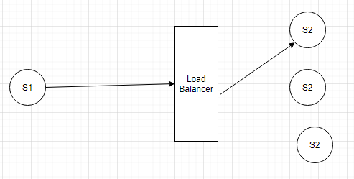

In above example we have two microservice i.e. S1 and S2, S1 is making a call to S2 and based on LB logic instance of S2 is assigned to that call. Here we can see we are having two remote calls. S1 to load balancer and then LB to S2. So, it will affect performance.

Now to over come this issue what microservice architect do that they have introduced another component call discovery server as shown in below diagram.

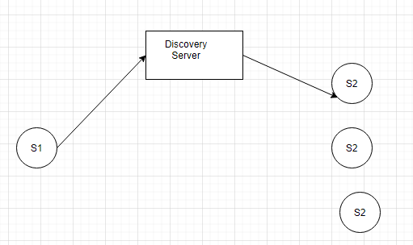

Discovery server will keep track of all the instance of S2. So, when call coming from S1 it will assign one instance of S2 to serve that request. But still our above problem is not resolve. So now what they do they have introduced another concept called client-side load balancing as shown in below diagram.

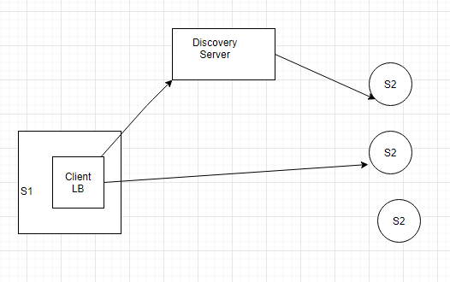

Here client side LB download all the registry of S2 instance from of discovery server and when S1 calls S2 based on some logic it will assign S2 instance to full fill the request. But here is another problem is that suppose if after sometime an instance of S2 is down then how client side LB know that S2 instance is down. Also, to download all the registry from discovery server it has to make a call to discovery server.

So, what Microservice architect has done during startup of S1 they have assigned one thread which actually get all the registry from discovery server and also after some seconds based on configuration it continuously synching the registry from discovery server. Similarly, Discovery server also call health check status of each S2 instance after some time interval and based on result it updates its registry and status.

For this purpose, Netflix have created Eureka (Discovery server) and Ribbon (Client side LB). what Netflix developer saw 30 secs is good time to synch and update registry as well as update the registry in Client-side LB.

Now suppose during that 30 sec one of instance of S2 went down. Every instance of S2 send heart beat on regular interval (30 sec). Now suppose one of heart beat is missing then what will Eureka do. Should it remove it from registry. No, we can configure that if 3 or more heart beat consecutively missing then only Eureka will remove this server from registry.

Now suppose during this time S1 call that down instance of S2. It got fail so we can configure retry logic, (Ribbon is providing this retry logic). But what should we do if all retry is over then in that case we can implement some fallback logic.

Also take one example if S1 calling one of S2 instance and that instance is busy or taking some time to response. In that case, may S1 can assign weight to that instance and similarly to other instance of S2 and based on this it may use weight round robin to call S2 instance.

1. Bulk-head issue.

Let take an example we have following server S1, S2, S3, S4 etc. And S1 have operation O1, O2 and O3. And S3 service is very slow. We may deploy those service to tomcat or other server and it has some thread pool. Suppose S1 is deployed to tomcat server and its thread pool size is 100. So, what will happen if O2 calls S3 service, due to slowness it might be waiting for response. Similarly, there might be chance that all 100 threads are calling to S3 and due to slowness is waiting for response and our application consume all the thread pool and no thread is available for other operation.

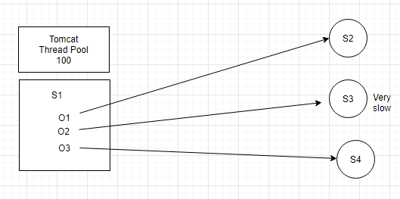

Now take example of bank having toll free no. with 100 limits. Suppose it has many departments like saving account, loan, credit card etc. When caller call the toll, free no. based on it’s choice call connected to different department. Suppose Loan department taking time to describe loan feature and if we don’t have any mechanism then all the 100 limits get used. So, what we can do we can assign some limit to each department like SA can have 30 call max, loan can have 40 calls max and CC can have 30 calls max. So, what will happen in this case if more than 40 callers try to connect to loan department either they will wait or call get disconnected after sometime automatically. By this here we can utilize limits. Means 60 call will be available for another department.

Similarly, in above case of microservice we can limit pool size specific to each service. This pattern is call Bulk head pattern. Means issue in one service could not make entire system down. This concept came from ship companies. We don’t need to implement bulk head pattern Netflix provide one more library called Hystrix which implement bulk head pattern. It also used in circuit breaker pattern.

1. Circuit breaker pattern.

Look below diagram, S1 calling S2, S2 calling S3 and S3 calling S4, S2 calling S4 and S1 calling S4. By the looks of this it looks like a circuit.

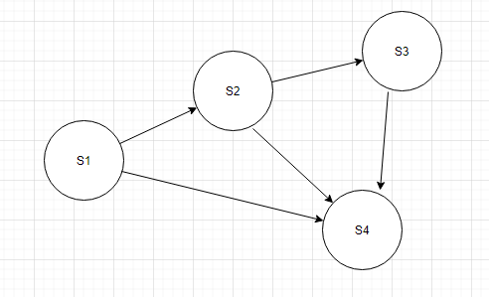

Here suppose due to some reason Service S4 fails, what will happen then after sometime S3 fails then S2 and then complete services.

One thing we can do we can write some fallback logic which will execute once S4 is down. Now suppose S4 is down and S3 is calling S4 1,2… 20 times it got failure and it execute fallback logic. Suppose if we have mechanism which will already identify that S4 is down without wasting time calling S4 it should execute fallback logic. In circuit breaker there are lots of logic which decide whether a circuit is open or close based. E.g. success count, failure count, time out, bucket with data all SC, FC, TC of 100sec etc.

1. Suppose we have 20 services like S1, S2 … S20 all register to Eureka. So, if internal call happens between these services then it will go to eureka and found the service registry and call those service.

Now suppose if any external client wants to use one of your service can you give it all the registry present in Eureka. So instead of giving all the registry present in Eureka we will provide a proxy server. So now client will call proxy server and proxy server will go to eureka get the registry and based on service call return data. Zuul is one of the libraries which is used as API gateway. It also implements hystrix. Suppose I want to secure my all service we will implement at zuul, similarly we can also configure process like pre-processing or post processing of any request. Also, we can write routing logic also if client wants to use only some of the services.

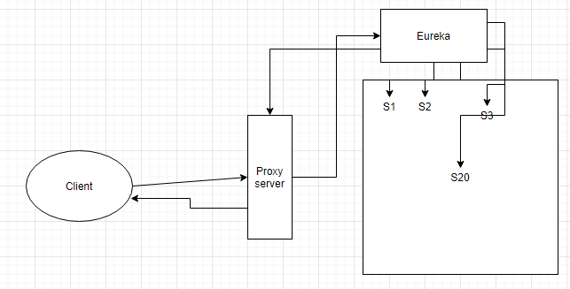

1. In our microservice there can be many services, so ideas are keeping all the configuration inside the central repo. And we should have config server. So, whenever a service starts then it calls config server and it will get from central repo. For this we can use spring cloud config server
2. Message driven microservice using spring cloud stream:

Spring cloud stream build on top of spring integration.

Suppose we have two application A and B. Service B uses Soap based webservices and A consume B service using wsdl file. If we are using Soap based service, till then contract i.e. wsdl is same then we don’t have any impact like B changes it language from java to python etc. We can say application A is loosely coupled with B. But what about logically coupling, logically coupling means application A don’t know whose is application B and vice versa but still they can talk to each other. But is case of soap implementation there is no logically coupling.

Take above example, B is exposing Soap service. Now what A will do, it will create general message like header and body and it has in memory queue in which it will push message. Now suppose we have something called Adapter. Which will take that message from in memory queue and convert it to Soap envelop and call the service exposed by B. In this case A will don’t know about service B. now suppose latter on service stop support for soap and converted it to REST service what we need to do we only need to change configuration from soap to REST. And here everything is done through configuration.

Now take example, we are pushing data as in json format in in-memory queue but service uses xml format so what we can do we put something called transformer which convert data. Now suppose we want to validate data based on some condition then we can also configure filter similarly, we can also configure router which based on some condition put data into another queue and on those queues, we can configure adapter which will call the service.

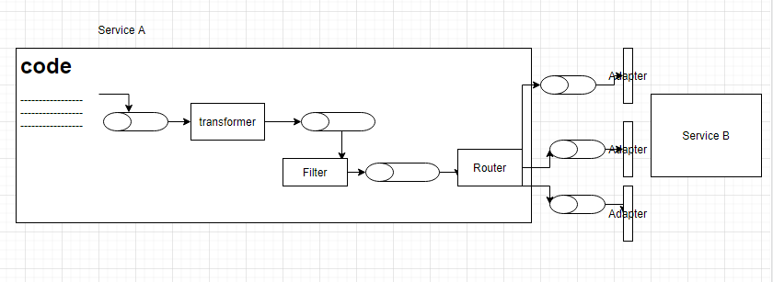

Any infrastructure which let us do above thing called as BUS framework or ESB e.g. MULE, apache camel, spring integration. Here those in-memory queue is called as channel.

Basic of RabbitMq:

In JMS we have two types of destination, queue and topic. Whenever a producer produce message then receiver receive message. Suppose we have a queue and three subscribers as shown is below diagram in which when a producer produces a message then one of consumer consume this message this is called point-to-point subscription.

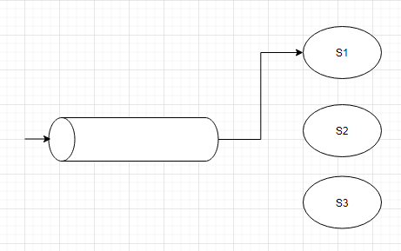

Similarly, we have topic, in which when producer sent a message it will be subscribe by multiple subscriber and this pattern is called as pub-sub i.e. publishing and subscribing.

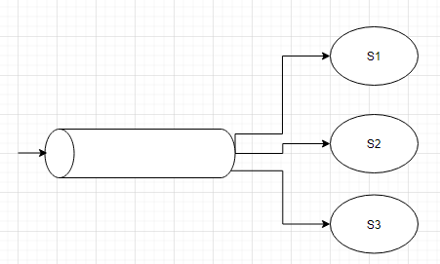

RabbitMQ uses AMQP protocols i.e. Advanced Message Queuing Protocol. So, if we are using AMQP we use different terminology where destination is called exchange. whenever sender wants to send any message we need to create AMQP message and publish it to exchange and it is bounded with multiple queues. Whenever we are bounding queue to exchange we need to define routing key. Now take below example we have exchange which have four queue Q1, Q2, Q3 and Q4 having routing x, y, z and *x (wild card). So, whenever sender create AMQP message it will be sent with routing header which is placed to exchange and based on routing header it will copied to that queue. In below case message will copied to Q1 and Q2 and it is called topic exchange.

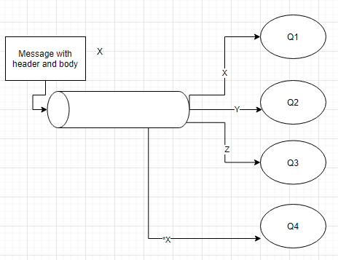

Setup RabbitMQ:

I have used docker for installing RabbitMQ.

1. Docker should be installed. Run docker and go to power shell or cmd and run below command.

docker run -it --rm --name rabbitmq -p 5672:5672 -p 15672:15672 rabbitmq:3-management

here it will download image from docker server if image not available locally and installed it to your local machine then it will start your rabbitmq on that docker image. Here -it is used to allow us to provide input/output to the container. similarly -p is used for port mapping because this rabbitmq installed and running in your docker container and it will don’t know when you try to access <http://localhost:15672/> that’s why we used port mapping in docker command so that when a request coming to above URL it will redirected to docker image.

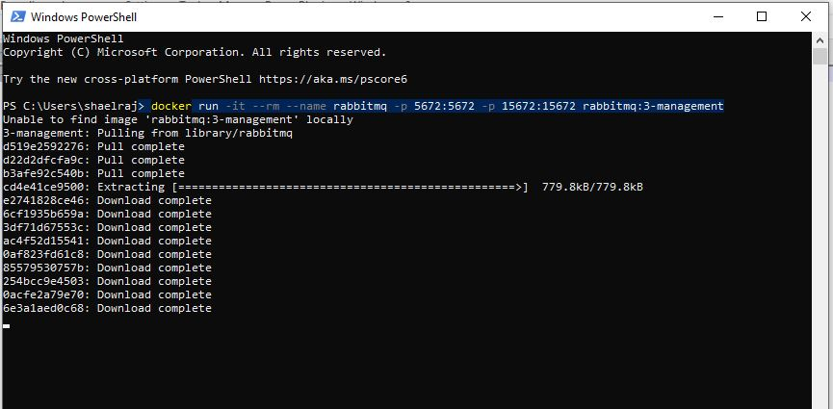

1. Open URL <http://localhost:15672/>

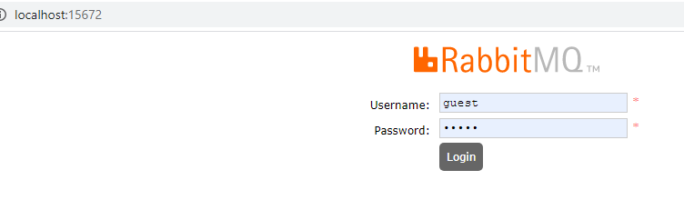

Username: guest

Password: guest

1. Click on exchanges tab

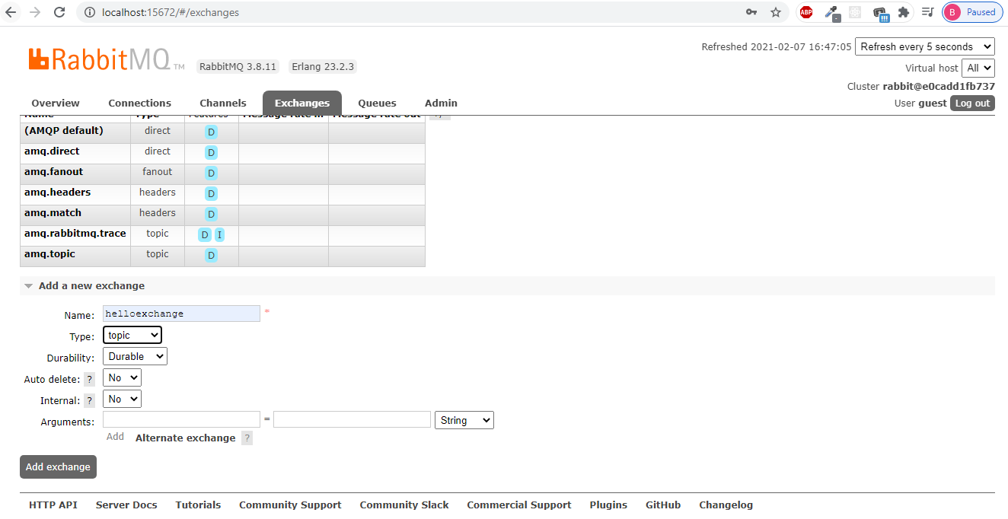

Now click on add a new exchange 🡪 type helloexchange select topic in type combo and click on add exchange button.

1. Now click on queues 🡪 click on add a new queue, given helloq in name. and click on add queue button.

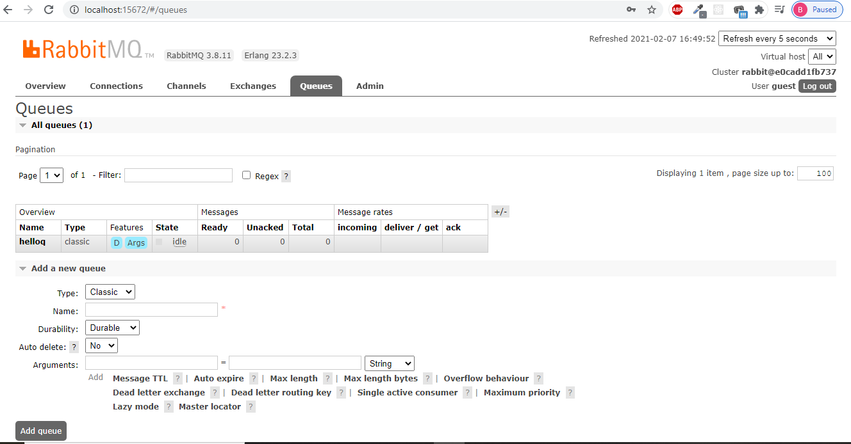

1. Now click on newly created queue and click on binding and enter # in routing

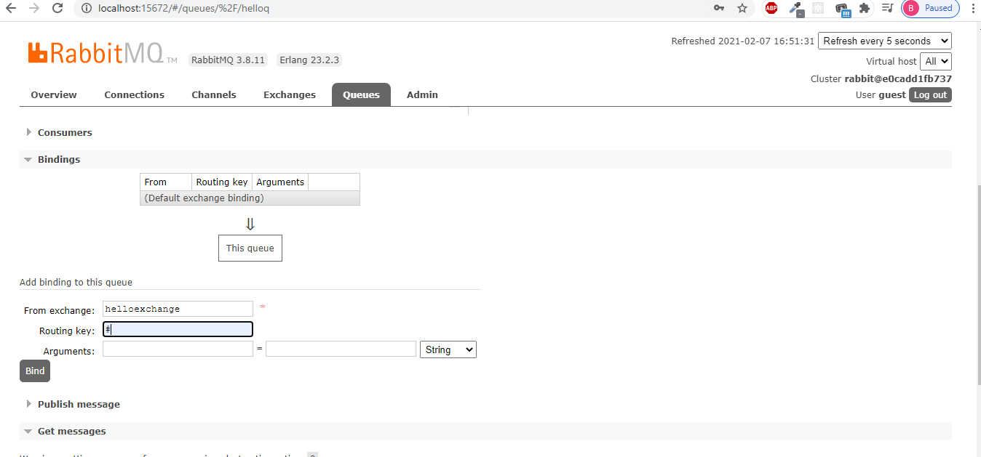

1. Project setup for Producer and consumer product.

Create a spring boot maven project **mdm-producer** and add below dependency.

<?xml version="1.0" encoding="UTF-8"?>

<project xmlns="http://maven.apache.org/POM/4.0.0"

xmlns:xsi="http://www.w3.org/2001/XMLSchema-instance"

xsi:schemaLocation="http://maven.apache.org/POM/4.0.0 https://maven.apache.org/xsd/maven-4.0.0.xsd">

<modelVersion>4.0.0</modelVersion>

<parent>

<groupId>org.springframework.boot</groupId>

<artifactId>spring-boot-starter-parent</artifactId>

<version>2.3.8.RELEASE</version>

<relativePath /> <!-- lookup parent from repository -->

</parent>

<groupId>com.javamonks</groupId>

<artifactId>mdm-producer</artifactId>

<version>0.0.1-SNAPSHOT</version>

<name>mdm-producer</name>

<description>Demo project for Spring Boot</description>

<properties>

<java.version>1.8</java.version>

<spring-cloud.version>Hoxton.SR9</spring-cloud.version>

<spring.fox.version>3.0.0</spring.fox.version>

</properties>

<dependencies>

<dependency>

<groupId>org.springframework.boot</groupId>

<artifactId>spring-boot-starter-web</artifactId>

</dependency>

**<dependency>**

**<groupId>org.springframework.cloud</groupId>**

**<artifactId>spring-cloud-starter-stream-rabbit</artifactId>**

**</dependency>**

<dependency>

<groupId>io.springfox</groupId>

<artifactId>springfox-boot-starter</artifactId>

<version>${spring.fox.version}</version>

</dependency>

<dependency>

<groupId>org.springframework.boot</groupId>

<artifactId>spring-boot-starter-test</artifactId>

<scope>test</scope>

<exclusions>

<exclusion>

<groupId>org.junit.vintage</groupId>

<artifactId>junit-vintage-engine</artifactId>

</exclusion>

</exclusions>

</dependency>

</dependencies>

<dependencyManagement>

<dependencies>

<dependency>

<groupId>org.springframework.cloud</groupId>

<artifactId>spring-cloud-dependencies</artifactId>

<version>${spring-cloud.version}</version>

<type>pom</type>

<scope>import</scope>

</dependency>

</dependencies>

</dependencyManagement>

<build>

<plugins>

<plugin>

<groupId>org.springframework.boot</groupId>

<artifactId>spring-boot-maven-plugin</artifactId>

</plugin>

</plugins>

</build>

</project>

In above pom.xml highlighted dependency we have added for RabbitMQ if you want to use for Kafka you can use Kafka dependency.

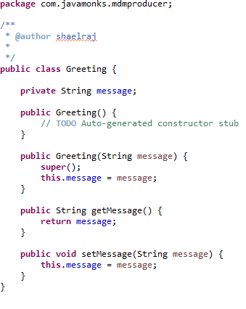In our example we can see simple use case like we have greeting message when we call a rest service it will push a message to RabbitMQ. For this we need to create a Greeting class which has only one attribute called message. Similarly, we need to create **source** interface which will define our channel as shown in below screenshot.

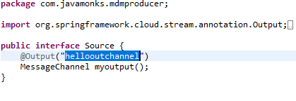In above code we created a channel and here we want our message to go out that’s why we annotated it with @Output and given a channel name.

Now we have to configure this hellooutchannel to exachange for this we need to make configuration in application.properties or application.yml file.

Below is the example of configuration

spring:

cloud:

stream:

bindings:

hellooutchannel:

destination: helloexchange

#group: order

binder: rabbit1

binders:

rabbit1:

type: rabbit

environment:

spring:

rabbitmq:

host: localhost

port: 5672

username: guest

password: guest

server:

port: ${PORT:2222}

So, we have spring.cloud.stream.bindings where we binding our hellooutchannel and giving destination to helloexchange and providing type of binder i.e. rabbit1. Now inside binders we are defining rabbit1 type to be rabbit and inside environment we provided details to which required to connect RabbitMQ.

If you want to use Kafka in future you just need to change configuration in YML file and just need to do changes in pom.xml.

Now to generate class we need to enable binding. So, we annotated ProducerApplication class with @EnableBinding

@SpringBootApplication

@EnableBinding(Source.**class**)

**public** **class** ProducerApplication {

**public** **static** **void** main(String[] args) {

SpringApplication.*run*(ProducerApplication.**class**, args);

}

}

Now we have a controller where we have defined a rest service where using @Autowired we have injected our Source.class

@RestController

**public** **class** GreetingsController {

**private** **static** Logger *LOG* = LogManager.*getLogger*(GreetingsController.**class**);

@Autowired

**private** Source source;

@GetMapping("/greet")

**public** Greeting createGreeting(String message) {

Greeting greeting=**new** Greeting(message);

*LOG*.info("Sending greeting!! ");

source.myoutput().send(MessageBuilder.*withPayload*(greeting).build());

**return** greeting;

}

}

Using source object we are calling myoutput method which will return MessageChannel and using MessageBuilder we are making payload using greeting object.

Now let start RabbitMQ using docker we already done necessary changes. And then start producer application. We have also added swagger-ui which is helpful for calling any rest service.

1. Call /greet service.

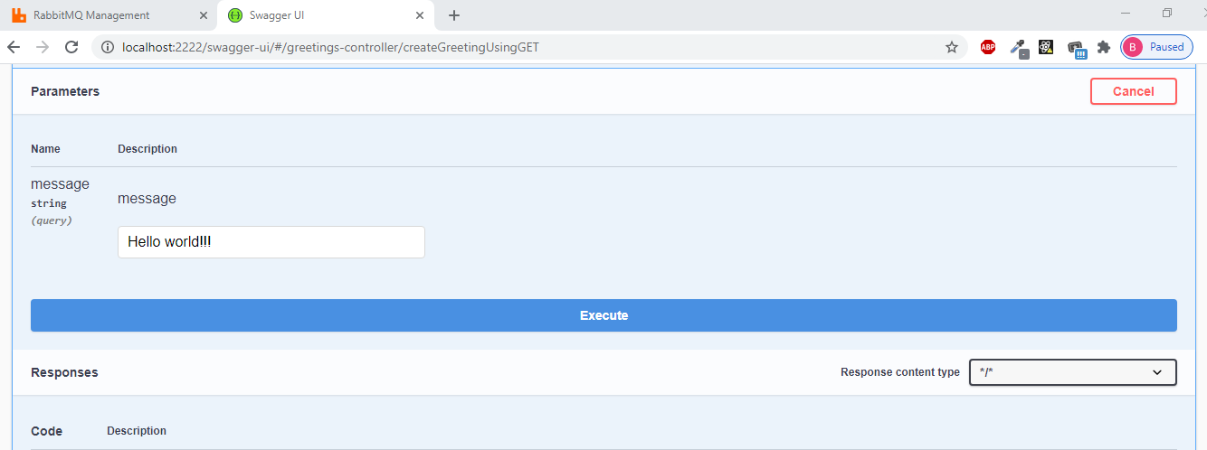

1. Click on execute you will see below message.

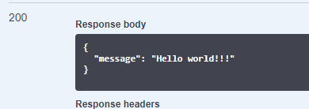

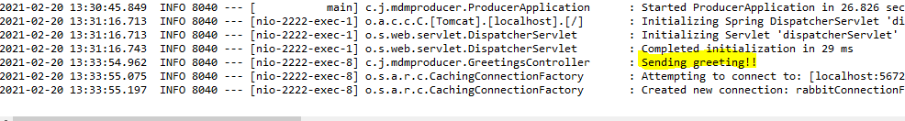

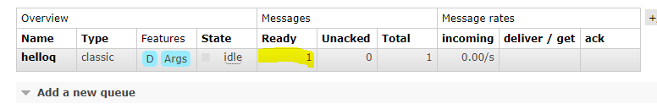

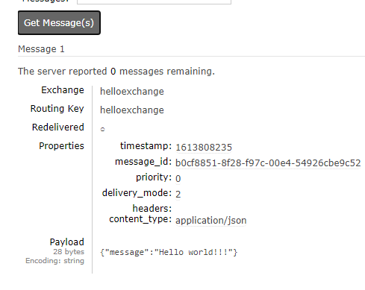

1. Go to RabbitMQ click on queue you will find one message in ready when you click on queue -> get message you can see the message.

Consumer-App:

1. same steps need to be followed, add RabbitMQ dependency in pom.xml

<dependency>

<groupId>org.springframework.cloud</groupId>

<artifactId>spring-cloud-starter-stream-rabbit</artifactId>

</dependency>

1. Now create a source class we below code. Here we are subscribing that’s why we used subcribechannel and it is incoming message so we annotated it with @Input

**public** **interface** Source {

@Input("helloinchannel")

SubscribableChannel myinput();

}

1. Now in YML file we need to put necessary config details as shown below.

spring:

cloud:

stream:

bindings:

helloinchannel:

destination: helloexchange

group: helloq

binder: rabbit1

binders:

rabbit1:

type: rabbit

environment:

spring:

rabbitmq:

host: localhost

port: 5672

username: guest

password: guest

server:

port: ${PORT:2225}

1. In Application class annotate it with @EnableBinding create a method which is annotated with @StreamListener, Whenever a message come to queue this method get called automatically.

@SpringBootApplication

@EnableBinding(Source.**class**)

**public** **class** ConsumerApplication {

**public** **static** **void** main(String[] args) {

SpringApplication.*run*(ConsumerApplication.**class**, args);

}

@StreamListener("helloinchannel")

**public** **void** processGreeting(Greeting greeting) {

System.***err***.println("Recevied Greeting with message ===="+greeting.getMessage());

}

}

1. Start consumer application.
2. If you go to RabbitMQ you will find our helloexchange.helloq in Queue.
3. Now send a message using producer application.

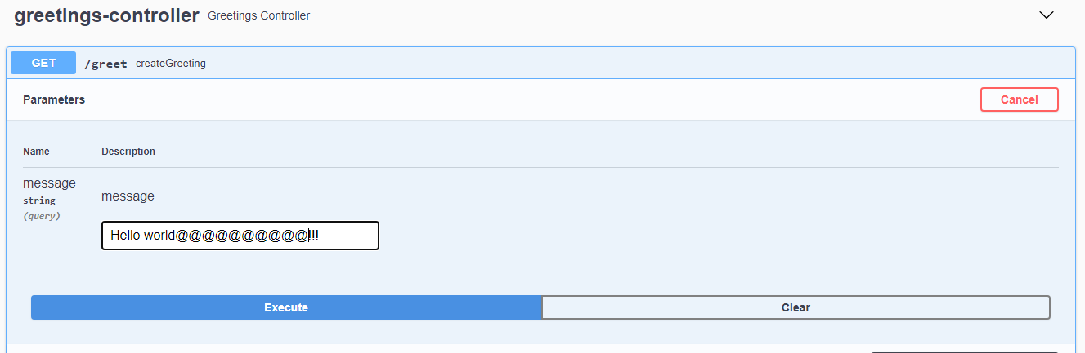

1. You can see below output in console of consumer application.

