

Volgenau School of Engineering
Department of Computer Science

INFS 614 – DATABASE MANAGEMENT
Dr. Jessica Lin

Project Final Phase
Shaeq Khan
G#00774501
Screenshots

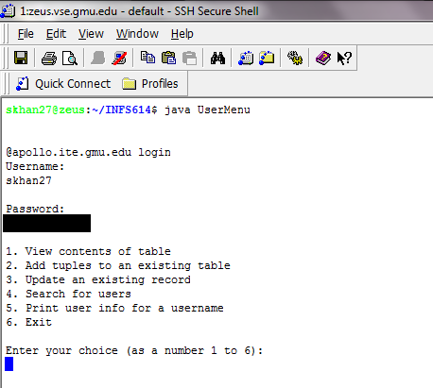
Figure 1 – login to database using command line

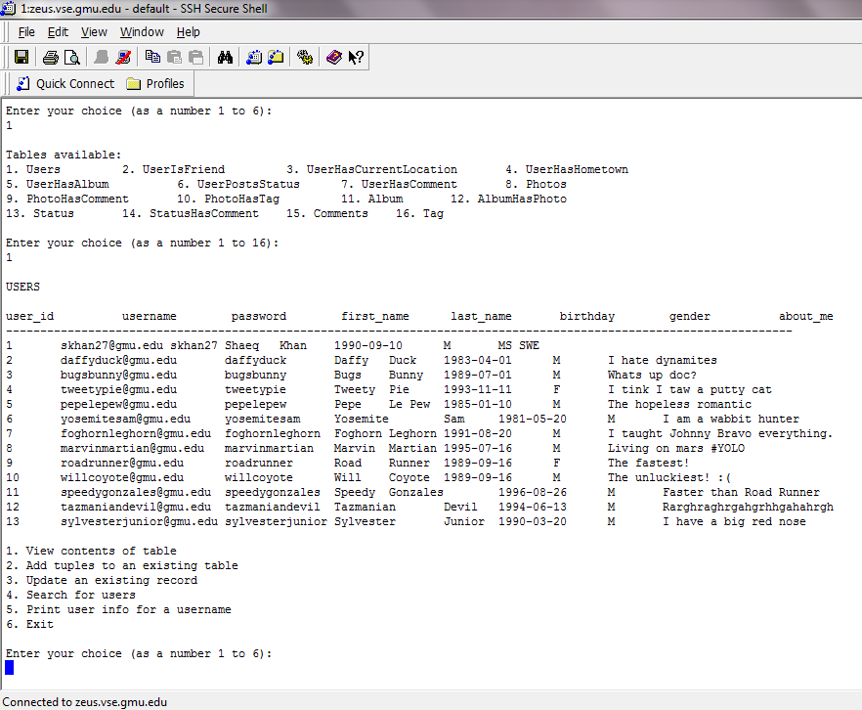
Figure 2 – continuation to login, using menu to view a table in command line
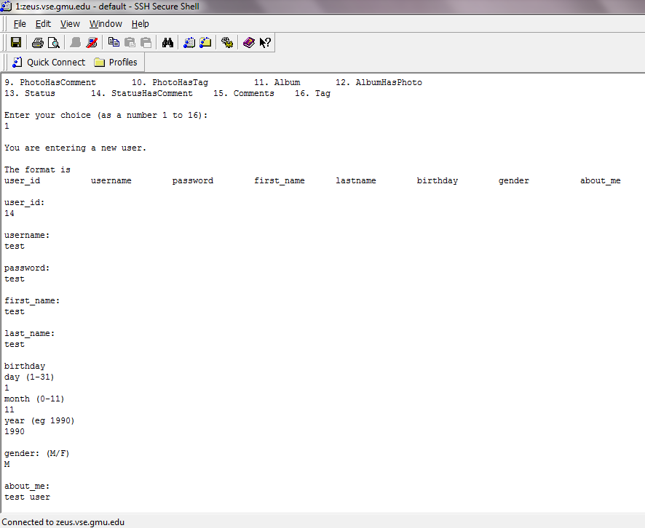
Figure 3 – Adding a tuple to an existing table. A tuple is being added to the table Users here.

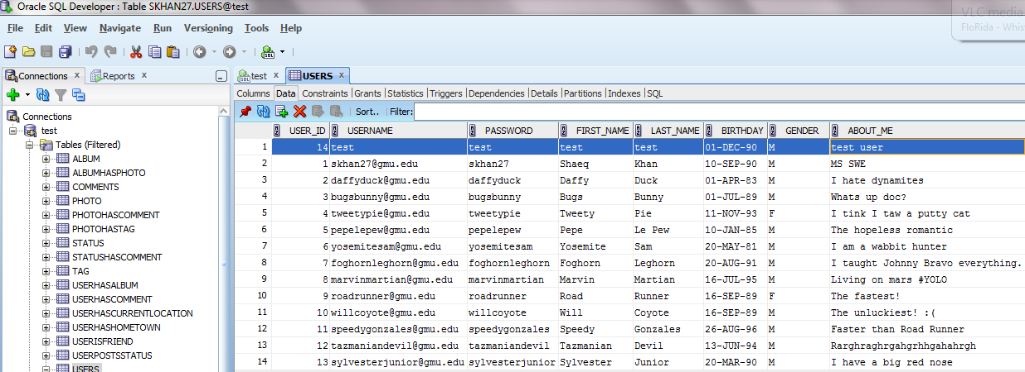
Figure 4 – database view to show tuple successfully added.
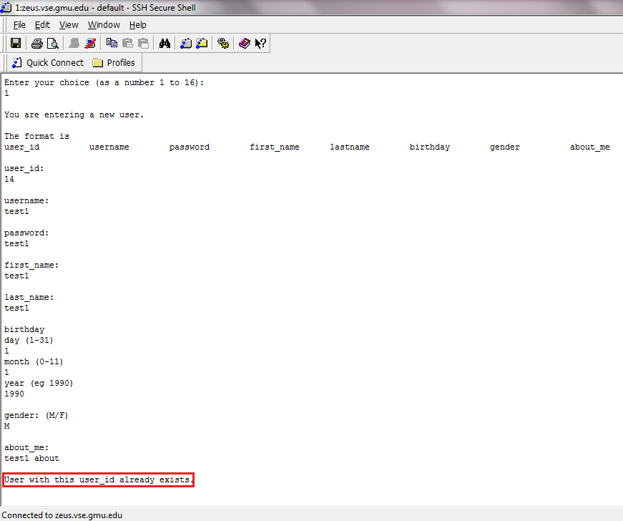
Figure 5 – adding another user with same user_id to demonstrate integrity constraint
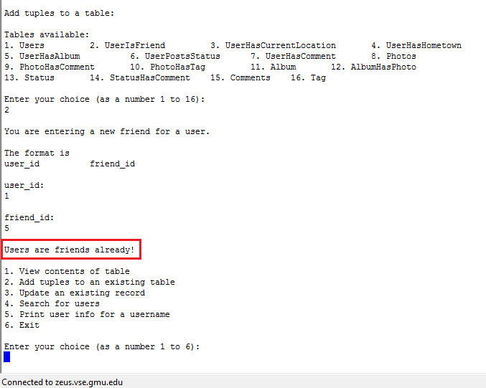
Figure 6 – Adding a friend to a user who is already a friend displays a message for the user.
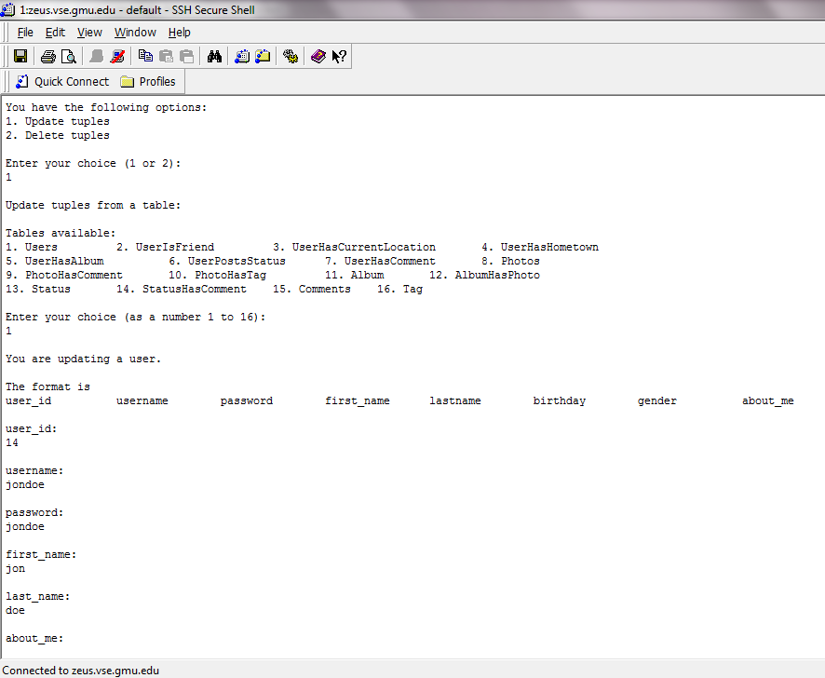
Figure 7 – updating the test user entered.

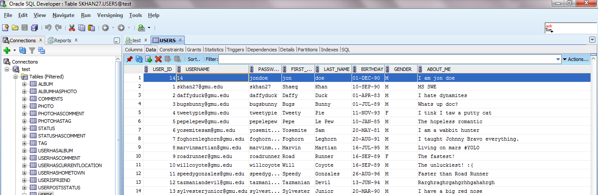
Figure 8 – database view showing updated values for test user.
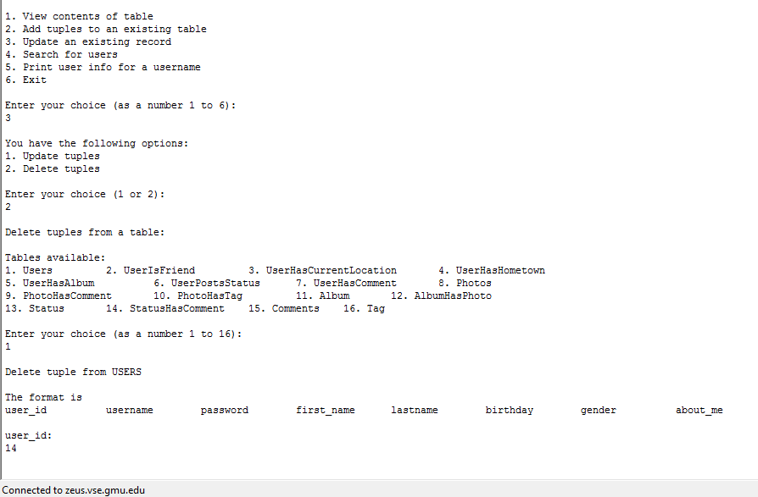
Figure 9 – deleting the test user from the Users table.

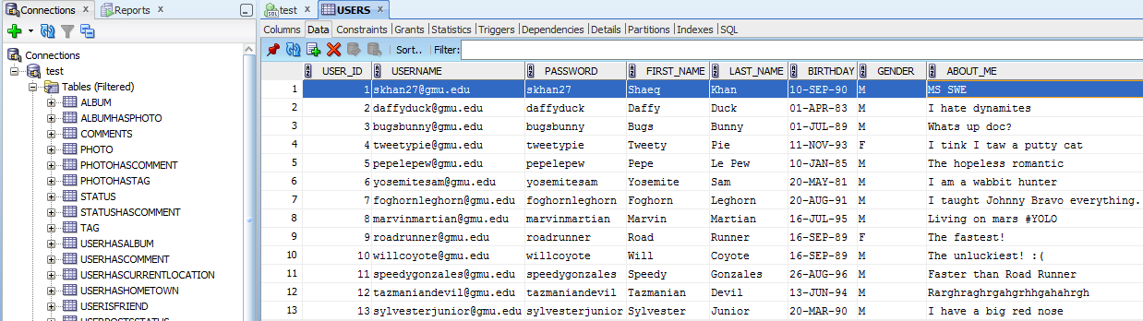
Figure 10 – database view to show that the test user is deleted successfully.
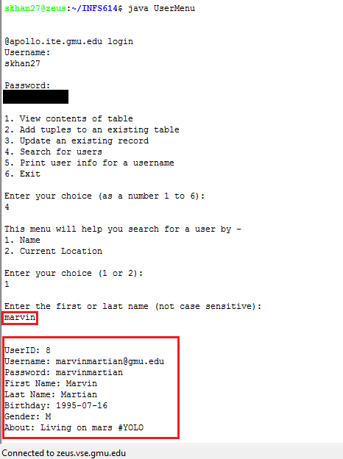
Figure 11 – Searching for a user using their name
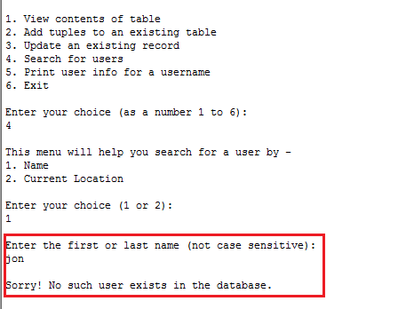
Figure 12 – search result for deleted user from the database
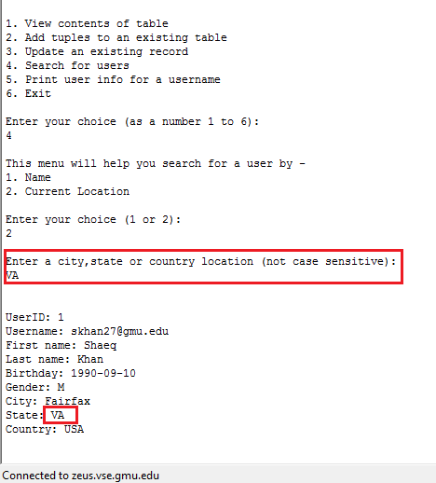
Figure 13 – Searching user according to location
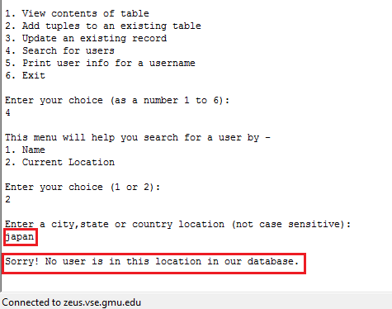
Figure 14 – Unsuccessful search for user according to location.
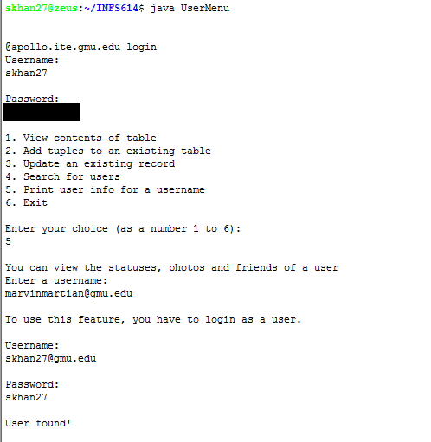
Figure 15(1) – Printing user info for a username, values to enter shown.
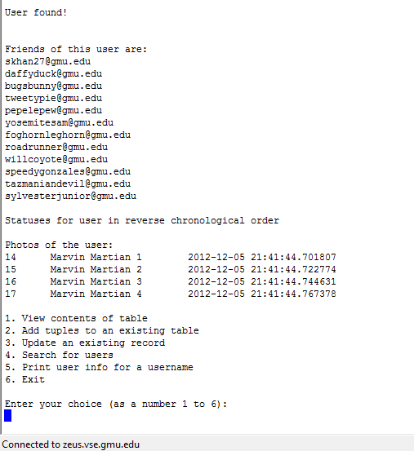
Figure 15(2) – result for the search
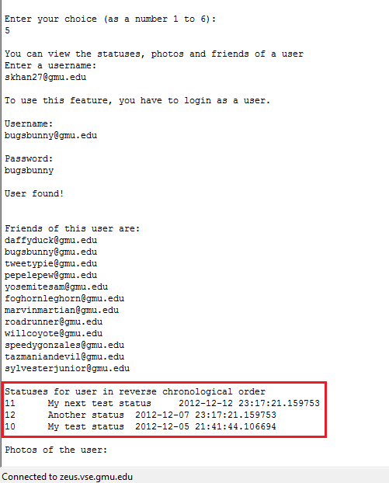
Figure 16 – statuses returned in reverse chronological order for a user.
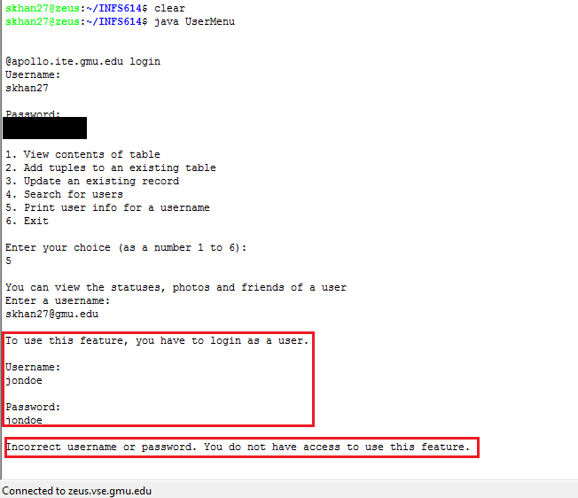
Figure 17 – User with no accounts don’t have access to search for other users.

