

**Volgenau School of Engineering**

*Department of Computer Science*

**INFS 614 – DATABASE MANAGEMENT**

*Dr. Jessica Lin*

**Project Phase 2**

*Shaeq Khan*

*G#00774501*

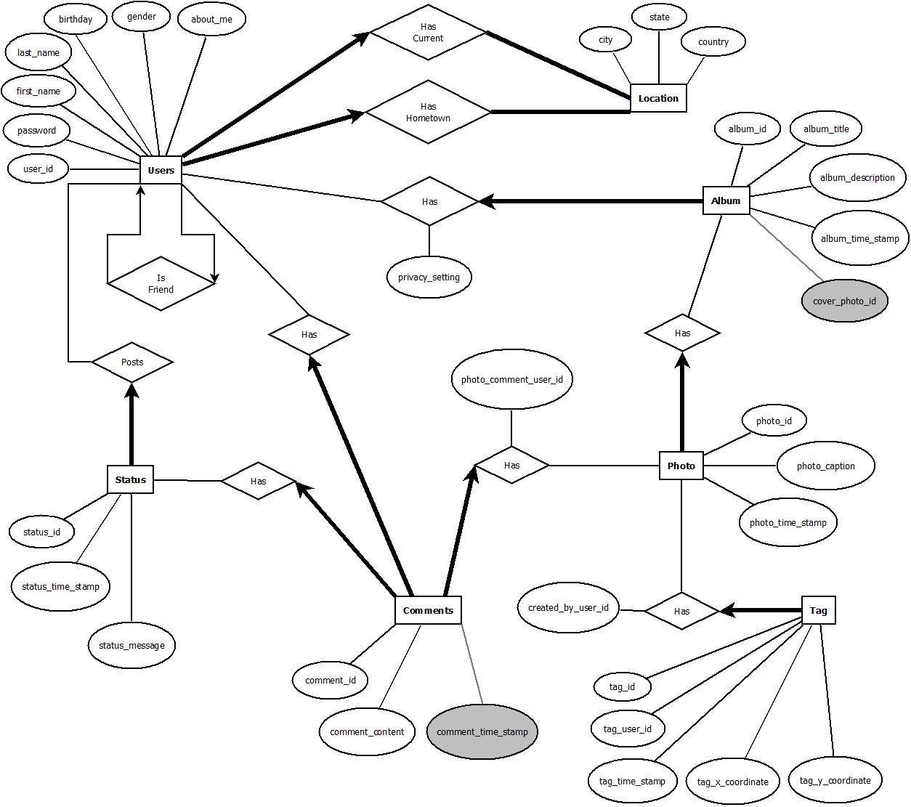

Relational Schema

**Users**

|  |  |  |  |  |  |  |  |
| --- | --- | --- | --- | --- | --- | --- | --- |
| user_id | username | password | first_name | last_name | birthday | gender | about_me |

Primary Key – user_id, username

Users (user_id: integer, username: VARCHAR(20), password: VARCHAR(10), first_name: VARCHAR(20), last_name: VARCHAR(20), birthday: date, gender: VARCHAR(1), about_me: VARCHAR(100))

**Comments**

|  |  |  |
| --- | --- | --- |
| comment_id | comment_content | comment_time_stamp |

Primary Key – comment_id

Comments (comment_id: integer, comment_content: VARCHAR(200), comment_time_stamp: timestamp)

**Status**

|  |  |  |
| --- | --- | --- |
| status_id | status_time_stamp | status_message |

Primary Key – status_id

Status (status_id: integer, status_time_stamp: timestamp, status_message: VARCHAR(200))

**Album**

|  |  |  |  |  |
| --- | --- | --- | --- | --- |
| album_id | album_title | album_description | album_time_stamp | cover_photo_id |

Primary Key – album_id

Foreign Key – cover_photo_id REFERS Photo.photo_id

Album (album_id: integer, album_title: VARCHAR(20), album_description: VARCHAR(200), album_time_stamp: timestamp)

**Photo**

|  |  |  |
| --- | --- | --- |
| photo_id | photo_caption | photo_time_stamp |

Primary Key – photo_id

Photo (photo_id: integer, photo_caption: VARCHAR(50), photo_time_stamp: timestamp)

**Tag**

|  |  |  |  |  |
| --- | --- | --- | --- | --- |
| tag_id | tag_user_id | tag_time_stamp | tag_x_coordinate | tag_y_coordinate |

Primary Key – tag_id

Foreign Key – tag_user_id REFERS Users.user_id

Tag (tag_id: integer, tag_time_stamp: timestamp, tag_x_coordinate: integer, tag_y_coordinate: integer)

**UserIsFriend**

|  |  |
| --- | --- |
| user_id | friend_id |

Foreign Key – user_id REFERS Users.user_id, friend_id REFERS Users.user_id

**UserHasCurrentLocation**

|  |  |  |  |
| --- | --- | --- | --- |
| user_id | city | state | country |

Foreign Key – user_id REFERS Users.user_id

UserHasCurrentLocation (city: VARCHAR(20), state: VARCHAR(2), country: VARCHAR(20))

**UserHasHomeTown**

|  |  |  |  |
| --- | --- | --- | --- |
| user_id | city | state | country |

Foreign Key – user_id REFERS Users.user_id

UserHasHomeTown (city: VARCHAR(20), state: VARCHAR(2), country: VARCHAR(20))

**UserHasAlbum**

|  |  |  |
| --- | --- | --- |
| user_id | album_id | privacy_setting |

Foreign Key – user_id REFERS Users.user_id, album_id REFERS Album.album_id

UserHasAlbum(privacy_setting: VARCHAR(10))

**UserPostsStatus**

|  |  |
| --- | --- |
| user_id | status_id |

Foreign Key – user_id REFERS Users.user_id, status_id REFERS Status.status_id

**UserHasComment**

|  |  |
| --- | --- |
| user_id | comment_id |

Foreign Key – user_id REFERS Users.user_id, comment_id REFERS Comments.comment_id

**StatusHasComment**

|  |  |
| --- | --- |
| status_id | comment_id |

Foreign Key – status_id REFERS Status.status_id, comment_id REFERS Comments.comment_id

**AlbumHasPhoto**

|  |  |
| --- | --- |
| album_id | photo_id |

Foreign Key – album_id REFERS Album.album_id, photo_id REFERS Photo.photo_id

**PhotoHasTag**

|  |  |  |
| --- | --- | --- |
| photo_id | tag_id | created_by_user_id |

Foreign Key – photo_id REFERS Photo.photo_id, tag_id REFERS Tag.tag_id,

created_by_user_id REFERS Users.user_id

**PhotoHasComment**

|  |  |  |
| --- | --- | --- |
| photo_id | comment_id | photo_comment_user_id |

Foreign Key – photo_id REFERS Photo.photo_id, comment_id REFERS Comment.comment_id,

photo_comment_user_id REFERS Users.user_id