**SWE 205 – Introduction to Software Engineering**

Project – Hereditary Blood Disorder Center (HBDC)

*Al-Khobar Central Hospital*

1. **Business Requirement Introduction**
2. *Purpose*

The Business Requirements Specification is a document, which reports the finding of the project team after analysis of the client’s requirements. The document specifies the project team’s proposed solutions relating to the software and hardware requirements of the system that is to be developed. It should be written in terms that the customer could understand.

We produce an introduction to the Business Requirement for this project where we define the purpose and the scope of the project. We also discuss the constraints that might be faced by the team.

We state the functional analysis in the next step. Here, we discuss the function of the project and express the system using USE CASE diagrams.

In the next step, we conduct an overall domain analysis. Here we first try to identify all the components of the system and represent them using high level class diagrams.

Then data analysis is done where we decide where the system will store the data how will it access it.

Finally , the format of the input and output screen is decided upon and the flow of events is planned.

1. *Project scope and Project definition*

The *Hereditary Blood Disorder Center* (HBDC) at *Al-Khobar Central Hospital* requires a system to keep track of the patients and their treatment history. It will be created in order to build up research and increase the level of care for the patients. All data can be accessed through a GUI (Graphical User Interface) which can be accessed by different personnel in order to edit or add new information and is protected by a username and a password for each individual. The users are an Administrator, who can add, remove, edit users' profile, maintain the tracker and print reports, then there are doctors who can retrieve patient information and update the visit history of the patient and finally there are receptionists who can either add a new patient's profile or schedule appointments for those who need care.

1. *Constraints on development*
2. Lack in experience in the Software Engineering field
3. The team is only familiar with java language.
4. Lack of experience in Databases.
5. Most of the team don’t have the experience in GUI(graphic user interface)
6. Don’t have the enough time to learn more about new languages.
7. **Functional Analysis**
8. *Product function*

System Functions:

1. Every user is required to enter a unique username and a password through a menu based system.
2. We will have two databases to store information; one of them will handle users` profiles as the other one handles patients’ profiles.
3. The system will be able to print reports.

Users’ functions:-

|  |  |
| --- | --- |
| Users | Functions |
| Admin | 1. Add, remove and edit users` profiles. 2. Maintains the tracker. 3. Print reports |
| Doctor | 1. Retrieve patient information. 2. Update the visit history of the patient. |
| Receptionist | 1. Add new patients` profiles. 2. Schedule appointments. |

1. *Use Case Analysis*

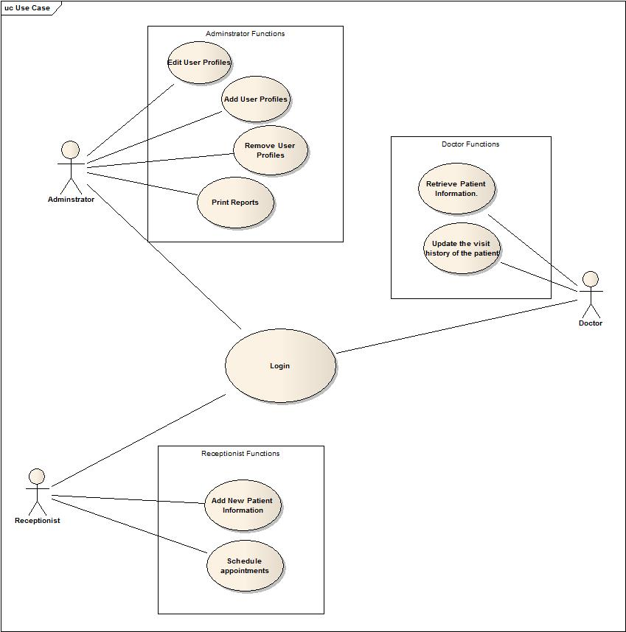

1. **Domain Analysis**
   1. Identification of components:

* Staff class
* Admin class
* Doctor class
* Receptionist class
* Patient class
* Appointment class
* Graphic user interface
* Patient database
* Users` database

b. High level class diagram

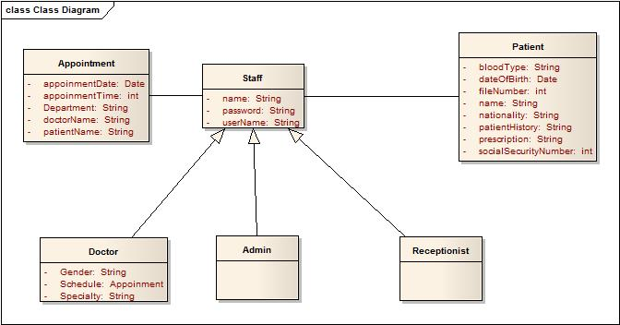

1. **Data Analysis**
   1. *Data storage*

Entity Diagram

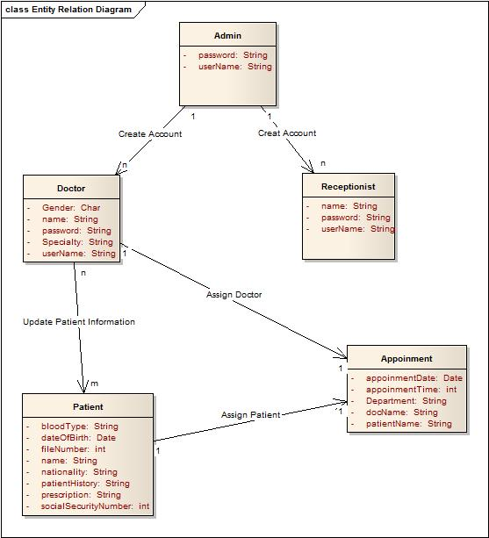

* 1. *Data Flow Diagram*

Add new patient information

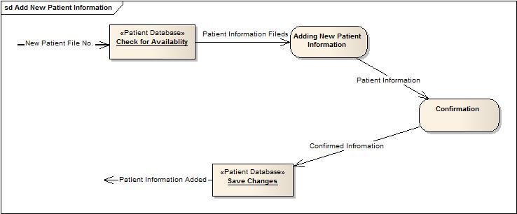

Add user profile

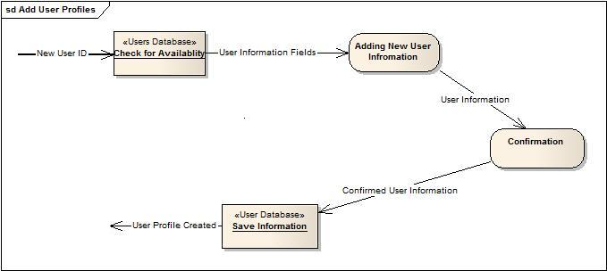

Edit user’s profiles

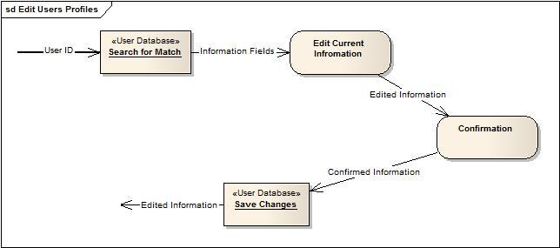

Remove users profiles

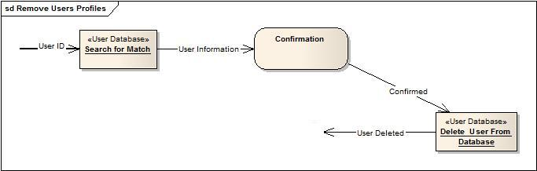

Retrieve patient information

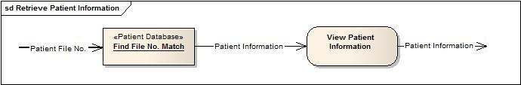

Schedule appointment

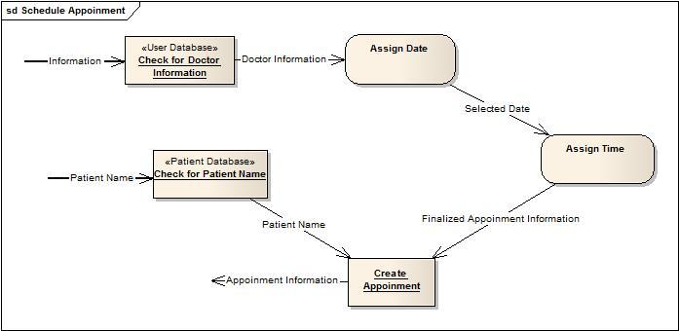

Update the visit history of a patient

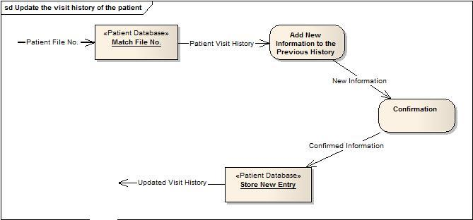

1. **User Interface Analysis**
   1. *General indication of flow of interaction and* ***Data input\Output***

|  |  |
| --- | --- |
| \\ccse-xeon\home\st279245\Desktop\Admin\1- Login Screen.JPG | All the system users are required to have a valid user name and password in order to use the system facilities. This screen will allow the system user to enter their username and password. It will also require them to select the type of account they have; for example, administrator, doctor or a receptionist. Different users have different accessibility options. |
| \\ccse-xeon\home\st279245\Desktop\Admin\2- If Wrong.JPG | In case the user enters a wrong username or password, the screen shown on the left appears and the user is asked to re-enter the information. |

1. *When an ADMINISTRATOR logs in:*

|  |  |
| --- | --- |
| \\ccse-xeon\home\st279245\Desktop\Admin\3- If successed.JPG | A message screen appears when an administrator successfully logs in. And he has to click the OK button in order to proceed to the menu. |
| C:\Documents and Settings\Mr.Hell\My Documents\SWE - 205\PROJECT\PHASE - 2\Admin\4- Admin Control Panel.JPG | Now the administrator can view his control panel for the system. He/she has complete access to all user accounts. There are 6 buttons on the control panel as shown in the figure. |
| C:\Documents and Settings\Mr.Hell\My Documents\SWE - 205\PROJECT\PHASE - 2\Admin\5- Adding Doctor.JPG | When the button “Add Doctor to the tracker” is pressed then the administrator can add a new Doctor. The admin enters a new username, password, specialty and gender. This information is stored in the system database and a new Doctors` account is created. |
| \\ccse-xeon\home\st279245\Desktop\Admin\6- Failed Adding Doctor.JPG | If there is any error in entering the required information then a message dialog box appears which asks the administrator to recheck all the data fields. Clicking “OK” will return you to the previous screen to re-enter data. |
| \\ccse-xeon\home\st279245\Desktop\Admin\7- Successed Adding Doctor.JPG | And if the account is added successfully then a message dialog box will confirm this and you will have to press “OK” to return to the administrator control panel. |
| C:\Documents and Settings\Mr.Hell\My Documents\SWE - 205\PROJECT\PHASE - 2\Admin\8- Adding Receptionist.JPG | When the button “Add Receptionist to the tracker” is pressed then the administrator can add a new Receptionist. The admin enters a new username, password. This information is stored in the system database and a new Receptionist account is created. |
| \\ccse-xeon\home\st279245\Desktop\Admin\9- Failed Adding Receptionist.JPG | If there is any error in entering the required information then a message dialog box appears which asks the administrator to recheck all the data fields. Clicking “OK” will return you to the previous screen to re-enter data. |
| \\ccse-xeon\home\st279245\Desktop\Admin\10- Successed Adding Receptionist.JPG | And if the account is added successfully then a message dialog box will confirm this and you will have to press “OK” to return to the administrator control panel. |
| C:\Documents and Settings\Mr.Hell\My Documents\SWE - 205\PROJECT\PHASE - 2\Admin\11- Removing User from Tracker.JPG | When the button “Remove user from the Tracker” is pressed, then a new window appears that’s asks for the category and the username. |
| \\ccse-xeon\home\st279245\Desktop\Admin\12- Confirm to Remove.JPG | When the button “Remove” is pressed, a dialog box appears which asks for the confirmation from the administrator. He/she has the choice to go ahead with the operation or cancel it. |
| \\ccse-xeon\home\st279245\Desktop\Admin\13- Failed Removing.JPG | Suppose the user is logged in then the account cannot be deleted and the operation will be aborted giving a message to log out of the account first. |
| \\ccse-xeon\home\st279245\Desktop\Admin\14- Successed Removing.JPG | If nothing goes wrong then the account is successfully deleted and a message Dialog box appears to confirm the action. |
| \\ccse-xeon\home\st279245\Desktop\Admin\15- Searching username to edit.JPG | When the button “Edit user” is pressed then the screen shown appears. It asks the administrator to enter the username of whose details are to be edited. After entering the detail, the admin presses the “Search” button. |
| \\ccse-xeon\home\st279245\Desktop\Admin\16- Editing.JPG | The screen on the left appears which shows the old user details and asks the administrator to enter all new details for the user. |
| \\ccse-xeon\home\st279245\Desktop\Admin\17- Editing Failed.JPG | In case any field is left unfilled, then an error message appears asking the user to re-enter the information by clicking “OK” and going back to the previous screen. |
| \\ccse-xeon\home\st279245\Desktop\Admin\18- Editing Successful.JPG | And if changes are implemented then a message appears to confirm the operation. |
| C:\Documents and Settings\Mr.Hell\My Documents\SWE - 205\PROJECT\PHASE - 2\Admin\19- Printing.JPG | When the button “Print Report” is pressed then the following screen appears where the administrator is required to enter the name of doctor, select his/her department and select the type of report to be printed and press “Print”. |
| \\ccse-xeon\home\st279245\Desktop\Admin\20- Print.JPG | The program connects the database to the printer and the report can easily be printed. |
| \\ccse-xeon\home\st279245\Desktop\Admin\21- Exit.JPG | To logout, press the “Logout” button on the control panel. |

* 1. *When a DOCTOR logs in:*

|  |  |
| --- | --- |
| \\ccse-xeon\home\st279245\Desktop\Doctor\3- If successed.JPG | A message appears to confirm that the doctor has successfully logged in. The doctor has to press “OK” to proceed to the control panel. |
| C:\Documents and Settings\Mr.Hell\My Documents\SWE - 205\PROJECT\PHASE - 2\Doctor\4- Doctor Control Panel.JPG | Now the doctor can view their control panel for the system. He/she has complete access to all patient information. There are 3 buttons on the control panel as shown in the figure. |
| \\ccse-xeon\home\st279245\Desktop\Doctor\5- Search to Retrieve patient information..JPG | When the button “Retrieve patient information” is pressed then the following screen appears. Here the doctor is required to enter the patient id number to view information. |
| \\ccse-xeon\home\st279245\Desktop\Doctor\6- File not found.JPG | If the doctor enters a wrong detail then a message appears which tells him of his mistake. To return to the previous screen and re-enter the information, press the “OK” button. |
| \\ccse-xeon\home\st279245\Desktop\Doctor\7- Retrieve patient information..JPG | If the file is found successfully then the following screen appears. Here the doctor can view the patient name, file number, date of birth, gender and view their medical history.  To edit the patient history, the doctor needs to press “Edit” which will allow him to change the patient history. |
| \\ccse-xeon\home\st279245\Desktop\Doctor\8- Update Patient History and Visits.JPG | After making changes to the patient history the doctor should press the “Save” button to make changes in the patient database. To go back to the menu, the doctor should press “Back”. |
| \\ccse-xeon\home\st279245\Desktop\Doctor\11- Exit.JPG | To logout, press the “Logout” button on the control panel. |

* 1. *When a RECEPTIONIST logs in:*

|  |  |
| --- | --- |
| \\ccse-xeon\home\st279245\Desktop\Reciptiants\3- If successed.JPG | A message appears to confirm that the receptionist has successfully logged in. The receptionist has to press “OK” to proceed to the control panel. |
| C:\Documents and Settings\Mr.Hell\My Documents\SWE - 205\PROJECT\PHASE - 2\Reciptiants\4- Receptionist Control Panel.JPG | Now the receptionist can view their control panel for the system. They can add new patients and schedule their appointments. There are 3 buttons on the control panel as shown in the figure. |
| \\ccse-xeon\home\st279245\Desktop\Reciptiants\5- Add new patient's profile.JPG | When the button “Add new patient’s profile” is pressed, the following screen appears. Here the receptionist enters the patient name, date of birth, gender.  To confirm the addition of new patient press “Save” and to cancel the operation press “Back” |
| \\ccse-xeon\home\st279245\Desktop\Reciptiants\6- Error Adding.JPG | In case any field is left unfilled, then an error message appears asking the receptionist to re-enter the information by clicking “OK” and going back to the previous screen. |
| \\ccse-xeon\home\st279245\Desktop\Reciptiants\7- Successed adding.JPG | If the patient is successfully added then a message confirms the operation. Press “OK” to return to the menu. |
| \\ccse-xeon\home\st279245\Desktop\Reciptiants\8- Add Appointment.JPG | When the button “Schedule Appointments” is pressed, the following screen appears. Here the receptionist selects the department and enters the name of the doctor.  To confirm the appointment of new patient press “Save” and to cancel the operation press “Back” |
| \\ccse-xeon\home\st279245\Desktop\Reciptiants\9- Error adding.JPG | In case any field is left unfilled, then an error message appears asking the receptionist to re-enter the information by clicking “OK” and going back to the previous screen. |
| \\ccse-xeon\home\st279245\Desktop\Reciptiants\10- Appointment Added.JPG | If the patient is successfully added to the doctors schedule then a message confirms the operation. Press “OK” to return to the menu. |
| \\ccse-xeon\home\st279245\Desktop\Reciptiants\11- Exit.JPG | To logout, press the “Logout” button on the control panel. |