King Fahd University Of Petroleum and Minerals

Information and Computer Science Department (ICS)

***SWE 215 – Software Requirements Engineering.***

**Project – Car Rental System (CRS).**

**Submission Phase 1**

**Team 1**

Yazeed Al-Habbed

Abdul Aziz Al-Amoudi

Shaeq Pervez Khan

Table of Contents

***i.*** ***Product Perspective*** 3

***ii.*** ***Product Features and User Requirements*** 4

***iii.*** ***User and User Characteristics*** 7

***iv.*** ***General Constraints*** 8

***v.*** ***Assumption and Dependencies*** 9

***Overall Description***

The main purpose of this document is to give details about what the user can expect from the Car Rental System (CRS). This document provides an important overview of the system according to the requirements that have been given to us during the requirement analysis for this *Car Rental System (CRS).*

1. ***Product Perspective***

Our company has been handed over the task to carry out the requirements analysis to implement a *Car Rental System (CRS)*. We want this software to completely be a front desk system and hence will only be used by the salespeople and an administrator. We have realized that there are three ways to implement the *Car Rental System (CRS)* and they are stated as follows –

* The existing software at the company can be upgraded to form the new *Car Rental System (CRS)*.
* A new *Car Rental System (CRS)* can be created from scratch.
* We can follow the Component based development technique to create the system from scratch.

We believe that the best way to implement the *Car Rental System (CRS)* is to create a new one. The reasons are as follows –

* In case we plan to upgrade the existing system, then we will have to work on integrating the system with a legacy system database. This might create problems for us since experts in the legacy system are not readily and cheaply available.
* We will be able to create a system of better quality. This will be possible if we review the faults in the old system and learn from the mistakes made during the various processes that were involved to create the old system.
* The new system will have better performance due to usage of new and time efficient data searching algorithms which will increase the efficiency of the workplace.
* The new system will provide a new user friendly Graphic User Interface (GUI) which will also help to increase the efficiency of the work place.
* The new system will be compatible with a new database that will be created along with it. A new database has to be created due to the increase in the amount and type of information that has to be stored.
* The new system will be able to undergo evolution in a much simpler way and will be more adaptable to the changing systems. The upcoming changes in the near future will be predicted and the system will be designed in a way to adapt to the changes that will occur over the years.

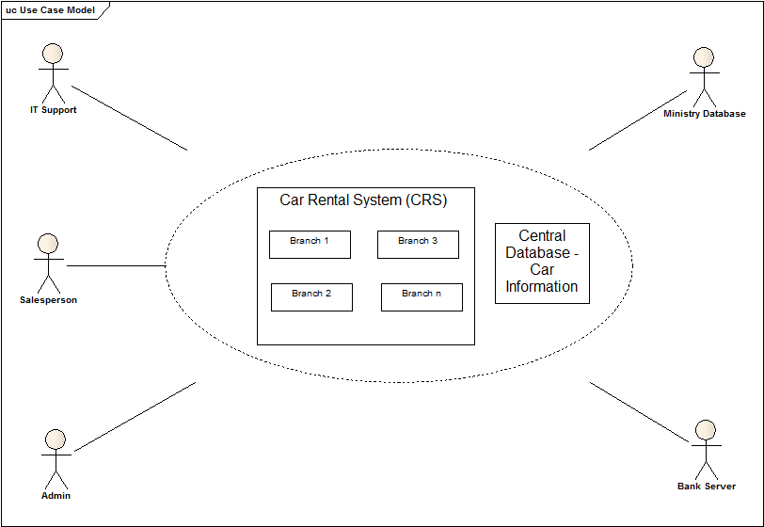

The system allows the stake holders to run an efficient business by providing company reports, stock inventory and sales information data. All these functionalities of the system provided in a timely and organised way will help the business to expand to generate more revenue and prevent losses.

1. ***Product Features and User Requirements***

The following are the *features* of the product –

* **User Account Management:**

The system will allow every salesperson to have a different account to login from. This will keep a record of their work time without them having to enter it every time they leave or enter the workplace.

* **Sales Record system:**

The system will allow all the salesmen account to keep a record of the sales that have been made by the account for the week in order to calculate the commission and monthly to calculate the bonus to be awarded by the company.

* **System Backup:**

The system will have a 24 hour backup to record car rental applications from users in case the server goes down.

* **High system security:**

The system will employ a fulltime high security antivirus and a secure network so that the system cannot be illegally modified or hacked into.

* **Car Information system:**

This system gives the ability to the company to keep track of the information on all the cars that are available in the branch’s stock. All relevant information related to the car such as colour, license plate, registration, model number, insurance etc. is stored in the system database. It will record the cars ages and update their condition and rent life. The system will show the car’s status (whether under maintenance, available or rented). The system will provide information about the rate of rent for a car for different periods of time (weekdays, weekends, holidays, Umrah).

* **User Information System:**

This system gives the ability to the company to keep track of the information on the customers in order to classify their association with the company. All customers will be classified according to the frequency with which they rent cars and offer them satisfactory discounts for usage.

* **Emergency Issue System:**

In case of emergency, if a car is not available, the salesperson can view the inventory of other branches and issue a car.

* **Bank to Branch Link System:**

When a customer will pay using a bank card rather than cash, it is necessary that a link is always maintained between the branch and bank for successful transaction.

* **Data Backup System:**

In case the system goes down due to server crashes or power failure or any other calamity, all operations are being run such as updating data, carrying requests etc. will be saved to a backup system. All of this will then be copied on to the original database as soon as the system is up and running.

The *user requirements* for the *Car Rental System (CRS)* has been listed as follows -

1. **System admin:**
2. The system shall allow admin to add a salesperson.
3. The system shall allow admin to add a car.
4. The system shall allow the admin to add seasonal discounts.
5. The system shall allow admin to delete a salesperson.
6. The system shall allow admin to delete a car.
7. The system shall allow the admin to delete seasonal discounts.
8. The system shall allow admin to modify a salesperson.
9. The system shall allow admin to modify a car.
10. The system shall allow the admin to modify seasonal discounts.
11. The system shall allow admin to view information on salesperson.
12. The system shall allow admin to view information on car.
13. The system shall allow admin to view inventory of other branches.
14. The system shall allow admin to back up the data manually from the system.
15. The system shall allow admin to install updates for anti-virus.
16. **The salesperson:**
17. The system shall allow salesperson to add a customer.
18. The system shall allow salesperson to modify a customer.
19. The system shall allow salesperson to modify a car.
20. The system shall allow salesperson to delete a customer.
21. The system shall allow salesperson to view a customer.
22. The system shall allow salesperson to view information on car.
23. The system shall allow salesperson to view inventory of other branches.
24. The system shall allow salesperson to rent a car.
25. The system shall allow salesperson to rent a car from other branch by Emergency Issue System.
26. The system shall allow salesperson to search for a customer.
27. The system shall allow salesperson to view seasonal discounts.
28. **IT Support:**
29. The system shall allow IT Support to install new anti-virus.
30. The system shall allow IT Support to update anti-virus.
31. The system shall allow IT Support to back up the data manually from the system.
32. ***User and User Characteristics***

The main people who have been identified as regular system users are as follows –

1. **System admin**
2. **Salesperson**
3. **IT Support**

The users can be classified according to their frequency of use, subset of product functions used, technical expertise, security or privilege levels, educational level, or experience they have to the Car Rental System (CRS).

1. **System admin is supposed to have the following characteristics –** 
   * On the whole, the admin spends comparatively lesser time than the salesperson on the system. Usually an admin would access the system when he is required to make reports or something else.
   * The system admin should have high technical expertise. He has to be fluent in the system usage and should be well aware of all the system functionalities.
   * Admin has access to all security levels as he has to access and maintain the system occasionally.
   * He should have experience in handling a system of this domain. He must be able to identify errors caused due to improper data entries.
2. **Salesperson is supposed to have the following characteristics –** 
   * A salesperson spends the maximum amount of time on the system in the form of entering information, updating it or deleting the information.
   * A salesperson is not required to have technical expertise. The most they would need is to be computer literate to understand the working of the system and use it efficiently.
   * A salesperson has very low security access. They cannot access quite a few functionalities of the system except the one’s they really have to use.
   * A salesperson should have good communication skills and even if they have no experience in system usage, it’s not a big problem.
3. **IT support is supposed to have the following characteristics –** 
   * IT Support mainly comes in when there is problem experienced with the system hardware and some aspects of the software as well.
   * IT Support is expected to have high technical expertise in order to diagnose the problem in less time and provide a quick solution.
   * IT Support has very low security access. They cannot access quite a few functionalities of the system except the one’s they really have to use.
   * IT Support should have experience in this area with a minimum diploma in IT.
4. ***General Constraints***

These are some of the constraints that can be faced by the *Car Rental System (CRS)* –

1. **Schedule and Resource Constraints**

* Time can be listed as a constraint. We are expected to finish this SRS document within 4 months with distractions in between due to the time demanded by the other courses.
* There may be budget constraints where the allocated amount for implementation might not be enough.
* A project member may take a leave due to sickness or in case of emergency. This may affect the time required to complete a particular milestone.
* To understand the things that were missing from the previous software, we may need the old requirements documents to identify the features that are required now. There is a possibility that the old system documents have been damaged due to improper storage or misplaced.

1. **Political Constraints**

* It may be a long procedure to acquire access to the Ministry database for customer identification.

1. **Technology Constraints**

* The branch may house defective hardware which can delay the deployment of our system.

1. ***Assumption and Dependencies***

We have made the following **assumptions** to the development of the *Car Rental System (CRS)* –

* We assume that the development team has all the software’s and tools that will be required to complete this project on time.
* We assume that at the time of the system deployment, the branches will have computers with the minimum system requirements as per required by the software for efficient runtime.
* We assume that our project team has been finalized and no new member will be added nor a present member will leave the group in the middle of the project.
* We assume that all the requirements we get from our sources are correct and achievable.

These are a few **dependencies** we have for the system –

* The system is based on Windows platform. It will have the most efficient runtime on Windows.

End of Document