**King Fahd University of Petroleum & Minerals**

Information and Computer Science Department

Second Semester 2009-2010 (092)

**SWE 312 – User Interface Design**

Assignment 4

Name: Shaeq Pervez Khan

ID: 200792450

Website chosen - <http://www.kfupm.edu.sa/cim/depts/FE/>

**Department of Finance and Economics**

**Superstructure**

1. **Is the site layout easy to understand?**

Yes. When I opened the website, I observed this following structure.

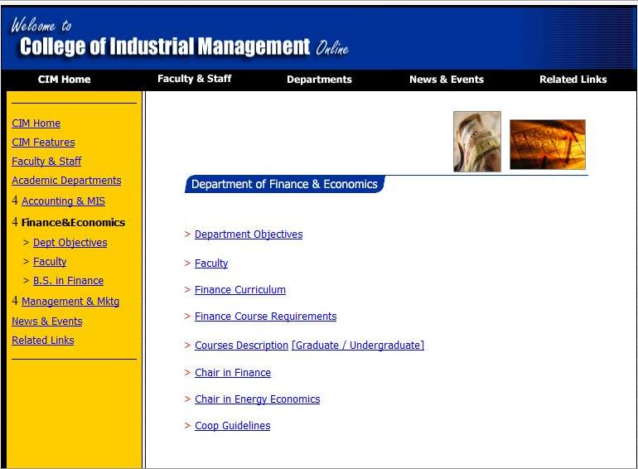

It has a column on the left for links to other department websites under the College of Industrial Management.

It has a central area with links to more information on the Department of Finance and Economics.

1. **Can you navigate readily from page to page?**

No. What happens is that when I go to a particular page there is no option provided for me to go back to the previous page. The linking of the pages is very ambiguous. When I click on a link assuming it will take me to a particular page, I end up on a completely different page than expected.

For example, clicking on the “Faculty” link on the homepage of the department takes me to the faculty list of all departments under the College of Industrial Management instead of only showing me the Accounting and Economics faculty.

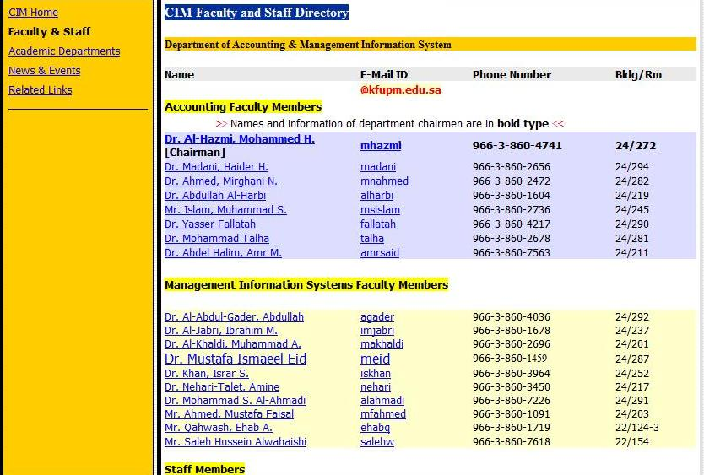

1. **Is there an intuitive feel for the visitor?**

No. I did not get an intuitive feel when I first visited this website. The major colours used for the construction of this website were black, white, yellow and blue. Except white, all the other colours are high in contrast which gives the website unwanted vibrancy. Since it’s a department website, a balanced mixture of high and low contrast colours would be more user friendly.

1. **Easy to get back to Home page or the top of a page?**

Yes. It is easy to get back to the home page. In fact, easy access to the department and the college home page has been provided as permanent links which are a part of the menu.

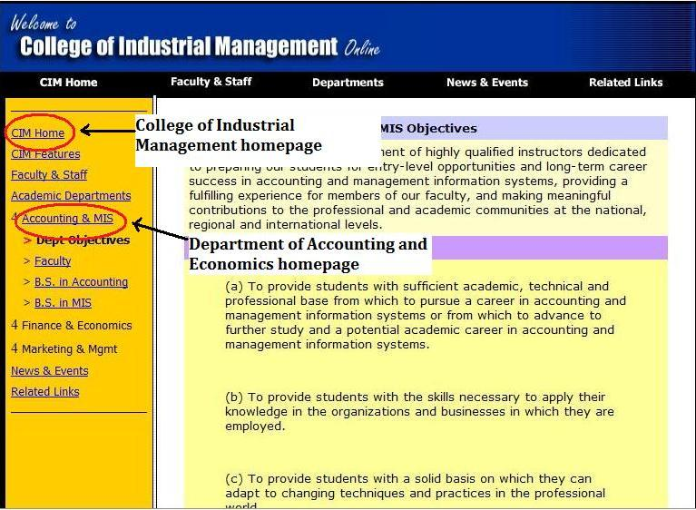

1. **Is the loading time excessive?**

No. Since this site is accessed mostly by students using the intranet, it was fairly fast to open almost 99% of the time.

**Graphics**

1. **Are graphics clear and attractive?**

Yes. The graphics of the website are very clear. The placement of objects on the page is fairly visible and understandable.

No. The graphics are not very attractive mainly because of the excessive use of high contrast colours.

1. **Do graphics contribute to the purpose of the page?**

No. The graphics will not contribute to the purpose of this page. The website is mainly supposed to contain course materials and department information. It’s not a high priority to have graphics on this page.

1. **Are graphics excessive or distracting?**

No. The graphics on any of the pages of the department website is not excessive and distracting.

1. **Do graphics contribute to understanding?**

No. My opinion is that since this website is majorly used by students around the year, the interface needs to make a trade off of efficiency over understandability.

1. **Will graphics contribute to excessive loading time?**

Yes. The use of graphics will contribute to the excessive load time. This is because of regular and heavy traffic from students who access this site regularly for information and updates for their majors.

1. **Do graphics aid visitor with navigation?**

Yes. Graphics will aid infrequent visitors to the website, so a little of graphics in selected places can be used to make it more understandable.

**Use of Colour**

1. **Are colours attractive and appealing to most visitors?**

Since we know that this is a website for a college, we assume that most of the visitors on the website will not be interested in attractive colours, rather they would be more interested in finding useful information they are looking for.

1. **Do too many colours contribute to messy look?**

No. The website does not have a messy look due to colours. There are a few colours used but the only issue is with their contrast.

1. **Would more colour aid the visitor in understanding the content?**

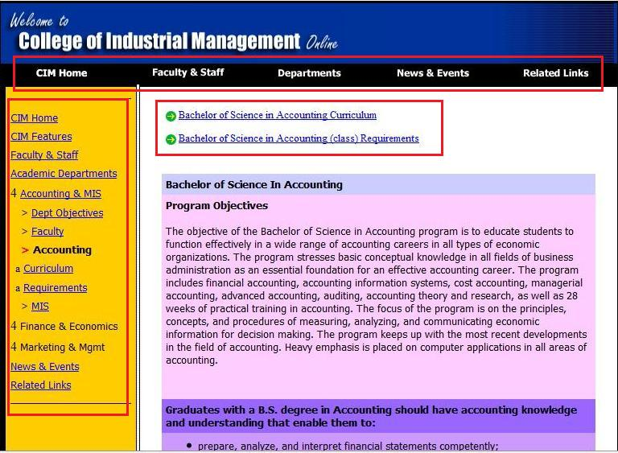

Concept explained on next page

Yes. More colours would help the visitor in understanding the contents of the page in a better way.

For example, the links on the left side in the column could have had a different colour than the links in the main page area. The colours used for links in both these areas are blue in colour. They could be of different colours. The links on the top have been given a black background which turns gray when the mouse is brought over it which shows that these links are separate from the other links on the same page.

**Content**

1. **Is the content of interest and value to the visitor?**

Yes. The contents of this website are of help to anyone who visits the website in search of information to select a major in finance and accounting.

For example, the website displays all course details required for the undergraduate and graduate programs with this university.

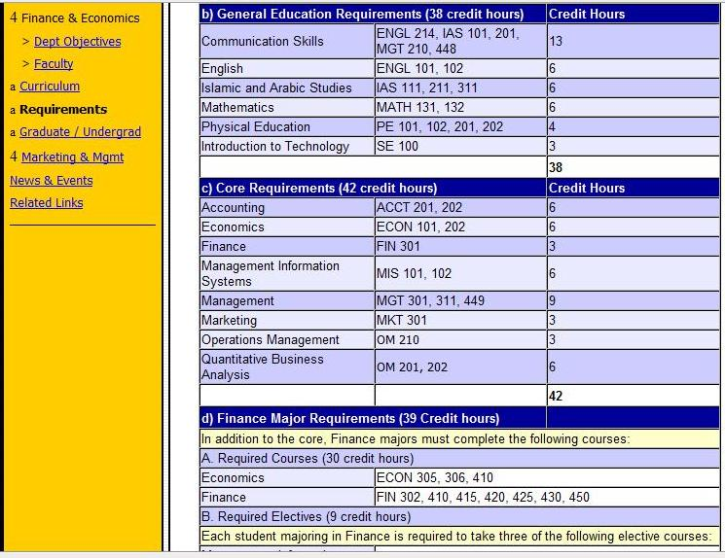

1. **Does the content attract more visitors?**

Maybe. Since this website has content for a specified audience, only people who are keen on knowing more about the finance and economics courses will visit the website.

1. **Has the content been kept current?**

No. It seems that the content of the website has not been updated for quite a long time. You can still spot the names of a few faculty members who have already left this university but their names still appear in the department website.

1. **Are there copyright violations?**

No. All documents published by instructors are under strict university and global copyright laws. If by chance any document is uploaded which violates any kind of law, then the webmaster removes any such material immediately.

1. **Is the content in good taste?**

Yes. All content present on the website is to the point and answer as many questions possible to students interested in taking courses with their department. And in case students have any more questions they have the liberty to call the department for further inquiry.

1. **Has your content been cleared re: legal considerations?**

Yes. All documents published by users are under strict university and global copyright laws.

**Readability**

1. **Are the pages easy for the visitor to read?**

Yes. The pages are easy for a visitor to read.

1. **Do the page elements follow a logical sequence?**

No. The page elements do not follow a logical sequence.

For example, when I try to view the faculty and staff for the finance and economics department, I am redirected outside the department website and it confuses me on how I could get back in to view the other information.

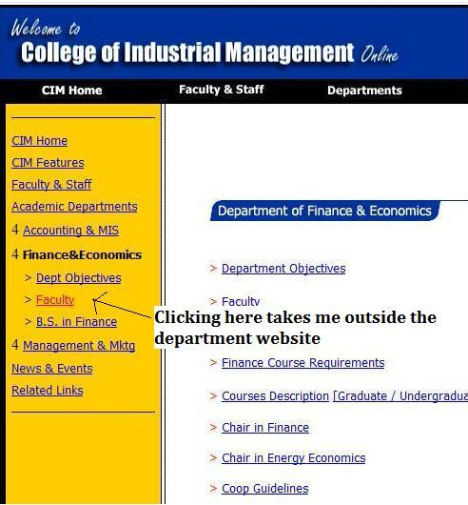 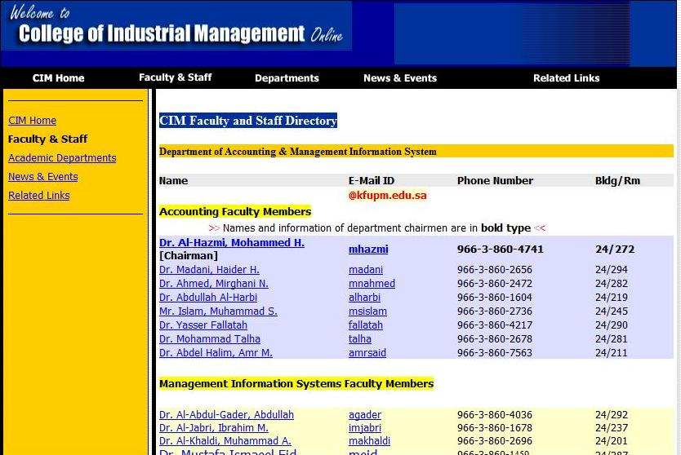

1. **Are type fonts readable, attractive and properly sized?**

Yes. The font on all pages is readable, attractive and properly sized.

1. **Will your pages look good with various browsers?**

The pages seem to have a good view with all the regular browsers like internet explorer, firefox and chrome.

**Page Layout**

1. **Is there a good use of "white space"?**

No. There seems to be a lot of unnecessary space left out.

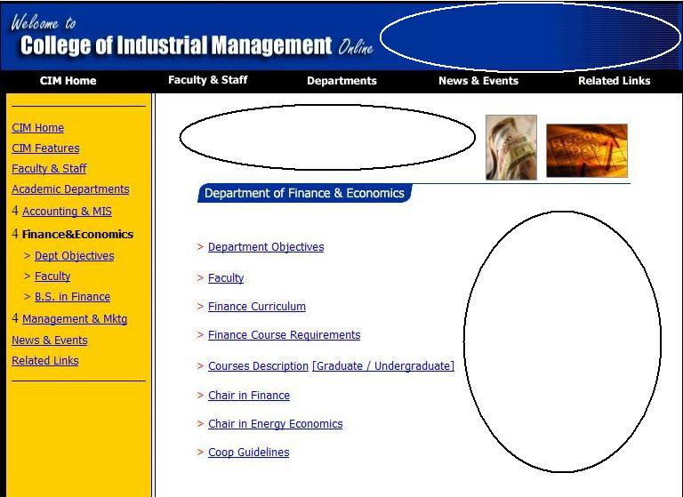

1. **Do the graphics add to or detract from readability?**

The graphics have mainly helped to some extent in the enhancing the readability of the web pages.

1. **Are elements sized and arranged to fit within browser window?**

Yes. The elements are sized and arranged to fit within browser window.

**Hyper links**

1. **What links would enhance the purpose of your site?**

All the links in the website follow the same design (blue colour and underlined). Special links such as the chairman’s message, department mission could be in different format so that they stand out and people see these first as soon as they open the website.

1. **Do you want to lead visitors away from your site?**

No. I don’t want to lead visitors away from this site.

1. **How many links really contribute to the purpose of your site?**

The majority of the links serve the purpose of this website. This is mainly because most of these lead to pages which contain important information regarding students, faculty and department programmes.

1. **Are your links easy for the visitor to spot?**

No. Some important links are not easy to spot mainly because of the similar format used for all links on the webpage.

**Promotion**

1. **Have you seeded the appropriate directory services?**

No. Like mentioned earlier, some of the links are ambiguous and they take the user to unexpected places.

1. **Does your site contain all the relevant terms for retrieval by search engines?**

Yes. The site does contain all relevant terms for retrieval by search engines.

1. **Have you established cooperative crosslinks with other web sites?**

No. It certainly appears that no cross links have been established with other websites because there are no links to any other websites (such as for employment purposes, funding for research) except with the university website itself.

1. **What are you doing to promote word-of-mouth referrals?**

Nothing. But this can be improved by putting links to the websites of companies that employ graduates from the department for summer training or COOP.

1. **Is your web site referenced in your correspondence, ads, etc.?**

No. It is not mainly it contains no information that will be relevant to any person I’m contacting as it has no information on students like me.

**Website Evaluation Criteria**

|  |  |  |  |
| --- | --- | --- | --- |
| **Weighting Percent %** | **Value 0 - 100** | **Score = Wt X Value** | **Evaluation Factor** |
| 5 | 60 | 3 | **Superstructure** |
| 7.5 | 75 | 5.625 | **Graphics** |
| 7.5 | 80 | 6 | **Use of Colour** |
| 30 | 95 | 28.5 | **Content** |
| 10 | 95 | 9.5 | **Readability** |
| 7.5 | 80 | 6 | **Page Layout** |
| 7.5 | 85 | 6.375 | **Hyperlinks** |
| 25 | 50 | 12.5 | **Promotion** |
| **100%** | **Total Score = 620 on 800** | **77.5 on 100** |  |