|  |  |  |
| --- | --- | --- |
| SWE 312 – User Interface and Design  Project Phase 2 submission | May 1  2010 | |
| In the second phase for the self check out system, we have identified the task objects that represent the units of information which the users interact to carry out their tasks. We have developed a content diagram that represents the structure of user interface from the designer’s perspective. A paper prototype model has been included in the document. | | Abdulaziz, Shaeq, Maitham, Hussein, Abdul-Rahman and Yasser |

Contents

TASK OBJECTS 4

TASK CHARACTERISTICS 6

CONTENT DIAGRAM 11

PAPER PROTOTYPE 20

WORK DISTRIBUTION 52

TASK OBJECTS

# TASK OBJECTS

|  |  |  |
| --- | --- | --- |
| **Task Objects** | **Attributes** | **Actions** |
| User | Loyalty Card  Debit Card  Credit Card | Display |
| Item | Barcode  Non-Barcode  Price | Add  Remove  View  Update |
| System | Status | Start  Confirm Messages |
| Barcode Reader | Loyalty Card  Items | Swipe Cards  Swipe Items |
| Receipt | Total price  Date  Items  Store  Quantities  Discount | Print |
| Loyalty Card | Number  Discount  Customer Name  Expiration Date | Swipe Card  Read Card  Validate Card |
| Debit Card | Number  Discount  Customer Name  Expiration Date | Swipe Card  Read Card  Validate Card |
| Credit Card | Number  Discount  Customer Name  Expiration Date | Swipe Card  Read Card  Validate Card |
| Inventory | Items | Update |

|  |  |  |
| --- | --- | --- |
| Report | Form-date  To-date  ID | Generate  view |
| Branch | Name  Location  Branch’s manager  Telephone number | view |

|  |  |  |
| --- | --- | --- |
| Product | * Product Name. * Description. * Company Name. * Price. * Discount. * Quantity. * Product Type. | Add  Modify  View |

# TASK CHARACTERISTICS

|  |  |
| --- | --- |
| Does the task vary from one occasion to the next? | No. |
| How frequently is the task carried out? | Daily, weekly, or less frequently. |
| What kinds of skills or knowledge are needed? | Have some strength to carry and swipe items. |
| Is the task affected by the environment? | Yes. |
| Is the task time critical? | Yes. |
| Are there any safety or security hazards? | There are no safety hazards in the use of the machine itself. However, there are guards in the supermarket if something’s happen. |
| Will the work be done alone or with others? | It can be alone or get helped from others. |
| Will the users normally be switching between several tasks? | Yes. |

Checkout Items:

Payment by Credit Card:

|  |  |
| --- | --- |
| Does the task vary from one occasion to the next? | No. |
| How frequently is the task carried out? | Daily, weekly, or less frequently. |
| What kinds of skills or knowledge are needed? | Nothing. |
| Is the task affected by the environment? | Yes. |
| Is the task time critical? | Yes. |
| Are there any safety or security hazards? | There are no safety hazards in the use of the machine itself. However, there are guards in the supermarket if something’s happen. |
| Will the work be done alone or with others? | Alone. |
| Will the users normally be switching between several tasks? | No. |

Payment by Debit Card:

|  |  |
| --- | --- |
| Does the task vary from one occasion to the next? | No. |
| How frequently is the task carried out? | Daily, weekly, or less frequently. |
| What kinds of skills or knowledge are needed? | Must remember PIN. |
| Is the task affected by the environment? | Yes. |
| Is the task time critical? | Yes. |
| Are there any safety or security hazards? | There are no safety hazards in the use of the machine itself. However, the users' personal safety in relation to onlookers and the safeguarding of their PINs. |
| Will the work be done alone or with others? | Alone. |
| Will the users normally be switching between several tasks? | No. |

Update Inventory:

|  |  |
| --- | --- |
| Does the task vary from one occasion to the next? | No. |
| How frequently is the task carried out? | May be hourly, daily, or weekly. |
| What kinds of skills or knowledge are needed? | Nothing. |
| Is the task affected by the environment? | No. |
| Is the task time critical? | Yes. |
| Are there any safety or security hazards? | There are no safety hazards in the use of the machine itself. |
| Will the work be done alone or with others? | Automatic in the machine. |
| Will the users normally be switching between several tasks? | Yes. |

View Inventory:

|  |  |
| --- | --- |
| Does the task vary from one occasion to the next? | No. |
| How frequently is the task carried out? | May be hourly, daily, or weekly. |
| What kinds of skills or knowledge are needed? | Nothing. |
| Is the task affected by the environment? | Yes. |
| Is the task time critical? | Yes. |
| Are there any safety or security hazards? | There are no safety hazards in the use of the machine itself. |
| Will the work be done alone or with others? | Alone. |
| Will the users normally be switching between several tasks? | No. |

Add Product:

|  |  |
| --- | --- |
| Does the task vary from one occasion to the next? | No. |
| How frequently is the task carried out? | May be hourly, daily, or weekly. |
| What kinds of skills or knowledge are needed? | Have some knowledge of a product he wants to add. |
| Is the task affected by the environment? | Yes. |
| Is the task time critical? | Yes. |
| Are there any safety or security hazards? | There are no safety hazards in the use of the machine itself. |
| Will the work be done alone or with others? | Alone. |
| Will the users normally be switching between several tasks? | No. |

Modify Product:

|  |  |
| --- | --- |
| Does the task vary from one occasion to the next? | No. |
| How frequently is the task carried out? | May be hourly, daily, or weekly. |
| What kinds of skills or knowledge are needed? | Have some knowledge of a product he wants to modify. |
| Is the task affected by the environment? | Yes. |
| Is the task time critical? | Yes. |
| Are there any safety or security hazards? | There are no safety hazards in the use of the machine itself. |
| Will the work be done alone or with others? | Alone. |
| Will the users normally be switching between several tasks? | No. |

View Report:

|  |  |
| --- | --- |
| Does the task vary from one occasion to the next? | No. |
| How frequently is the task carried out? | May be daily, or weekly. |
| What kinds of skills or knowledge are needed? | Have some knowledge of mathematics. |
| Is the task affected by the environment? | Yes. |
| Is the task time critical? | Yes. |
| Are there any safety or security hazards? | There are no safety hazards in the use of the machine itself.  However, there are guards in the supermarket if something’s happen. |
| Will the work be done alone or with others? | Alone. |
| Will the users normally be switching between several tasks? | Yes. |

CONTENT DIAGRAM

# CONTENT DIAGRAM

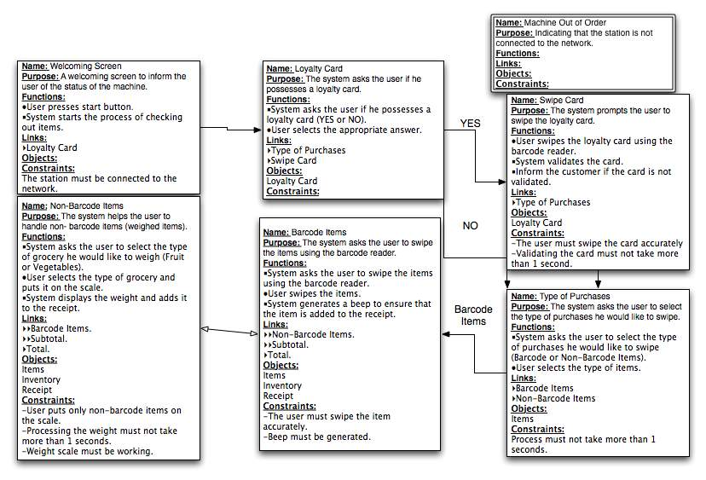

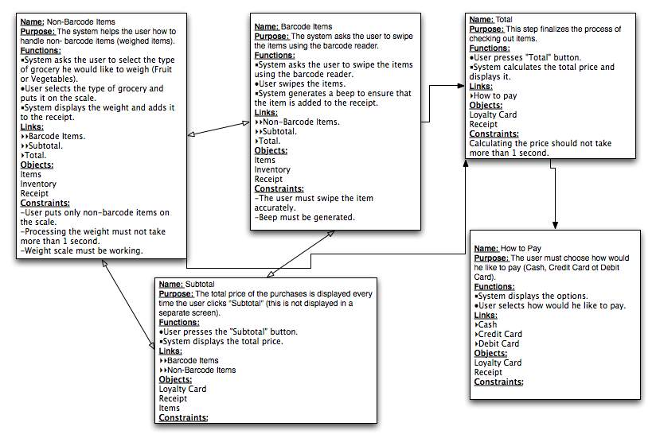

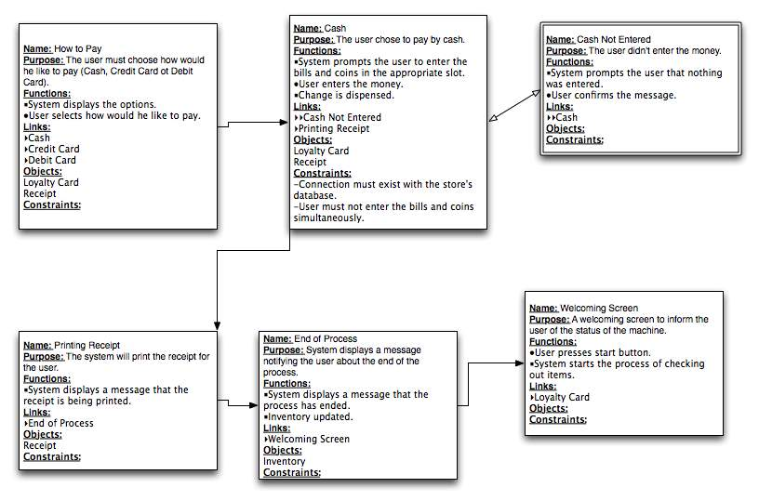

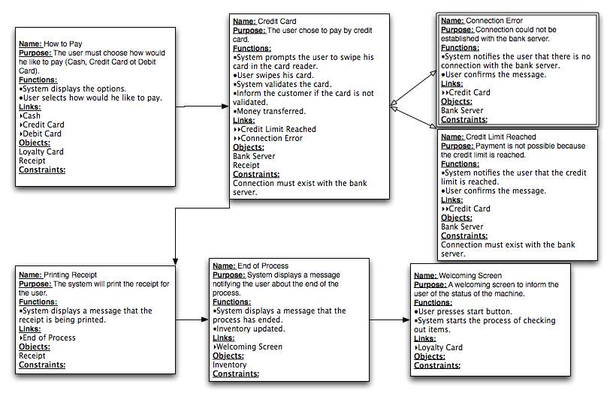

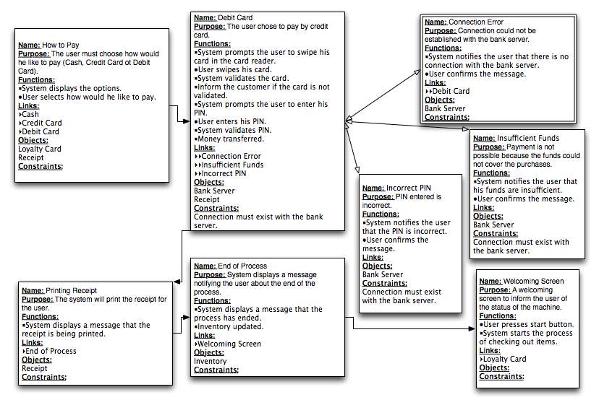

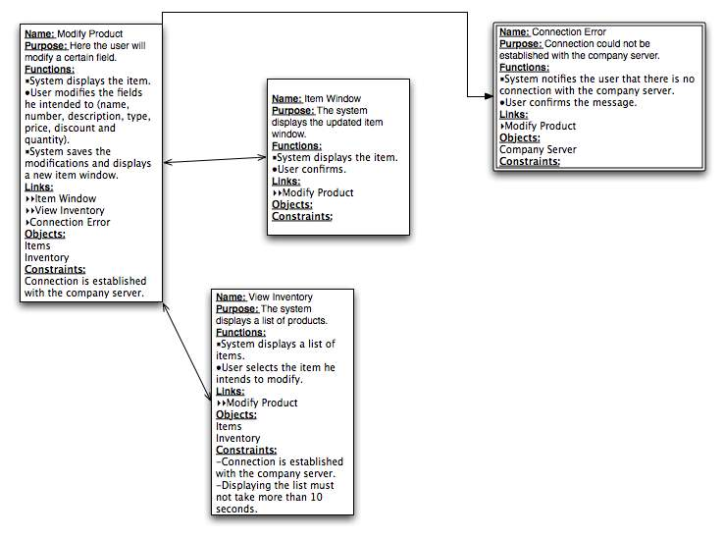

Name: View Inventory

Propose: The system displays a list of products.

Functions:

* System displays a list of items.
* The user selects the item he intends to modify.

Links:

►►Modify Product

►Connection Error

Objects:

Items

Inventory

Constraints:

-Connection established with company server.

-Displaying the list should take no more than 10 seconds.

Name: Connection Error

Propose: Connection could not be established with the server company.

Functions:

* System notifies the user that there is no connection with the server of the company.
* The user confirm the message

Links:

►View Inventory

►Add product

►Modify Product

Objects:

View Product.

Constraints:

Name: Modify Product

Propose: Here the user will modify a certain field.

Functions:

* System display the item
* User modifies the fields he intended to (Name, Number, description, type, price, discount and quantity).
* System saves the modification and displays a new item window.

Links:

►►Item window

►►View Inventory

►Connection Error

Objects:

Items

Inventory

Constraints:

-Connection established with company server.

**Name:** Add product

**Purpose:** The user will be able to add a new product.

**Functions:**

* The system prompts the user to enter all the essential information for adding a product:
* The user will fill the required fields for new product.
* System checks if all required fields are filled.

**Links:**

►►Confirmation window

►►View Inventory

►Connection Error

**Objects**:

Items

Inventory

**Constraints**:

-The product should not already exist.

-Connection established with company server.

**Name:** Choosing report type

**Purpose:** The system asks the user to choose the report type.

**Functions:**

* The user selects the type of report.

**Links:**

 Connection error

 Branch report

Duration report

**Objects:**

**Constrains:**

**Name:** Branch-report

**Purpose:** The system asks the user to choose one of the braches-list

**Functions:**

* The user selects a branch to view the report.

**Links:**

 Displaying branch report

**Objects:**

Branch

**Constrains:**

**Name:** Duration-report

**Purpose:** The system asks the user to enter from-date and to-date

**Functions:**

* User selects (from-date and to-date)
* The system displays the report within the entered duration

**Links:**

**Objects:**

Report

**Constrains:**

**Name:** Displaying branch report

**Purpose:** The system displays the selected branch report

**Functions:**

* The system displays branch report.

**Links:**

**Objects:**

Report

Branch

**Constrains:**

**Name:** Connection error

**Purpose:** The system is not able to establish a connection with the company server.

**Functions:**

* The system displays a message says there is no connection with the company server.
* User confirms the message.

**Links:**

* Choosing report type

**Objects:**

**Constrains:**

**Name:** Updating database of the system.

**Purpose:** To update the server by modifying the existing products or add new products.

**Functions:**

* Updating the system with the new information from the user input.

**Links**

* System server**.**

**Objects**

System database.

**Constraints**

The system must be well connected to the server.

**Name:** Quantity of product is below limit

**Purpose:** To create an inventory message and print it on the supermarket printer.

**Functions:**

* The system recognizes that some products quantity is below the limit and it print a message in the supermarket printer.
* The system stores the message in a buffer and sends a notification to the headquarters at night.

**Links**

* Supermarket printer.
* Storage Buffer.

**Objects**

System database.

**Constraints**

**Name:** Failed Server Connection

**Purpose:** The system displays a message that the connection to the company server cannot be made.

**Functions**

* System displays a message to the user that the connection to the server has failed.
* System stores the results into a buffer so that the stocks can be updated later.

**Links**

* System buffer.

**Objects:**

System database.

**Constraints**

# PAPER PROTOTYPE

MACHINE OUT OF ORDER!

Please ask a store clerk for assistance…

Welcome to

PANDA SELF CHECKOUT

service.

CONTINUE

Do you have a loyalty card that you want to use?

YES NO

Please swipe you loyalty card here.

Validating loyalty card…

Sorry your loyalty card could NOT be verified…

Do you want to proceed and purchase items anyway?

YES NO

Exiting self checkout services…

Have a nice day!!!

Select the type of items to scan

Barcoded

Non-Barcoded

Sub-Total Scan Non-barcoded items Total

Item Scanned

Name: XYZ

Price: XXXX.XX

Please swipe your items with the barcode facing the reader below.

Sub-Total Scan Barcoded items Total

Fruits

Vegetables

Sub-Total Scan Barcoded items Total

Select the fruit and place it on the weigh scale below.

<<This area contains buttons with names of the fruits>>

More Fruits

Weigh Vegetables

Sub-Total Scan Barcoded items Total

Select the vegetable and place it on the weigh scale below.

<<This area contains names of the vegetables>>

More Vegetables

Weigh Fruits

Your sub-total is -

SR. XXXX.XX

Taxes

SR. XXXX.XX

Return to previous screen Total

Your Total is (inclusive of taxes)-

SR. XXXX.XX

|  |  |  |  |  |
| --- | --- | --- | --- | --- |
| **SNo.** | **Name of Product** | **Quantity** | **Taxes** | **Sub-Total** |
|  |  |  |  |  |
|  |  |  |  |  |
|  |  |  |  |  |
|  |  |  |  |  |
|  |  |  |  |  |
|  |  |  |  |  |
|  |  |  |  |  |
|  |  |  |  |  |
|  |  |  |  |  |
|  |  |  |  |  |
|  |  |  |  |  |
|  |  |  |  |  |
|  |  |  |  |  |

Please select you mode of payment.

Cash Credit Card Debit Card

Please place your cash in the cash machine.

Cash Entered

SR. XXXX.XX

Change Dispensed

SR. XXXX.XX

Cancel Purchase

Do you want to print receipt?

Yes No

Thank You for using

PANDA SELF CHECKOUT

service.

Have a nice day!!!

Please swipe you credit card here.

Validating Credit Card…

Sorry!

Your credit card could not be validated.

Cancelling order…

Please swipe you debit card here.

Enter your PIN number.

_ _ _ _

Enter

Validating Debit Card…

Sorry!

Your debit card could not be validated.

Cancelling order…

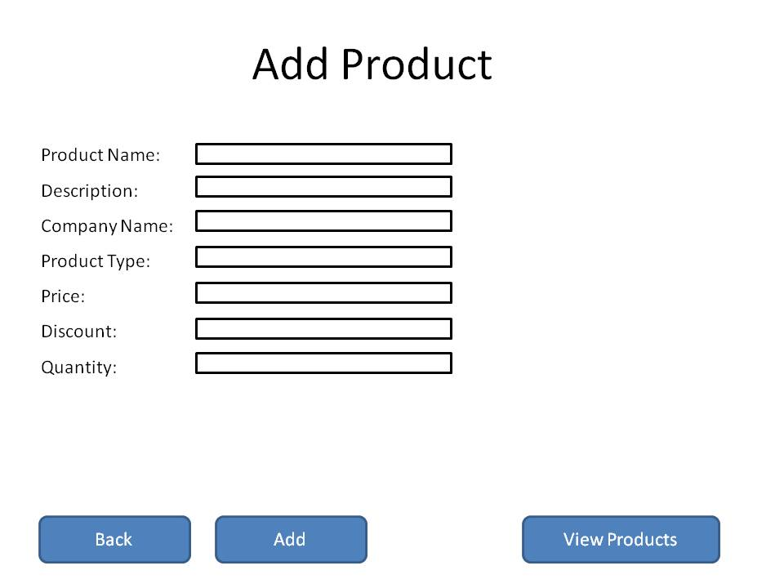

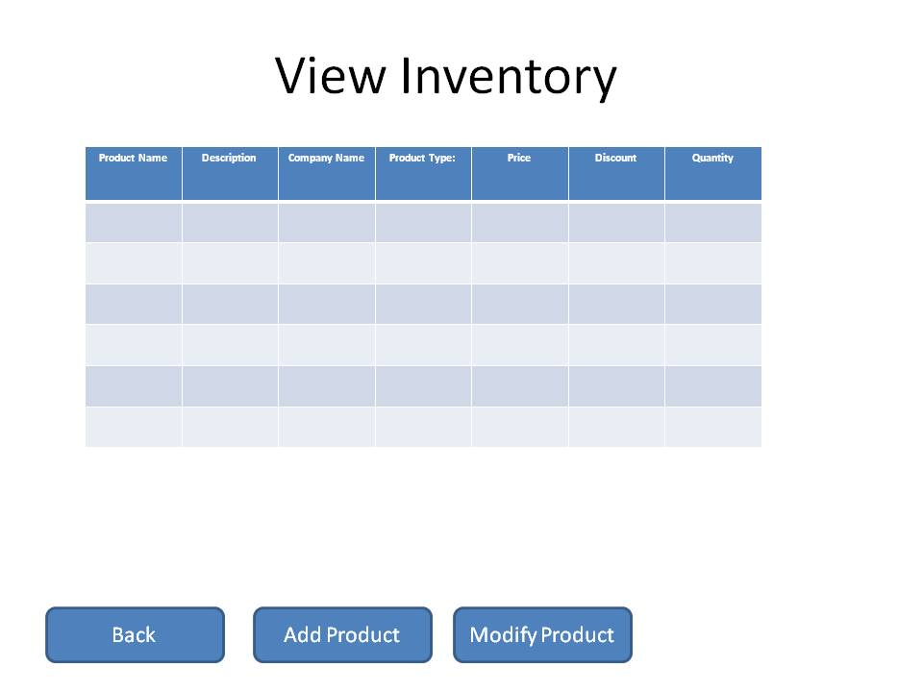

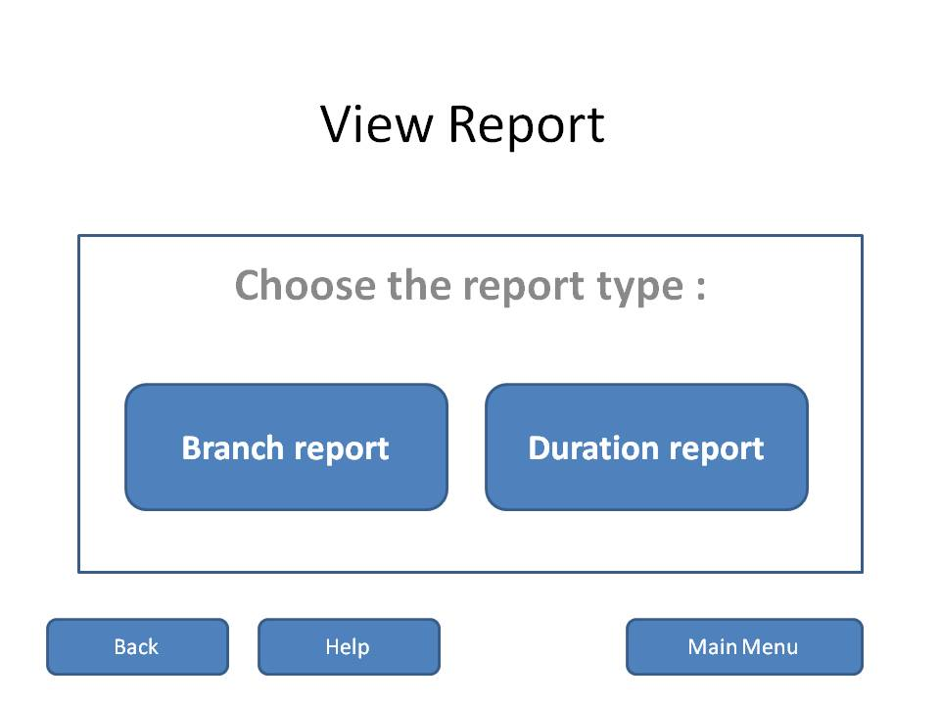

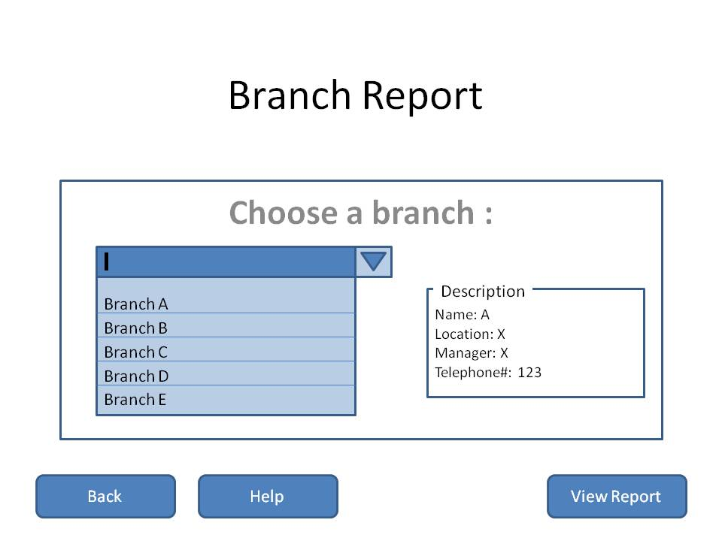

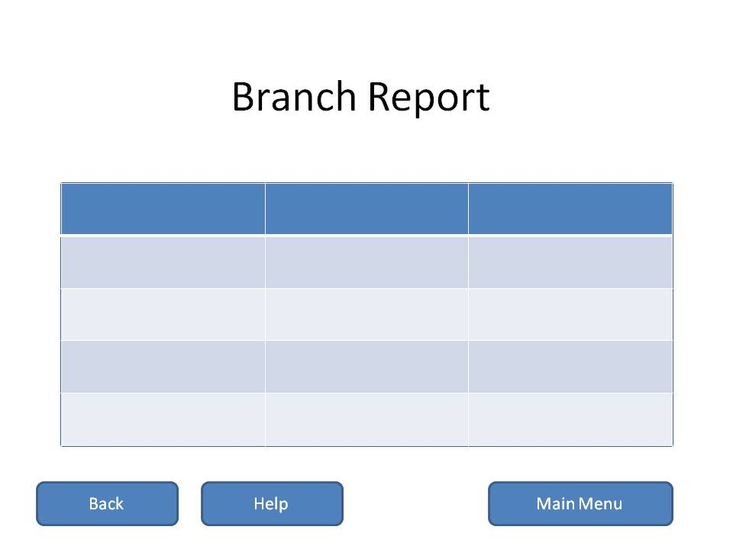

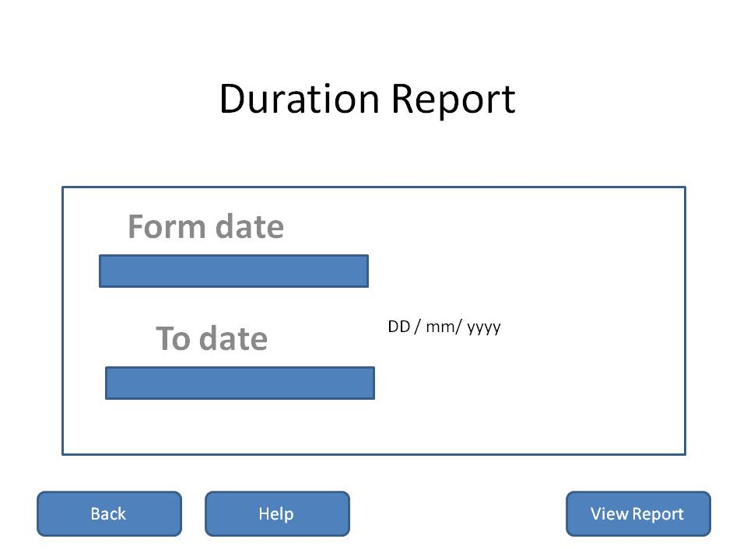

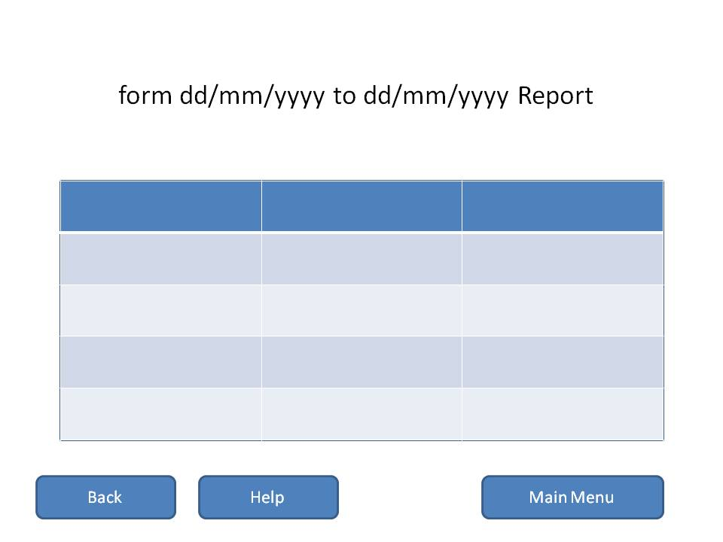

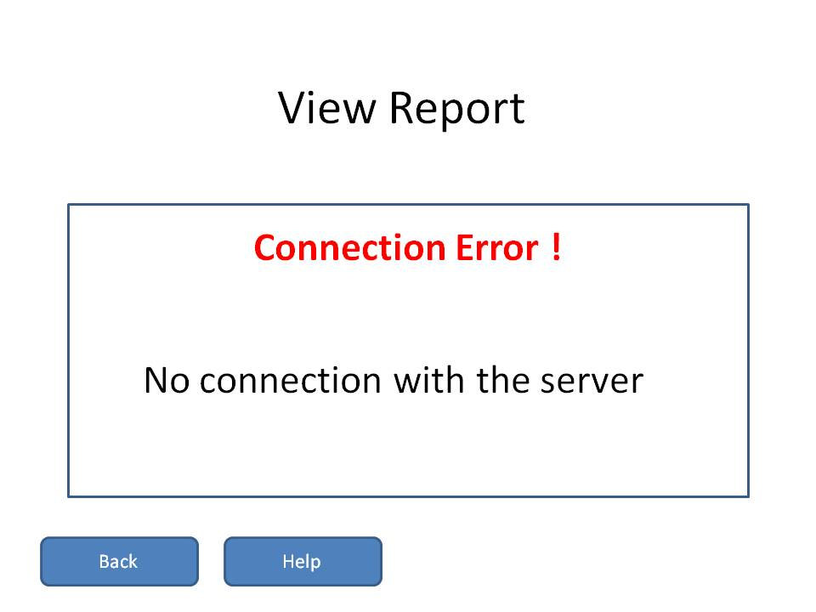

# WORK DISTRIBUTION

**Task characteristics**: Yasser and Abdulrahman.

“**Checkout Items**” task objects, content diagram & prototype: Shaeq and Abdulaziz.

“**Payment by Credit Card**” task objects, content diagram & prototype: Shaeq and Abdulaziz.

“**Payment by Debit Card**” task objects, content diagram & prototype: Shaeq and Abdulaziz.

“**Update Inventory**” task objects, content diagram & prototype: Maitham and Hussein.

“**View Inventory**” task objects, content diagram & prototype: Maitham and Hussein.

“**Add Product**” task objects, content diagram & prototype: Maitham and Hussein.

“**Modify Product**” task objects, content diagram & prototype: Shaeq and Abdulaziz.

“**View Report**” task objects, content diagram & prototype: Yasser and Abdulrahman.