

DEPLOYMENT MANUAL

Manual for Obesity Group Clinic: deployment and technical information, version 1.0

Windows, Mac OS X and Linux

January 6, 2012

This code to this web application is the property of King Fahd University of Petroleum and Minerals.

King Fahd University of Petroleum and Minerals

Dhahran, 31261

Kingdom of Saudi Arabia

# System Requirements

The system requirements of the OGCS are these:

Windows XP, Windows Vista or Windows 7

Mac OS X 10.5 or newer

32 or 64 bit OS

256 MB RAM required

512 MB RAM recommended

1024 x 768 display recommended

Intel or AMD CPU required

Microsoft Office 2007 or later

# Software Installations



For windows

The latest version of XAMPP contains the following –

* Apache 2.2.21
* MySQL 5.5.16
* PHP 5.3.8
* phpMyAdmin 3.4.5
* FileZilla FTP Server 0.9.39
* Tomcat 7.0.21 (with mod_proxy_ajp as connector)

Using the installer version is the easiest way to install XAMPP.

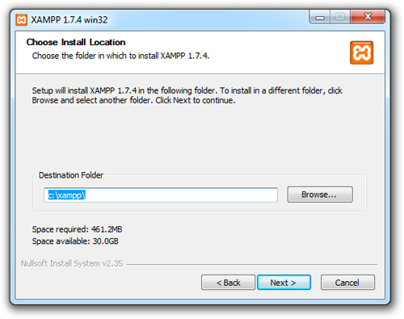

After the installation is complete, you will find XAMPP under Start | Programs | XAMPP. You can use the XAMPP Control Panel to start/stop all server and also install/uninstall services.

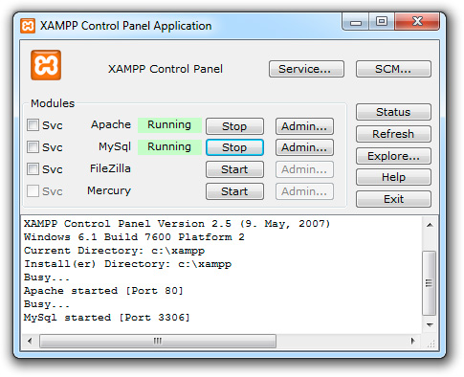

The XAMPP control panel for start/stop Apache, MySQL, FilaZilla & Mercury or install these server as services.

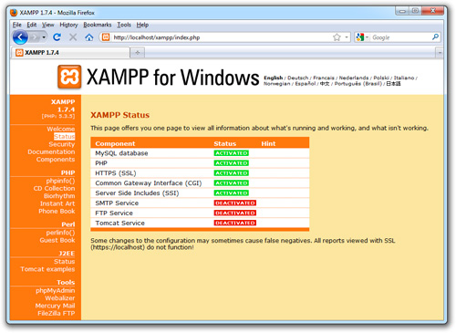



MySQL use from XAMPP is possible using the control panel. This will enable you to view the entire database and allow you to add, remove or modify it.

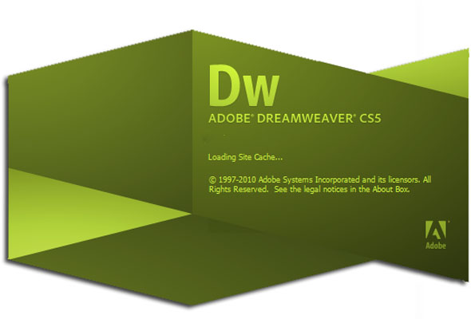

In order to maintain the website (add, remove, modify) static or dynamic pages to the website we suggest you use Adobe Dreamweaver CS5 to do so. This IDE allows you to have a complete website view and mounts it on a local testing server that would help you to view dynamic pages as they would be generated over The Internet.

**Step 1** – Copy the entire website folder (as given in the CD) to this location

C:\xampp\htdocs

**Step 2** – Use toolbar to create a new site

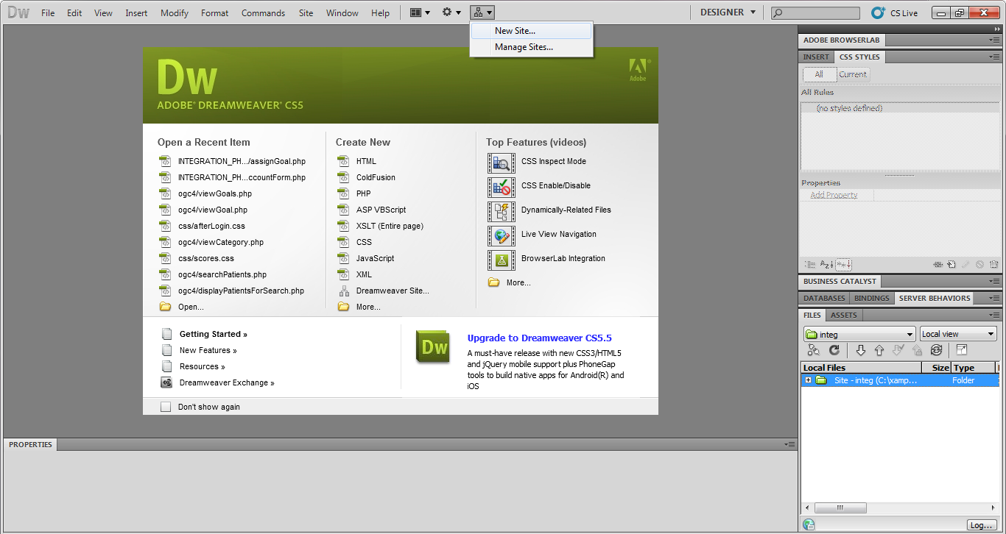

**Step 3** – Enter the site name as ‘Obesity Group Clinic System’ as shown below.

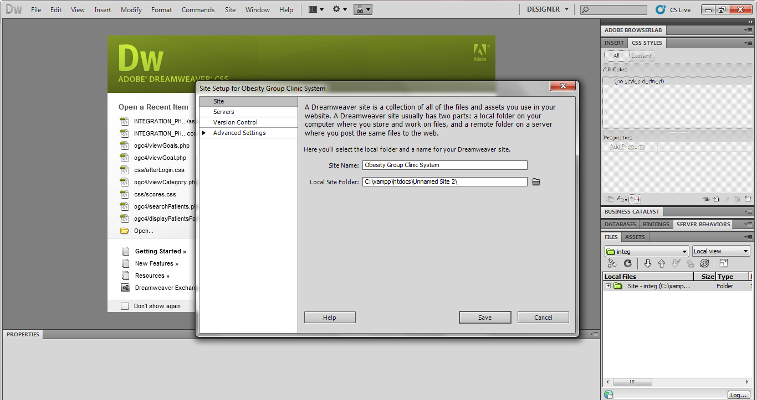

**Step 4** – Click on the folder icon beside the input space of local site folder to choose the site folder you just copied in step 1.

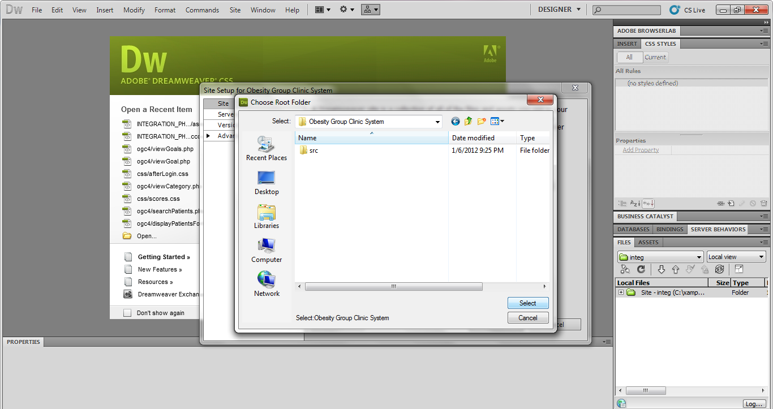

**Step 5** – The popup window should have information displayed as following

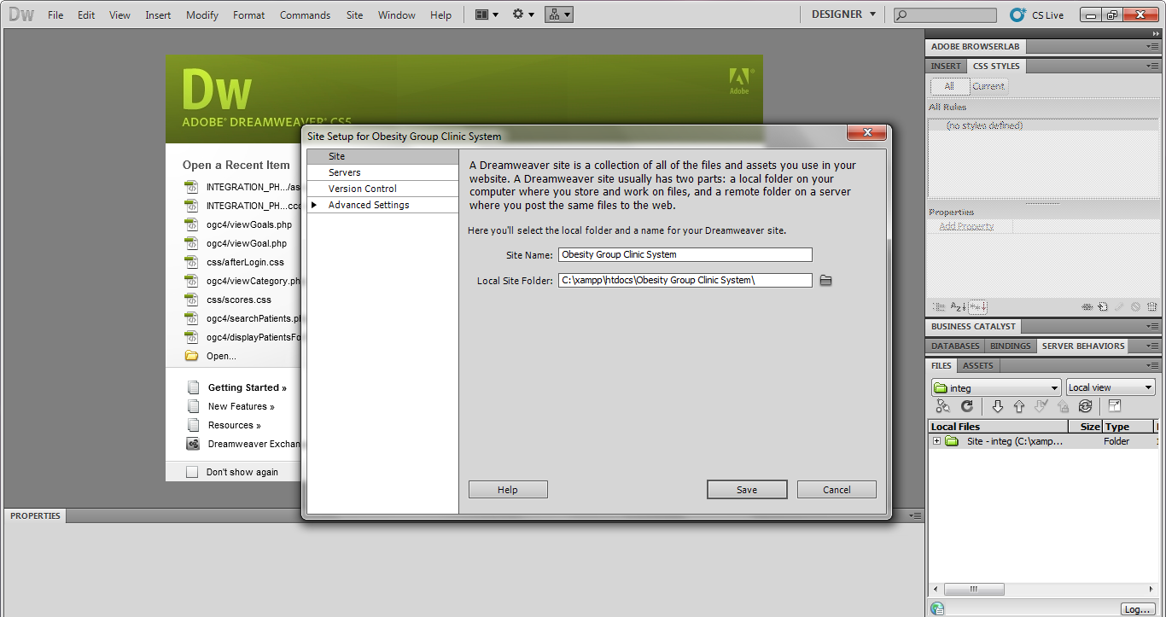

**Step 6** – Now select the Servers tab in the same window for site setup and click on add a new server icon (the plus sign)

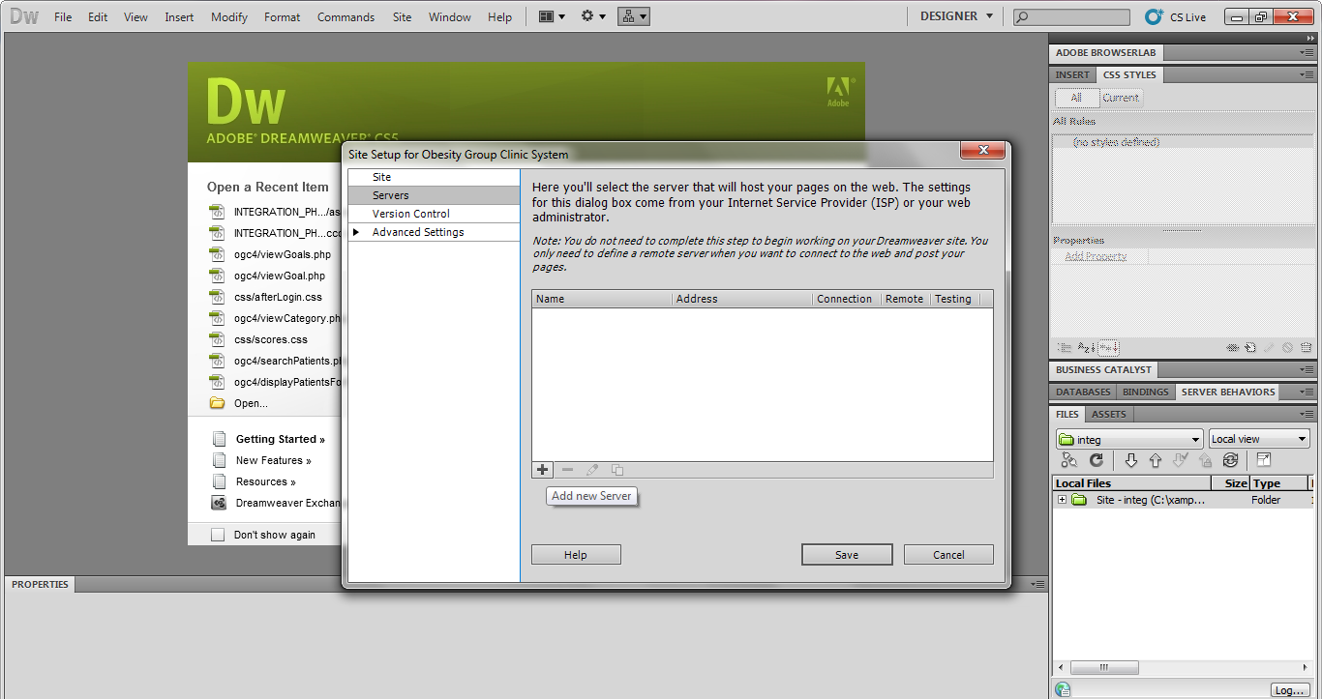

**Step 7** – You should see another window popup as shown below

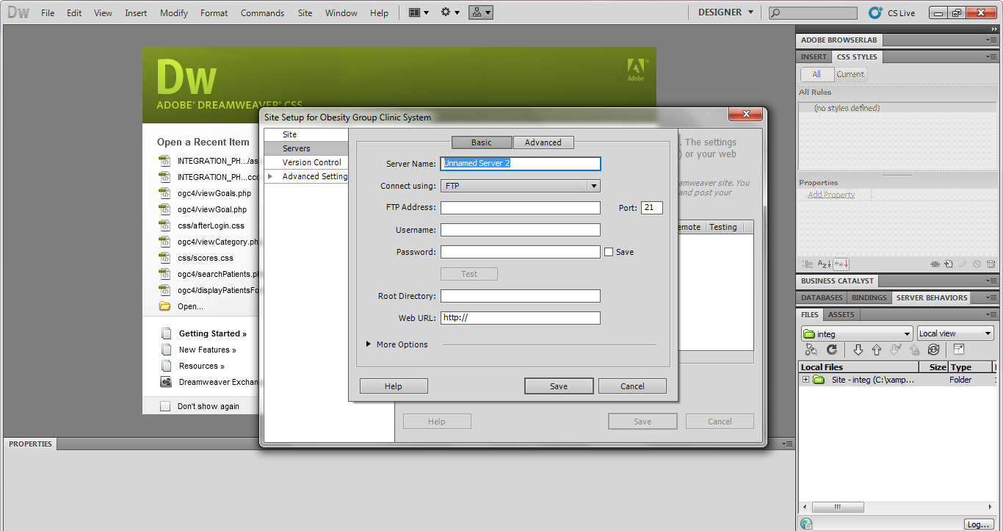

**Step 8** – Use drop drown for ‘Connect using’ to select Local/Network. You will see changes in the fields as follows

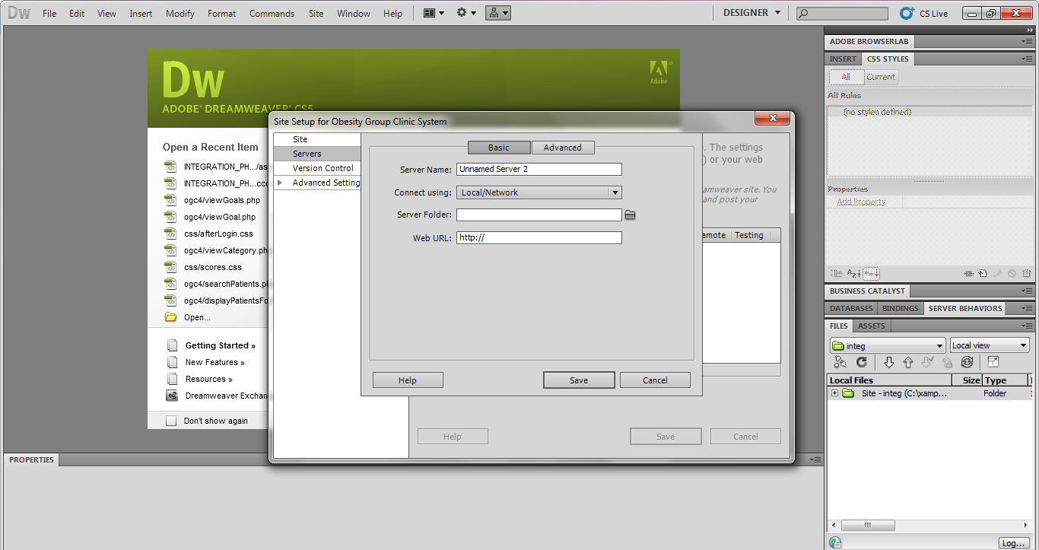

**Step 9** – Enter the information for fields as shown below and click Save.

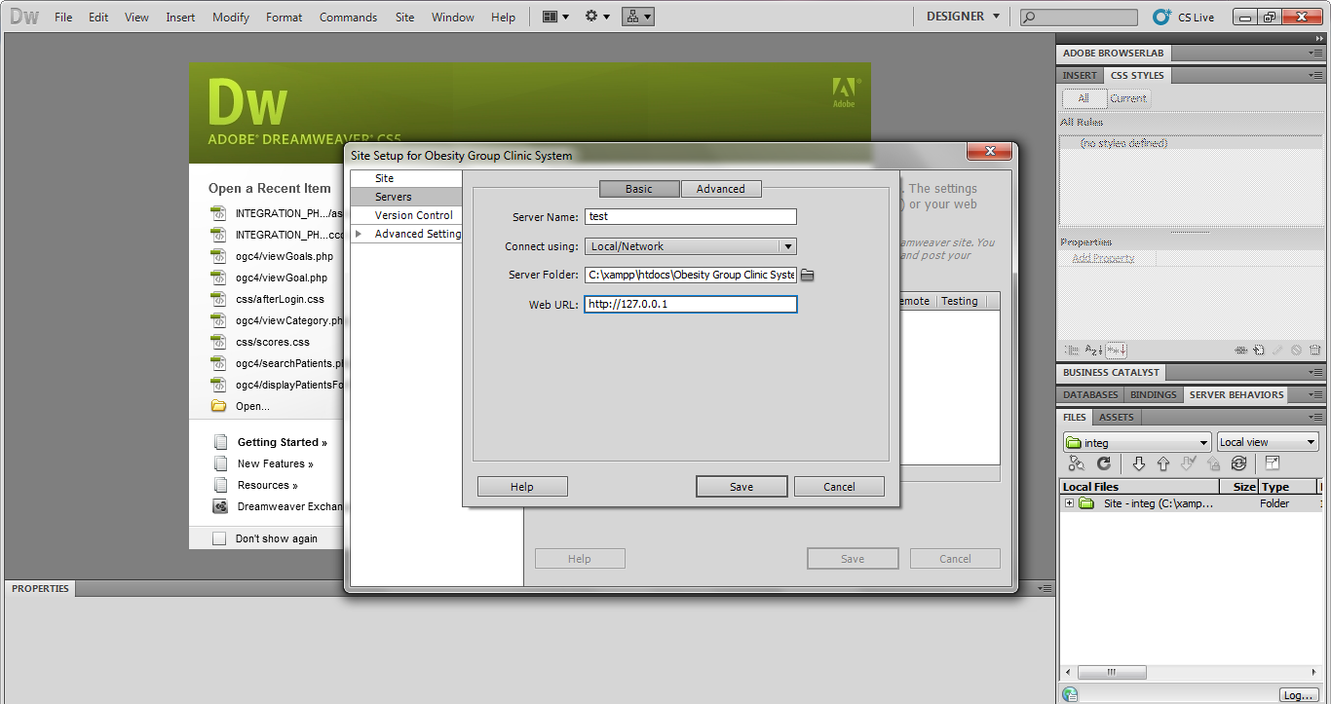

**Step 10** – You will be redirected to a screen as shown below.

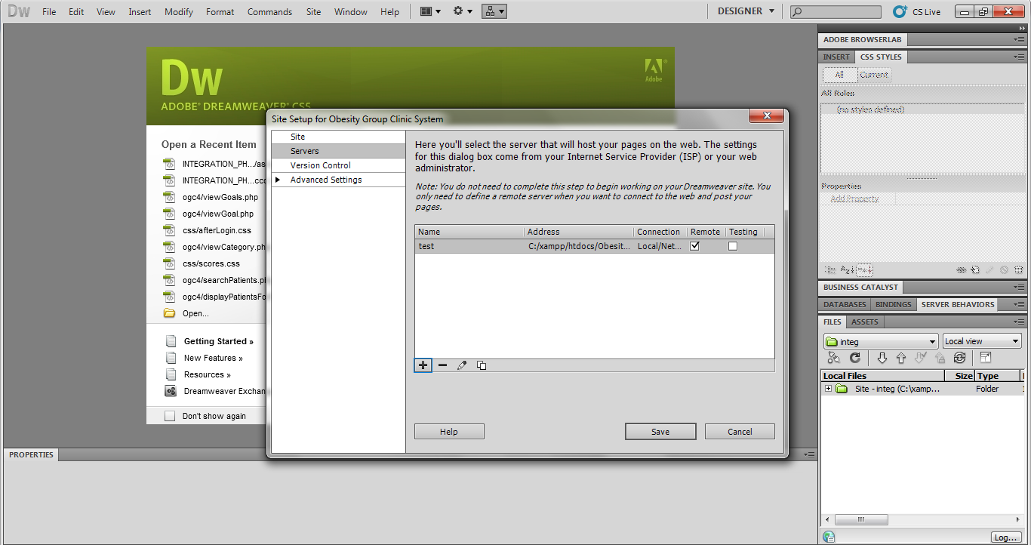

**Step 11** – Unselect ‘Remote’ checkbox and select ‘Testing’ and click save.

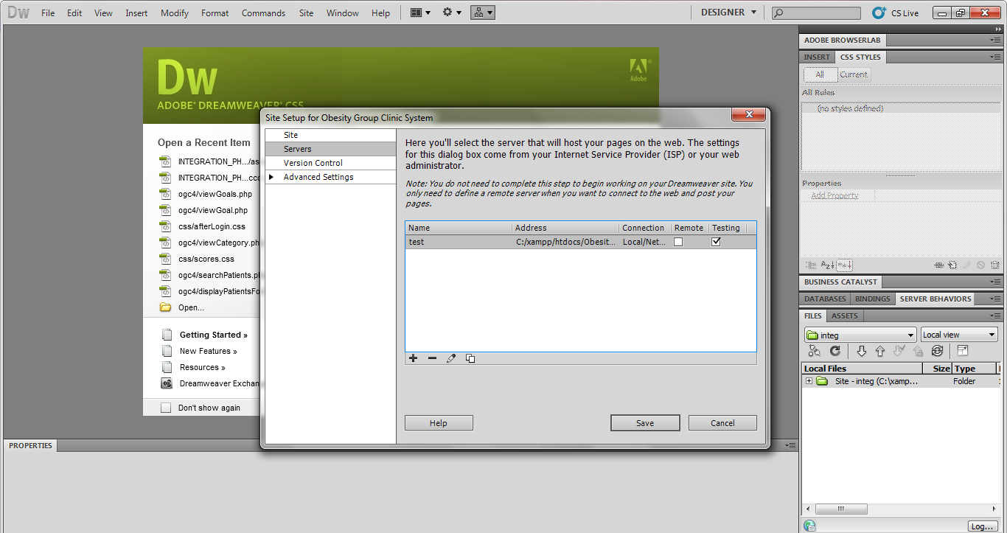

**Step 12** – Dreamweaver will take a couple of seconds to load all the files and then you will be able to browse through all the dynamic and static pages using the Files tab as shown in the bottom right corner of the Ide window.

