

Table of Contents

1. Introduction 6

1.1 Purpose 6

1.2 Scope 6

1.3 Definitions and Abbreviations 6

1.4 Overview 7

2. Class Diagram 8

2.1 First Part of the Class Diagram 8

2.2 Second half of the Class Diagram 9

2.3 Full Class Diagram 10

2.4 Class Diagram Dictionary 11

2.4.1 PatientWeeklyRecord 11

2.4.2 PatientMonthlyRecord 13

2.4.3 GoalsAssignedToPatients 15

2.4.4 Patient 17

2.4.5 Goal 18

2.4.6 Profile 20

2.4.7 PatientRecord 22

2.5 Package Diagram 23

3. Database Design 24

3.1 Enhanced Entity Relationship Model 24

3.2 Database Relational Schema 25

3.3 Database Dictionary 27

3.3.1 Profile 27

3.3.2 PATIENT 27

3.3.3 PATIENT_WEIGHT_HISTORY 28

3.3.4 PATIENT_HEIGHT_HISTORY 28

3.3.5 PATIENT_MEDICAL_HISTORY 28

3.3.6 GOAL 28

3.3.7 PATIENT_GOALS 29

3.3.8 PATIENT_WEEKLY_RECORD 30

3.3.9 PATIENT_MONTHLY_RECORD 30

4. Activity Diagram 31

4.1 Add Goal 31

4.2 Add Patient 32

4.3 Search Patient 33

4. 4 Search Goal 34

4.5 Assign Goal To Patient: 35

4.6 Generate Report For Patient: 36

4.7 Generate Reports For Goal 37

4.8 Add Team Member: 38

4.9 Search Team Member: 39

5. System Architecture 40

5.1 Thin Client-Server Architecture: 40

5.2 3-Tier Client-Server Architecture: 41

5.3 Repository Architecture: 43

5.4 Chosen Alternative 44

6. Capability Matrix 45

7. White Box Test Cases 46

Document Revision History

|  |  |  |  |
| --- | --- | --- | --- |
| Date | Version | Description | Author |
| 15th May 2011 | 1.0 | SDD initial | Sameer |
| 27th May 2011 | 1.1 | SDD Final | Yasir |
| 2nd June 2011 | 1.2 | Corrections to SDD v1.1 | Saeed |
| 29th December 2011 | 1.3 | Final SDD after SWE 418 | Shaeq |

1. Introduction

## 1.1 Purpose

The purpose of this document is to define the solution that will be used for implementing Obesity Group Clinic System. It shows how the Software Requirements Document for this system is mapped to design a complete solution for OGCS. It shows the relation between the classes and the packages in the system and how they interact with each other in a detailed way to support the requested requirements.

## 1.2 Scope

This document includes the class diagram of the whole OGCS. It includes for each class its methods and variables that complete the class. Also, it has a class diagram dictionary that explains each class’s methods, attributes and relations. White box test cases for the whole design are implemented. Finally, it specifies the database design

## 1.3 Definitions and Abbreviations

* *SPMP* – Software Project Management Plan
* *SRS* – Software Requirements Specification
* *SDD* – Software Design Document
* *STD* – Software Testing Documentation
* *OGC* – Obesity Group Clinic
* *OGCT* – Obesity Group Clinic Health Team
* *OGCS* – Obesity Group Clinic System
* *OGCC* – Obesity Group Clinic Committee
* *SAMSO* – Saudi Aramco Medical Services Organization
* *BOI* – Bank of Ideas

## 1.4 Overview

This document provides detailed design specifications for OGCS, including system high-level overview as packages diagram and deployment architecture. It also shows the database design approach used and the details for the database, including relationships, keys, clustering attributes. The internal data of each class is shown. Lastly, for easier tracking of the system features and the classes they interacts with, the capability matrix is developed.

# 2. Class Diagram

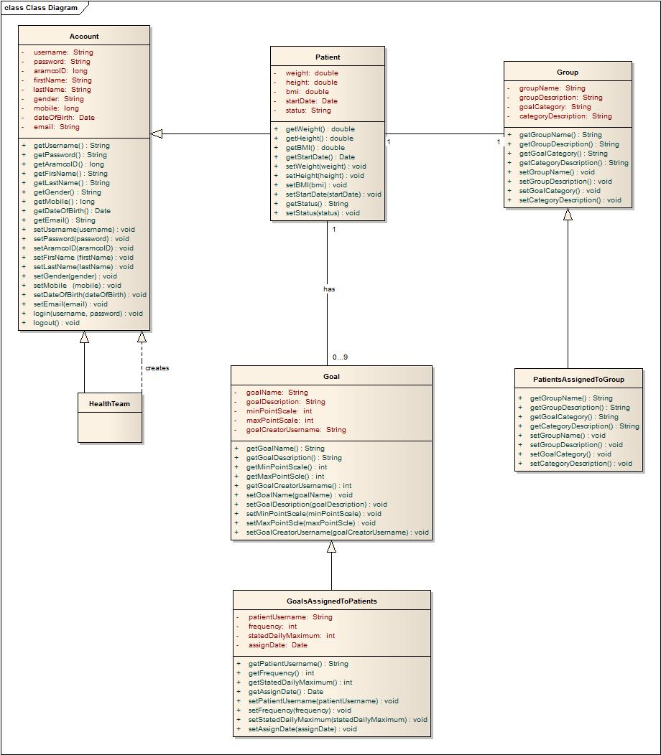

## 2.4 Class Diagram Dictionary

The class diagram dictionary shows the full details of every class. It specifies the attributes and their type, methods and their signature and return type, and the relations between all related classes.

### 2.4.1 GoalsAssignedToPatients

|  |  |
| --- | --- |
| **Name** | GoalsAssignedToPatients |
| **Description** | This class stores description of a goal assigned to a patient with some modified goals’ field. |

**Attributes**

|  |  |  |
| --- | --- | --- |
| **Name of Attribute** | **Data Type** | **Description** |
| assignDate | Date | Private attribute that stores the date of assigning a goal to a patient. |
| frequency | Integer | Private attribute that stores the frequency of repeating a goal. |
| patientUsername | String | Private attribute that stores the name of the patient along with the goal assigned. |
| StatedDailyMaximum | Integer | Private attribute that stores maximum amount of goal stated to be achieved per day. |

**Methods**

|  |  |
| --- | --- |
| **Method Signature** | **Description** |
| getAssignDate(): Date | Public method to access the assignment date of the goal to a patient. |
| getFrequency(): int | Public method to access the frequency of the goal per week. |
| getpatientUsername(): String | Public method to access the username of the patient assigned to a specific goal. |
| getStatedDailyMaximum(): int | Public method to access the stated daily maximum amount of a goal for a specific patient. |
| setAssignDate(Date: assignDate): void | Public method to set the assignment date of the goal to a patient. |
| setFrequency(int: frequenct): void | Public method to set the frequency of the goal per week. |
| setPatientUsername(String: patientUsername): void | Public method to set the username of the patient assigned to a specific goal. |
| setStatedDailyMaximum(int: StatedDailyMaximum): void | Public method to set the stated daily maximum amount of a goal for a specific patient. |

**Relationships**

|  |  |  |
| --- | --- | --- |
| **Class Name** | **Type of Relationship** | **Comments** |
| Goal | Inheritance | Goal is the parent class |

### 2.4.2 Patient

|  |  |
| --- | --- |
| **Name** | Patient |
| **Description** | Dealing with patient information within the system |

**Attributes**

|  |  |  |
| --- | --- | --- |
| **Name of Attribute** | **Data Type** | **Description** |
| BMI | Double | Private attribute to store BMI of the patient |
| Height | Double | Private attribute to store Height of the patient |
| Start date | Date | Private attribute to store StartDate of the patient |
| Status | String | Private attribute to store Status of the patient |
| Weight | Double | Private attribute to store Weight of the patient |

**Methods**

|  |  |
| --- | --- |
| **Method Signature** | **Description** |
| getBMI() Double | Public method to access the patient’s BMI |
| getHeight()Double | Public method to access the patient’s Height |
| getStartDate() Date | Public method to access the patient’s StartDate |
| getStatus() String | Public method to access the patient’s Status |
| getWeight()Double | Public method to access the patient’s Weight |
| setBMI(bmi) void | Public method to set the patient’s BMI |
| setHeight(height) void | Public method to set the patient’s Height |
| setStartDate(startDate) void | Public method to set the patient’s startDate |
| setStatus(status) void | Public method to set the patient’s status |
| setWeight(weight) void | Public method to set the patient’s weight |

**Relationships**

|  |  |  |
| --- | --- | --- |
| **Class Name** | **Type of Relationship** | **Comments** |
| Profile | Inheritance (Profile- parent class) |  |
| PatientRecord | Association | Patient has 0 to * PatientRecords. |
| Goal | Association | Patient has 0 to 9 goals. |

### 2.4.3 Goal

|  |  |
| --- | --- |
| **Name** | Goal |
| **Description** | Dealing with goal information within the system |

**Attributes**

|  |  |  |
| --- | --- | --- |
| **Name of Attribute** | **Data Type** | **Description** |
| goalCreatorUserName | String | Private attribute to store goal creator name. |
| goalDescription | String | Private attribute to store goal description |
| goalName | String | Private attribute to store goal’s name |
| maxPointScale | Integer | Private attribute to store goal’s maxPointScale |
| minPointScale | Integer | Private attribute to store goal’s minPointScale |

**Methods**

|  |  |
| --- | --- |
| **Method Signature** | **Description** |
| getgoalCreatorUserName()String | Public method to access the goal’s goalCreatorUserName |
| getGoalDescription()String | Public method to access the goal’s goalDescription |
| getGoalName() String | Public method to access the goal’s goalName |
| getMaxPointScale() integer | Public method to access the goal’s maxPointScale |
| getMinPointScale() integer | Public method to access the goal’s minPointScale |
| setGoalCreatorUserName(goalCreatorUserName)void | Public method to access the goal’s goalCreatorUserName |
| setGoalDescription(goalDescription) void | Public method to access the goal’s GoalDescription |
| setGoalName(goalName) void | Public method to access the goal’s GoalName |
| setMaxPointScale(maxPointScale) void | Public method to access the goal’s MaxPointScale |
| setMinPointScale(minPointScale) void | Public method to access the goal’s MinPointScale |

**Relationships**

|  |  |  |
| --- | --- | --- |
| **Class Name** | **Type of Relationship** | **Comments** |
| GoalsAssignedToPatients | Inheritance(Goal –parent class) |  |
| Patient | Association | 0 -9 goal belongs to patient |

### 2.4.4 Profile

|  |  |
| --- | --- |
| **Name** | Profile |
| **Description** | A class that stores the information of users who can login to OGCS. |

**Attributes**

|  |  |  |
| --- | --- | --- |
| **Name of Attribute** | **Data Type** | **Description** |
| username | String | Private attribute used by the user to login to OGCS. |
| password | String | Private attribute used by the user to login to OGCS. |
| aramcoID | long | Private attribute to identify the user. |
| firstName | String | Private attribute to store the user’s first name. |
| lastName | String | Private attribute to store the user’s last name. |
| gender | String | Private attribute to store the user’s gender |
| mobile | long | Private attribute to store the user’s mobile. |
| dateOfBirth | Date | Private attribute to store the user’s date of birth. |
| email | String | Private attribute to store the user’s email. |

**Methods**

|  |  |
| --- | --- |
| **Method Signature** | **Description** |
| getUsername(): String | Public method to access the user’s username. |
| getPassword(): String | Public method to access the user’s password. |
| getAramcoID(): long | Public method to access the user’s Armco ID. |
| getFirsName(): String | Public method to access the user’s first name. |
| getLastName(): String | Public method to access the user’s last name. |
| getGender(): String | Public method to access the user’s gender. |
| getMobile(): long | Public method to access the user’s mobile. |
| getDateOfBirth(): Date | Public method to access the user’s date of birth. |
| getEmail(): String | Public method to access the user’s email. |
| setUsername(username): void | Public method to set the user’s username. |
| setPassword(password): void | Public method to set the user’s password. |
| setAramcoID(aramcoID): void | Public method to set the user’s aramco ID |
| setFirsName (firstName): void | Public method to set the user’s first name. |
| setLastName(lastName): void | Public method to set the user’s last name. |
| setGender(gender): void | Public method to set the user’s gender. |
| setMobile(mobile): void | Public method to set the user’s mobile. |
| setDateOfBirth(dateOfBirth): void | Public method to set the user’s date of birth. |
| setEmail(email): void | Public method to set the user’s email. |
| login(username,password): void | Public method used to allow users to login to OGCS. |
| logout (): void | Public method used to allow users to logout from OGCS. |

**Relationships**

|  |  |  |
| --- | --- | --- |
| **Class Name** | **Type of Relationship** | **Comments** |
| Patient | Inheritance |  |
| HealthTeam | Realization | HealthTeam can create profiles for users. |
| HealthTeam | Inheritance |  |

### 2.4.5 PatientRecord

|  |  |
| --- | --- |
| **Name** | PatientRecord |
| **Description** | A class that stores the information of patient’s records. |

**Attributes**

|  |  |  |
| --- | --- | --- |
| **Name of Attribute** | **Data Type** | **Description** |
| username | String | Private attribute to identify the patients’ records. |

**Methods**

|  |  |
| --- | --- |
| **Method Signature** | **Description** |
| getUsername(): String | Public method to access the patient’s username. |
| setUsername(username): void | Public method to set the patient’s username. |

**Relationships**

|  |  |  |
| --- | --- | --- |
| **Class Name** | **Type of Relationship** | **Comments** |
| Patient | Association | A patient can have 0..* records |
| PatientWeeklyRecord | Inheritance |  |
| PatientMonthlyRecord | Inheritance |  |

## 2.5 Package Diagram

## C:\Users\saeed\Desktop\PacakgeDiagram.jpg3. Database Design

This clause f the document shows the full design of the database. It has the DB schema, enhanced entity relationship model and the DB dictionary.

## 3.1 Enhanced Entity Relationship Model

## 3.2 Database Relational Schema

**account_details**

|  |  |  |  |  |  |  |  |  |  |  |  |  |  |
| --- | --- | --- | --- | --- | --- | --- | --- | --- | --- | --- | --- | --- | --- |
| ID | Email | Username | Password | Aramco ID | First Name | Last Name | Gender | Mobile Number | Date of Birth | Type Flag | Start Date | Active Flag | Assigned Group |

* Type Flag: 0 = Admin, 1 = Health Team, 2 = Patient
* Active Flag: 0 = Not Active, 1 = Active
* Assigned Group: NULL = no group assigned

**Patient BMI History**

|  |  |  |  |  |
| --- | --- | --- | --- | --- |
| Bmi_id | Patient_ID | Weight | Height | BMI Timestamp |

**Patient Medical History**

|  |  |  |
| --- | --- | --- |
| History ID | Patient ID | Description |

**Goal**

|  |  |  |  |  |  |  |  |
| --- | --- | --- | --- | --- | --- | --- | --- |
| ID | Goal Name | Goal Description | Goal Type | Goal Category id | Min Patient On Scale | Max Patient On Scale | Deleted Flag |

* Goal Type: 0 = Incriminatory, 1 = Decrementory.
* Deleted Flag: 0 = not deleted, 1 = deleted.

**Category**

|  |  |  |  |
| --- | --- | --- | --- |
| Category_ID | Category Name | Category Description | Deleted Flag |

* Deleted Flag: 0 = No, 1 = Yes.

**Patient Goals**

|  |  |  |  |  |  |  |
| --- | --- | --- | --- | --- | --- | --- |
| Assigned_ID | Goal ID | Patient_ID | Frequency | Stated Daily Max | Timestamp | Current Flag |

* Current Flag: 0 = No, 1 = Yes.

**Patient_daily_record**

|  |  |  |  |
| --- | --- | --- | --- |
| Assign_ID | Date | Score | timestamp |

**Patient_group**

|  |  |  |  |  |
| --- | --- | --- | --- | --- |
| Group_ID | Group_name | Group_description | Active_flag | Group_time_stamp |

## 3.3 Database Dictionary

### 3.3.1 account_details

|  |  |  |
| --- | --- | --- |
| **Attribute name** | **Type** | **Description** |
| username | VARCHAR(15) | Unique identification of the user in the system |
| password | VARCHAR(15) | Password to login to the system and use services |
| aramcoID | INTEGER | Users may be required to enter their unique Aramco id if they are from Aramco |
| firstName | VARCHAR(20) | First name |
| lastName | VARCHAR(20) | Last name |
| gender | VARCHAR(6) |  |
| mobileNumber | INTEGER | Primary contact number of patient using the system |
| dateOfBirth | DATE |  |
| email | VARCHAR(20) | Primary email contact of patient using the system |
| typeFlag | INTEGER | The type of account of the user  1 = health team member  2 = patient |

### 3.3.2 PATIENT

|  |  |  |
| --- | --- | --- |
| **Attribute name** | **Type** | **Description** |
| username | VARCHAR(15) | Unique identification of the user in the system |
| weight | DOUBLE |  |
| height | DOUBLE |  |
| bmi | DOUBLE | Body Mass Index - calculated from the weight and height of the patient |
| startDate | DATE | date when the patients is registered into the system |
| activeFlag | INTEGER | To mark whether the patient has an active account or not  0 = not active  1 = active |

### 3.3.3 PATIENT_MEDICAL_HISTORY

|  |  |  |
| --- | --- | --- |
| **Attribute name** | **Type** | **Description** |
| historyID | INTEGER | Unique identification of the user’s history in the system |
| username | VARCHAR(15) | Unique identification of the user in the system |
| description | VARCHAR(500) | Description of any medical diseases the patient has |

### 3.3.4 GOAL

|  |  |  |
| --- | --- | --- |
| **Attribute name** | **Type** | **Description** |
| goalID | INTEGER | Unique identification of a goal in the system |
| goalName | VARCHAR(100) | A brief name of the goal |
| goalDescription | VARCHAR(200) | A complete description of the goal explained to the patients. |
| minPointScale | INTEGER | The minimum possible score for a goal. In all cases it is 0 |
| maxPointScale | INTEGER | Maximum possible score for a goal. This varies between goals. [8/10/100] |
| goalType | INTEGER | 0 = decrementory  1 = incrementory |
| goalCreatorUsername | VARCHAR(15) |  |
| deletedFlag | INTEGER | To record of the goal is deleted from the system or not by the health team  0 = not deleted  1 = deleted |

### 3.3.5 PATIENT_GOALS

|  |  |  |
| --- | --- | --- |
| **Attribute name** | **Type** | **Description** |
| assignID | INTEGER | Unique identification of the goals assigned to a user in the system |
| goalID | INTEGER | Unique identification of a goal in the system |
| username | VARCHAR(15) | Unique identification of the user in the system |
| frequency | INTEGER | Number of times the goal can be taken up by a patient for a week. Range between [1 to 7] |
| statedDailyMax | INTEGER | A maximum score to achieve can be set by the patient for a week out of the possible maximum and the patient’s progress will be calculated according to the set maximum |
| assignDate | DATE | Date on which the goal was assigned to the patient |
| currentFlag | INTEGER | Whether the goal is under progress or has been finished earlier  0 = not current  1 = current |

### 3.3.8 PATIENT_DAILY_RECORD

|  |  |  |
| --- | --- | --- |
| **Attribute name** | **Type** | **Description** |
| assignID | INTEGER | Unique identification of the goals assigned to a user in the system |
| Date | date |  |
| Score | INTEGER |  |
| Timestamp | timestamp |  |

### 3.3.9 PATIENT_GROUP

|  |  |  |
| --- | --- | --- |
| **Attribute name** | **Type** | **Description** |
| Group_ID | integer | Unique id for the group |
| Group_name | VARCHAR(15) | Name for the group |
| Group_description | VARCHAR(500) | Description of the group |
| Active_flag | integer |  |
| Group_time_stamp | Timestamp |  |

# 4. Activity Diagram

## 4.1 Add Goal

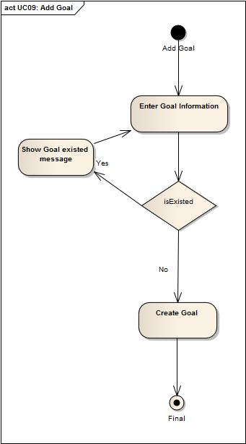

## 4.2 Add Patient

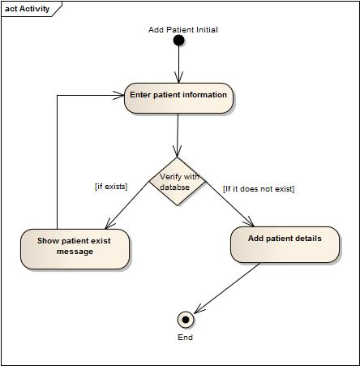

## 4.3 Search Patient

### 

## 4. 4 Search Goal

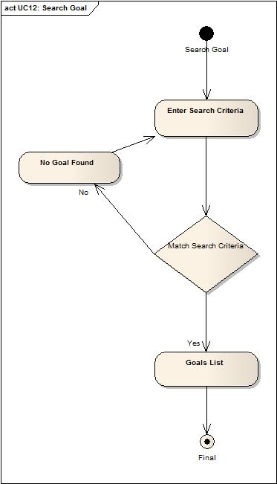

## 4.5 Assign Goal To Patient:

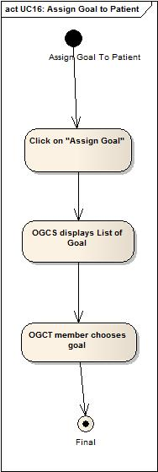

## 4.6 Generate Report For Patient:

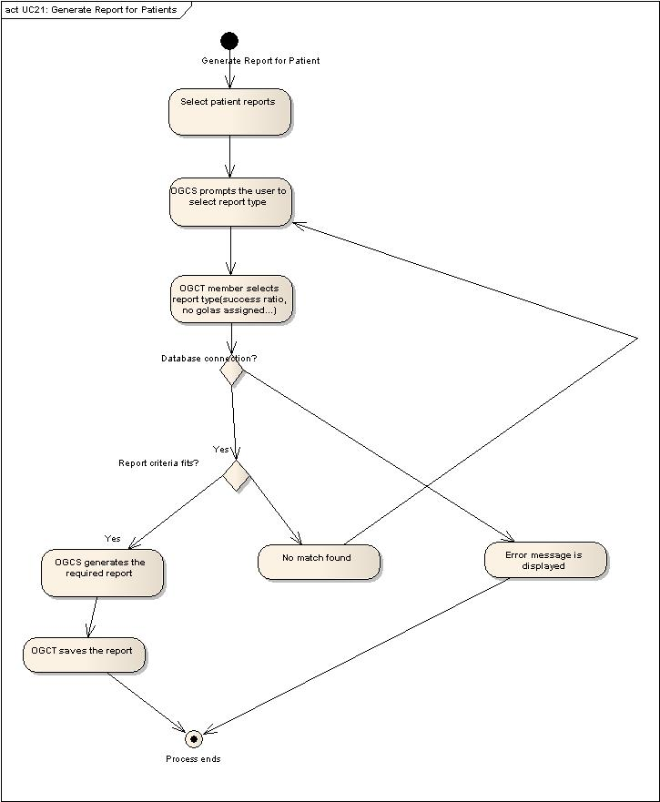

## C:\Users\saeed\Desktop\Generate Reports for Goals.jpg4.7 Generate Reports for Goal

## C:\Users\saeed\Desktop\Add Team Member.jpg4.8 Add Team Member:

## 4.9 Search Team Member:

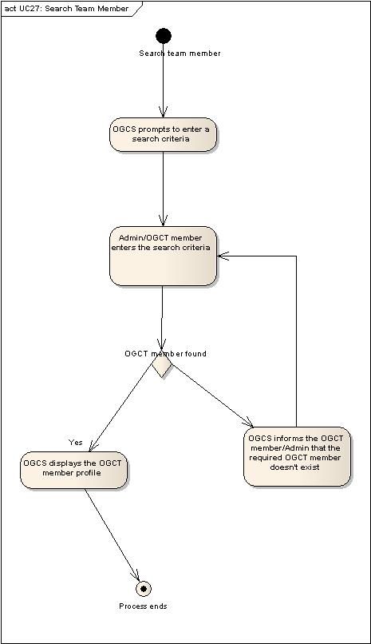

# 5. System Architecture

## 5.1 Thin Client-Server Architecture:

In this architecture the client and server are represented in two layers, which are:

1. Presentation Layer (client): responsible for running the presentation software.
2. Application Processing and Data Management Layer (server): responsible for application processing and data management.

The detailed architecture will be as follows:

The classes will be distributed in the layers as follows:

## 5.2 3-Tier Client-Server Architecture:

In this architecture the client and server are represented in three layers, which are:

1. Presentation Layer (client)

This is the topmost layer in this architecture. It represents the interface which is responsible for the communication with the application processing tier and displays the output to the client.

1. Application Processing (server)

This layer coordinates the processing and commands, makes logical decisions, performs calculations and moves data between the presentation and data layers.

1. Data Management Layer (server)

This layer is responsible for storing and retrieving data into and from the database. It passes the information to the application layer for processing.

The detailed architecture will be as follows:

The classes will be distributed in the layers as follows:

## 5.3 Repository Architecture:

In this architecture, applications are allowed to exchange data by having a shared repository of data that is accessed by these applications.

This architecture is helpful when there is a huge amount of data to be exchanged and the data repository is concerned with the data management processes. The applications are only concerned with querying the data repository to fetch the required information.

The detailed architecture will be as follows:

The classes will be distributed in the layers as follows:

## 5.4 Chosen Alternative

The architecture alternative that the OGCS will be based on is the *thin client architecture,* since the processing required by the server is not complicated and the database won’t store huge amounts of data.

All of the application processing and data management is carried out in the server. The client is simply responsible for running the presentation software and requesting the required information.

# 6. Capability Matrix

|  |  |  |  |  |  |
| --- | --- | --- | --- | --- | --- |
| **Capability**  **Class** | **Patient Profile Management** | **OGCT Profile Management** | **Goal Management** | **Goal Suggestions** | **Report Management** |
| **Profile** | **✓** | **✓** | **🗶** | **🗶** | **🗶** |
| **Patient** | **✓** | **🗶** | **🗶** | **🗶** | **✓** |
| **HealthTeam** | **🗶** | **✓** | **🗶** | **🗶** | **🗶** |
| **Goal** | **🗶** | **🗶** | **✓** | **✓** | **✓** |
| **PatientRecord** | **✓** | **🗶** | **🗶** | **🗶** | **✓** |
| **PatientWeeklyRecord** | **✓** | **🗶** | **🗶** | **🗶** | **🗶** |
| **PatientMonthlyRecord** | **✓** | **🗶** | **🗶** | **🗶** | **🗶** |
| **GoalsAssignedToPatients** | **✓** | **🗶** | **🗶** | **🗶** | **🗶** |

# 

# 7. White Box Test Cases

|  |  |
| --- | --- |
| Method | setHeight(double height) |
| Class Name | Patient. |
| Test Case ID | TC 1 |
| Initial State | Height is zero. |
| Author | Sameer Al-Amri |
| Pre-conditions (if applicable) | It must be a primitive data of type double |
| Use Case (if applicable) | * UC02 : Add Patient * UC03: Edit Patient * UC04: Delete Patient |
| Test Input | Height of the patient. (x) Where x is a double value. |
| Expected Output | Height value is accepted. |
| Failure | No failure. |
| Priority | High. |
| Test Type | Functional. |

|  |  |
| --- | --- |
| Method | setHeight(double height) |
| Class Name | Patient. |
| Test Case ID | TC 2 |
| Initial State | Height is zero. |
| Author | Sameer Al-Amri |
| Pre-conditions (if applicable) | It must be a primitive data of type double |
| Use Case (if applicable) | * UC02 : Add Patient * UC03: Edit Patient * UC04: Delete Patient |
| Test Input | Height of the patient (xy) where x is a double value and y is string. |
| Expected Output | Height value is rejected. |
| Failure | If the system accepts the value contains a string or out of range. |
| Priority | High. |
| Test Type | Functional. |

|  |  |
| --- | --- |
| Method | setStartDate(Date startDate) |
| Class Name | Patient. |
| Test Case ID | TC 3. |
| Initial State | StartDate is empty. |
| Author | Sameer Al-Amri |
| Pre-conditions (if applicable) | It must be a data of type date |
| Use Case (if applicable) | * UC02 : Add Patient * UC03: Edit Patient * UC04: Delete Patient |
| Test Input | The startdate of the patient (dd/mm/yyyy) where :   * dd is value between (0-31). * mm is value between (1-12). * yyyy is value between (2011-2050).   Test input : 2011 |
| Expected Output | startdate value is accepted. |
| Failure | No failure. |
| Priority | High. |
| Test Type | Functional. |

|  |  |
| --- | --- |
| Method | setStartDate(Date startDate) |
| Class Name | Patient. |
| Test Case ID | TC 4 |
| Initial State | StartDate is empty. |
| Author | Sameer Al-Amri |
| Pre-conditions (if applicable) | It must be a data of type Date. |
| Use Case (if applicable) | * UC02 : Add Patient * UC03: Edit Patient * UC04: Delete Patient |
| Test Input | The startdate of the patient (dd/mm/yyyy) where :   * dd is value between (0-31). * mm is value between (1-12). * yyyy is value between (1900-2012).   Test input : 1990 |
| Expected Output | startDate value is rejected. |
| Failure | If the system accepts the value which has less than 2011 or contains string. |
| Priority | High. |
| Test Type | Functional. |

|  |  |
| --- | --- |
| Method | setWeight( double weight) |
| Class Name | Patient. |
| Test Case ID | TC 5 |
| Initial State | Weight is zero. |
| Author | Sameer Al-Amri |
| Pre-conditions (if applicable) | It must be a primitive data of type double. |
| Use Case (if applicable) | * UC02 : Add Patient * UC03: Edit Patient * UC04: Delete Patient |
| Test Input | Weight of the patient. (x) Where x is a double value. |
| Expected Output | Weight value is accepted. |
| Failure | No Failure. |
| Priority | High. |
| Test Type | Functional. |

|  |  |
| --- | --- |
| Method | setWeight( double weight) |
| Class Name | Patient. |
| Test Case ID | TC 6 |
| Initial State | Weight is zero. |
| Author | Sameer Al-Amri |
| Pre-conditions (if applicable) | It must be a primitive data of type double. |
| Use Case (if applicable) | * UC02 : Add Patient * UC03: Edit Patient * UC04: Delete Patient |
| Test Input | Weight of the patient (xy) where x is a double value and y is string.  Test Input: 21ahm |
| Expected Output | Weight value is rejected. |
| Failure | If the system accepts the value which contains letters. |
| Priority | High. |
| Test Type | Functional. |

|  |  |
| --- | --- |
| Method | setGoalName(String goalName) |
| Class Name | Goal. |
| Test Case ID | TC 7 |
| Initial State | goalName is null. |
| Author | Sameer Al-Amri |
| Pre-conditions (if applicable) | It must be a primitive data of type String |
| Use Case (if applicable) | * UC09 : Add Goal * UC10: Delete Goal * UC11: Modify Goal |
| Test Input | goalName of the goal must be string value contains only letters. It cannot contain number. |
| Expected Output | goalName value is accepted. |
| Failure | No Failure. |
| Priority | High. |
| Test Type | Functional. |

|  |  |
| --- | --- |
| Method | setGoalName(String goalName) |
| Class Name | Goal. |
| Test Case ID | TC 8 |
| Initial State | goalName is null. |
| Author | Sameer Al-Amri |
| Pre-conditions (if applicable) | It must be a primitive data of type String |
| Use Case (if applicable) | * UC09 : Add Goal * UC10: Delete Goal * UC11: Modify Goal |
| Test Input | goalName of the goal must be string value contains only letters. It cannot contain number. |
| Expected Output | goalName value is accepted. |
| Failure | If system accepts the goalName which does not applicable according to the rules. If it contains number. |
| Priority | High. |
| Test Type | Functional. |

|  |  |
| --- | --- |
| Method | setMaxPointScale(double maxPointScale) |
| Class Name | Goal. |
| Test Case ID | TC 9 |
| Initial State | maxPointScale is zero. |
| Author | Sameer Al-Amri |
| Pre-conditions (if applicable) | It must be a primitive data of type double. |
| Use Case (if applicable) | * UC09 : Add Goal * UC10: Delete Goal * UC11: Modify Goal |
| Test Input | maxPointScale of the goal must be double value.  Test input : 10 |
| Expected Output | maxPointScale value is accepted. |
| Failure | No failure. |
| Priority | High. |
| Test Type | Functional. |

|  |  |
| --- | --- |
| Method | setMaxPointScale(double maxPointScale) |
| Class Name | Goal. |
| Test Case ID | TC 10 |
| Initial State | maxPointScale is zero. |
| Author | Sameer Al-Amri |
| Pre-conditions (if applicable) | It must be a primitive data of type double. |
| Use Case (if applicable) | * UC09 : Add Goal * UC10: Delete Goal * UC11: Modify Goal |
| Test Input | maxPointScale of the goal must be double value not string.  Test input : 10c |
| Expected Output | maxPointScale value is rejected. |
| Failure | If system accepts the maxPointScale which does not applicable according to the rules. If it contains letters. |
| Priority | High. |
| Test Type | Functional. |

|  |  |
| --- | --- |
| Method | setMinPointScale(double minPointScale) |
| Class Name | Goal. |
| Test Case ID | TC 11 |
| Initial State | minPointScale is zero. |
| Author | Sameer Al-Amri |
| Pre-conditions (if applicable) | It must be a primitive data of type double. |
| Use Case (if applicable) | * UC09 : Add Goal * UC10: Delete Goal * UC11: Modify Goal |
| Test Input | minPointScale of the goal must be double value.  Test input : 10 |
| Expected Output | minPointScale value is accepted. |
| Failure | No failure. |
| Priority | High. |
| Test Type | Functional. |

|  |  |
| --- | --- |
| Method | setMinPointScale(double minPointScale) |
| Class Name | Goal. |
| Test Case ID | TC 12 |
| Initial State | minPointScale is zero. |
| Author | Sameer Al-Amri |
| Pre-conditions (if applicable) | It must be a primitive data of type double. |
| Use Case (if applicable) | * UC09 : Add Goal * UC10: Delete Goal * UC11: Modify Goal |
| Test Input | minPointScale of the goal must be double value.  Test input : 12bv |
| Expected Output | minPointScale value is rejected. |
| Failure | If system accepts the minPointScale which does not applicable according to the rules. If it contains letters or it greater than maximum. |
| Priority | High. |
| Test Type | Functional. |

|  |  |
| --- | --- |
| Method | setUsername(String username) |
| Class Name | Profile |
| Test Case ID | TC13 |
| Initial State | none |
| Author | Saeed Al-Tuwaileb |
| Pre-conditions (if applicable) | none |
| Use Case (if applicable) | * UC01: Login * UC02 : Add Patient * UC03: Edit Patient * UC24: Add Team Member * UC26: Edit Team Member |
| Test Input | Username is set to a string value. |
| Expected Output | The entered string is assigned to username. |
| Failure | No failure. |
| Priority | High. |
| Test Type | Functional. |

|  |  |
| --- | --- |
| Method | setUsername(String username) |
| Class Name | Profile |
| Test Case ID | TC14 |
| Initial State | none |
| Author | Saeed Al-Tuwaileb |
| Pre-conditions (if applicable) | none |
| Use Case (if applicable) | * UC01: Login * UC02 : Add Patient * UC03: Edit Patient * UC24: Add Team Member * UC26: Edit Team Member |
| Test Input | A valid string is set to username. |
| Expected Output | The entered string is not assigned to username. |
| Failure | If the entered username is assigned. |
| Priority | High. |
| Test Type | Functional. |

|  |  |
| --- | --- |
| Method | setPassword(String password) |
| Class Name | Profile |
| Test Case ID | TC15 |
| Initial State | none |
| Author | Saeed Al-Tuwaileb |
| Pre-conditions (if applicable) | none |
| Use Case (if applicable) | * UC01: Login * UC02 : Add Patient * UC03: Edit Patient * UC24: Add Team Member * UC26: Edit Team Member |
| Test Input | A valid string is set to password. |
| Expected Output | The entered string is assigned to password. |
| Failure | No failure. |
| Priority | High. |
| Test Type | Functional. |

|  |  |
| --- | --- |
| Method | setPassword(String password) |
| Class Name | Profile |
| Test Case ID | TC16 |
| Initial State | none |
| Author | Saeed Al-Tuwaileb |
| Pre-conditions (if applicable) | none |
| Use Case (if applicable) | * UC01: Login * UC02 : Add Patient * UC03: Edit Patient * UC24: Add Team Member * UC26: Edit Team Member |
| Test Input | An invalid string is set to password. |
| Expected Output | The entered string is not assigned to password. |
| Failure | If the entered password is assigned. |
| Priority | High. |
| Test Type | Functional. |

|  |  |
| --- | --- |
| Method | setAramcoID(long aramcoID) |
| Class Name | Profile |
| Test Case ID | TC17 |
| Initial State | none |
| Author | Saeed Al-Tuwaileb |
| Pre-conditions (if applicable) | none |
| Use Case (if applicable) | * UC02 : Add Patient * UC03: Edit Patient * UC24: Add Team Member * UC26: Edit Team Member |
| Test Input | A valid long number is set to aramco id. |
| Expected Output | The entered number is assigned to aramco id. |
| Failure | No failure. |
| Priority | High. |
| Test Type | Functional. |

|  |  |
| --- | --- |
| Method | setAramcoID(long aramcoID) |
| Class Name | Profile |
| Test Case ID | TC18 |
| Initial State | none |
| Author | Saeed Al-Tuwaileb |
| Pre-conditions (if applicable) | none |
| Use Case (if applicable) | * UC02 : Add Patient * UC03: Edit Patient * UC24: Add Team Member * UC26: Edit Team Member |
| Test Input | A string is set to aramco id. |
| Expected Output | A message saying that aramco id can’t be a string. |
| Failure | If the entered id is assigned. |
| Priority | High. |
| Test Type | Functional. |

|  |  |
| --- | --- |
| Method | setFirstName (String firstName) |
| Class Name | Profile |
| Test Case ID | TC19 |
| Initial State | none |
| Author | Saeed Al-Tuwaileb |
| Pre-conditions (if applicable) | none |
| Use Case (if applicable) | * UC02 : Add Patient * UC03: Edit Patient * UC24: Add Team Member * UC26: Edit Team Member |
| Test Input | firstName = “Ali” |
| Expected Output | “Ali” is assigned to firstName successfully. |
| Failure | No failure. |
| Priority | High. |
| Test Type | Functional. |

|  |  |
| --- | --- |
| Method | setFirstName (String firstName) |
| Class Name | Profile |
| Test Case ID | TC20 |
| Initial State | none |
| Author | Saeed Al-Tuwaileb |
| Pre-conditions (if applicable) | none |
| Use Case (if applicable) | * UC02 : Add Patient * UC03: Edit Patient * UC24: Add Team Member * UC26: Edit Team Member |
| Test Input | firstName = “233” |
| Expected Output | A message saying that first name must be a valid name. |
| Failure | If the entered first name is assigned. |
| Priority | High. |
| Test Type | Functional. |

|  |  |
| --- | --- |
| Method | setLastName(String lastName) |
| Class Name | Profile |
| Test Case ID | TC21 |
| Initial State | none |
| Author | Saeed Al-Tuwaileb |
| Pre-conditions (if applicable) | none |
| Use Case (if applicable) | * UC02 : Add Patient * UC03: Edit Patient * UC24: Add Team Member * UC26: Edit Team Member |
| Test Input | lastName = “Al-majed” |
| Expected Output | “Al-majed” is set to last name successfully. |
| Failure | No failure. |
| Priority | High. |
| Test Type | Functional. |

|  |  |
| --- | --- |
| Method | setLastName(String lastName) |
| Class Name | Profile |
| Test Case ID | TC22 |
| Initial State | none |
| Author | Saeed Al-Tuwaileb |
| Pre-conditions (if applicable) | none |
| Use Case (if applicable) | * UC02 : Add Patient * UC03: Edit Patient * UC24: Add Team Member * UC26: Edit Team Member |
| Test Input | lastName = “12al-jabir” |
| Expected Output | A message saying that last name must be a valid name. |
| Failure | If the entered last name is assigned. |
| Priority | High. |
| Test Type | Functional. |

|  |  |
| --- | --- |
| Method | setGender(String gender) |
| Class Name | Profile |
| Test Case ID | TC23 |
| Initial State | none |
| Author | Saeed Al-Tuwaileb |
| Pre-conditions (if applicable) | none |
| Use Case (if applicable) | * UC02 : Add Patient * UC03: Edit Patient * UC24: Add Team Member * UC26: Edit Team Member |
| Test Input | Gender= “Male” |
| Expected Output | “Male” is assigned successfully. |
| Failure | No failure. |
| Priority | High. |
| Test Type | Functional. |

|  |  |
| --- | --- |
| Method | setGender(String gender) |
| Class Name | Profile |
| Test Case ID | TC25 |
| Initial State | none |
| Author | Saeed Al-Tuwaileb |
| Pre-conditions (if applicable) | none |
| Use Case (if applicable) | * UC02 : Add Patient * UC03: Edit Patient * UC24: Add Team Member * UC26: Edit Team Member |
| Test Input | Gender= “Female” |
| Expected Output | “Female” is assigned successfully. |
| Failure | No failure. |
| Priority | High. |
| Test Type | Functional. |

|  |  |
| --- | --- |
| Method | setMobile(long mobile) |
| Class Name | Profile |
| Test Case ID | TC26 |
| Initial State | none |
| Author | Saeed Al-Tuwaileb |
| Pre-conditions (if applicable) | none |
| Use Case (if applicable) | * UC02 : Add Patient * UC03: Edit Patient * UC24: Add Team Member * UC26: Edit Team Member |
| Test Input | Mobile= 0554336278 |
| Expected Output | The entered mobile number is assigned successfully. |
| Failure | No failure. |
| Priority | High. |
| Test Type | Functional. |

|  |  |
| --- | --- |
| Method | setMobile(long mobile) |
| Class Name | Profile |
| Test Case ID | TC27 |
| Initial State | none |
| Author | Saeed Al-Tuwaileb |
| Pre-conditions (if applicable) | none |
| Use Case (if applicable) | * UC02 : Add Patient * UC03: Edit Patient * UC24: Add Team Member * UC26: Edit Team Member |
| Test Input | Mobile= 055433 |
| Expected Output | A message saying that the entered mobile number is not valid. |
| Failure | The entered mobile number is assigned. |
| Priority | High. |
| Test Type | Functional. |

|  |  |
| --- | --- |
| Method | setMobile(long mobile) |
| Class Name | Profile |
| Test Case ID | TC28 |
| Initial State | none |
| Author | Saeed Al-Tuwaileb |
| Pre-conditions (if applicable) | none |
| Use Case (if applicable) | * UC02 : Add Patient * UC03: Edit Patient * UC24: Add Team Member * UC26: Edit Team Member |
| Test Input | Mobile= z554336278 |
| Expected Output | A message saying that the entered mobile number is not valid. |
| Failure | The entered mobile number is assigned. |
| Priority | High. |
| Test Type | Functional. |

|  |  |
| --- | --- |
| Method | setDateOfBirth(Date dateOfBirth) |
| Class Name | Profile |
| Test Case ID | TC29 |
| Initial State | none |
| Author | Saeed Al-Tuwaileb |
| Pre-conditions (if applicable) | none |
| Use Case (if applicable) | * UC02 : Add Patient * UC03: Edit Patient * UC24: Add Team Member * UC26: Edit Team Member |
| Test Input | dateOfBirth = 19-05-1980 |
| Expected Output | The entered date is assigned to dateOfBirth successfully. |
| Failure | No failure. |
| Priority | High. |
| Test Type | Functional. |

|  |  |
| --- | --- |
| Method | setDateOfBirth(Date dateOfBirth) |
| Class Name | Profile |
| Test Case ID | TC30 |
| Initial State | none |
| Author | Saeed Al-Tuwaileb |
| Pre-conditions (if applicable) | none |
| Use Case (if applicable) | * UC02 : Add Patient * UC03: Edit Patient * UC24: Add Team Member * UC26: Edit Team Member |
| Test Input | dateOfBirth = oq-05-1980 |
| Expected Output | A message saying the entered date is not valid. |
| Failure | The entered date is assigned. |
| Priority | High. |
| Test Type | Functional. |

|  |  |
| --- | --- |
| Method | setEmail(String email) |
| Class Name | Profile |
| Test Case ID | TC31 |
| Initial State | none |
| Author | Saeed Al-Tuwaileb |
| Pre-conditions (if applicable) | none |
| Use Case (if applicable) | * UC02 : Add Patient * UC03: Edit Patient * UC24: Add Team Member * UC26: Edit Team Member |
| Test Input | Email = “ab2000@hotmail.com” |
| Expected Output | The entered email is assigned successfully. |
| Failure | No failure. |
| Priority | High. |
| Test Type | Functional. |

|  |  |
| --- | --- |
| Method | setEmail(String email) |
| Class Name | Profile |
| Test Case ID | TC32 |
| Initial State | none |
| Author | Saeed Al-Tuwaileb |
| Pre-conditions (if applicable) | none |
| Use Case (if applicable) | * UC02 : Add Patient * UC03: Edit Patient * UC24: Add Team Member * UC26: Edit Team Member |
| Test Input | Email = “ab20# hotmail.com” |
| Expected Output | A message saying that the entered email is not valid email address. |
| Failure | The entered email is assigned. |
| Priority | High. |
| Test Type | Functional. |

|  |  |
| --- | --- |
| Method | login(String username,String password) |
| Class Name | Profile |
| Test Case ID | TC33 |
| Initial State | none |
| Author | Saeed Al-Tuwaileb |
| Pre-conditions (if applicable) | User is not logged-in. |
| Use Case (if applicable) | * UC01: Login |
| Test Input | Valid username and password are entered. |
| Expected Output | The user is directed to the main screen. |
| Failure | No failure |
| Priority | High. |
| Test Type | Functional. |

|  |  |
| --- | --- |
| Method | login(String username,String password) |
| Class Name | Profile |
| Test Case ID | TC34 |
| Initial State | none |
| Author | Saeed Al-Tuwaileb |
| Pre-conditions (if applicable) | User is not logged-in. |
| Use Case (if applicable) | * UC01: Login |
| Test Input | Invalid username or passwords are entered. |
| Expected Output | A message saying that the username or passwords are invalid. |
| Failure | User is directed to main screen. |
| Priority | High. |
| Test Type | Functional. |

|  |  |
| --- | --- |
| Method | logout() |
| Class Name | Profile |
| Test Case ID | TC35 |
| Initial State | none |
| Author | Saeed Al-Tuwaileb |
| Pre-conditions (if applicable) | User is logged-in. |
| Use Case (if applicable) | * UC01: Login |
| Test Input | Logout button is clicked. |
| Expected Output | The user is logged-out from OGCS. |
| Failure | No failure. |
| Priority | High. |
| Test Type | Functional. |

|  |  |
| --- | --- |
| Method | logout() |
| Class Name | Profile |
| Test Case ID | TC36 |
| Initial State | none |
| Author | Saeed Al-Tuwaileb |
| Pre-conditions (if applicable) | User is logged-in. |
| Use Case (if applicable) | * UC01: Login |
| Test Input | Session expired. |
| Expected Output | The user is logged-out from OGCS. |
| Failure | No failure. |
| Priority | High. |
| Test Type | Functional. |

|  |  |
| --- | --- |
| Method | setScore_friday (int score_friday) |
| Class Name | PatientWeeklyRecord |
| Test Case ID | TC37 |
| Author | Abdulaziz Alamoudi |
| Initial State | 0 |
| Pre-conditions (if applicable) | The entered value should be of type int and greater than or equals to zero. |
| Use Case (if applicable) | UC04: Edit Patient |
| Test Input | 2 |
| Expected Output | The attribute “score_friday” is set to the entered value. |
| Failure | The attribute “score_friday” is not set to the entered value. |
| Priority (High/Medium/Low) | High |
| Test Type (Functional, Performance, stress, etc.) | Functional |

|  |  |
| --- | --- |
| Method | setScore_friday (int score_friday) |
| Class Name | PatientWeeklyRecord |
| Test Case ID | TC38 |
| Author | Abdulaziz Alamoudi |
| Initial State | 0 |
| Pre-conditions (if applicable) | The entered value should be of type int and greater than or equals to zero. |
| Use Case (if applicable) | UC04: Edit Patien |
| Test Input | -6 |
| Expected Output | The attribute “score_friday” is not set to the entered value and the OGCS notifies the user that the input is rejected. |
| Failure | The attribute “score_friday” is set to the entered value and no notification is generated. |
| Priority (High/Medium/Low) | High |
| Test Type (Functional, Performance, stress, etc.) | Functional |

|  |  |
| --- | --- |
| Method | setScore_friday (int score_friday) |
| Class Name | PatientWeeklyRecord |
| Test Case ID | TC39 |
| Author | Abdulaziz Alamoudi |
| Initial State | 0 |
| Pre-conditions (if applicable) | The entered value should be of type int and greater than or equals to zero. |
| Use Case (if applicable) | UC04: Edit Patient |
| Test Input | X4f2.2 |
| Expected Output | The attribute “score_friday” is not set to the entered value and the OGCS notifies the user that the input is rejected. |
| Failure | The attribute “score_friday” is set to the entered value and no notification is generated. |
| Priority (High/Medium/Low) | High |
| Test Type (Functional, Performance, stress, etc.) | Functional |

|  |  |
| --- | --- |
| Method | setScore_friday (int score_friday) |
| Class Name | PatientWeeklyRecord |
| Test Case ID | TC40 |
| Author | Abdulaziz Alamoudi |
| Initial State | 0 |
| Pre-conditions (if applicable) | The entered value should be of type int and greater than or equals to zero. |
| Use Case (if applicable) | UC04: Edit Patient |
| Test Input | 2.5 |
| Expected Output | The attribute “score_friday” is not set to the entered value and the OGCS notifies the user that the input is rejected. |
| Failure | The attribute “score_friday” is set to the entered value and no notification is generated. |
| Priority (High/Medium/Low) | High |
| Test Type (Functional, Performance, stress, etc.) | Functional |

|  |  |
| --- | --- |
| Method | setScore_monday (int score_monday) |
| Class Name | PatientWeeklyRecord |
| Test Case ID | TC41 |
| Author | Abdulaziz Alamoudi |
| Initial State | 0 |
| Pre-conditions (if applicable) | The entered value should be of type int and greater than or equals to zero. |
| Use Case (if applicable) | UC04: Edit Patient |
| Test Input | 2 |
| Expected Output | The attribute “score_monday” is set to the entered value. |
| Failure | The attribute “score_monday” is not set to the entered value. |
| Priority (High/Medium/Low) | High |
| Test Type (Functional, Performance, stress, etc.) | Functional |

|  |  |
| --- | --- |
| Method | setScore_monday (int score_monday) |
| Class Name | PatientWeeklyRecord |
| Test Case ID | TC42 |
| Author | Abdulaziz Alamoudi |
| Initial State | 0 |
| Pre-conditions (if applicable) | The entered value should be of type int and greater than or equals to zero. |
| Use Case (if applicable) | UC04: Edit Patient |
| Test Input | -2 |
| Expected Output | The attribute “score_monday” is not set to the entered value and the user is notified that the input is rejected. |
| Failure | The attribute “score_monday” is set to the entered value and the notification is not generated. |
| Priority (High/Medium/Low) | High |
| Test Type (Functional, Performance, stress, etc.) | Functional |

|  |  |
| --- | --- |
| Method | setScore_monday (int score_monday) |
| Class Name | PatientWeeklyRecord |
| Test Case ID | TC43 |
| Author | Abdulaziz Alamoudi |
| Initial State | 0 |
| Pre-conditions (if applicable) | The entered value should be of type int and greater than or equals to zero. |
| Use Case (if applicable) | UC04: Edit Patient |
| Test Input | 2.5 |
| Expected Output | The attribute “score_monday” is not set to the entered value and the user is notified that the input is rejected. |
| Failure | The attribute “score_monday” is set to the entered value and the notification is not generated. |
| Priority (High/Medium/Low) | High |
| Test Type (Functional, Performance, stress, etc.) | Functional |

|  |  |
| --- | --- |
| Method | setScore_monday (int score_monday) |
| Class Name | PatientWeeklyRecord |
| Test Case ID | TC44 |
| Author | Abdulaziz Alamoudi |
| Initial State | 0 |
| Pre-conditions (if applicable) | The entered value should be of type int and greater than or equals to zero. |
| Use Case (if applicable) | UC04: Edit Patient |
| Test Input | 4cr.4 |
| Expected Output | The attribute “score_monday” is not set to the entered value and the user is notified that the input is rejected. |
| Failure | The attribute “score_monday” is set to the entered value and the notification is not generated. |
| Priority (High/Medium/Low) | High |
| Test Type (Functional, Performance, stress, etc.) | Functional |

|  |  |
| --- | --- |
| Method | setScore_saturday (int score_saturday) |
| Class Name | PatientWeeklyRecord |
| Test Case ID | TC45 |
| Author | Abdulaziz Alamoudi |
| Initial State | 0 |
| Pre-conditions (if applicable) | The entered value should be of type int and greater than or equals to zero. |
| Use Case (if applicable) | UC04: Edit Patient |
| Test Input | 2 |
| Expected Output | The attribute “score_ saturday” is set to the entered value. |
| Failure | The attribute “score_ saturday” is not set to the entered value. |
| Priority (High/Medium/Low) | High |
| Test Type (Functional, Performance, stress, etc.) | Functional |

|  |  |
| --- | --- |
| Method | setScore_saturday (int score_saturday) |
| Class Name | PatientWeeklyRecord |
| Test Case ID | TC46 |
| Author | Abdulaziz Alamoudi |
| Initial State | 0 |
| Pre-conditions (if applicable) | The entered value should be of type int and greater than or equals to zero. |
| Use Case (if applicable) | UC04: Edit Patient |
| Test Input | 3.5 |
| Expected Output | The attribute “score_saturday” is not set to the entered value and the user is notified that the input is rejected. |
| Failure | The attribute “score_saturday” is set to the entered value and the notification is not generated. |
| Priority (High/Medium/Low) | High |
| Test Type (Functional, Performance, stress, etc.) | Functional |

|  |  |
| --- | --- |
| Method | setScore_saturday (int score_saturday) |
| Class Name | PatientWeeklyRecord |
| Test Case ID | TC47 |
| Author | Abdulaziz Alamoudi |
| Initial State | 0 |
| Pre-conditions (if applicable) | The entered value should be of type int and greater than or equals to zero. |
| Use Case (if applicable) | UC04: Edit Patient |
| Test Input | -3 |
| Expected Output | The attribute “score_saturday” is not set to the entered value and the user is notified that the input is rejected. |
| Failure | The attribute “score_saturday” is set to the entered value and the notification is not generated. |
| Priority (High/Medium/Low) | High |
| Test Type (Functional, Performance, stress, etc.) | Functional |

|  |  |
| --- | --- |
| Method | setScore_saturday (int score_saturday) |
| Class Name | PatientWeeklyRecord |
| Test Case ID | TC48 |
| Author | Abdulaziz Alamoudi |
| Initial State | 0 |
| Pre-conditions (if applicable) | The entered value should be of type int and greater than or equals to zero. |
| Use Case (if applicable) | UC04: Edit Patient |
| Test Input | 4cr.4 |
| Expected Output | The attribute “score_saturday” is not set to the entered value and the user is notified that the input is rejected. |
| Failure | The attribute “score_saturday” is set to the entered value and the notification is not generated. |
| Priority (High/Medium/Low) | High |
| Test Type (Functional, Performance, stress, etc.) | Functional |

|  |  |
| --- | --- |
| Method | setScore_sunday (int score_sunday) |
| Class Name | PatientWeeklyRecord |
| Test Case ID | TC49 |
| Author | Abdulaziz Alamoudi |
| Initial State | 0 |
| Pre-conditions (if applicable) | The entered value should be of type int and greater than or equals to zero. |
| Use Case (if applicable) | UC04: Edit Patient |
| Test Input | 2 |
| Expected Output | The attribute “score_ sunday” is set to the entered value. |
| Failure | The attribute “score_ sunday” is not set to the entered value. |
| Priority (High/Medium/Low) | High |
| Test Type (Functional, Performance, stress, etc.) | Functional |

|  |  |
| --- | --- |
| Method | setScore_sunday (int score_sunday) |
| Class Name | PatientWeeklyRecord |
| Test Case ID | TC50 |
| Author | Abdulaziz Alamoudi |
| Initial State | 0 |
| Pre-conditions (if applicable) | The entered value should be of type int and greater than or equals to zero. |
| Use Case (if applicable) | UC04: Edit Patient |
| Test Input | 4.4 |
| Expected Output | The attribute “score_sunday” is not set to the entered value and the user is notified that the input is rejected. |
| Failure | The attribute “score_sunday” is set to the entered value and the notification is not generated. |
| Priority (High/Medium/Low) | High |
| Test Type (Functional, Performance, stress, etc.) | Functional |

|  |  |
| --- | --- |
| Method | setScore_sunday (int score_sunday) |
| Class Name | PatientWeeklyRecord |
| Test Case ID | TC51 |
| Author | Abdulaziz Alamoudi |
| Initial State | 0 |
| Pre-conditions (if applicable) | The entered value should be of type int and greater than or equals to zero. |
| Use Case (if applicable) | UC04: Edit Patient |
| Test Input | -4 |
| Expected Output | The attribute “score_sunday” is not set to the entered value and the user is notified that the input is rejected. |
| Failure | The attribute “score_sunday” is set to the entered value and the notification is not generated. |
| Priority (High/Medium/Low) | High |
| Test Type (Functional, Performance, stress, etc.) | Functional |

|  |  |
| --- | --- |
| Method | setScore_sunday (int score_sunday) |
| Class Name | PatientWeeklyRecord |
| Test Case ID | TC52 |
| Author | Abdulaziz Alamoudi |
| Initial State | 0 |
| Pre-conditions (if applicable) | The entered value should be of type int and greater than or equals to zero. |
| Use Case (if applicable) | UC04: Edit Patient |
| Test Input | 4cde3 |
| Expected Output | The attribute “score_sunday” is not set to the entered value and the user is notified that the input is rejected. |
| Failure | The attribute “score_sunday” is set to the entered value and the notification is not generated. |
| Priority (High/Medium/Low) | High |
| Test Type (Functional, Performance, stress, etc.) | Functional |

|  |  |
| --- | --- |
| Method | setScore_thursday (int score_thursday) |
| Class Name | PatientWeeklyRecord |
| Test Case ID | TC53 |
| Author | Abdulaziz Alamoudi |
| Initial State | 0 |
| Pre-conditions (if applicable) | The entered value should be of type int and greater than or equals to zero. |
| Use Case (if applicable) | UC04: Edit Patient |
| Test Input | 2 |
| Expected Output | The attribute “score_ thursday” is set to the entered value. |
| Failure | The attribute “score_ thursday” is not set to the entered value. |
| Priority (High/Medium/Low) | High |
| Test Type (Functional, Performance, stress, etc.) | Functional |

|  |  |
| --- | --- |
| Method | setScore_thursday (int score_thursday) |
| Class Name | PatientWeeklyRecord |
| Test Case ID | TC54 |
| Author | Abdulaziz Alamoudi |
| Initial State | 0 |
| Pre-conditions (if applicable) | The entered value should be of type int and greater than or equals to zero. |
| Use Case (if applicable) | UC04: Edit Patient |
| Test Input | -3 |
| Expected Output | The attribute “score_thursday” is not set to the entered value and the user is notified that the input is rejected. |
| Failure | The attribute “score_thursday” is set to the entered value and the notification is not generated. |
| Priority (High/Medium/Low) | High |
| Test Type (Functional, Performance, stress, etc.) | Functional |

|  |  |
| --- | --- |
| Method | setScore_thursday (int score_thursday) |
| Class Name | PatientWeeklyRecord |
| Test Case ID | TC55 |
| Author | Abdulaziz Alamoudi |
| Initial State | 0 |
| Pre-conditions (if applicable) | The entered value should be of type int and greater than or equals to zero. |
| Use Case (if applicable) | UC04: Edit Patient |
| Test Input | 3.5 |
| Expected Output | The attribute “score_thursday” is not set to the entered value and the user is notified that the input is rejected. |
| Failure | The attribute “score_thursday” is set to the entered value and the notification is not generated. |
| Priority (High/Medium/Low) | High |
| Test Type (Functional, Performance, stress, etc.) | Functional |

|  |  |
| --- | --- |
| Method | setScore_thursday (int score_thursday) |
| Class Name | PatientWeeklyRecord |
| Test Case ID | TC56 |
| Author | Abdulaziz Alamoudi |
| Initial State | 0 |
| Pre-conditions (if applicable) | The entered value should be of type int and greater than or equals to zero. |
| Use Case (if applicable) | UC04: Edit Patient |
| Test Input | 3gfd21 |
| Expected Output | The attribute “score_thursday” is not set to the entered value and the user is notified that the input is rejected. |
| Failure | The attribute “score_thursday” is set to the entered value and the notification is not generated. |
| Priority (High/Medium/Low) | High |
| Test Type (Functional, Performance, stress, etc.) | Functional |

|  |  |
| --- | --- |
| Method | setTotalScore (int totalScore) |
| Class Name | PatientWeeklyRecord |
| Test Case ID | TC57 |
| Author | Abdulaziz Alamoudi |
| Initial State | 0 |
| Pre-conditions (if applicable) | The entered value should be of type int and greater than or equals to zero. |
| Use Case (if applicable) | UC04: Edit Patient |
| Test Input | 20 |
| Expected Output | The attribute “totalScore” is set to the entered value. |
| Failure | The attribute “totalScore” is not set to the entered value. |
| Priority (High/Medium/Low) | High |
| Test Type (Functional, Performance, stress, etc.) | Functional |

|  |  |
| --- | --- |
| Method | setTotalScore (int totalScore) |
| Class Name | PatientWeeklyRecord |
| Test Case ID | TC58 |
| Author | Abdulaziz Alamoudi |
| Initial State | 0 |
| Pre-conditions (if applicable) | The entered value should be of type int and greater than or equals to zero. |
| Use Case (if applicable) | UC04: Edit Patient |
| Test Input | -5 |
| Expected Output | The attribute “totalScore” is not set to the entered value and the user is notified that the input is rejected. |
| Failure | The attribute “totalScore” is set to the entered value and the notification is not generated. |
| Priority (High/Medium/Low) | High |
| Test Type (Functional, Performance, stress, etc.) | Functional |

|  |  |
| --- | --- |
| Method | setTotalScore (int totalScore) |
| Class Name | PatientWeeklyRecord |
| Test Case ID | TC59 |
| Author | Abdulaziz Alamoudi |
| Initial State | 0 |
| Pre-conditions (if applicable) | The entered value should be of type int and greater than or equals to zero. |
| Use Case (if applicable) | UC04: Edit Patient |
| Test Input | 20.88 |
| Expected Output | The attribute “totalScore” is not set to the entered value and the user is notified that the input is rejected. |
| Failure | The attribute “totalScore” is set to the entered value and the notification is not generated. |
| Priority (High/Medium/Low) | High |
| Test Type (Functional, Performance, stress, etc.) | Functional |

|  |  |
| --- | --- |
| Method | setTotalScore (int totalScore) |
| Class Name | PatientWeeklyRecord |
| Test Case ID | TC60 |
| Author | Abdulaziz Alamoudi |
| Initial State | 0 |
| Pre-conditions (if applicable) | The entered value should be of type int and greater than or equals to zero. |
| Use Case (if applicable) | UC04: Edit Patient |
| Test Input | 2rrr8 |
| Expected Output | The attribute “totalScore” is not set to the entered value and the user is notified that the input is rejected. |
| Failure | The attribute “totalScore” is set to the entered value and the notification is not generated. |
| Priority (High/Medium/Low) | High |
| Test Type (Functional, Performance, stress, etc.) | Functional |

|  |  |
| --- | --- |
| Method | setFrequency(int frequency): void |
| Class Name | GoalsAssignedToPatients |
| Test Case ID | TC61 |
| Author | Yasir Al-Agl |
| Initial State | 0 |
| Pre-conditions (if applicable) | The entered value should be of type int and greater than or equals to zero. It shouldn’t exceed 7 |
| Use Case (if applicable) | UC16: Assign goal to patient |
| Test Input | 2 |
| Expected Output | The attribute “frequency” is set to the entered value. |
| Failure | The attribute “ frequency” is not set to the entered value. |
| Priority (High/Medium/Low) | High |
| Test Type (Functional, Performance, stress, etc.) | Functional |

|  |  |
| --- | --- |
| Method | setFrequency(int frequency): void |
| Class Name | GoalsAssignedToPatients |
| Test Case ID | TC62 |
| Author | Yasir Al-Agl |
| Initial State | 0 |
| Pre-conditions (if applicable) | The entered value should be of type int and greater than or equals to zero. It shouldn’t exceed 7 |
| Use Case (if applicable) | UC16: Assign goal to patient |
| Test Input | 34 |
| Expected Output | The attribute “frequency” is not set to the entered value and the user is notified that the input is rejected. |
| Failure | The attribute “frequency” is set to the entered value and the notification is not generated. |
| Priority (High/Medium/Low) | High |
| Test Type (Functional, Performance, stress, etc.) | Functional |

|  |  |
| --- | --- |
| Method | setFrequency(int frequency): void |
| Class Name | GoalsAssignedToPatients |
| Test Case ID | TC63 |
| Author | Yasir Al-Agl |
| Initial State | 0 |
| Pre-conditions (if applicable) | The entered value should be of type int and greater than or equals to zero. It shouldn’t exceed 7 |
| Use Case (if applicable) | UC16: Assign goal to patient |
| Test Input | -4 |
| Expected Output | The attribute “frequency” is not set to the entered value and the user is notified that the input is rejected. |
| Failure | The attribute “frequency” is set to the entered value and the notification is not generated. |
| Priority (High/Medium/Low) | High |
| Test Type (Functional, Performance, stress, etc.) | Functional |

|  |  |
| --- | --- |
| Method | setFrequency(int frequency): void |
| Class Name | GoalsAssignedToPatients |
| Test Case ID | TC64 |
| Author | Yasir Al-Agl |
| Initial State | 0 |
| Pre-conditions (if applicable) | The entered value should be of type int and greater than or equals to zero. It shouldn’t exceed 7 |
| Use Case (if applicable) | UC16: Assign goal to patient |
| Test Input | 3gt56 |
| Expected Output | The attribute “frequency” is not set to the entered value and the user is notified that the input is rejected. |
| Failure | The attribute “frequency” is set to the entered value and the notification is not generated. |
| Priority (High/Medium/Low) | High |
| Test Type (Functional, Performance, stress, etc.) | Functional |