

Table of Contents

1. Introduction 7

1.1 Purpose 7

1.2 Objective 7

1.3 Definition and abbreviations 8

2. Product Description 9

2.1 Problem statement 9

2.2 Project Scope 10

2.3 Product Position 10

2.3 Purposed solution 11

3. Project capabilities 12

4. System stakeholders and users 18

4.1 Market Demographics 18

4.2 Stakeholder Summary 19

4.3 User Summary 20

4.4 User Environment 20

4.5 Stakeholder Profiles 20

4.5.1 Obesity Group Clinic Team (OGCT) 20

4.5.2 Dr. Essam 21

4.5.3 Patients 21

4.5.4 iDhahran 22

4.5.5 Dr. Sajjad Mahmood 22

4.5.6 College of Computer Sciences and Engineering, KFUPM 23

4.6 User Profiles 24

4.6.1 OGCT 24

4.6.2 Patients 24

4.7 Key Stakeholder / User Needs 25

5. Project Plan 27

5.1 Work Breakdown Structure 27

5.2 Risk analysis and management 31

5.2.1 Identifying Risks 31

5.2.2 Assessing Risks 32

5.2.3 Analyzing Risks 32

5.2.4 Monitoring Risks 32

5.2.5 Risk Management Roles and Responsibilities 32

5.2.6 Opportunities Management 33

5.3 Project schedule and grant chart 34

6. Use case model 40

6.1 Use case Diagram 40

6.1.1 OGCT member view 40

6.1.2 Patients view 41

6.2 Use case description 42

7. State transition diagram 87

7.1 Patient Profile management 87

7.2 OGCT member profile management 89

7.3 Follow-up reminders 91

7.4 Goals Management 92

7.5 Goals Suggestion 94

7.6 Report Management 95

7.7 System 96

8. Class model 97

8.1 Class diagram 97

9. Sequence diagram model 98

10. Programing framework 120

11. Screen layouts 120

12. Test cases 121

Figure 1: Risk Management Plan 33

Figure 2: Schedule Allocation (1/6) 36

Figure 3: Resource Allocation (2/6) 37

Figure 4: Resource Allocation (3/6) 38

Figure 5: Resource Allocation (4/6) 39

Figure 6: Resource Allocation (5/6) 40

Figure 7: Resource Allocation (6/6) 41

Figure 8: Use case Diagram (OGCT members’ view) 42

Figure 9: Use Case Diagram (Patients’ view) 43

Figure 10: Add Patient State Transition Diagram 91

Figure 11: Delete Patient State Transition Diagram 91

Figure 12: Edit Patient State Transition Diagram 92

Figure 13: Search Patient State Transition Diagram 92

Figure 14: Add OGCT member State Transition Diagram 93

Figure 15: Delete OGCT member State Transition Diagram 93

Figure 16: Edit OGCT member State Transition Diagram 94

Figure 17: Search OGCT member State Transition Diagram 94

Figure 18: Follow-Up Reminder State Transition Diagram 95

Figure 19: Add Goal State Transition Diagram 96

Figure 20: Delete Goal State Transition Diagram 96

Figure 21: Edit Goal State Transition Diagram 97

Figure 22: Assign Goal State Transition Diagram (OGCT) 97

Figure 23: Assign Goal State Transition Diagram (Patient) 97

Figure 24: Goal Suggestion State Transition Diagram (OGCT View) 98

Figure 25: Report Management State Transition Diagram 99

Figure 26: System State Transition Diagram 100

Figure 27: Class Diagram 101

Figure 28: OGCT login Sequence Diagram 102

Figure 29: Add Patient Sequence Diagram 103

Figure 30: Delete Patient Sequence Diagram 104

Figure 31: Edit Patient Sequence Diagram 105

Figure 32: Search Patient Sequence Diagram 106

Figure 33: View Patient Sequence Diagram 107

Figure 34: View Patient With No Goals Sequence Diagram 108

Figure 35: Assign Goal To Patient Sequence Diagram 109

Figure 36: Add Goal Sequence Diagram 110

Figure 37: Delete Goal Sequence Diagram 111

Figure 38:Modify Goal Sequence Diagram 112

Figure 39: Search Goal Sequence Diagram 113

Figure 40: Generate Report For Patient Sequence Diagram 114

Figure 41: Generate Report For Goals Sequence Diagram 115

Figure 42: Add Team Member Sequence Diagram 116

Figure 43: Delete Team Member Sequence Diagram 117

Figure 44: Edit Team Member Sequence Diagram 118

Figure 45: Search Team Member Sequence Diagram 119

Figure 46: View Team Member Sequence Diagram 120

Figure 47: Evaluate Patient Sequence Diagram 121

Figure 48: Modify Assigned Goal Sequence Diagram 122

Figure 49: Delete Assigned Goal Sequence Diagram 123

Document Revision History

|  |  |  |  |
| --- | --- | --- | --- |
| Date | Version | Description | Author |
| 18th April 2011 | 1.0 | SRS initial | Yasir |
| 3rd June 2011 | 1.1 | SRS final submission for term 102 | Yasir |
| 15th November 2011 | 1.2 | SRS revision according to revised FIT criteria’s | Shaeq |
| 29th December 2011 | 1.3 | Final SRS Revision after completion of system | Shaeq |

# Introduction

This clause shall provide an overview of the purpose, objectives and the definitions used for this project. It’s an abstract overview that will ease the understanding of the following parts.

## Purpose

The purpose of this document is to present a detailed description of the Obesity Group Clinic System. It will explain the purpose and features of the system, the interfaces of the system, what the system will do, the constraints under which it must operate and how the system will react to external stimuli. This document is intended for both the stakeholders and the developers of the system and will be proposed to Dr. Mahmood Sajjad for its approval.

## Objective

The **objectives** of The Obesity Group Clinic System (*OGCS*) are as follows -

* Developing a user-friendly system, since the Obesity Group Clinic System (*OGCS*) will replace the current complicated process of profiling the patients and monitoring their progress.
* Developing a robust and reliable system that can handle the progress of many patients.
* Developing a reusable system, that can be implemented offshore for economic purposes.
* Making the profiling of patients, suggestion of ideas and the workflow of *OGCS* as easy as possible.
* Transferring the experiment of patient-doctor relationship into a more digitized, electronic and web-based relationship.

## Definition and abbreviations

The **definitions** that will be used along the development cycle of the project:

* *SPMP* – Software Project Management Plan
* *SRS* – Software Requirements Specification
* *SDD* – Software Design Document
* *STD* – Software Testing Documentation
* *OGC* – Obesity Group Clinic
* *OGCT* – Obesity Group Clinic Health Team
* *OGCS* – Obesity Group Clinic System
* *SAMSO* – Saudi Aramco Medical Services Organization
* *BOI* – Bank of Ideas

# Product Description

## Problem statement

|  |  |
| --- | --- |
| **The problem of** | Currently, the *OGCT* records information on paper or uses simple tools like Microsoft Excel. |
| **Affects** | This affects the professionalism and consistency of the *OGCT* as well as the degree of quality to which the services are provided*.* |
| **The impact of which is** | This may be one of the factors to explain the high dropout rate from the support group. |
| **A successful solution would be** | After implementation of this system, the *OGC* would be able to keep online records of all patients’ information and history. Patients will be able, as well, to interact with the system and watch their progress over time. They can choose their goals and determine wither it’s suitable for them or not. This will help *OGCT* to set more realistic goals for patients, monitor them and ensure their success. |

## Project Scope

The **scope** of The Obesity Group Clinic System (*OGCS*) will be developed to manage and organize the Obesity Group Clinic (*OGC*) located in Saudi Aramco Medical Services Organization (*SAMSO*) in Dhahran. The main functionality of the system is the profiling of each patient and the organizing of goals. In addition, The Obesity Group Clinic System (*OGCS*) will provide other functionalities that will help and improve the workflow of the system. Patients will be able to interact with the system, manage their goals and report back to Obesity Group Clinic Health Team (OGCT). Also, OGCT will be able to monitor patients. The system should be deployed by January 2011 and the resources provided should accommodate the development process of the project.

## 2.3 Product Position

|  |  |
| --- | --- |
| **For** | Hospitals with support groups for obese people |
| **Who** | Currently, no hospital in the Eastern Province in KSA employs the use of systems that helps a health team and patients keep track of their progress simultaneously. |
| **The (product name)** | *OGCS* [Obesity Group Clinic System] |
| **That** | This system will help the patient and *OGCT* to make informed and appropriate decisions in selecting a goal for the patient. |
| **Unlike** | This system is not scheduling software because it provides more flexibility to *OGCT* to customize goals from the database for every individual patient. |
| **Our product** | This system will make the choosing of ideas and the communications of patients with the clinic easier and clear. Patients can register to the system through the doctor, choose appropriate goals to be achieved and monitor their progress. |

## Purposed solution

iDhahran team has purposed to develop a Patient Management and Profiling System under the name of Obesity Group Clinic System (*OGCS*). The system should be able to create profiles, assign goals, keep records and present progress reports for each patient. The system will present a more elegant and efficient way of handling the clinic’s processes and improve the quality measures in the criteria of time and monitoring. The system will also handle the follow-up reminders to monitor the patient. It will also be more flexible in regards of assigning goals, suggesting goals and in general uses.

# Project capabilities

|  |  |
| --- | --- |
| Capability ID | 1 |
| Name | Patient Profile Management |
| Use Cases # |  |
| Description | This feature will allow the health team member to create new profiles for patients who want to join the clinic, modify profile, delete profile, and search for a patient profile. Patient profile will have the patient's info plus his or her goals and progress in the program. The patient has the option to create, modify and deactivate their profile. |
| Rationale | This is a basic capability of the system. It’s one of the main reasons to replace the current paper-work method. |
| Source | Dr. Essam Jalal |
| Fit Criteria | 1. From the Patient Profile management page the user can do the following – 2. Search for a patient using specific known information 3. View a patient’s profile. 4. While viewing the patient’s profile, the user can modify information stored. 5. On the search page, the user can directly delete the patient profile without viewing it. 6. Go to a screen that allows user to add a new patient. 7. Assign goals to a patient. |
| Dependencies | None |
| Conflicts | None |
| Supporting Material | Dr. Essam’s document  Meeting with Dr. Essam and Dr. Sajjad on 26th February 2011 |
| History | Dr. Essam proposed this capability in the report that he sent to Dr. Sajjad |
| Priority | 5 |
| Risk | 5 |
| Effort | 5 |
| Approval | Done |

|  |  |
| --- | --- |
| Capability ID | 2 |
| Name | Health Team Profile Management |
| Use Cases # |  |
| Description | This capability allows a doctor to add, view, modify, and delete health team members and doctors from the system. |
| Rationale | This is a basic capability of the system. It’s one of the main reasons to replace the current paper-work method. |
| Source | Dr. Essam Jalal, Dr. Sajjad, Project team |
| Fit Criteria | An admin/health team member are allowed do the following -   1. Search for a health team member using specific known information 2. View an admin/health team member’s profile. 3. While viewing their own or health team member’s profile, the admin can modify information stored. 4. On the search page, the admin can directly delete a user’s profile without viewing it. 5. Go to a screen that allows user to add a new health team member. 6. View a list of all health team members in the system. |
| Dependencies | None |
| Conflicts | None |
| Supporting Material | Meeting with Dr. Essam and Dr. Sajjad on 26th February 2011 |
| History | Date: Thursday, March 10, 2011  Version: 1.0  Author: Saeed Al-Tuwaileb  Version: 1.1  Author: Shaeq Khan  This capability was proposed to Dr. Essam on our second meeting on 7th March 2011 and he approved the idea. |
| Priority | 1 |
| Risk | 3 |
| Effort | 2 |
| Approval | Done |

|  |  |
| --- | --- |
| Capability ID | 3 |
| Name | Evaluating progress for patients |
| Use Cases # |  |
| Description | This will help the health team and patients to keep track of their progress over selected goals. |
| Rationale | It is important to make sure that the health team keeps a track of the patient’s progress and the patient information remains up to date |
| Source | Dr. Essam Jalal |
| Fit Criteria | After the patient is added to the system, they can add goal(s) for themselves or the health team set goal(s) for patient.   1. After the patient’s goal has been set, they can customize their frequency and stated daily max and then they will enter their scores to evaluate their own progress. 2. Patients can be put into groups and then these groups can be assigned goals generally. These goals assigned can later be customized for patients individually. 3. Patients that don’t fall into any group can be assigned goals individually or they can select goals for themselves. They don’t necessarily have to fall into certain groups. |
| Dependencies | This capability depends on:   * Patient profile management: to get the patients data. * Goals management: to see whether the patient has chosen a goal or not. |
| Conflicts |  |
| Supporting Material | Dr. Essam’s document  Meeting with Dr. Essam and Dr. Sajjad on 26th February 2011 |
| History | Dr. Essam proposed this capability in the report that he sent to Dr. Sajjad |
| Priority | 5 |
| Risk | 4 |
| Effort | 4 |
| Approval | Done |

|  |  |
| --- | --- |
| Capability ID | 4 |
| Name | Goals Management |
| Use Cases # |  |
| Description | This is the most important feature in the System. The health team comes up with new goals after brainstorming sessions with patients. These are then added to the “Bank of Ideas” under specific categories determined by the health team. These goals can be customized according to individual patients by the health team and then assigned. The system will be able to relate these customized goals to patients assigned with them. The health team can remove goals from the “Bank of Ideas” too. The “Bank of Ideas” contains goals that are classified according to their nature [eg. Physical, Dietary etc.] upon their addition to the system. |
| Rationale | This database created to store goals makes it easier for doctors to view the basic ideas of weight loss opportunities, creates a more flexible and interactive system with respect to information storage. |
| Source | Idea developed by Dr. Essam  Capture by project team during interview with Dr. Essam  Idea enhanced by project team  Meeting 1 [26th February 2011] and 2 with Dr. Essam and Dr. Sajjad |
| Fit Criteria | 1. Brainstorming session/ Interactive session with patients to capture basic ideas and goals to promote weight loss 2. The doctor/health team corrects and finalizes the goals captured 3. These goals are then entered into the system by the user and referred to as the “Bank of Ideas” 4. The user can also delete a goal from the “Bank of Ideas” 5. The user can search goals based on certain parameters like most popular, most, successful, most failed etc. 6. The patients choose a goal from the “Bank of Ideas” and customize it with approval from a member of the health team. 7. A goal is added with attributes such as frequency, amount etc. according to the patient. 8. This goal is then assigned to a patient and stored into the patient’s profile. 9. In case the patient decides to discontinue temporarily, their name is added to a list of patients with no current goals or if they choose to leave the program, their profile can be disabled which will disable further notifications for follow ups to the health team members. |
| Dependencies | Goal Suggestions |
| Conflicts | None |
| Supporting Material | Dr. Essam’s document  Meeting with Dr. Essam and Dr. Sajjad on 26th February 2011 |
| History |  |
| Priority | 5 |
| Risk | 4 |
| Effort | 5 |
| Approval | Done |

|  |  |
| --- | --- |
| Capability ID | 5 |
| Name | Reports Management |
| Use Cases # |  |
| Description | This capability allows the health team to generate and save records of patients, goals and the heath team. |
| Rationale | To assess the progress of patients and health team members and the success of brainstorming sessions with patients for suggestions of goals. |
| Source | Dr. Essam Jalal  Project Team |
| Fit Criteria | The user will be able to generate reports as per their own convince based on current data in the system. The system supports generation of 3 kinds of reports –   1. Patient Report - The health team can generate reports based on the following criteria’s - 2. Success ratio of patients enrolled in clinic 3. Dropout ratio 4. Patients with high bmi. 5. Patients with other disease [1,2,3,more] 6. Patients more prone to drop out 7. <more report types to decided> 8. Goal Report – The health team can generate reports based on the following criteria’s - 9. Most popular 10. Most successful 11. Most failed 12. Least assigned 13. <more report types to be decided> 14. Health Team Report – the admin and health team can generate reports based on the following criteria’s – 15. Success rate 16. <more report types to be decided> |
| Dependencies | Patients Management, Health Team Profile Management, Goal Management |
| Conflicts | None. |
| Supporting Material | Dr. Essam’s document  Meeting with Dr. Essam and Dr. Sajjad on 26th February 2011 |
| History | None |
| Priority | 3 |
| Risk | 4 |
| Effort | 5 |
| Approval | Done |

# System stakeholders and users

**Stakeholders**

*Organizations*: KFUPM, ARAMCO

*Individuals or groups*: Obesity Group Clinic of Aramco Hospital, Dr. Essam as project sponsor, iDhahran project team, Dr. Sajjad, Patients, College of Computer Sciences and Engineering at KFUPM

**Users**

Dr. Essam, *OGCT*, Patients.

## Market Demographics

With this project we want people to realize the importance of making informed decisions with the help of a computer system. Saudi Arabia is seeing obesity as a growing problem and not much is being done to solve it. A lot of people have taken surgical procedures as the only solution to weight loss. With this system we aim to provide patients with a successful and natural choice. As obesity increases, we predict a rise in similar support groups that will be started by hospitals in the Eastern Province and we aim to provide them with a tested and successful system.

This is the first time iDhahran develops a system of this kind. We vision the product to be component based so that code can be reused to develop similar systems in the future for other hospitals with obesity groups. This project gives us the satisfaction that we are making a difference in the lives of people by suggesting them with healthy habits and in a way enhancing their life span.

## 4.2 Stakeholder Summary

|  |  |  |
| --- | --- | --- |
| Name | Represents | Role |
| Obesity Group Clinic [Aramco Hospital] | Our primary customer | To provide us with their vision of the system and provide the project team with requirements and expectations of the system |
| Dr. Essam as project sponsor | Point of contact between the *OGC* and project team | Interviews and presentations are held with Dr. Essam and he provides a collective feedback to the project team |
| Patients | People who will majorly decide the success or failure of the system. The decreasing dropout rates are a measure of the success of the system. Second main users of the system. | Present some constraints such as making the system bi-lingual [English, Arabic] and will eventually be the people who are using by the system. |
| iDhahran | The development team for the *OGC* system | Gathering requirements, designing the system, implementation and deployment. |
| Dr. Sajjad Mahmood as Supervisor | To monitor and approve the development team’s progress with the system | Providing feedback and improvements that can be made to the system |

## 4.3 User Summary

|  |  |  |
| --- | --- | --- |
| Name | Description | Stakeholder |
| *OGCT* members | Primary end user of the system. Capable of adding new users to the system. | A part of the Obesity Group Clinic [Aramco Hospital] |
| Patients | Secondary end users of the system. Capable of adding goals and monitoring their progress. | Patients. |

## 4.4 User Environment

The users of the OGC System will be either the patients or the OGCT. System will be accessible from any platform with Internet connection. OGCT can follow-up upon patients’ progress by getting emails reminders. Currently the team uses Microsoft Excel to store patient information. They have also uploaded a set of goals onto the Aramco hospital website where patients can visit and view goals and select one.

## 4.5 Stakeholder Profiles

### 4.5.1 Obesity Group Clinic Team (OGCT)

|  |  |
| --- | --- |
| **Representative** | Dr. Essam Jalal |
| **Description** | Our primary customer who will be using the system |
| **Type** | No experience with using a similar system. Most of them are technology competent but will need training to use the system efficiently. |
| **Responsibilities** | Appropriate usage of the system to benefit patients |
| **Success Criteria** | Increase in number of patients choosing to stay with the program over seeking surgical alternatives. |
| **Involvement** | Major source of requirements elicitation |
| **Deliverables** | Online tutorials and user manuals |
| **Comments / Issues** |  |

### 4.5.2 Dr. Essam

|  |  |
| --- | --- |
| **Representative** |  |
| **Description** | He is the point of contact between the project team and the *OGC* |
| **Type** | No experience with using a similar system. Technology competent but will need training to use the system efficiently. |
| **Responsibilities** | Will overlook the *OGCT* and deal with patients himself |
| **Success Criteria** | Increase in number of patients choosing to stay with the program over seeking surgical alternatives. |
| **Involvement** | Major source of information for requirements elicitation |
| **Deliverables** | The system itself, Online tutorials and user manuals |
| **Comments / Issues** |  |

### 4.5.3 Patients

|  |  |
| --- | --- |
| **Representative** | Dr. Essam Jalal |
| **Description** | Is our major stakeholder. Decides the future success or failure of the system. Second main users of the system. |
| **Type** | Has direct interaction with the system and is going to be affected by it |
| **Responsibilities** | Register to the system, modify goals and report back to OGCT. |
| **Success Criteria** | Increase in number of patients choosing to stay with the program over seeking surgical alternatives. |
| **Involvement** | Minor source of information for requirements elicitation |
| **Deliverables** |  |
| **Comments / Issues** |  |

### 4.5.4 iDhahran

|  |  |
| --- | --- |
| **Representative** | The team leader |
| **Description** | Development team of the system |
| **Type** | Technical expertise in developing systems |
| **Responsibilities** | Gathering Requirements, Designing the system, Implementation and Deployment and documentation |
| **Success Criteria** | Satisfaction of users in terms of their usage of the system and increase in number of patients choosing to stay with the program over seeking surgical alternatives. |
| **Involvement** | The creators of the system, gathering Requirements, Designing the system, Implementation and Deployment |
| **Deliverables** | Ideas and requirements from the *OGCT* |
| **Comments / Issues** |  |

### 4.5.5 Dr. Sajjad Mahmood

|  |  |
| --- | --- |
| **Representative** |  |
| **Description** | In charge of collecting documentation from the project team, making sure project is on time and consultant to the project for new ideas and better solutions |
| **Type** | Guru of technical and software systems development, the development team’s mentor and guidance |
| **Responsibilities** | Provide feedback to group discussions and ideas |
| **Success Criteria** | Completion of the system and successful deployment |
| **Involvement** | In charge of collecting documentation from the project team, making sure project is on time and consultant to the project for new ideas and better solutions |
| **Deliverables** | Weekly deliverables [adjustable frequency] are delivered by the development team to record progress |
| **Comments / Issues** |  |

### 4.5.6 College of Computer Sciences and Engineering, KFUPM

|  |  |
| --- | --- |
| **Representative** | Dr. Sajjad Mahmood |
| **Description** | Is owner of the system to be developed |
| **Type** | Guru in technical aspects and have taken responsibility of completion of thousands of student projects to date. |
| **Responsibilities** | Supervising the overall project and to ensure the integrity of the entire team. |
| **Success Criteria** | Completion of the system and successful deployment |
| **Involvement** | Ensuring project manager has the system development on schedule |
| **Deliverables** | The final system |
| **Comments / Issues** |  |

## 

## 4.6 User Profiles

## 

This section describes each unique user of the system and their attributes in regards to the system. A through profile should cover the following topics for each type of user:

### 4.6.1 OGCT

|  |  |
| --- | --- |
| **Representative** |  |
| **Description** | A private individual that will use the system to profile patients and monitor their progress, as well as creating new *OGCT* member profiles. |
| **Type** | This is a casual user, possibly with previous use of similar patient’s record system |
| **Responsibilities** | Adding patient’s profiles, monitoring their progress and adding more goals to the BOI, as well as creating new OGCT member profiles. |
| **Success Criteria** | The success is completely defined by the customers continuing business with using our system. |
| **Involvement** | We will have sample customers to help evaluate our design. |
| **Deliverables** |  |
| **Comments / Issues** |  |

### 4.6.2 Patients

|  |  |
| --- | --- |
| **Representative** |  |
| **Description** | Private individuals that will use the system to register themselves and choose goals to be achieved. |
| **Type** | This is a casual user, possibly with no previous use of similar patient’s record system |
| **Responsibilities** | Registration, managing goals and reporting back to OGCT. |
| **Success Criteria** | The success is completely defined by the customers continuing business with using our system. |
| **Involvement** | We will have sample customers to help evaluate our design. |
| **Deliverables** |  |
| **Comments / Issues** |  |

## 4.7 Key Stakeholder / User Needs

|  |  |  |  |  |
| --- | --- | --- | --- | --- |
| Need | Priority | Concerns | Current Solution | Proposed Solutions |
| Secured access | High | Management of private patients information | None | Manage user access with PIN numbers and encryption |
| Scalable | Moderate | None | None | Allow ample number of access channels for end users |
| Profiling of patients | High | Mixing patient’s profiles | Paper forms | E-profiling of patients information |
| Monitoring patient’s progress | High | Mixing patient’s profiles | Paper forms | E-profiling of patients progress |
| Easy to use | High | Ability to provide complex operations with simple user interface | None | Provide user friendly, highly intuitive, help guided navigation in application |
| Flexible | High | Ability to provide a truly customized user experience | None | Provide a simple, yet robust, ability for the end user to customize the goals to match every patient’s goals |
| Instant | Moderate to High | Ability to provide live feedback from the database | None | Use an appropriate tool to provide live feedbacks of the most recent activities |

# Project Plan

## Work Breakdown Structure

|  |
| --- |
| **1.Initial Project Proposal** |
| 1.1 Project Objective |
| 1.2 The need of the project |
| 1.3 Expected Output |
| 1.4 Key Feature |
| **1.5 Project Impact** |
| 1.5.1 Impact on Individual and Organization |
| 1.5.2 Impact on Society |
| 2.Final Project Proposal |
| **3. Management Plan** |
| **3.1 Overview** |
| **3.1.1 Project Summary** |
| 3.1.1.1 Purpose, scope and objectives |
| 3.1.1.2 Assumptions and Constraints |
| 3.1.1.3 Project deliverables |
| 3.1.1.4 Schedule and budget summary |
| 3.1.2 Evolution of the plan |
| 3.2 References |
| 3.3 definitions |
| **3.4 Project Organization** |
| 3.4.1 External Interface |
| 3.4.2 Internal Interface |
| 3.4.3 Roles And Responsibilities |
| **3.5 Managerial Process Plan** |
| **3.5.1 Start-up Plan** |
| 3.5.1.1 Estimation Plan |
| 3.5.1.3 Resource Acquisition Plan |
| 3.5.1.4 Project Staff Training Plan |
| **3.5.2 Work Plan** |
| 3.5.2.1 Work Activities |
| 3.5.2.2 Schedule Allocation |
| 3.5.2.3 Resource Allocation |
| **3.5.3 Control Plan** |
| 3.5.3.1 Requirements Control Plan |
| 3.5.3.2 Schedule Control Plan |
| 3.5.3.3 Budget Control Plan |
| 3.5.3.4 Quality Control Plan |
| 3.5.3.5 Reporting Plan |
| 3.5.3.6 Metrics Collection Plan |
| **3.5.4 Risk Management Plan** |
| 3.5.4.1 Identifying Risks |
| 3.5.4.2 Assessing Risks |
| 3.5.4.3 Analyzing Risks |
| 3.5.4.4 Monitoring Risks |
| 3.5.4.5 Risk Management Roles and Responsibilities |
| 3.5.4.6 Opportunities Management |
| 3.5.5 Closeout Plan |
| **3.6 Technical Process Plan** |
| 3.6.1 Process Model |
| 3.6.2 Methods, Tools, and Techniques |
| 3.6.3 Infrastructure Plan |
| 3.6.4 Product Acceptance Plan |
| **3.7 Supporting Process Plan** |
| 3.7.1 Configuration Management Plan |
| 3.7.2 Verification and Validation Plan |
| 3.7.3 Documentation Plan |
| 3.7.4 Quality Assurance Plan |
| 3.7.5 Reviews and Audits Plan |
| 3.7.6 Problem resolution plan |
| 3.7.7 Subcontractor management plans |
| 3.7.8 Process improvement plan |
| 3.8 SPMP Submission |
| 4.Vision Document |
| **5.SRS Document** |
| 5.1 State Transition Diagrams & Use cases |
| 5.2 Class & sequence diagrams |
| 5.3 Screens Layout |
| 5.4 Revised Project Plan |
| 5.5 Revised Vision Document |
| 5.6 Initial test cases |
| 5.7 SRS |
| 5.8 Requirement Review Report |
| 5.9 Revised SRS |
| **6. SDS Document** |
| 6.1 Deployment Architecture |
| 6.2 Package Diagram |
| 6.3 Refined Class Diagram |
| 6.5 DB design |
| 6.6 White Box Test Cases |
| 6.7 Software Design Document (SDD) |
| 6.8 Design Review Report |
| 6.9 Revised SDD |
| 7. Prototype and Presentation |

## Risk analysis and management

Risk Management Plan (RMP) will specify the process and the strategy of identifying, assessing, analyzing, and monitoring risks that can occur and affect the Obesity Group Clinic (OGC) system. The general process of risk management that will be followed in this project is specified as follows:

Figure 1: Risk Management Plan

Identifying Risks

Communicate and track Risks

Assessing Risks

Analyzing Risks

Monitor Risks

### Identifying Risks

Risks will be considered and identifies thoroughly until the completion of the Obesity Group Clinic (OGC) system. Any risk that is identified at any time of the project life cycle will be added to the (RMP). The following techniques will be followed to help in identifying risks that can affect the progress and the quality of the project:

* Inspecting the work breakdown structure (WBS) of the project to spot risks that may arise.
* Reviewing the risk management efforts of the previous similar system.
* Reviewing the design specifications and the agreement requirements.
* Brainstorming.

### 5.2.2 Assessing Risks

Each identified risk will be assessed and will be given the probability and the impact values so that all risks can be prioritized and handled based on the assigned values. Assessing criteria will be as follows:

* Probability:

|  |  |  |
| --- | --- | --- |
| High | The risk is more likely to occur. | > 75 % |
| Medium | The risk has about 50 % chances to occur or not. | 25 to 75 % |
| Low | The risk is not likely to occur. | < 25 % |

* Impact:

|  |  |
| --- | --- |
| High | The risk may result in a complete failure for the system. |
| Medium | The risk may have a major impact that can effect schedule, quality...etc. |
| Low | The risk may have a minor impact on the project. |

### 5.2.3 Analyzing Risks

The assessed risks will be analyzed thoroughly so that proper mitigation actions can be taken to reduce or eliminate the risks. Once the risks are analyzed, they will be categorized with their effects on the project.

### 5.2.4 Monitoring Risks

Continuous monitoring of the risks will be applied until the completion of the project. If there is any risk that has been identified, assessed and analyzed but not mitigated properly, then the risk must be reported as soon as possible to change the mitigation method. After that, (RMP) should be updated accordantly.

### 5.2.5 Risk Management Roles and Responsibilities

The team leader of the project will be responsible for the risk management plan of the project. However, the team leader can delegate the responsibility of (RMP) to any member of the team. The project manager or the responsible member will have the following tasks in order to manage the risks:

* Creating the (RMP).
* The participation in the identification of risks.
* Communicating and tracking risks process and tasks with other team members.

### 5.2.6 Opportunities Management

Similar to risks, the process is applied to identify, analyze and monitor opportunities that may occur. The opportunities may have a positive impact on the schedule, quality … etc. so, here comes the role of opportunities management where the appropriate steps should be taken to maximize the benefits of the identified opportunity. The same procedure of risk management will be applied here and also with the same roles and responsibilities pointed out in the previous sections.

## Project schedule and grant chart

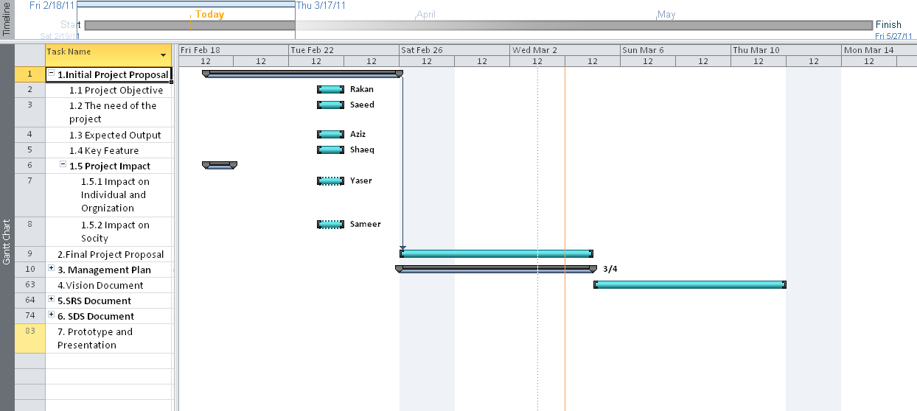

Figure 2: Schedule Allocation (1/6)

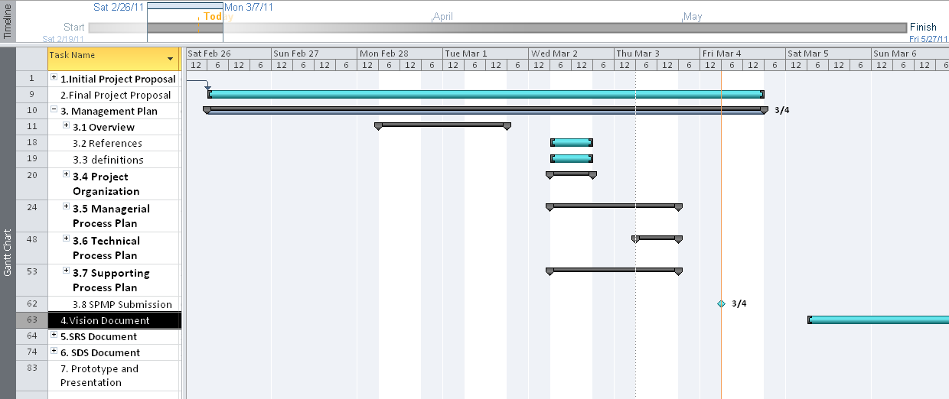

Figure 3: Resource Allocation (2/6)

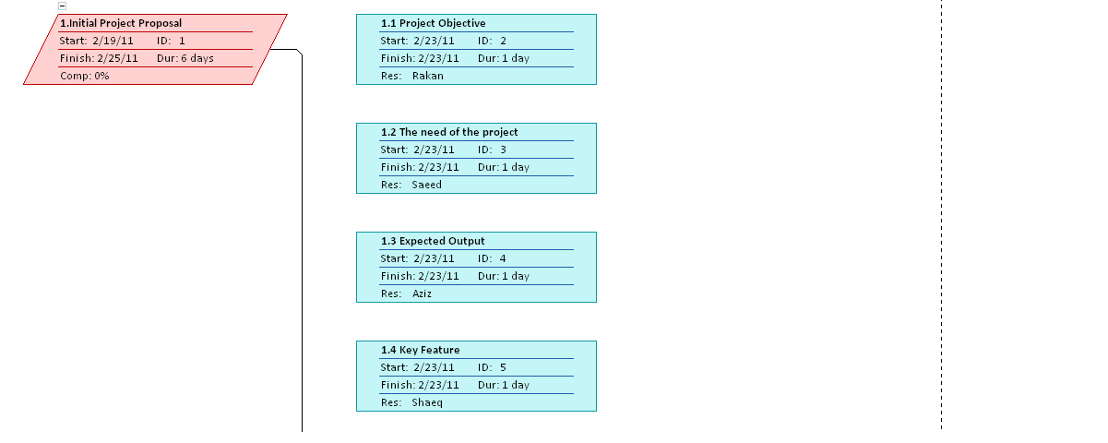

Figure 4: Resource Allocation (3/6)

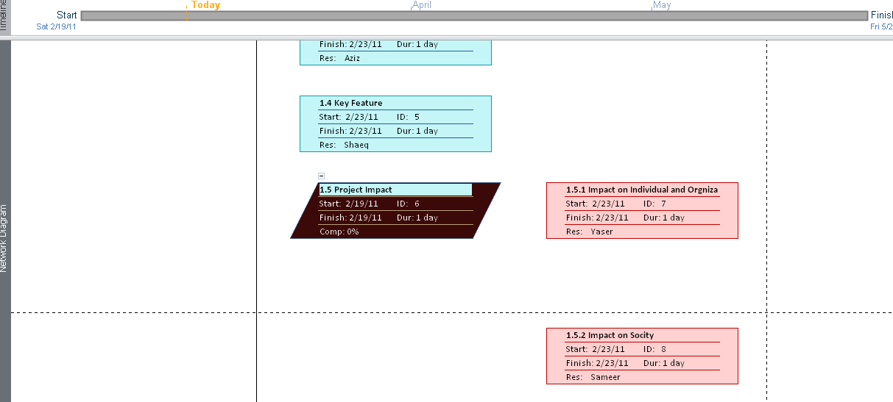

Figure 5: Resource Allocation (4/6)

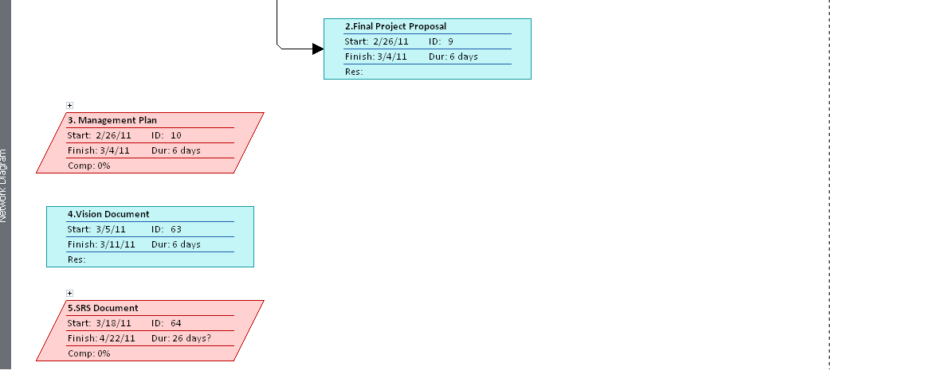

Figure 6: Resource Allocation (5/6)

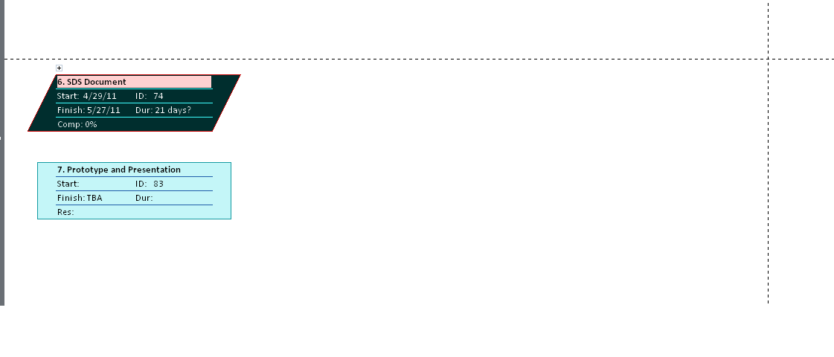

Figure 7: Resource Allocation (6/6)

# Use case model

## Use case Diagram

### 6.1.1 OGCT member view

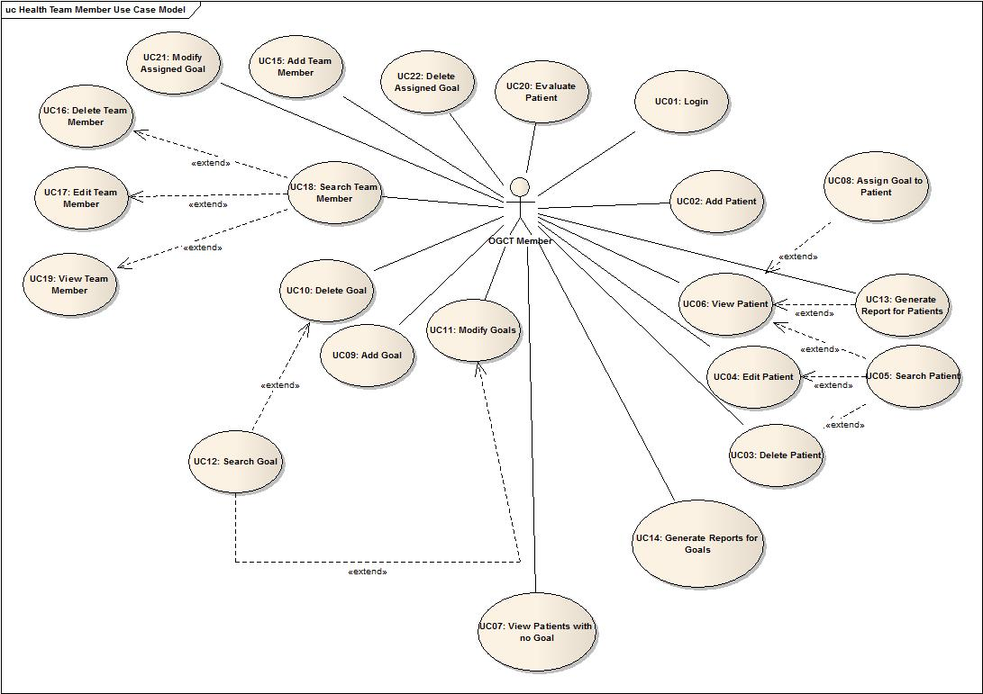

Figure 8: Use case Diagram (OGCT members’ view)

### 6.1.2 Patients view

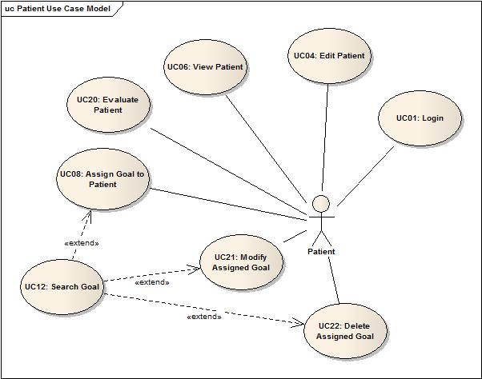

Figure 9: Use Case Diagram (Patients’ view)

## Use case description

|  |  |  |
| --- | --- | --- |
| **Use Case Number** | UC01 | |
| **Use Case Name** | Login | |
| **Author** | Saeed Al-Tuwaileb | |
| **Date of Creation** | 07-April-11 | |
| **Precondition(s)** | OGCT member or patient have a valid username and password. | |
| **Successful Post Condition** | OGCT member or patient will be logged-in into the system successfully. | |
| **Failed Post Condition** | OGCT member or patient will not be able to login to the system. | |
| **Related Use Cases** | None. | |
| **Actors** | * OGCT member. * Patient. | |
| **Priority** | High | |
| **Trigger** | OGCT member or patient want to access the system’s functionalities when clicking on login. | |
| **Flow of Events** | **Flow** | |
| **Step Number** | **Steps** |
| 1 | User clicks login. |
| 2 | OGCS prompts User to enter:   * Username * Password * Account Type |
| 3 | User enters:   * Username * Password * Account Type   And confirms the entered information.  A1: User forgot username or password. |
| 4 | OGCS will allow User to login to the system successfully, and show the relevant main screen of User and use case ends.  A3: Invalid username or password.  E1: System is not accessible. |
| **Alternate Flow A1: User forgot username or password.** | |
| 1 | User initiates the process that he forgot the username or password. |
| 2 | OGCS prompts User to enter his/her e-mail address that is stored in the User’s profile and chooses to retrieve the required information. |
| 3 | User enters his/her e-mail address. |
| 4 | OGCS shows a message saying that username and password have been sent successfully.  A2: E-mail address does not exist. |
| **Alternate Flow A2: E-mail address does not exist.** | |
| 1 | OGCS shows a message saying that the entered e-mail address does not exist in the system. |
| 2 | User confirms and the flow returns back to Alternate flow 1 step 2. |
| **Alternate Flow A3: Invalid username or password** | |
| 1 | OGCS shows a message saying that username or password is invalid |
| 2 | The flow returns back to Basic flow step 2. |
| **Error Flow E1: System is not accessible.** | |
| 1 | System shows a message saying that the system is not accessible and use case ends. |

|  |  |  |
| --- | --- | --- |
| **Use Case Number** | UC02 | |
| **Use Case Name** | Add patient | |
| **Author** | Sameer Al-Amri & Abdulaziz Alamoudi | |
| **Date of Creation** | 31-May-11 | |
| **Precondition(s)** | No username should exist matching the entered username. | |
| **Successful Post Condition** | A username and password are created for the patient. | |
| **Failed Post Condition** | Username and password are not created for the patient. | |
| **Related Use Cases** | None. | |
| **Actors** | OGCT member. | |
| **Priority** | High | |
| **Trigger** | The profile creation UI for patients is displayed to the OGCT member. | |
| **Flow of Events** | **Basic Flow** | |
| **Step Number** | **Steps** |
| 1 | The OGCT member requests to create a profile for the patient. |
| 2 | The OGCS prompts the OGCT member to enter the following:   * Patient’s username. * Password. |
| 3 | OGCT member enters the required information and submits it. |
| 4 | OGCS displays a confirmation message that the profile is created and the use case ends.   * A1: Username already exists in the OGCS. * A2: Password not accepted. |
| **Alternate Flow A1: Username already exists in the OGCS.** | |
| 1 | OGCS displays a message saying that the account already exists. |
| 2 | OGCT confirms and the flow goes back to step 3 of the main flow. |
| **Alternate Flow A2: Password not accepted.** | |
| 1 | OGCS displays a message that the password is not accepted. |
| 2 | OGCT confirms the message and the flow goes back to step 3 of the main flow. |
| **Error Flow E1: System failure.** | |
| 1 | The OGCS displays an error message. |
| 2 | The OGCT member confirms and the use case ends. |

|  |  |  |
| --- | --- | --- |
| **Use Case Number** | UC03 | |
| **Use Case Name** | Delete Patient | |
| **Author** | Abdulaziz Alamoudi | |
| **Date of Creation** | 31-May-11 | |
| **Precondition(s)** | The patient should already exist in the OGCS. | |
| **Successful Post Condition** | The patient’s profile and account is deleted from OGCS. | |
| **Failed Post Condition** | The patient’s profile and account is not deleted from OGCS. | |
| **Related Use Cases** | UC05: Search Patient | |
| **Actors** | OGCT member | |
| **Priority** | High | |
| **Trigger** | The patient’s profile is displayed. | |
| **Flow of Events** | **Basic Flow** | |
| **Step Number** | **Steps** |
| 1 | The OGCT member will select a patient’s profile and then deletes it.   * A1: The OGCT member wants to search for a patient. |
| 2 | The OGCS will prompt the OGCT member to confirm the deletion process. |
| 3 | The OGCT member will confirm the deletion.   * A2: The OGCT member cancels the operation. |
| 4 | The OGCS will delete the patient and the use case ends.   * E1: System Failure. |
| **Alternate Flow A1: The OGCT member wants to search for a patient** | |
| 1 | UC05 Search Patient is executed and the flow goes to step 1 of the main flow. |
| **Alternate Flow A2: The OGCT member cancels the operation** | |
| 1 | The OGCT member cancels the operation |
| 2 | The OGCS cancels the operation and goes back to step 1 of the main flow. |
| **Error Flow E1: System Failure** | |
| 1 | The OGCS displays an error message. |
| 2 | The OGCT member confirms and the use case ends. |

|  |  |  |
| --- | --- | --- |
| **Use Case Number** | UC04 | |
| **Use Case Name** | Edit Patient | |
| **Author** | Abdulaziz Alamoudi | |
| **Date of Creation** | 31-May-11 | |
| **Precondition(s)** | The patient should already exist in the OGCS. | |
| **Successful Post Condition** | The patient’s personal information is updated. | |
| **Failed Post Condition** | The patient’s personal information is not updated. | |
| **Related Use Cases** | UC05: Search Patient. | |
| **Actors** | * OGCT member * Patient | |
| **Priority** | High | |
| **Trigger** | The patient’s profile is displayed. | |
| **Flow of Events** | **Basic Flow** | |
| **Step Number** | **Steps** |
| 1 | The user (OGCT member or patient) will view the patient’s profile and updates the required fields.   1. First name. 2. Last name. 3. Date of birth. 4. Gender. 5. Mobile. 6. Email. 7. Weight. 8. Height. 9. BMI. 10. Aramco ID.  * A1: The user wants to search for a patient. |
| 2 | The OGCS will save the edited information and the use case ends.   * E1: System Failure |
| **Alternate Flow A1: The OGCT member wants to search for a patient** | |
| 1 | UC05 Search Patient is executed and the flow goes to step 1 of the main flow. |
| **Error Flow E1: System Failure** | |
| 1 | The OGCS displays an error message. |
| 2 | The OGCT member confirms and the use case ends. |

|  |  |  |
| --- | --- | --- |
| **Use Case Number** | UC05 | |
| **Use Case Name** | Search Patient | |
| **Author** | Saeed Al-Tuwaileb & Abdulaziz Alamoudi | |
| **Date of Creation** | 07-April-11 | |
| **Precondition(s)** | OGCT member is logged-in the system. | |
| **Successful Post Condition** | OGCS shows the result of searching for a patient. | |
| **Failed Post Condition** | Search result will not be returned due to database error or patient does not exist. | |
| **Related Use Cases** | * UC03. Delete Patient * UC04. Edit Patient * UC06. View Patient | |
| **Actors** | OGCT member. | |
| **Priority** | High | |
| **Trigger** | OGCT member clicks search patient. | |
| **Flow of Events** | **Basic Flow** | |
| **Step Number** | **Steps** |
| 1 | OGCT member requests to search for a patient. |
| 2 | OGCS prompts OGCT member to enter one or more of the following search criteria:   * First Name * Last Name * ARAMCO ID * Gender |
| 3 | OGCT member enters one or more search criteria:   * First Name * Last Name * ARAMCO ID * Gender   And confirms the search request. |
| 4 | OGCS returns the search result based on the entered criteria and use case ends.  A1: No result returned.  E1: Database is not accessible. |
| **Alternate Flow A1: No result returned** | |
| 1 | OGCS shows a message saying that patient with the entered criteria does not exist. |
| 2 | OGCT member confirms the message and the flow returns back to Basic flow step 2. |
| **Error Flow E1: Database is not accessible.** | |
| 1 | System shows a message saying that the database is not accessible and use case ends. |

|  |  |  |
| --- | --- | --- |
| **Use Case Number** | UC06 | |
| **Use Case Name** | View Patient | |
| **Author** | Abdulaziz Alamoudi | |
| **Date of Creation** | 31-March-2011 | |
| **Precondition(s)** | The patient should already exist in the OGCS. | |
| **Successful Post Condition** | The patient’s profile is displayed. | |
| **Failed Post Condition** | The patient’s profile is not displayed. | |
| **Related Use Cases** | UC05: Search Patient  UC08: Assign Goal to Patient  UC13: Generate Report for Patients | |
| **Actors** | * OGCT member * Patient | |
| **Priority** | High | |
| **Trigger** | None | |
| **Flow of Events** | **Basic Flow** | |
| **Step Number** | **Steps** |
| 1 | The user (OGCT member or patient) chooses to view the patient’s profile that contains his personal information and work progress.   * A1: Search for a patient (if the user was an OGCT member). |
| 2 | The OGCS displays the patient’s profile.   * E1: System failure. |
| 3 | The user might do the following:   * A2: Assign Goal to a patient. * A3: Generate report for a patient (if the user was an OGCT member)   The use case ends. |
| **Alternate Flow A1: Search for a patient** | |
| 1 | The OGCS executes UC05 Search Patient. |
| **Alternate Flow A2: Assign Goal to a patient** | |
| 1 | The OGCS executes UC08 Assign Goal to Patient. |
| **Alternate Flow A3: Generate report for a patient** | |
| 1 | The OGCS executes UC13 Generate Report for Patients. |
| **Error Flow E1: System failure.** | |
| 1 | The OGCS displays an error message. |
| 2 | The user confirms and the use case ends. |

|  |  |  |
| --- | --- | --- |
| **Use Case Number** | UC07 | |
| **Use Case Name** | View patient with no goals. | |
| **Author** | Sameer Al-Amri & Abdulaziz Alamoudi | |
| **Date of Creation** | 31-March-11 | |
| **Precondition(s)** | * OGCT member successfully login into the OGCS. * Patient already exists in OGCS. | |
| **Successful Post Condition** | Patient(s) with no goals list are displayed to the OGCT member successfully. | |
| **Failed Post Condition** | The list of patients is not displayed | |
| **Related Use Cases** | None | |
| **Actors** | OGCT member | |
| **Priority** | Moderate | |
| **Trigger** | OGCT member chooses to “View Patients with no goals” | |
| **Flow of Events** | **Basic Flow** | |
| **Step Number** | **Steps** |
| 1 | The OGCT member requests to view all the patients with no goals. |
| 2 | OGCS displays a list of patients with no goals and use case ends.   * A1: No such patient exists. * E1: System failure |
| **Alternate Flow A1: No such patient exists** | |
| 1 | OGCS displays a message saying that no such patient exists. |
| 2 | OGCT member confirms and use case ends. |
| **Error Flow E1: System failure.** | |
| 1 | The OGCS displays an error message. |
| 2 | The OGCT member confirms and the use case ends. |

|  |  |  |
| --- | --- | --- |
| **Use Case Number** | UC08 | |
| **Use Case Name** | Assign Goal to Patient | |
| **Author** | Abdulaziz Alamoudi | |
| **Date of Creation** | 1-May-11 | |
| **Precondition(s)** | Both the patient and the goal should already exist. | |
| **Successful Post Condition** | A goal is assigned to a patient. | |
| **Failed Post Condition** | The goal is not assigned to a patient. | |
| **Related Use Cases** | * UC06: View Patient * UC12: Search Goal | |
| **Actors** | * OGCT member * Patient | |
| **Priority** | High | |
| **Trigger** | The patient’s profile should be displayed. | |
| **Flow of Events** | **Basic Flow** | |
| **Step Number** | **Steps** |
| 1 | The user (OGCT member or patient) requests to assign a goal to patient.   * A1: Search Goal |
| 2 | The OGCS displays the list of goals.   * E1: System failure. |
| 3 | The user selects the goal, fills the required fields and confirms the goal assignment.   * A2: The user cancels the process. |
| 4 | The OGCS assigns the goal to the patient and the use case ends. |
| **Alternate Flow A1: Search Goal** | |
| 1 | OGCS executes UC 12 Search Goal. |
| **Alternate Flow A2: The user cancels the process** | |
| 1 | The user cancels the process. |
| 2 | The OGCS displays the patient’s profile and the use case ends. |
| **Error Flow E1: System failure** | |
| 1 | The OGCS displays an error message. |
| 2 | The user confirms and the use case ends. |

|  |  |  |
| --- | --- | --- |
| **Use Case Number** | UC09 | |
| **Use Case Name** | Add Goal | |
| **Author** | Sameer Alamri | |
| **Date of Creation** | 31-May-11 | |
| **Precondition(s)** | The goal shouldn’t exist in the OGCS.  The OGCT Member Successfully login. | |
| **Successful Post Condition** | -The goal is added to the OGCS and can be assigned to a patient.  -The goal can be viewed and modified later. | |
| **Failed Post Condition** | The goal is not added to OGCS. | |
| **Related Use Cases** | UC08: Assign Goal to patient  UC14: Generate Report for goal | |
| **Actors** | OGCT member | |
| **Priority** | High | |
| **Trigger** | The list of goals is displayed. | |
| **Flow of Events** | **Basic Flow** | |
| **Step Number** | **Steps** |
| 1 | The OGCT member is going to request to add a goal. |
| 2 | The OGCS asks OGCT member to select type of the goal.   1. Incremenatory 2. Decrementory |
| 3 | The OGCT member chooses the goal type. |
| 4 | The OGCS asks the OGCT Member to enter  Goal information:  Goal Name.  Goal Description.  Goal MaxPointScale  Goal MinPointScale. |
| 5 | The OGCT Member enters the information then proceeds.  A1: The OGCT member resets the fields.  A2: The OGCT member cancels the addition of the goal. |
| 6 | The OGCS creates the goal and the use case ends.  A3: Similar goal already exists.  E1: System failure. |
| **Alternate Flow A1: The OGCT member resets the fields** | |
| 1 | The OGCT member chooses to reset all fields. |
| 2 | The OGCS empties all fields and the flow goes back to step 4 of the main flow. |
| **Alternate Flow A2: The OGCT member cancels the addition of the goal** | |
| 1 | The OGCT member chooses to cancel the addition of a goal. |
| 2 | The addition process is cancelled and the use case ends. |
| **Alternate Flow A3: Similar goal already exists** | |
| 1 | The OGCS notifies the OGCT member that a similar goal already exists. |
| 2 | The user chooses to search for this goal. |
| 3 | The OGCS executes UC12 Search Goal and the use case ends. |
| **Error Flow E1: System failure.** | |
| 1 | The OGCS displays an error message. |
| 2 | The OGCT member confirms and the use case ends. |

|  |  |  |
| --- | --- | --- |
| **Use Case Number** | UC10 | |
| **Use Case Name** | Delete Goal | |
| **Author** | Sameer AlAmri. | |
| **Date of Creation** | 1-June-11 | |
| **Precondition(s)** | The goal should already exist in the OGCS. | |
| **Successful Post Condition** | The goal is deleted from OGCS. | |
| **Failed Post Condition** | The goal is not deleted from OGCS. | |
| **Related Use Cases** | UC12: Search Goal. | |
| **Actors** | OGCT member. | |
| **Priority** | High | |
| **Trigger** | A list of goal is displayed. | |
| **Flow of Events** | **Basic Flow** | |
| **Step Number** | **Steps** |
| 1 | The OGCS will display a list of goals.  A1: OGCT member searches for a goal. |
| 2 | The OGCT member will delete the goal. |
| 3 | The OGCS will display a confirmation message. |
| 4 | The OGCT member will confirm the deletion.  A2: The OGCT member cancels the operation. |
| 5 | The OGCS will delete the goal and the use case ends.  E1: System failure |
| **Alternate Flow A1: OGCT member searches for a goal** | |
| 1 | UC12 Search Goal is executed. |
| **Alternate Flow A2: The OGCT member cancels the operation** | |
| 1 | The OGCT member cancels the operation. |
| 2 | The OGCS cancels the operation and goes back to step 1 of the main flow. |
| **Error Flow E1: System failure.** | |
| 1 | The OGCS displays an error message. |
| 2 | The OGCT member confirms and the use case ends. |

|  |  |  |
| --- | --- | --- |
| **Use Case Number** | UC11 | |
| **Use Case Name** | Modify Goals | |
| **Author** | Sameer Alamri | |
| **Date of Creation** | 1-June-11 | |
| **Precondition(s)** | The goal that is going to be modified should exist in the OGCS. | |
| **Successful Post Condition** | The goal modification here doesn’t necessarily indicate that the goal needs to be updated only. The goal modification might be done while assigning the goal to the patient but it won’t change the original information. | |
| **Failed Post Condition** | Failure of goal modification process. | |
| **Related Use Cases** | UC12: Search Goal | |
| **Actors** | OGCT member | |
| **Priority** | High | |
| **Trigger** | The goals Description and scale are displayed. | |
| **Flow of Events** | **Basic Flow** | |
| **Step Number** | **Steps** |
| 1 | The OGCT member is going to select the goal that needs to be changed.  A1: The OGCT member wants to search for a goal. |
| 2 | The system will display the goal’s related information.  E1: System Failure. |
| 3 | The OGCT member will change the information that he/she needs and confirms the changes.  Changes :  Goal Scale.  Goal Description. |
| 4 | The OGCS updates the modified fields and the use case ends.  A2: The MinPoint greater than MaxPoint |
| **Alternate Flow A1: The OGCT member wants to search for a goal.** | |
| 1 | UC12 Search Goal is executed. |
| **Alternate Flow A2:** **The MinPoint greater than MaxPoint** | |
| 1 | The OGCS displays a message saying that a MinPointScale is greater than MaxPointScale. |
| 2 | The OGSC confirms the message and the flow returns back to basic flow step 3. |
| **Error Flow E1: System Failure.** | |
| 1 | The system displays error message. |
| 2 | The OGCT member confirms and the use case ends. |

|  |  |  |
| --- | --- | --- |
| **Use Case Number** | UC12 | |
| **Use Case Name** | Search Goal | |
| **Author** | Sameer Alamri. | |
| **Date of Creation** | 1-June-11 | |
| **Precondition(s)** | None | |
| **Successful Post Condition** | The goals that fit the query are displayed. | |
| **Failed Post Condition** | No results were found. | |
| **Related Use Cases** | UC10: Delete Goal  UC11: Modify Goal | |
| **Actors** | OGCT member | |
| **Priority** | High | |
| **Trigger** | The goal screen is displayed. | |
| **Flow of Events** | **Basic Flow** | |
| **Step Number** | **Steps** |
| 1 | The OGCT member is going to enter the search criteria.  -Keyword.  -Type.  -Checkbox (most popular, most successful and most failed). |
| 2 | The OGCS is going to display a filtered list of goals.  A1: The intended goal was not found.  E1: System Failure. |
| 3 | The OGCT member is going to select the intended goal and the use case ends. |
| **Alternate Flow A1: The intended goal was not found.** | |
| 1 | The OGCS couldn’t find the required results. Then the flow goes back to step 1 of the main flow. |
| **Error Flow E1: System Failure** | |
| 1 | The OGCS displays an error message. |
| 2 | The OGCT member confirms and the use case ends. |

|  |  |  |
| --- | --- | --- |
| **Use Case Number** | UC13 | |
| **Use Case Name** | Generate Report for Patient. | |
| **Author** | Sameer Al-Amri | |
| **Date of Creation** | 1-June-11 | |
| **Precondition(s)** | OGCT member is logged-in the system. | |
| **Successful Post Condition** | OGCS shows the report to OGCT member. | |
| **Failed Post Condition** | Report is not generated by OGCS. | |
| **Related Use Cases** | None. | |
| **Actors** | OGCT member. | |
| **Priority** | High | |
| **Trigger** | OGCT member clicks on Patient Reports. | |
| **Flow of Events** | **Basic Flow** | |
| **Step Number** | **Steps** |
| 1 | OGCT member clicks on Patient Reports. |
| 2 | OGCS shows the patient report page and prompts OGCT member to select patient report type:  Success Ratio  Dropout Ratio  No Goals Assigned |
| 3 | OGCT member selects one of the patient reports type:  Success Ratio  Dropout Ratio  No Goals Assigned |
| 4 | OGCS prompts OGCT member to select and fill in one or more of the following report criteria:  Age  Weight  BMI  And to select the report period:  Report Period  Current Month  Last Month  Current week  Last Week |
| 5 | OGCT member  Select and fill in the report criteria  Select the report period And clicks Generate. |
| 6 | OGCS generates and shows the report based on the entered report type, criteria, and period with the appropriate graphical representation of data.  A1: No records match report criteria.  A2: Save Report.  E1: Database is not accessible. |
| **Alternate Flow A1: No records match report criteria.** | |
| 1 | OGCS shows a message saying that no records match the report criteria. |
| 2 | OGCT member confirms the message and the flow returns back to Basic flow step 4. |
| **Alternate Flow A2: Save Report.** | |
| 1 | OGCT member clicks on save report. |
| 2 | OGCS shows a message saying that the report has been saved successfully. And the flow returns back to Basic flow step 2. |
| **Error Flow E1: Database is not accessible.** | |
| 1 | System shows a message saying that the database is not accessible and use case ends. |

|  |  |  |
| --- | --- | --- |
| **Use Case Number** | UC14 | |
| **Use Case Name** | Generate Reports for Goals | |
| **Author** | Sameer Al-Amri | |
| **Date of Creation** | 01-June-11 | |
| **Precondition(s)** | OGCT member is logged-in the system. | |
| **Successful Post Condition** | OGCS shows the report to OGCT member. | |
| **Failed Post Condition** | Report is not generated by OGCS. | |
| **Related Use Cases** | None. | |
| **Actors** | OGCT member. | |
| **Priority** | High | |
| **Trigger** | OGCT member clicks on Goals Reports. | |
| **Flow of Events** | **Basic Flow** | |
| **Step Number** | **Steps** |
| 1 | OGCT member clicks on Goals Reports. |
| 2 | OGCS shows the goals report page and prompts OGCT member to select goal report type:  Most Chosen Goals  Most Successful Goals  Number of chosen goals and relation to outcome. |
| 3 | OGCT member selects one of the goals reports type. |
| 4 | OGCS prompts OGCT member to select and fill in one or more of the following report criteria:  Patients’ Age Range  Weight Range  BMI Range  A1: Generate report without report criteria. |
| 5 | OGCT member Selects and fills in the report criteria. |
| 6 | OGCS prompts OGCT member to select the report period:  Report Period  Current Month  Last Month  Current week  Last Week |
| 7 | OGCT member selects the report period and clicks Generate. |
| 8 | OGCS generates and shows the report based on the entered report type, criteria, and period with the appropriate graphical representation of data.  A2: No records match report criteria.  A3: Save Report.  E1: Database is not accessible. |
| **A1: Generate report without report criteria.** | |
| 1 | OGCT member clicks on Generate report without entering report criteria and the flow returns back to Basic flow step 6. |
| **Alternate Flow A2: No records match report criteria.** | |
| 1 | OGCS shows a message saying that no records match the report criteria. |
| 2 | OGCT member confirms the message and the flow returns back to Basic flow step 4. |
| **Alternate Flow A3: Save Report.** | |
| 1 | OGCT member clicks on save report. |
| 2 | OGCS shows a message saying that the report has been saved successfully. And the flow returns back to Basic flow step 2. |
| **Error Flow E1: Database is not accessible.** | |
| 1 | System shows a message saying that the database is not accessible and use case ends. |

|  |  |  |
| --- | --- | --- |
| **Use Case Number** | UC15 | |
| **Use Case Name** | Add Team Member | |
| **Author** | Sameer Al-Amri | |
| **Date of Creation** | 1-June-11 | |
| **Precondition(s)** | * OGCT Member (Admin) successfully login into the OGCS. * The new OGCT member does not already exist in the OGCS. | |
| **Successful Post Condition** | OGCT member is added to the OGCS successfully. | |
| **Failed Post Condition** | OGCT member is not added to the OGCS. | |
| **Related Use Cases** | None. | |
| **Actors** | OGCT Member (Admin). | |
| **Priority** | High | |
| **Trigger** | New OGCT member join the OGC program staff | |
| **Flow of Events** | **Basic Flow** | |
| **Step Number** | **Steps** |
| 1 | OGCS prompts the user to enter the following information:  First name  Last name  Date of birth  Gender  E-Mail  Phone Number  Aramco ID  Username  Password |
| 2 | OGCT Member (Admin) enters all the required information |
| 3 | OGCS display message saying that the new OGCT member has been added successfully to the OGCS.  A1: OGCT member already exists in the OGCS. |
| 4 | OGCT Member (Admin) confirms the message and use case ends. |
| **Alternate Flow A1: OGCT member is already exist in the OGCS** | |
| 1 | OGCS displays a message saying that the OGCT member already exists. |
| 2 | OGCT Member (Admin) confirms and the flow returns to step 1 of the basic flow |

|  |  |  |
| --- | --- | --- |
| **Use Case Number** | UC16 | |
| **Use Case Name** | Delete Team Member | |
| **Author** | Sameer Al-Amri | |
| **Date of Creation** | 1-June-11 | |
| **Precondition(s)** | * OGCT member (Admin) successfully login into the OGCS. * The OGCT member exists in the OGCS. | |
| **Successful Post Condition** | OGCT member is deleted from the OGCS successfully. | |
| **Failed Post Condition** | OGCT member is not deleted to the OGCS. | |
| **Related Use Cases** | UC18: Search Team Member. | |
| **Actors** | OGCT member (Admin). | |
| **Priority** | Medium | |
| **Trigger** | OGCT member leaves the OGC program. | |
| **Flow of Events** | **Basic Flow** | |
| **Step Number** | **Steps** |
| 1 | “UC18: Search Team Member” is executed |
| 2 | OGCT member (Admin) chooses to delete OGCT member. |
| 3 | OGCS displays message saying that following OGCT member (Admin) will be deleted.  A1: OGCT member deleted is an admin. |
| 4 | OGCT member (Admin) confirms and use case ends.  A2: OGCT member (Admin) does not confirm. |
| **Alternate Flow A1: OGCT member (Admin) deleted is an admin.** | |
| 1 | OGCS displays a message saying that the OGCT member (Admin) deleted is an admin and prompts the OGCT member (Admin) to choose another admin. |
| 2 | OGCT Member (Admin) confirms and flow returns back to basic flow step 4. |
| **Alternate Flow A2: OGCT member (Admin) does not confirm.** | |
| 1 | OGCT member (Admin) does not confirm. |
| 2 | OGCS returns the flow to basic flow step 1. |

|  |  |  |
| --- | --- | --- |
| **Use Case Number** | UC17 | |
| **Use Case Name** | Edit Team Member | |
| **Author** | Sameer Al-Amri | |
| **Date of Creation** | 1-June-11 | |
| **Precondition(s)** | OGCT member (Admin) successfully login into the OGCS. | |
| **Successful Post Condition** | OGCT member information is updated in the OGCS successfully. | |
| **Failed Post Condition** | OGCT member profile is not updated in the OGCS. | |
| **Related Use Cases** | UC18: Search Team Member. | |
| **Actors** | OGCT member (Admin). | |
| **Priority** | Medium. | |
| **Trigger** | OGCT member (Admin) chooses to changes OGCT member information. | |
| **Flow of Events** | **Basic Flow** | |
| **Step Number** | **Steps** |
| 1 | “UC18: Search Team Member” is executed |
| 2 | OGCT member (Admin) chooses to modify OGCT member. |
| 3 | OGCS displays OGCT member profile with enabled editing filed. |
| 4 | OGCT member (Admin) edits the OGCT member profile and confirms.  A1: Member with similar information exists in the system |
| 6 | OGCS display the updated profile. |
| 7 | OGCT member (Admin) confirms and use case ends. |
| **Alternate Flow A1: Member with similar information exists in the system** | |
| 1 | OGCT member (Admin) confirms the message. |
| 2 | OGCS returns the flow to basic flow step 1. |

|  |  |  |
| --- | --- | --- |
| **Use Case Number** | UC18 | |
| **Use Case Name** | Search Team Member | |
| **Author** | Sameer Al-Amri | |
| **Date of Creation** | 1-June-11 | |
| **Precondition(s)** | OGCT member is logged-in the OGCS successfully. | |
| **Successful Post Condition** | OGCS shows the result of searching for OGCT member. | |
| **Failed Post Condition** | None | |
| **Related Use Cases** | OGCT member(Admin) :  UC 16: Delete Team Member  UC 17: Edit Team Member  UC 19: View Team Member  OGCT member :  UC 19: View Team Member | |
| **Actors** | OGCT member. | |
| **Priority** | High | |
| **Trigger** | OGCT member chooses to search. | |
| **Flow of Events** | **Basic Flow** | |
| **Step Number** | **Steps** |
| 1 | OGCS prompts the user to enter one or more of the following search criteria:  First Name  Last Name  ARAMCO ID |
| 2 | User enters OGCT member to enter one or more search criteria and confirms. |
| 3 | OGCS returns the search result based on the entered criteria and use case ends.  A1: No match found |
| **Alternate Flow A1: No match found** | |
| 1 | OGCS shows a message saying that patient with the entered criteria does not exist. |
| 2 | User confirms the message and the flow returns back to Basic flow step 2. |

|  |  |  |
| --- | --- | --- |
| **Use Case Number** | UC19 | |
| **Use Case Name** | View Team Member | |
| **Author** | Sameer Al-Amri | |
| **Date of Creation** | 1-June-11 | |
| **Precondition(s)** | OGCT member successfully login into the OGCS. | |
| **Successful Post Condition** | OGCT member information is displayed. | |
| **Failed Post Condition** | OGCT member information is not displayed. | |
| **Related Use Cases** | UC18: Search Team Member | |
| **Actors** | OGCT member. | |
| **Priority** | Medium | |
| **Trigger** | OGCT member wants to see OGCT member information. | |
| **Flow of Events** | **Basic Flow** | |
| **Step Number** | **Steps** |
| 1 | “UC18: Search Team Member” is executed |
| 2 | User selects the desired profile to be displayed. |
| 3 | OGCS displays OGCT member profile and use case ends. |

|  |  |  |
| --- | --- | --- |
| **Use Case Number** | UC20 | |
| **Use Case Name** | Evaluate Patient | |
| **Author** | Abdulaziz Alamoudi | |
| **Date of Creation** | 31-May-11 | |
| **Precondition(s)** | The patient’s profile should already exist. | |
| **Successful Post Condition** | The patient’s records are evaluated. | |
| **Failed Post Condition** | The patient’s record is not evaluated. | |
| **Related Use Cases** | None | |
| **Actors** | * OGCT member * Patient | |
| **Priority** | High | |
| **Trigger** | The patient’s progress table is displayed. | |
| **Flow of Events** | **Basic Flow** | |
| **Step Number** | **Steps** |
| 1 | The OGCS displays the patient’s profile.   * E1: System failure. |
| 2 | The user (OGCT member or patient) enters the patient’s progress for goals that he is working on. |
| 3 | The OGCS updates the patient’s progress table and the use case ends. |
| **Error Flow E1: System failure** | |
| 1 | The OGCS displays an error message. |
| 2 | The user confirms and the use case ends. |

|  |  |  |
| --- | --- | --- |
| **Use Case Number** | UC21 | |
| **Use Case Name** | Modify Assigned Goal. | |
| **Author** | Sameer Al-Amri | |
| **Date of Creation** | 1-June-11 | |
| **Precondition(s)** | * OGCT member or patient logged-in the OGCS successfully. * No Entry is existed in the first slot of the table of weekly assigned goal for the patient. | |
| **Successful Post Condition** | The weekly Frequency or MaxScale is updated successfully. | |
| **Failed Post Condition** | The weekly Frequency or MaxScale is not updated. | |
| **Related Use Cases** | UC 20: Evaluate Patient.  UC 08: Assign Goal To Patient. | |
| **Actors** | OGCT member or Patient. | |
| **Priority** | High | |
| **Trigger** | Patient wants to increase his performance. | |
| **Flow of Events** | **Basic Flow** | |
| **Step Number** | **Steps** |
| 1 | OGCS executes “UC06:View Patient” |
| 2 | User edits the frequency or MaxScale then proceed.  A1: Patient has no goal. |
| 3 | OGCS displays the updated goal table along with the updated entries.  A3: invalid entries. |
| **Alternate Flow A1: Patient has no goal** | |
| 1 | OGCS shows a message saying that patient has no goal.  A2: OGCS execute UC08. |
| 2 | User confirms the message and the flow return back to Basic flow step 1. |
| **Alternate Flow A2: OGCS execute UC08** | |
| 1 | OGCS execute “UC08 : Assign Goal To Patient” |
| **Alternate Flow A3: invalid entries** | |
| 1 | OGCS shows a message saying the frequency is greater than seven. |
| 2 | User confirms the message and the flow return back to Basic flow step 2. |

|  |  |  |
| --- | --- | --- |
| **Use Case Number** | UC22 | |
| **Use Case Name** | Delete Assigned Goal. | |
| **Author** | Sameer Al-Amri | |
| **Date of Creation** | 1-June-11 | |
| **Precondition(s)** | * OGCT member or patient logged-in the OGCS successfully. * Patient has a goal in progress. | |
| **Successful Post Condition** | The goal assigned is deleted for that patient. | |
| **Failed Post Condition** | Goal is not deleted. | |
| **Related Use Cases** | UC 20: Evaluate Patient.  UC 08: Assign Goal To Patient. | |
| **Actors** | OGCT member or Patient. | |
| **Priority** | High | |
| **Trigger** | Patient wants to drop certain goal. | |
| **Flow of Events** | **Basic Flow** | |
| **Step Number** | **Steps** |
| 1 | OGCS executes “UC06:View Patient” |
| 2 | User Selects goal/goals to drop then confirms. |
| 3 | OGCS displays the updated goal and use case ends. |

# State transition diagram

## Patient Profile management



Figure 10: Add Patient State Transition Diagram



Figure 11: Delete Patient State Transition Diagram



Figure 12: Edit Patient State Transition Diagram



Figure 13: Search Patient State Transition Diagram

## OGCT member profile management



Figure 14: Add OGCT member State Transition Diagram



Figure 15: Delete OGCT member State Transition Diagram



Figure 16: Edit OGCT member State Transition Diagram



Figure 17: Search OGCT member State Transition Diagram

## Follow-up reminders



Figure 18: Follow-Up Reminder State Transition Diagram

## Goals Management



Figure 19: Add Goal State Transition Diagram



Figure 20: Delete Goal State Transition Diagram



Figure 21: Edit Goal State Transition Diagram



Figure 22: Assign Goal State Transition Diagram (OGCT)



Figure 23: Assign Goal State Transition Diagram (Patient)

## Goals Suggestion



Figure 24: Goal Suggestion State Transition Diagram (OGCT View)

## Report Management



Figure 25: Report Management State Transition Diagram

## System

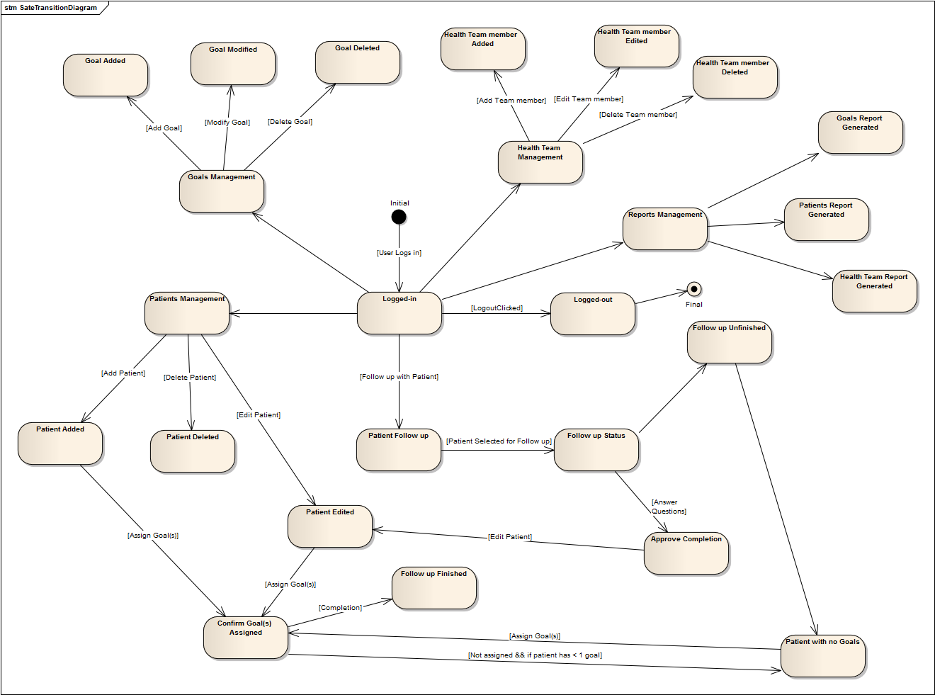

Figure 26: System State Transition Diagram

# Class model

## Class diagram

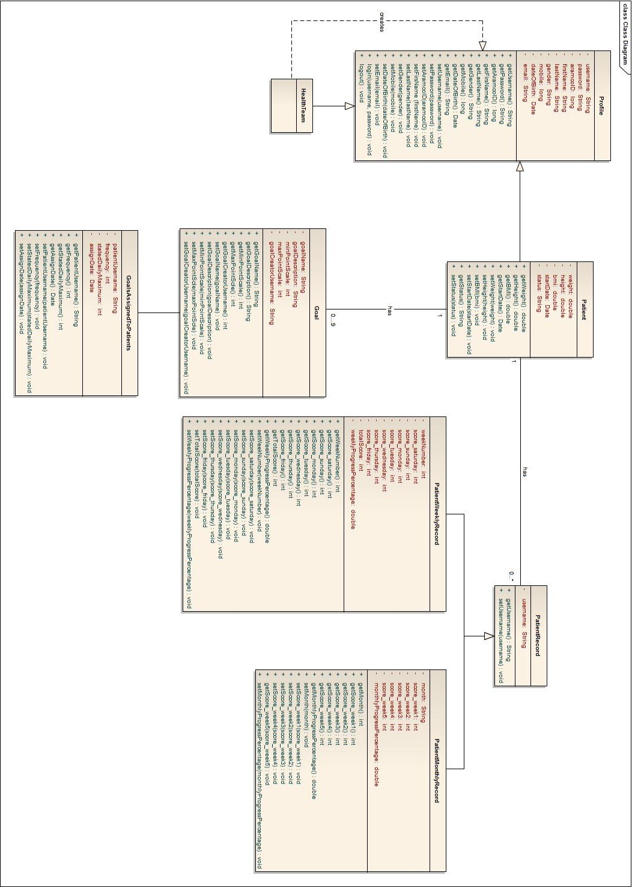

Figure 27: Class Diagram

# Sequence diagram model

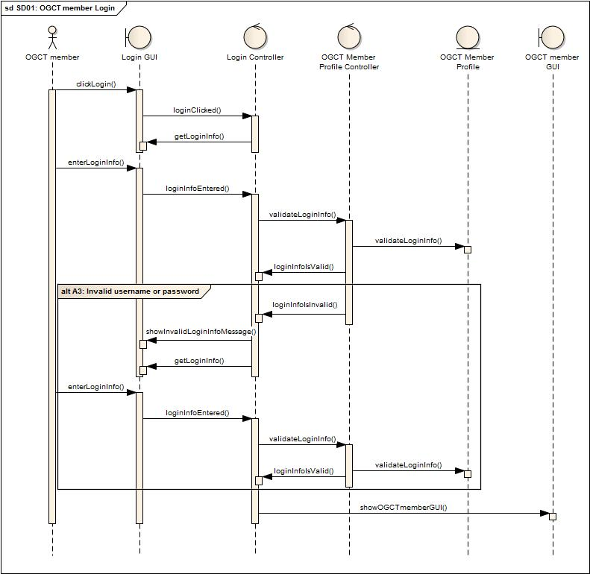

Figure 28: OGCT login Sequence Diagram

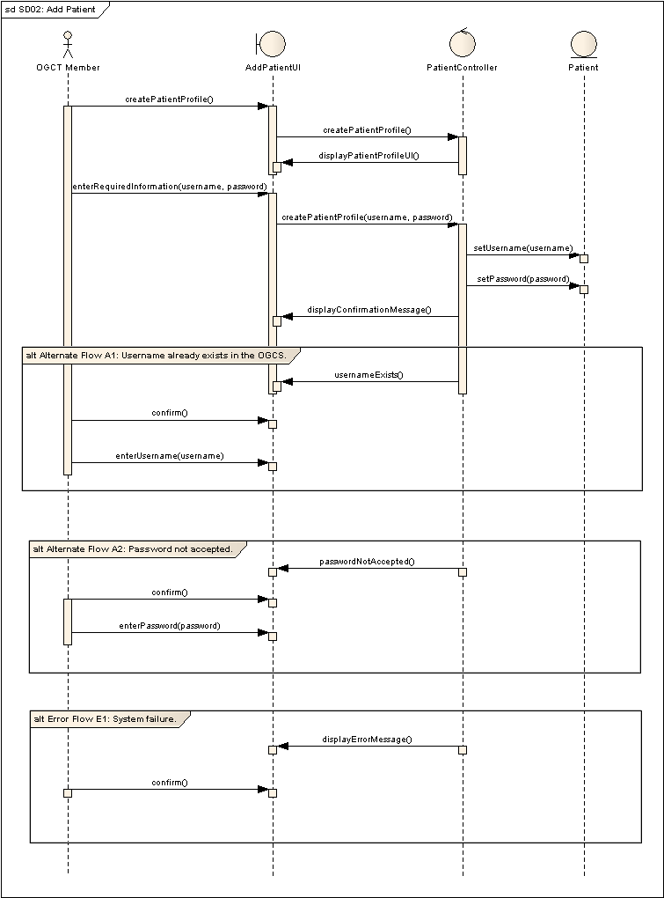

Figure 29: Add Patient Sequence Diagram

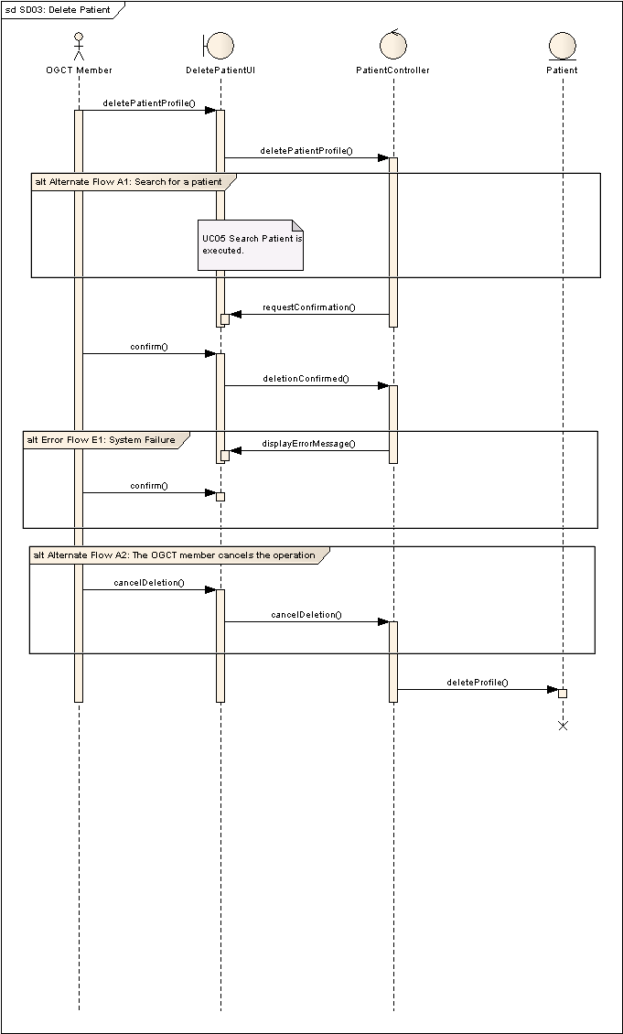

Figure 30: Delete Patient Sequence Diagram

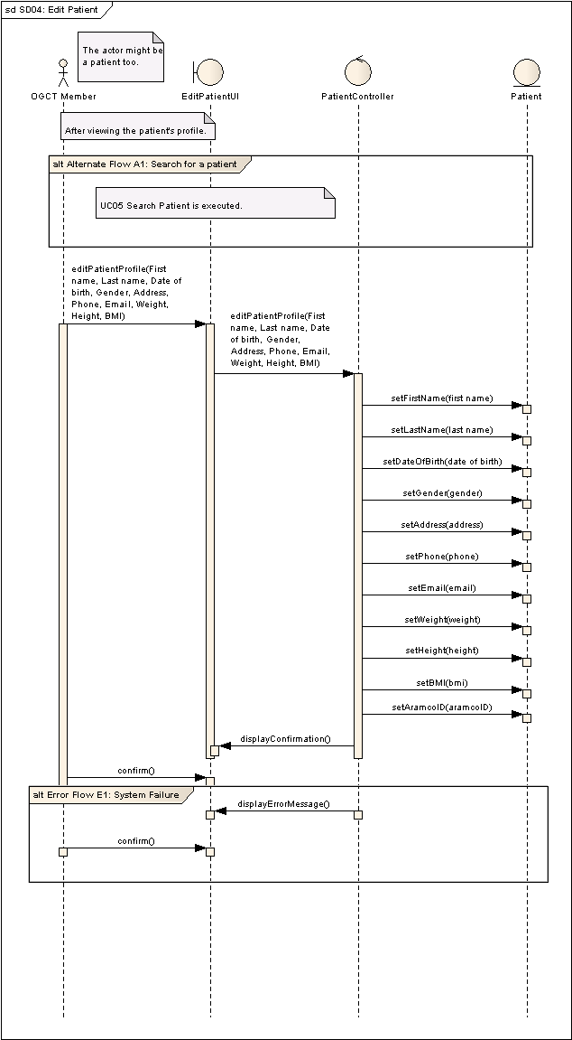

Figure 31: Edit Patient Sequence Diagram

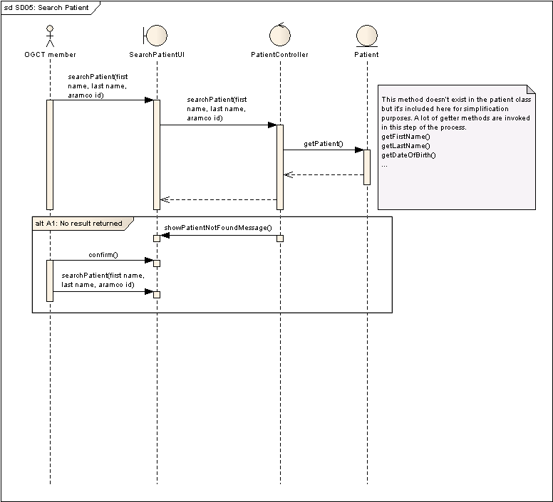

Figure 32: Search Patient Sequence Diagram

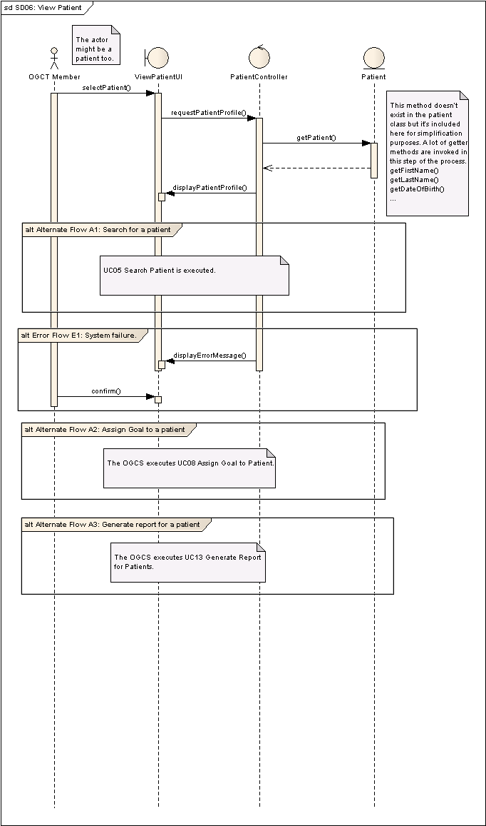

Figure 33: View Patient Sequence Diagram

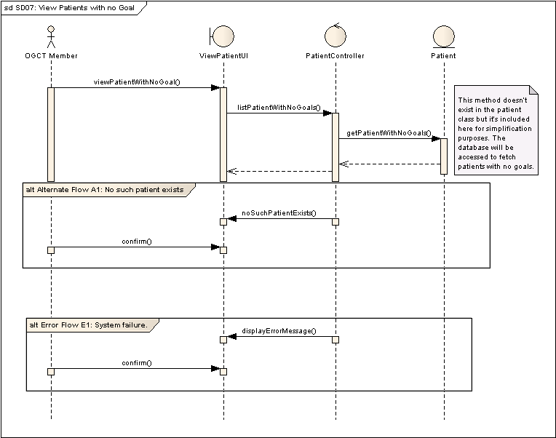

Figure 34: View Patient With No Goals Sequence Diagram

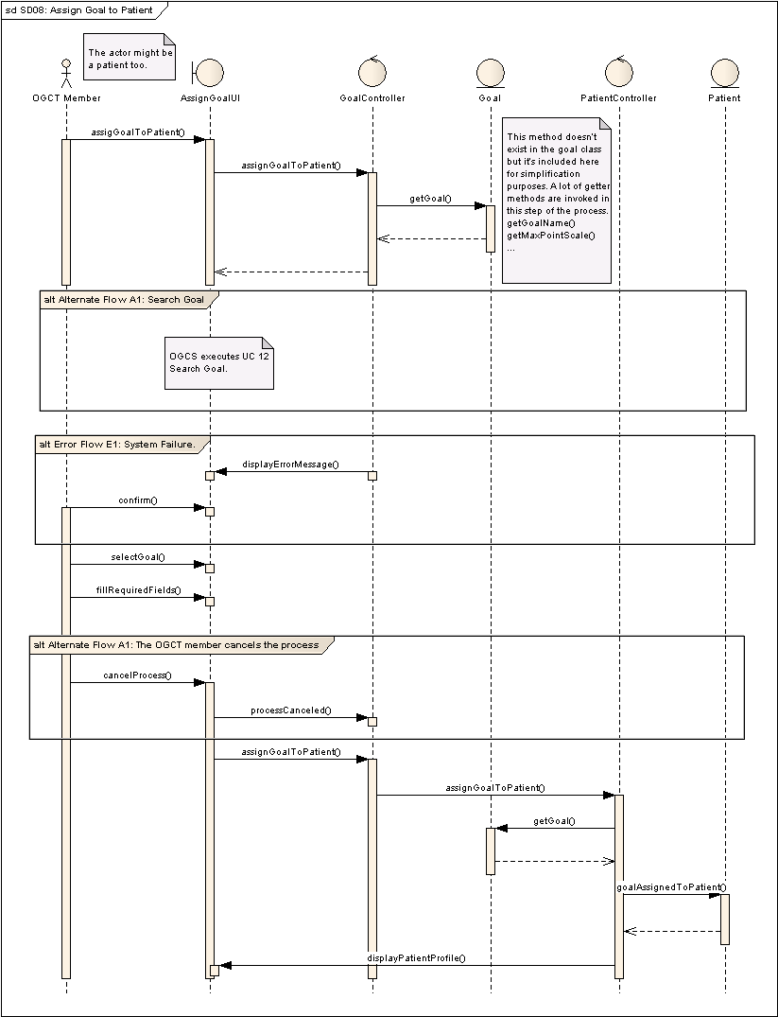

Figure 35: Assign Goal To Patient Sequence Diagram

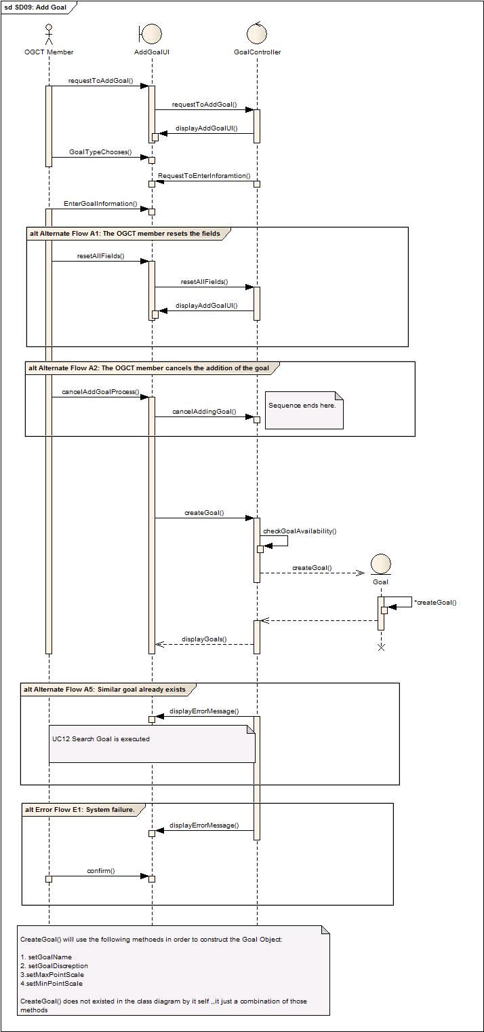

Figure 36: Add Goal Sequence Diagram

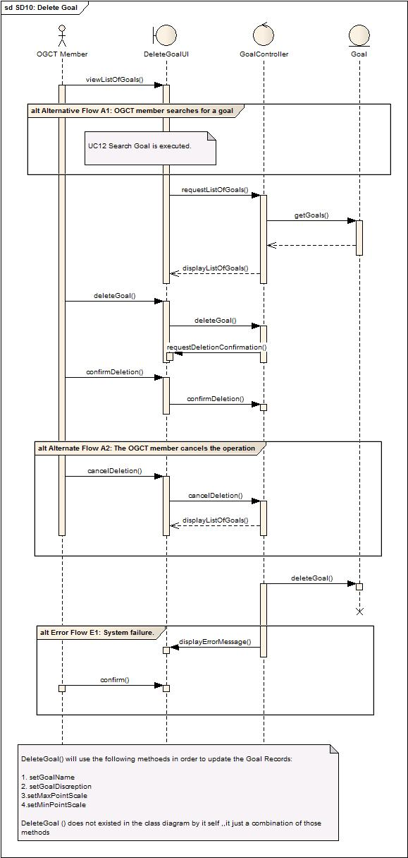

Figure 37: Delete Goal Sequence Diagram

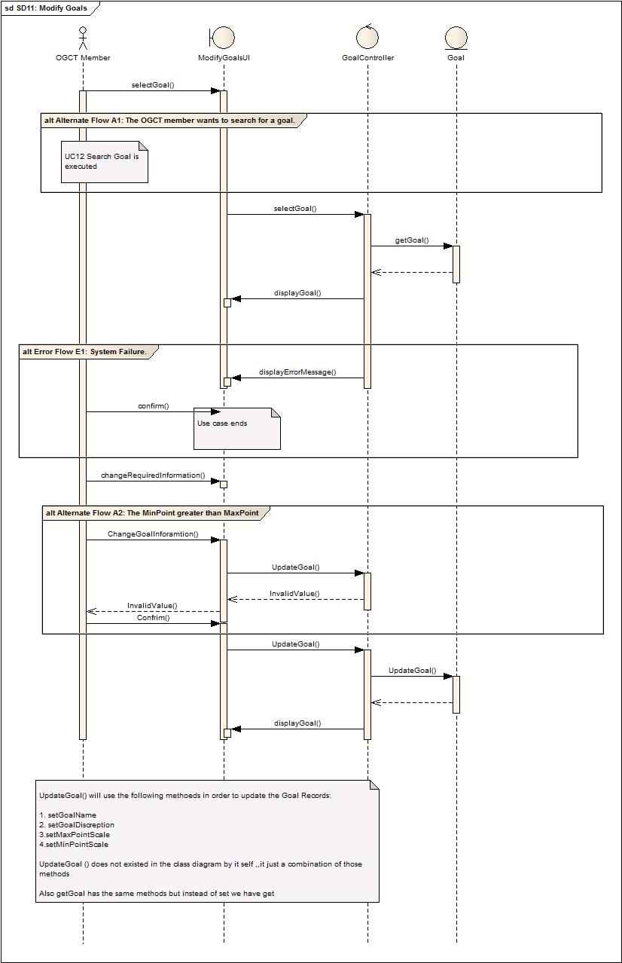

Figure 38:Modify Goal Sequence Diagram

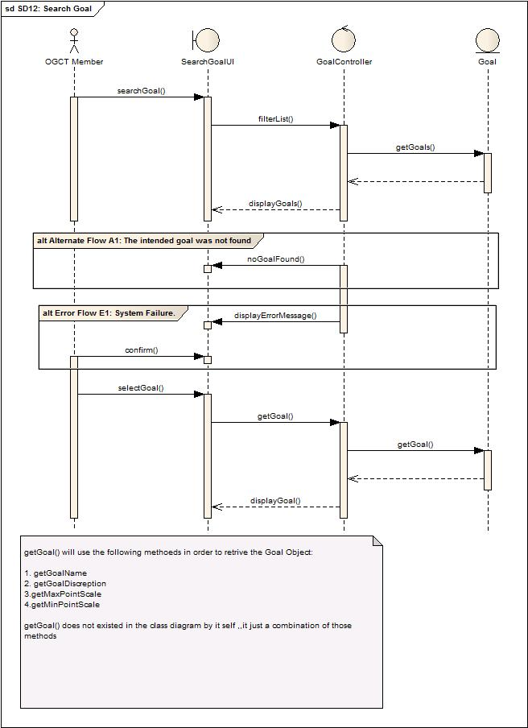

Figure 39: Search Goal Sequence Diagram

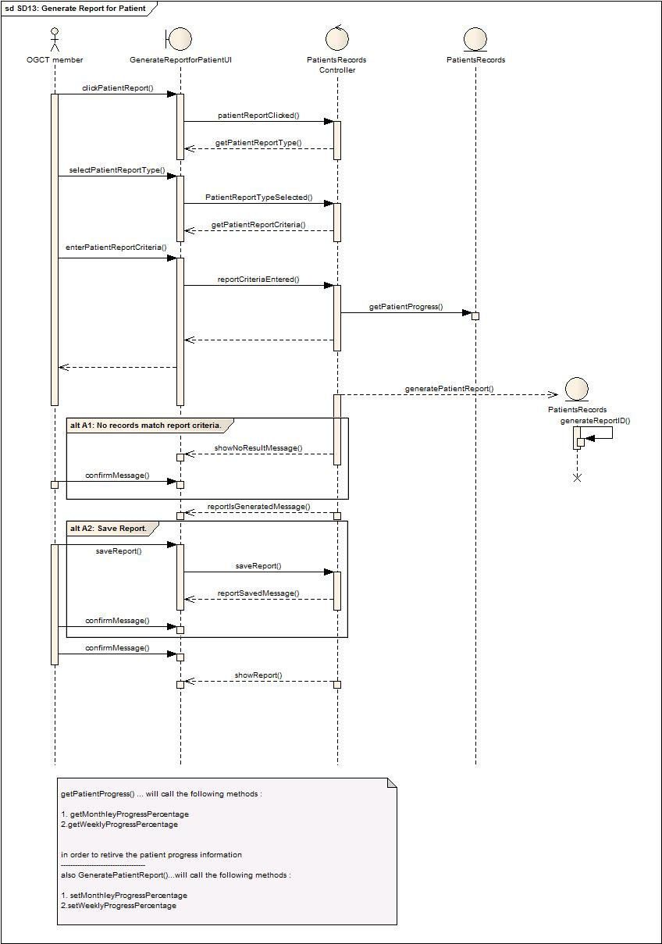

Figure 40: Generate Report For Patient Sequence Diagram

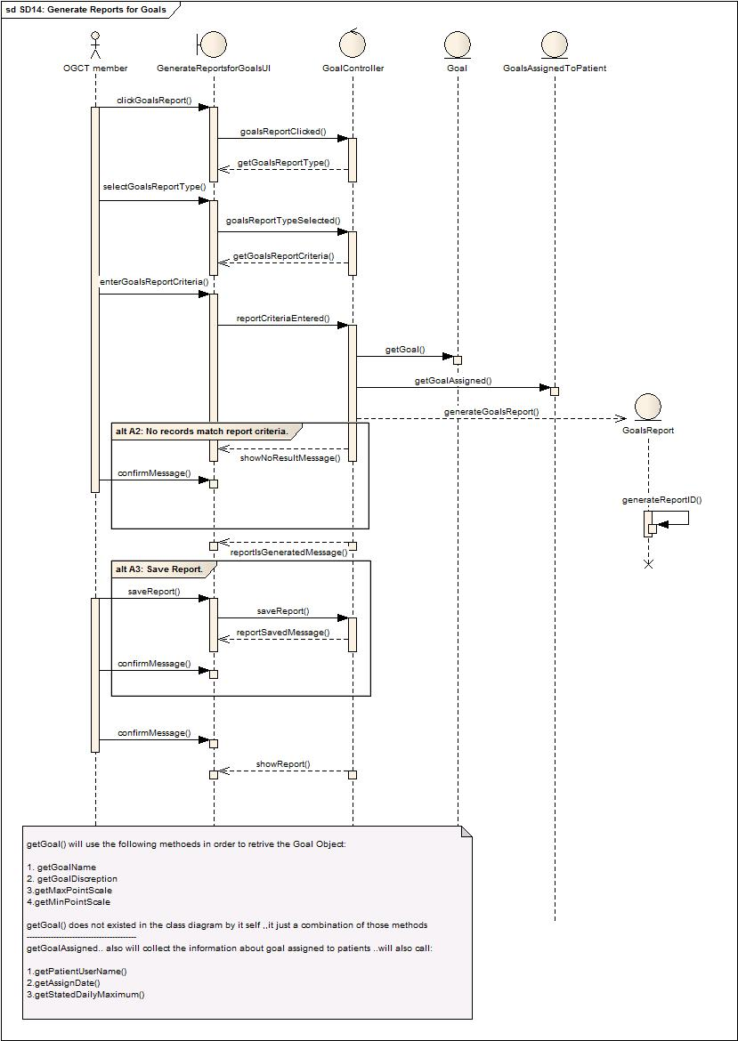

Figure 41: Generate Report For Goals Sequence Diagram

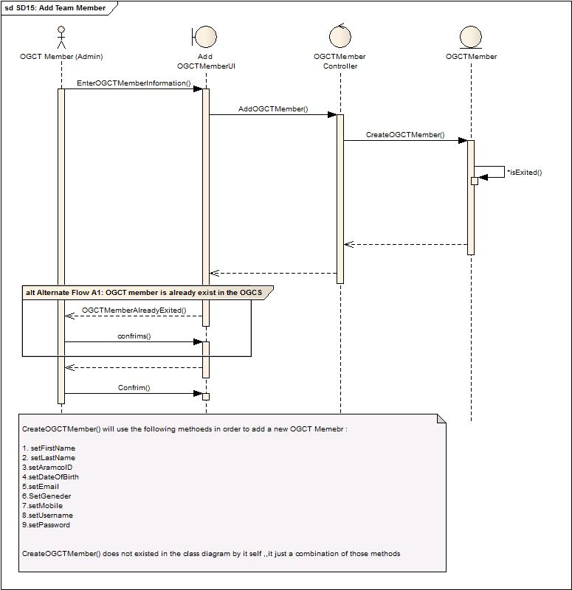

Figure 42: Add Team Member Sequence Diagram

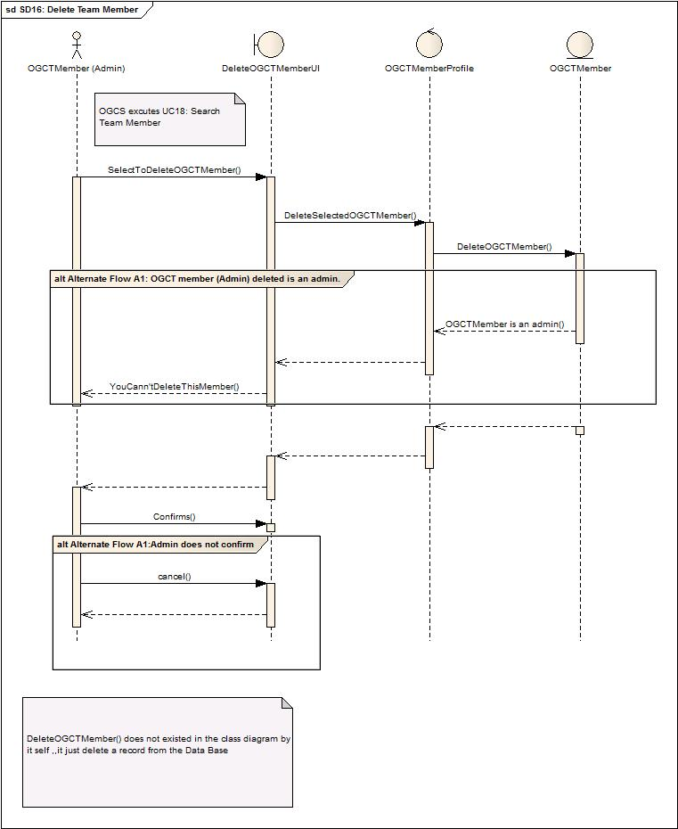

Figure 43: Delete Team Member Sequence Diagram

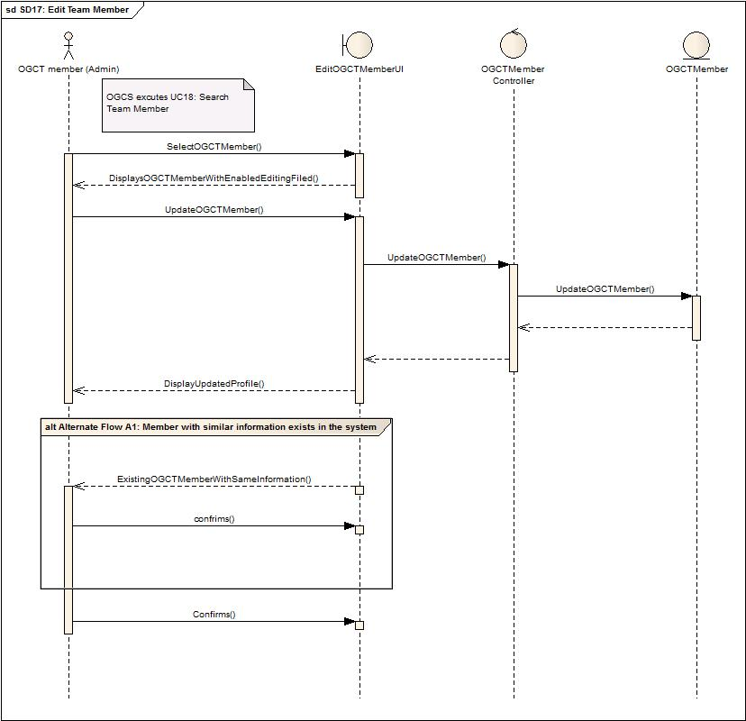

Figure 44: Edit Team Member Sequence Diagram

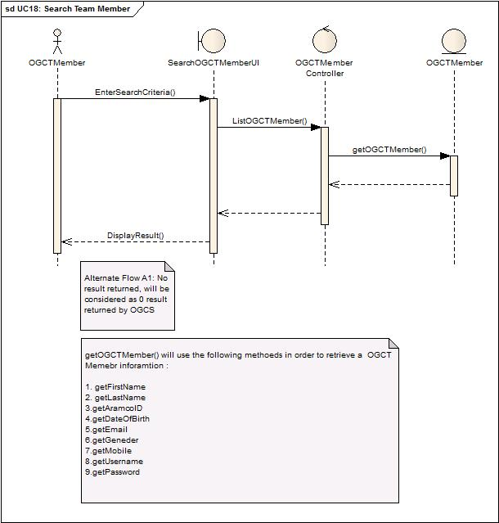

Figure 45: Search Team Member Sequence Diagram

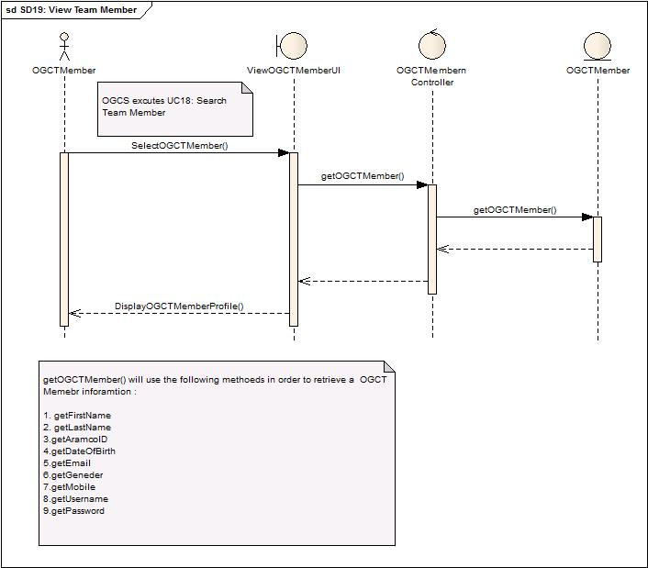

Figure 46: View Team Member Sequence Diagram

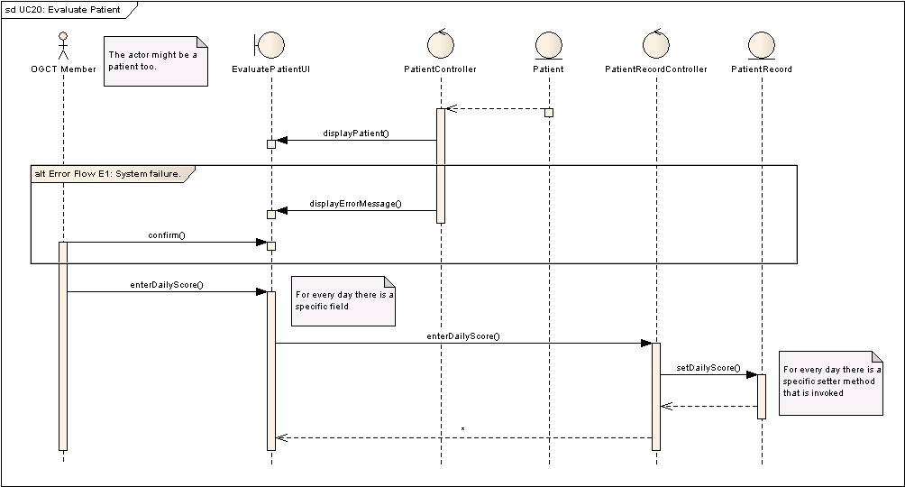

Figure 47: Evaluate Patient Sequence Diagram

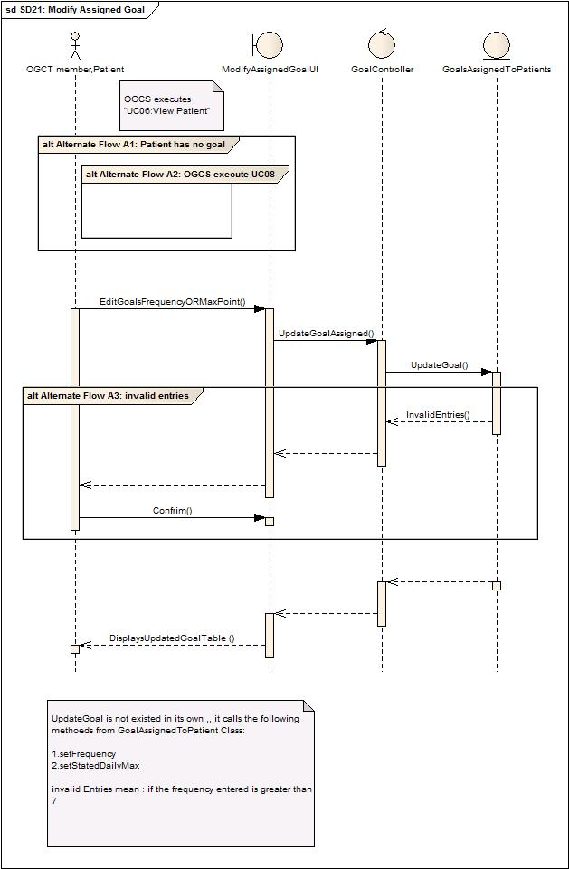

Figure 48: Modify Assigned Goal Sequence Diagram

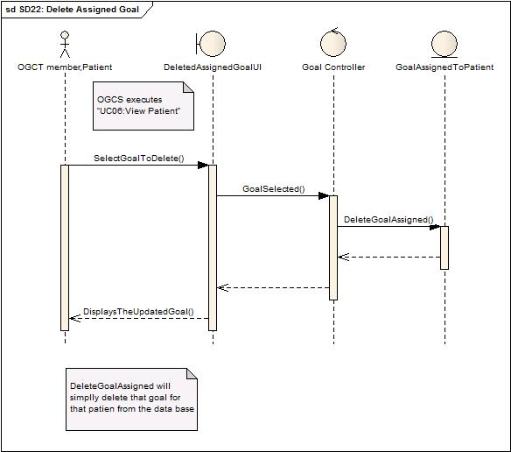

Figure 49: Delete Assigned Goal Sequence Diagram

# Programing framework

As per agreement, we have to use open source programs and programming languages only. The following are more likely to be used:-

1. **PHP**
2. **HTML**
3. **XHTML**
4. **CSS**
5. **JavaScripts**
6. **JQuery**

# Screen layouts

Enclosed with the submission as a PDF file [Screen Layots.pdf]

# Test cases

|  |  |
| --- | --- |
| Test Case Title | Login Test Case |
| Test Case ID | TC01-1 |
| Initial State | OGCT member state is logged out. |
| Author | Saeed Al-Tuwaileb |
| Pre-conditions (if applicable) | OGCT member has a valid username and password. |
| Use Case (if applicable) | UC01: Login |
| Test Input | OGCT member enters a valid username and password. |
| Expected Output | OGCT member page is displayed. |
| Priority | High. |
| Test Type | Functional. |

|  |  |
| --- | --- |
| Test Case Title | Login Test Case |
| Test Case ID | TC01-2 |
| Initial State | Admin state is logged out. |
| Author | Saeed Al-Tuwaileb |
| Pre-conditions (if applicable) | Admin has a valid username and password. |
| Use Case (if applicable) | UC01: Login |
| Test Input | Admin enters a valid username and password. |
| Expected Output | Admin page is displayed. |
| Priority | High. |
| Test Type | Functional. |

|  |  |
| --- | --- |
| Test Case Title | Login Test Case |
| Test Case ID | TC01-3 |
| Initial State | User state is logged out. |
| Author | Saeed Al-Tuwaileb |
| Pre-conditions (if applicable) | User has a valid username and password. |
| Use Case (if applicable) | UC01: Login |
| Test Input | User enters an invalid username or password. |
| Expected Output | A message that says that the username or password is invalid. |
| Priority | High. |
| Test Type | Functional. |

|  |  |
| --- | --- |
| Test Case Title | Login Test Case |
| Test Case ID | TC01-4 |
| Initial State | User state is logged out. |
| Author | Saeed Al-Tuwaileb |
| Pre-conditions (if applicable) | User must enter his or her email that is stored in the profile. |
| Use Case (if applicable) | UC01: Login |
| Test Input | User clicks on forgot username or password. |
| Expected Output | OGCS prompts User to enter his or her email that is stored in the system. |
| Priority | Medium. |
| Test Type | Functional. |

|  |  |
| --- | --- |
| Test Case Title | Login Test Case |
| Test Case ID | TC01-5 |
| Initial State | User state is logged out. |
| Author | Saeed Al-Tuwaileb |
| Pre-conditions (if applicable) | User must enter his or her email that is stored in the profile. |
| Use Case (if applicable) | UC01: Login |
| Test Input | User enters a valid email address. |
| Expected Output | OGCS sends an email to the entered email address with the login information. |
| Priority | Medium. |
| Test Type | Functional. |

|  |  |
| --- | --- |
| Test Case Title | Login Test Case |
| Test Case ID | TC01-6 |
| Initial State | User state is logged out. |
| Author | Saeed Al-Tuwaileb |
| Pre-conditions (if applicable) | None. |
| Use Case (if applicable) | UC01: Login |
| Test Input | User enters an invalid email address. |
| Expected Output | OGCS shows a message saying that the entered email is not valid. |
| Priority | Medium. |
| Test Type | Functional. |

|  |  |
| --- | --- |
| Test Case Title | Add Patient Test Case |
| Test Case ID | TC02-1 |
| Author | Abdulaziz Alamoudi |
| Initial State | The profile creation UI for patients is displayed to the OGCT member. |
| Pre-conditions (if applicable) | No username should exist matching the entered username. |
| Use Case (if applicable) | UC02 Add Patient |
| Test Input | Fill the following fields:   * Username, password, Aramco id, email * Weight, height, medical history * First name, last name, gender, mobile number |
| Expected Output | A username and password are created for the patient. |
| Failure | Username and password are not created for the patient. |
| Priority (High/Medium/Low) | High |
| Test Type (Functional, Performance, stress, etc.) | Functional |

|  |  |
| --- | --- |
| Test Case Title | Add Patient Test Case |
| Test Case ID | TC02-2 |
| Author | Abdulaziz Alamoudi |
| Initial State | The profile creation UI for patients is displayed to the OGCT member. |
| Pre-conditions (if applicable) | No username should exist matching the entered username. |
| Use Case (if applicable) | UC02 Add Patient |
| Test Input | Fill the following fields:   * Username, password, Aramco id, email * Weight, height, medical history * First name, last name, gender, mobile number   But for an existing patient or incorrect input. |
| Expected Output | Error message generated. |
| Failure | Input accepted and no error is generated. |
| Priority (High/Medium/Low) | High |
| Test Type (Functional, Performance, stress, etc.) | Functional |

|  |  |
| --- | --- |
| Test Case Title | Delete Patient Test Case |
| Test Case ID | TC03-1 |
| Author | Abdulaziz Alamoudi |
| Initial State | The patient’s profile is displayed. |
| Pre-conditions (if applicable) | The patient should already exist in the OGCS. |
| Use Case (if applicable) | UC03 Delete Patient |
| Test Input | Try to delete the patient. |
| Expected Output | The patient is deleted. |
| Failure | The patient is not deleted. |
| Priority (High/Medium/Low) | High |
| Test Type (Functional, Performance, stress, etc.) | Functional |

|  |  |
| --- | --- |
| Test Case Title | Delete Patient Test Case |
| Test Case ID | TC03-2 |
| Author | Abdulaziz Alamoudi |
| Initial State | A list of patients should be displayed. |
| Pre-conditions (if applicable) | The patient should already exist in the OGCS. |
| Use Case (if applicable) | UC03 Delete Patient |
| Test Input | Cancel deletion process |
| Expected Output | The deletion process is canceled. |
| Failure | The deletion process is not canceled. |
| Priority (High/Medium/Low) | High |
| Test Type (Functional, Performance, stress, etc.) | Functional |

|  |  |
| --- | --- |
| Test Case Title | Edit Patient Test Case |
| Test Case ID | TC04-1 |
| Author | Abdulaziz Alamoudi |
| Initial State | The patient’s profile is displayed. |
| Pre-conditions (if applicable) | The patient should already exist in the OGCS. |
| Use Case (if applicable) | UC04 Edit Patient |
| Test Input | Personal information of the patient is updated. |
| Expected Output | The patient’s personal information is updated. |
| Failure | The patient’s profile is not updated. |
| Priority (High/Medium/Low) | High |
| Test Type (Functional, Performance, stress, etc.) | Functional |

|  |  |
| --- | --- |
| Test Case Title | Search Patient Test Case |
| Test Case ID | TC05-1 |
| Author | Abdulaziz Alamoudi |
| Initial State | OGCT member clicks search patient. |
| Pre-conditions (if applicable) | OGCT member is logged-in the system. |
| Use Case (if applicable) | UC05 Search Patient |
| Test Input | OGCT member enters search criteria for a patient that exists in OGCS. |
| Expected Output | OGCS returns the search result to OGCT member with the patient profile that matches search criteria. |
| Failure | OGCS doesn’t return the search result. |
| Priority (High/Medium/Low) | High |
| Test Type (Functional, Performance, stress, etc.) | Functional |

|  |  |
| --- | --- |
| Test Case Title | Search Patient Test Case |
| Test Case ID | TC05-2 |
| Author | Abdulaziz Alamoudi |
| Initial State | OGCT member clicks search patient. |
| Pre-conditions (if applicable) | OGCT member is logged-in the system. |
| Use Case (if applicable) | UC05 Search Patient |
| Test Input | OGCT member enters search criteria for a patient that does not exist in OGCS. |
| Expected Output | OGCS shows a message saying that the patient with the entered search criteria does not exist. |
| Failure | OGCS doesn’t return the search result. |
| Priority (High/Medium/Low) | High |
| Test Type (Functional, Performance, stress, etc.) | Functional |

|  |  |
| --- | --- |
| Test Case Title | View Patient Test Case |
| Test Case ID | TC06-1 |
| Author | Abdulaziz Alamoudi |
| Initial State | None |
| Pre-conditions (if applicable) | The patient should already exist in the OGCS. |
| Use Case (if applicable) | UC06 View Patient |
| Test Input | The OGCT member selects a patient’s profile. |
| Expected Output | The patient’s profile is displayed. |
| Failure | The patient’s profile is not displayed. |
| Priority (High/Medium/Low) | High |
| Test Type (Functional, Performance, stress, etc.) | Functional |

|  |  |
| --- | --- |
| Test Case Title | View Patients with no Goal Test Case |
| Test Case ID | TC07-1 |
| Author | Abdulaziz Alamoudi |
| Initial State | OGCT member chooses to “View Patients with no goals” |
| Pre-conditions (if applicable) | * OGCT member successfully login into the OGCS. * Patient already exists in OGCS. |
| Use Case (if applicable) | UC07 View Patients with no Goal |
| Test Input | OGCT member tries to view patents with no goals. |
| Expected Output | Patient(s) with no goals list are displayed to the OGCT member successfully. If no such patient exists then the OGCT member should notified. |
| Failure | The list of patients is not displayed |
| Priority (High/Medium/Low) | High |
| Test Type (Functional, Performance, stress, etc.) | Functional |

|  |  |
| --- | --- |
| Test Case Title | Assign Goal to Patient Test Case |
| Test Case ID | TC08-1 |
| Author | Abdulaziz Alamoudi |
| Initial State | The patient’s profile should be displayed. |
| Pre-conditions (if applicable) | Both the patient and the goal should already exist. |
| Use Case (if applicable) | UC08 Assign Goal to Patient |
| Test Input | Select the goal and fill the required fields. |
| Expected Output | A goal is assigned to a patient. |
| Failure | No goal was assigned to the patient. |
| Priority (High/Medium/Low) | High |
| Test Type (Functional, Performance, stress, etc.) | Functional |

|  |  |
| --- | --- |
| Test Case Title | Assign Goal to Patient Test Case |
| Test Case ID | TC08-2 |
| Author | Abdulaziz Alamoudi |
| Initial State | The patient’s profile should be displayed. |
| Pre-conditions (if applicable) | Both the patient and the goal should already exist. |
| Use Case (if applicable) | UC08 Assign Goal to Patient |
| Test Input | Cancel assigning a goal to the patient. |
| Expected Output | Assigning goal is canceled. |
| Failure | The goal is assigned. |
| Priority (High/Medium/Low) | High |
| Test Type (Functional, Performance, stress, etc.) | Functional |

|  |  |
| --- | --- |
| Test Case Title | Add Goal Test Case |
| Test Case ID | TC09-1 |
| Author | Sameer AlAmri |
| Initial State | The list of goals is displayed. |
| Pre-conditions (if applicable) | The new goal shouldn’t exist in the OGCS. |
| Use Case (if applicable) | UC09 Add Goal |
| Test Input | The OGCT member will enter the attributes of a goal:  -Name of the goal.  -description of the goal.  -MaxPointScale  -MinPointScale |
| Expected Output | A new goal is created. |
| Failure | The goal is not added to OGCS. |
| Priority (High/Medium/Low) | High |
| Test Type (Functional, Performance, stress, etc.) | Functional |

|  |  |
| --- | --- |
| Test Case Title | Add Goal Test Case |
| Test Case ID | TC09-2 |
| Author | Abdulaziz Alamoudi |
| Initial State | The list of goals is displayed. |
| Pre-conditions (if applicable) | The goal shouldn’t exist in the OGCS. |
| Use Case (if applicable) | UC09 Add Goal |
| Test Input | Reset all fields. |
| Expected Output | All fields are cleared. |
| Failure | Fields are not cleared. |
| Priority (High/Medium/Low) | High |
| Test Type (Functional, Performance, stress, etc.) | Functional |

|  |  |
| --- | --- |
| Test Case Title | Add Goal Test Case |
| Test Case ID | TC09-3 |
| Author | Abdulaziz Alamoudi |
| Initial State | The list of goals is displayed. |
| Pre-conditions (if applicable) | The goal shouldn’t exist in the OGCS. |
| Use Case (if applicable) | UC09 Add Goal |
| Test Input | Cancel adding a goal. |
| Expected Output | Adding goal process is canceled. |
| Failure | Adding goal process is not canceled. |
| Priority (High/Medium/Low) | High |
| Test Type (Functional, Performance, stress, etc.) | Functional |

|  |  |
| --- | --- |
| Test Case Title | Add Goal Test Case |
| Test Case ID | TC09-4 |
| Author | Abdulaziz Alamoudi |
| Initial State | The list of goals is displayed. |
| Pre-conditions (if applicable) | The goal shouldn’t exist in the OGCS. |
| Use Case (if applicable) | UC09 Add Goal |
| Test Input | Add a goal that already exists in the OGCS. |
| Expected Output | The OGCS notifies the OGCT member that a similar goal exists. |
| Failure | The duplicated goal is added. |
| Priority (High/Medium/Low) | High |
| Test Type (Functional, Performance, stress, etc.) | Functional |

|  |  |
| --- | --- |
| Test Case Title | Delete Goal Test Case |
| Test Case ID | TC10-1 |
| Author | Abdulaziz Alamoudi |
| Initial State | A list of goal is displayed. |
| Pre-conditions (if applicable) | The goal should already exist in the OGCS. |
| Use Case (if applicable) | UC10 Delete Goal |
| Test Input | The OGCT member deletes the goal. |
| Expected Output | The goal is deleted. |
| Failure | The goal is not deleted. |
| Priority (High/Medium/Low) | High |
| Test Type (Functional, Performance, stress, etc.) | Functional |

|  |  |
| --- | --- |
| Test Case Title | Delete Goal Test Case |
| Test Case ID | TC10-2 |
| Author | Abdulaziz Alamoudi |
| Initial State | A list of goal is displayed. |
| Pre-conditions (if applicable) | The goal should already exist in the OGCS. |
| Use Case (if applicable) | UC10 Delete Goal |
| Test Input | The OGCT member cancels the deletion of the goal. |
| Expected Output | The deletion process is canceled. |
| Failure | The deletion is not canceled. |
| Priority (High/Medium/Low) | High |
| Test Type (Functional, Performance, stress, etc.) | Functional |

|  |  |
| --- | --- |
| Test Case Title | Modify Goals Test Case |
| Test Case ID | TC11-1 |
| Author | Abdulaziz Alamoudi |
| Initial State | The goals attributes are displayed. |
| Pre-conditions (if applicable) | The goal that is going to be modified should exist in the OGCS. |
| Use Case (if applicable) | UC11 Modify Goals |
| Test Input | Certain attributes are modified. |
| Expected Output | Updating the original information of the goal. |
| Failure | Failure of goal modification process. |
| Priority (High/Medium/Low) | High |
| Test Type (Functional, Performance, stress, etc.) | Functional |

|  |  |
| --- | --- |
| Test Case Title | Modify Goals Test Case |
| Test Case ID | TC11-2 |
| Author | Sameer AlAmri |
| Initial State | The goals attributes are displayed. |
| Pre-conditions (if applicable) | The goal that is going to be modified should exist in the OGCS. |
| Use Case (if applicable) | UC11 Modify Goals |
| Test Input | The OGCT member modifies the goal. |
| Expected Output | The OGCS updates the goal. |
| Failure | The original information does not change. |
| Priority (High/Medium/Low) | High |
| Test Type (Functional, Performance, stress, etc.) | Functional |

|  |  |
| --- | --- |
| Test Case Title | Search Goal Test Case |
| Test Case ID | TC12-1 |
| Author | Sameer AlAmri |
| Initial State | The goal screen is displayed. |
| Pre-conditions (if applicable) | None |
| Use Case (if applicable) | UC12 Search Goal |
| Test Input | Search criteria.  -Keyword.  -Type.  -Checkbox (most popular, most successful and most failed |
| Expected Output | A filtered list of goals is displayed. |
| Failure | Wrong results are displayed. |
| Priority (High/Medium/Low) | High |
| Test Type (Functional, Performance, stress, etc.) | Functional |

|  |  |
| --- | --- |
| Test Case Title | Search Goal Test Case |
| Test Case ID | TC12-2 |
| Author | Abdulaziz Alamoudi |
| Initial State | The goal screen is displayed. |
| Pre-conditions (if applicable) | None |
| Use Case (if applicable) | UC12 Search Goal |
| Test Input | Search criteria for a goal that doesn’t exist.  -Keyword.  -Type.  -Checkbox (most popular, most successful and most failed |
| Expected Output | No results were found. |
| Failure | Wrong results are displayed. |
| Priority (High/Medium/Low) | High |
| Test Type (Functional, Performance, stress, etc.) | Functional |

|  |  |
| --- | --- |
| Test Case Title | Add Team Member Test Case |
| Test Case ID | TC13-1 |
| Author | Sameer Al-Amri |
| Initial State | Add Team Member form is displayed. |
| Pre-conditions (if applicable) | * OGCT Member (Admin) successfully login into the OGCS. * The new OGCT member does not exist in the OGCS. |
| Use Case (if applicable) | UC15: Add Team Member |
| Test Input | OGCT Member (Admin) tries to add a Team Member. |
| Expected Output | Team Member is added. |
| Failure | Team Member is not added. |
| Priority (High/Medium/Low) | High |
| Test Type (Functional, Performance, stress, etc.) | Functional |

|  |  |
| --- | --- |
| Test Case Title | Add Team Member Test Case |
| Test Case ID | TC13-2 |
| Author | Sameer Al-Amri |
| Initial State | Add Team Member form is displayed. |
| Pre-conditions (if applicable) | * OGCT Member (Admin) successfully login into the OGCS. * The new OGCT member does not exist in the OGCS. |
| Use Case (if applicable) | UC15: Add Team Member |
| Test Input | Adding a Team Member that already exists. |
| Expected Output | A message is displayed saying that the Team Member already exists. |
| Failure | Team Member is added. |
| Priority (High/Medium/Low) | High |
| Test Type (Functional, Performance, stress, etc.) | Functional |

|  |  |
| --- | --- |
| Test Case Title | Edit Team Member |
| Test Case ID | TC14-1 |
| Author | Sameer Al-Amri |
| Initial State | Edit Team Member form is displayed. |
| Pre-conditions (if applicable) | * OGCT Member (Admin) successfully login into the OGCS. |
| Use Case (if applicable) | UC17: Edit Team Member |
| Test Input | OGCT Member (Admin) tries to edit a Team Member. |
| Expected Output | Team Member profile is edited. |
| Failure | Team Member profile is not edited. |
| Priority (High/Medium/Low) | High |
| Test Type (Functional, Performance, stress, etc.) | Functional |

|  |  |
| --- | --- |
| Test Case Title | Search Patient Test Case |
| Test Case ID | TC15-1 |
| Author | Sameer Al-Amri |
| Initial State | OGCT member chooses search. |
| Pre-conditions (if applicable) | OGCT member is logged-in the OGCS successfully. |
| Use Case (if applicable) |  |
| Test Input | User enters OGCT member to enter one or more search criteria:   * First Name * Last Name * ARAMCO ID |
| Expected Output | OGCS shows the result of searching for OGCT member. |
| Failure | Patient not found. |
| Priority (High/Medium/Low) | High |
| Test Type (Functional, Performance, stress, etc.) | Functional |

|  |  |
| --- | --- |
| Test Case Title | View Patient Profile Test Case |
| Test Case ID | TC16-1 |
| Author | Sameer Al-Amri |
| Initial State | OGCT member wants to see OGCT member information. |
| Pre-conditions (if applicable) | OGCT member successfully login into the OGCS. |
| Use Case (if applicable) |  |
| Test Input | The Admin chooses to view the Patient Profile. |
| Expected Output | Patient Profile information is displayed. |
| Failure | Patient Profile information is not displayed. |
| Priority (High/Medium/Low) | High |
| Test Type (Functional, Performance, stress, etc.) | Functional |

|  |  |
| --- | --- |
| Test Case Title | Evaluate Patient Test Case |
| Test Case ID | TC20-1 |
| Author | Abdulaziz Alamoudi |
| Initial State | The patient’s progress table is displayed. |
| Pre-conditions (if applicable) | The patient’s profile should already exist. |
| Use Case (if applicable) | UC20 Evaluate Patient |
| Test Input | Fill in the required fields with correct input. |
| Expected Output | The progress table is updated. |
| Failure | -Values are not accepted.  -Table is not updated. |
| Priority (High/Medium/Low) | High |
| Test Type (Functional, Performance, stress, etc.) | Functional |

|  |  |
| --- | --- |
| Test Case Title | Evaluate Patient Test Case |
| Test Case ID | TC20-2 |
| Author | Abdulaziz Alamoudi |
| Initial State | The patient’s progress table is displayed. |
| Pre-conditions (if applicable) | The patient’s profile should already exist. |
| Use Case (if applicable) | UC20 Evaluate Patient |
| Test Input | Fill in the required fields with incorrect input. |
| Expected Output | The OGCS rejects the inputs and notifies the user. |
| Failure | -Values are accepted.  -Table is updated. |
| Priority (High/Medium/Low) | High |
| Test Type (Functional, Performance, stress, etc.) | Functional |

|  |  |
| --- | --- |
| Test Case Title | Modify Assigned Goal Test Cases |
| Test Case ID | TC21 |
| Author | Sameer Al-Amri |
| Initial State | OGCT member or patient wants to edit the goal assigned. |
| Pre-conditions (if applicable) | -OGCT member or patient successfully login into the OGCS.  - No entry in the first slot of the goal assigned table. |
| Use Case (if applicable) | UC21 Modify Assigned Goal |
| Test Input | OGCT member or patient wants to edit the following:  -Frequency  -daily Max |
| Expected Output | Updated goal assigned table is displayed. |
| Failure | The original information is not changed. |
| Priority (High/Medium/Low) | High |
| Test Type (Functional, Performance, stress, etc.) | Functional |

|  |  |
| --- | --- |
| Test Case Title | Deleted Assigned Goal Test Cases |
| Test Case ID | TC22 |
| Author | Sameer Al-Amri |
| Initial State | OGCT member or patient wants to delete the goal assigned. |
| Pre-conditions (if applicable) | -OGCT member or patient successfully login into the OGCS. |
| Use Case (if applicable) | UC22 Delete Assigned Goal |
| Test Input | OGCT member or patient selects the goal that he wants to delete then confirms. |
| Expected Output | Updated goal assigned table is displayed. |
| Failure | The original table is not changed. |
| Priority (High/Medium/Low) | High |
| Test Type (Functional, Performance, stress, etc.) | Functional |