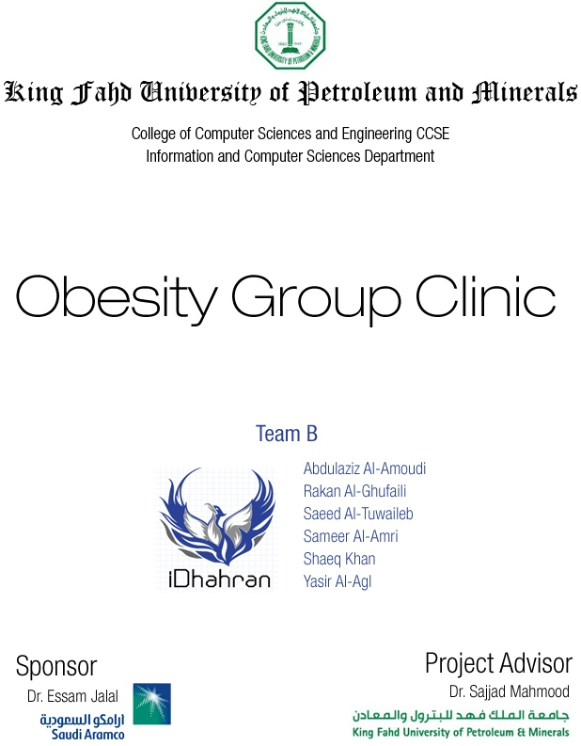

Project Summary Report

Table of Contents

[Team Communication Plan 4](#_Toc313056044)

[Meeting Management 5](#_Toc313056045)

[Training 5](#_Toc313056046)

[Social Events 6](#_Toc313056047)

[Tools and Technologies used 7](#_Toc313056048)

[Social Impact 8](#_Toc313056049)

[Customer Meeting Summary 8](#_Toc313056050)

# Team Communication Plan

|  |  |  |  |  |  |  |
| --- | --- | --- | --- | --- | --- | --- |
|  | **Deliverable** | **Description** | **Delivery Method** | **Freque-ncy** | **Owner** | **Audience** |
| **Reports** | Software Requirements Specification | Document stating the software requirements that have been gathered from the customer. All functionalities are stated and well documented with the help of diagrams and description conventions | Version control and editing by team on dropbox. Final submission made via WebCT | monthly | Team leader and Project advisor | Project team and Project sponsor |
|  | Software Design Document | Document stating the software design and architecture for the system with the stated requirements as in SRS. Understanding of the system functionalities and the entire system is enhanced to the team. | Version control and editing by team on dropbox. Final submission made via WebCT | monthly | Team leader and Project advisor | Project team and Project sponsor |
|  | Software Testing [alpha and beta testing] documents | Document stating the alpha and beta test cases for the system recognized over the development of the system. The results of the test are recorded and presented to the project advisor to support the correctness or problems in the final deployed system. | Version control and editing by team on dropbox. Final submission made via WebCT | monthly | Team leader and Project advisor | Project team and Project sponsor |
|  | Progress reports | Individual documents recording the contribution of individual members to each deliverable | Submitted by each member individually using webCT | Each project deliverable had a progress report with it | Project advisor and project team | none |
| **Reviews and Meetings** | Team meeting | Meeting to review project status and individual progress | Meeting | Weekly | Team leader | Team members |

# Meeting Management

Besides having the weekly meeting with the project advisor, we used to meet to discuss our progress with each other about the project.

Our meetings would be initiated through a simple sms sent by one of the team members to set up a time and date, we would agree on a time and then everyone would be notified of a meeting through email, sms or a call. The location of the meetings was mainly in the university campus in building 24 in any room that would be available at that time.

During the meetings we would discuss our understanding of the system and evenly distribute the work for deliverables if any. On a later stage, during the implementation, we would meet every week and sit together for a couple of hours and do coding.

# Training

Our team had to train ourselves in developing a web application. We first started with individual learning by doing tutorials on [W3Schools](http://www.w3schools.com/). Once we were familiar with the idea of web programming at a minimum, Rakan al-Ghufaily stepped up and held some sessions for the team where we would sit together and make mock functionalities from the project. This way we got familiar and used to the areas of php we would be using to implement our system in particular.

We also had to brush up our skills from the databases course to write queries. We decided not to go with the MVC architecture, but after individually implementing all the functions, we did end up with architecture similar to MVC.

# Social Events

During our weekly team meetings, we would order some food. It did happen that we had a couple of meetings outside the university campus over lunch.

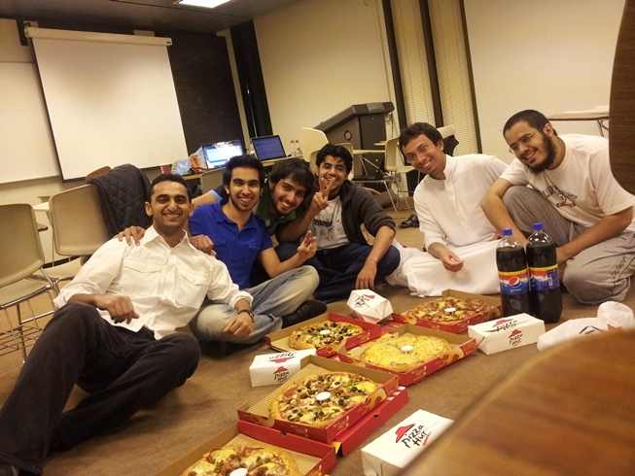

# Tools and Technologies used

|  |  |
| --- | --- |
| C:\Users\Shaeq\Desktop\adobe-cs5-dreamweaver.jpg | Adobe Dreamweaver CS5 was used to create the structure and styling for the web pages. |
| C:\Users\Shaeq\Desktop\jquery.jpg | JQuery v1.7.1 plugins were used for validating input. |
| C:\Users\Shaeq\Desktop\php.gif | To add functionality and logic to the site, php v5.3.4 was used. |
| C:\Users\Shaeq\Desktop\komodo_orb_256.png | We did not use any framework to the coding, instead used a simple IDE called Komodo IDE 6 to code. |
| C:\Users\Shaeq\Desktop\mysql-logo.jpg | To implement the database, MySQL v5.5.16 was used. |
| C:\Users\Shaeq\Desktop\xampp-20100616-154048.jpg | To host the database and use a testing server on localhost, the team members used their respective tools like WAMP or XAMPP v1.7.7 |

# Social Impact

We do expect this system to have a considerable social impact on society. We feel that obesity is a genuinely growing problem in KSA and this system can be considered a small contribution to help curb this problem. This website encourages people to take up weight loss as goals in their lives and motivate them to keep in constant touch with their progress. The scoring system on this software gives patients the sense of competition with themselves, by giving them a reason to do better than what they have already achieved. This system also aims to reduce people who go for the option of cosmetic surgery after their failed attempts as such weight loss program. In the long run, it is the physical activities they have performed that will be of benefit to them and not the surgical way.

# Customer Meeting Summary

|  |  |  |
| --- | --- | --- |
| **Event** | **Day** | **Attendees** |
| Meeting 1 | 26th February 2011 | Dr. Essam, Dr. Sajjad and project team |
| Meeting 2 | 10th May 2011 | Dr. Essam and project team |
| Meeting 3 | 23rd May 2011 | Dr. Essam and project team |