

**DEPARTMENT OF COMPUTER SCIENCE AND ENGENEERING**

**COURSE CODE :**CSE 212

**COURSE TITLE :**Database System Lab

**Name of Project:** Programming contest Managing system

**Date of Submission :**29-07-2019

**Submitted to**

Mr. Nadeem Ahmed

Assistant professor, Dept. of CSE

University of Asia Pacific

**Submitted by**

**Name:**Hosain Mohammad Shafa Khan

**ID:**17201020

**Sec:**A1

**INDEX**

|  |  |  |
| --- | --- | --- |
| Serial No | Subject | Page no |
| 01 | Story Of The Project | 03 |
| 02 | ER Diagram | 04 |
| 03 | Schema Diagram | 05 |
| 04 | Create Table | 06-07 |
| 05 | , Select Table | 07 |
| 06 | Insert Data | 07-11 |
| 07 | Query& Output Of The Query | 11 to last |

**Story**

**Managing a Programming contest in a systematic way**

AS a CSE student i also have a dream to participant any reputed programming contest.

My project is about a programming contest managing system based project where all participates are comfortably participate this contest in a systematic way and finally they will be able to find all the information about this contest at a glance.

People will participate this contest as a team. They will select their project type. There will be one Advisor in each team.

There will also be some sponsor in this event. At last prize giving ceremony will also be held in this event and there will be few chef guests in this ceremony.

**ER Diagram**

Moderator

Advisor

**Participants**

**join**

**Team**

Management

**Combination**

**project**

**Main_Event**

**Help**

**Sponsor**

**Program**

Event name

**Schema Diagram**

**Team**

Team_id

team_name

advisor_id

part_id

Type

**Sponsor**

sponser_name

office location

contract _number

**Advisor**

advisor_id

advisor_name

contract_number

**Event name**

event_name

guest_name

arrival_time

**Main Event**

event_name

event_ location

sponser_name

start_time

**Participant**

part_id

part_name

Semester

**Project**

Type

Price

createdatabase project

use project

createtableevent_name(

event_namevarchar(50),

guest_namevarchar(50),

arrival_timeint,

constraintpk_event_namePrimarykey(event_name)

);

createtablesponser(

sponser_namevarchar(50),

office_locationvarchar(50),

contact_noint,

constraintpk_sponser_namePrimarykey (sponser_name)

);

createtablemain_event(

event_namevarchar(50),

event_locationvarchar(50),

sponser_namevarchar(50),

start_timeint,

constraint pk_event_name2 Primarykey (event_name),

foreignkey (event_name)referencesevent_name(event_name),

foreignkey (sponser_name)referencessponser(sponser_name)

);

createtable participant(

part_idint,

part_namevarchar(50),

semestervarchar(50),

constraintpk_part_idPrimarykey (part_id)

);

createtable advisor(

advisor_idint,

advisor_namevarchar(50),

contract_novarchar(50)

constraintpk_advisor_idPrimarykey (advisor_id)

);

createtable project(

tyepvarchar(50),

pricevarchar(50)

);

createtable team(

team_idint,

team_namevarchar(50),

advisor_idint,

part_idint,

tyepvarchar(50),

constraintpk_team_idPrimarykey (team_id),

foreignkey(part_id)references participant(part_id),

foreignkey (advisor_id)references advisor(advisor_id)

);

select*fromevent_name

select*fromsponser

select*frommain_event

select*from participant

select*from advisor

select*from project

select*from team

insertintoevent_name

values('IDPC','Shojibwajed joy',9),

('Programming War','Ayub Khan ',10),

('Contest War','Sheikh Hasina',11),

('ICPC','Abdul Hamid Khan',12),

('NCPC','imran bin ajad',1),

('NDPC','Sheikh tonmoy',2),

('Programming juddo','sharuk Khan ',3),

('Contest War uap','Sheikh rehena',4),

('CPC','mr.kaikobad ',9),

('DPC','Tarana Halim',11),

('DVPC','Dr. jaforullah ',12),

('Programming uap','Ayub Khan ',11),

('Contest War uap2','kobir uddin mia',10),

('APC','Sheikh Hasina',12),

('BPC',' nilofar chowdhury',1),

('EPC','modi',5),

('FPC','abulkalam ajad',2),

('GPC','norulhaque ',8),

('HPC','hyn min son ',4),

('IPC','varat sing',9),

('JPC','yuching Honda',3),

('KPC','yuchingjacky ',2),

('LPC','jack jones ',11),

('MPC','randeep hoda',2),

('NPC','williamhervy ',3),

('OPC','keton jenings',2),

('Contest War2','micheal maxweel ',9),

('Contest War3','Tarana nipa',12),

('Contest War uap3','Dr. nilima khan ',9),

('Programming Contest SPring','aminul biswas',10),

('Programming Contest Fall','halimbiswas ',11)

select*fromevent_name

insertintosponser

values('Bosondara group','ghaka',8800),

('crown cement','gazipur',1100),

('matador','Banani',5561),

('ambuza Cement','Gabtalia india',1120),

('ispahani','mirjapur',5565),

('star','india delli',1345),

('sony','mumbai',55670),

('windows','america',11007),

('Pran','dhaka',5960),

(' cocola','dhamrai',11300),

('khan group','chuadanga',88001),

('chowdhury group','luxmirpur',55692),

('fresh Cement','munshiging',110032),

('gtv','Banani',556165),

('btv','dhanmondi',541120),

('rfl','manikgong',550965),

('dano group','kolkata india',891345),

('geogle','america',0055670),

('reliance group','mumbai',1100897),

('nokia ','india',594560),

('symphony','dhaka',128800),

('bata shoe','dhaka',551160),

('squre pharma','dhamrai',111100),

('mam pani','uttara',125561),

('center fruit','Gazipur',1234120),

('bangla phone','ghulsan',5523465),

('desh bangla','mirpur',2341345),

('jagobd chanel','mirpur',955670),

('news 24 chanel','kawran bazar',0911007),

('bikroy,com','dhaka',55960),

('JR paribahan','dhaka gabtoli',5596780)

select*fromsponser

insertintomain_event

values('IDPC','University of Asia Pacific','Bosondara group ',9),

('Programming War','Daffodil International University','crown cement',10),

('Contest War','american International University','matador',11),

('ICPC','Dhaka University ','ambuza Cement',9),

('NCPC','Sydney International University','ispahani',10),

('NDPC','University of Newzeland','star ',9),

('Programming juddo','Daffodil International University bangladesh','sony',10),

('Contest War uap','University of Asia Pacific','windows ',9),

('CPC','Kustia Islamic University','pran',10),

('DPC','University of Dhenmark','pran ',12),

('DVPC','KhulnaUniversity','khan group',1),

('Programming uap',' University of Asia Pacific','chowdhury group',2)

select*frommain_event

insertinto participant

values(17201020,'shafa khan','four'),

(17201021,'anik khan','four'),

(17101020,'hasin','five'),

(17101021,'sakib','1st'),

(18201021,'sifat khan','second'),

(18201020,'shihab jhan','third'),

(16201021,'ahad khan','sixth'),

(16201020,'tasim khan','seven'),

(15201021,'lulu khan','eight'),

(15201020,'anik khan','four'),

(15101020,'hasin','five'),

(15101021,'sakib','1st'),

(19201021,'sifat khan','second'),

(19201020,'shihab jhan','third'),

(19101021,'ahad khan','sixth'),

(19101020,'tasim khan','seven'),

(171,'jack','second'),

(1712,'maxy gerny','eight'),

(17123,'rodrigo','1st'),

(171234,'govinda','seven'),

(1712345,'wu chuhang','third'),

(11,'michel mory','six'),

(112,'harry gerny','five'),

(1123,'pedro','eight'),

(11234,'javed wasim','two'),

(112345,'mialina ','third'),

(1123456,'beyazid','four'),

(11234567,'oliver pope','1st'),

(21,'jerin akther','eight'),

(212,'rnespal roy','1st'),

(2123,'julian robbert','seven'),

(21234,'dilruhan perera','third')

select*from participant

insertinto advisor

values(01,'imran bin ajad','01923'),

(02,'sakib hasandhrobo ','017345'),

(03,'rajib sir','01843'),

(04,'naima sultana','01123'),

(05,'alok kumar saha','6789'),

(06,'shopon','09675'),

(07,'shammi akter','8974'),

(08,'shila rahman','27834'),

(09,'ayub khan','011234'),

(101,'robert','01123'),

(102,'frankistain ','011345'),

(103,'joe burns','011843'),

(104,'ojit sorkar','011223'),

(105,'ajoy ghosh','06789'),

(106,'luka david','0229675'),

(107,'iftikur rahman','0668974'),

(108,'rustom mia','2237834'),

(109,'cris moris','01001234'),

(201,'pervez chowdhury','0231923'),

(202,' nikhilroy ','01337345'),

(203,'wu chang jam','01234843'),

(204,'nilofar khan','06781123'),

(205,'omar akbar','01126789'),

(206,'Md. nasir khasru','0193675'),

(207,'peter michel','018974'),

(208,'kusal javed perera','01227834'),

(209,'harry maquire','0177234'),

(301,'Mst. tarana nipa','0167923'),

(302,'fernando perez','014567345'),

(303,'thiago mathew','03345843'),

(304,'philipe kane','01435234')

select*from advisor

insertinto project

values('junior natinal level','20 lakh'),

('juniorinternatinal level(JPC)','2 cr'),

('national level(NCPC)',' 70 lakh'),

('international level(ICPC)','5 cr'),

('inter district level(DPC)',' 5 lakh'),

('inter division level(DVPC)',' 10 lakh'),

('inter college level(CPC)','10 thousands'),

('inter versitylevel(VCPC)',' 2 lakh'),

('gold category(GPC)',' 5 cr'),

('all kind of UAP contest ',' 5 lakh'),

('selver(normal) category(NPC)','1 cr'),

('other all contest','25 lakh')

select*from project

insertinto team

values(1,'Uap coder',01,17201020,'junior natinal level'),

(2,'safa the boss',02,17201021,'junior internatinal level(JPC)'),

(3,'sustian',03,17101020,'national level(NCPC)'),

(7,'uapian',04,17101021,'international level(ICPC)'),

(4,'kuetian',05,18201021,'inter district level(DPC)'),

(5,'coder7',06,18201020,'inter division level(DVPC)'),

(6,'heavy coder',07,16201021,'inter college level(CPC)'),

(8,'du coder',08,16201020,'inter versity level(VCPC)'),

(9,'junior coder',09,15201021,'gold category(GPC)'),

(10,'all star',101,15201020,'all kind of UAP contest'),

(11,'chapion',102,15101021,'selver(normal) category(NPC)'),

(12,'great coder',103,15101020,'other all contest'),

(13,'team infinity',104,19201021,'international level(ICPC)'),

(014,'long time no ac',105,19201020,'international level(ICPC)'),

(015,'coder79',106,19101020,'international level(ICPC)'),

(016,'loop coder',107,19101021,'inter district level(DPC)'),

(017,'dynamic coder',108,171,'inter district level(DPC)'),

(018,'recursive coder',109,1712,'inter district level(DPC)'),

(019,'jetboi jetbo',201,17123,'inter versity level(VCPC)'),

(020,'shining star',202,171234,'inter versity level(VCPC)'),

(21,'shei rokom coder',203,1712345,'inter versity level(VCPC)'),

(22,'code breakers',204,11,'inter versity level(VCPC)'),

(23,'xenon 42',205,112,'inter versity level(VCPC)'),

(244,'single man',206,1123,'inter college level(CPC)'),

(255,'one man army',207,11234,'gold category(GPC)'),

(26,'talented coder',208,112345,'gold category(GPC)'),

(027,'time complexity best',209,1123456,'gold category(GPC)'),

(028,'avarage case',301,11234567,'inter college level(CPC)'),

(29,'geogle dream',302,21,'gold category(GPC)'),

(030,'hanter',303,212,'inter college level(CPC)')

select*from team

selectteam_name

from team

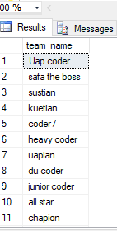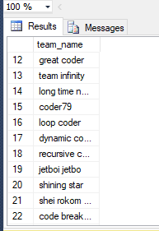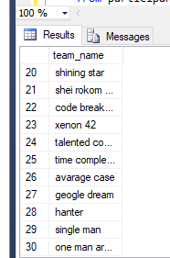

selectguest_name_ 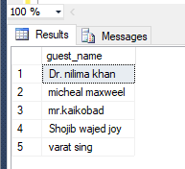

fromevent_name

wherearrival_time= 9

selectevent_name 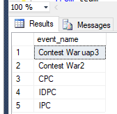

fromevent_name

wherearrival_time= 9

select*from participant, advisor

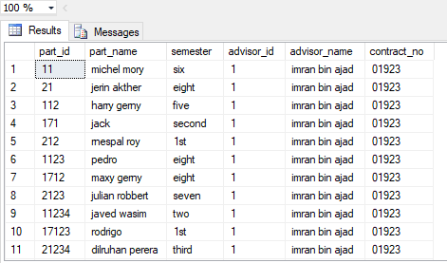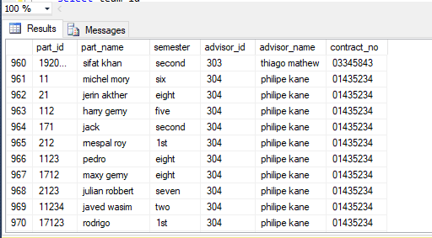

selectevent_location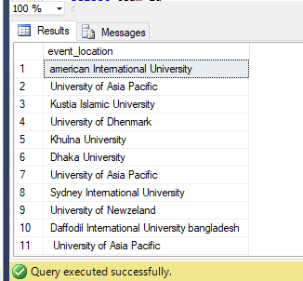

frommain_event,event_name

whereevent_name.event_name=main_event.event_name

selectevent_name_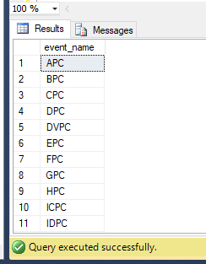

fromevent_name

whereevent_namelike'%PC%'

selectdistinctoffice_location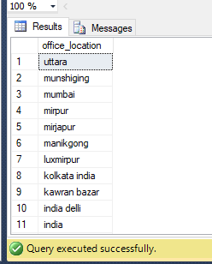

fromsponser

orderbyoffice_locationdesc

selectdistinct price _from project 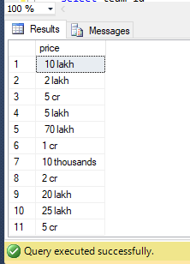

selectcount(*)_from advisor 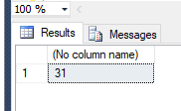

selectteam_name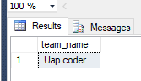

from team

whereadvisor_id=01

selectadvisor_name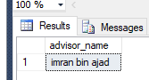

from advisor

whereadvisor_id=01

selecttype 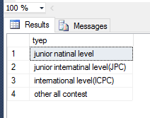

from project

where price >'1o lakh'

select sponser_name 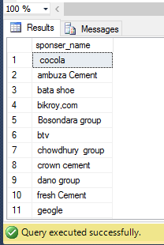

from sponser

wherecontact_no between 1100 and 1100897