**NAME: SHAFAQ ANEES  
SUNDAY 2 TO 5  
(SIR ALI JAWWAD)**

**Technical foundation for e car rental marketplace**

**Core Features of the Marketplace**

The car rental marketplace should have the following features:

* **User Roles**:
  1. Admin: Manages platform operations, cars, and users.
  2. Renter: Rents cars.
  3. Owner (optional): Lists their cars for rent.
* **Functional Features**:
  1. User Registration/Login (via email, phone, or social login).
  2. Browse and Search Cars (filter by location, price, car type, availability, etc.).
  3. Book Cars (with date and time selection).
  4. Payments (via online gateways).
  5. Vehicle Tracking (via GPS).
  6. Customer Support Chat.
  7. Reviews & Ratings.
  8. Notifications (email/SMS/in-app).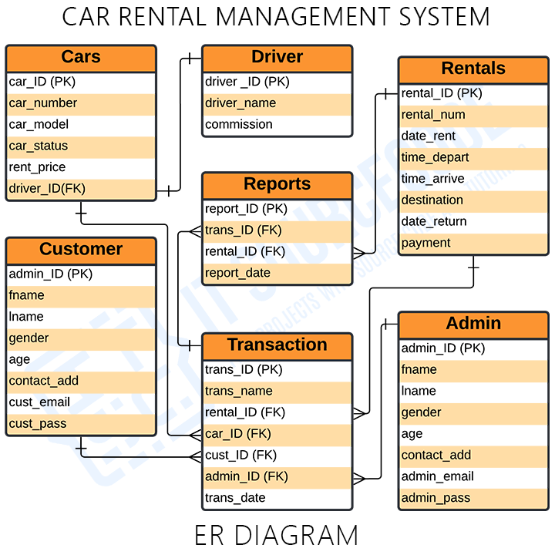

**Car Rental Process**

**Search**:

* Users search for cars based on location, dates, and other filters.

**Select Vehicle**:

* User selects a car and views its details (pricing, features, reviews).

**Book Car**:

* User selects dates, reviews pricing, and confirms booking.

**Payment**:

* User makes a payment through integrated payment methods.

**Pickup & Drop-off**:

* User picks up the car from the specified location or opts for delivery.

**Return & Feedback**:

* User returns the car and provides a review.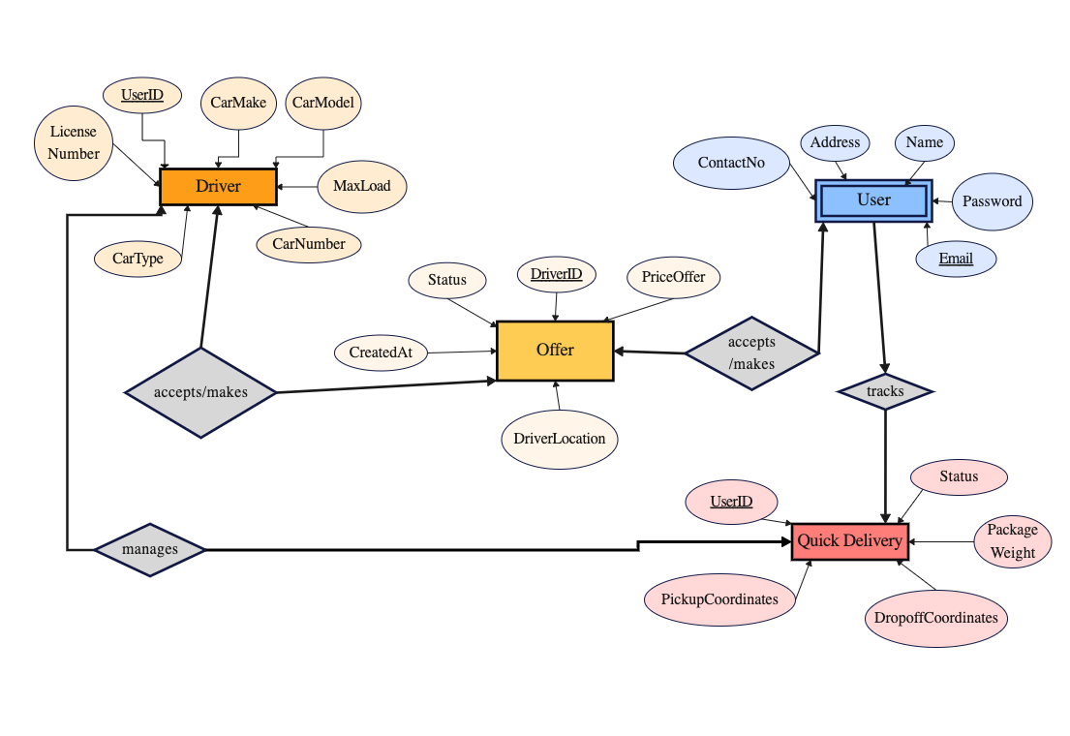

**Admin Workflow**

Manage user accounts.

Approve/verify new cars added by owners.

Handle disputes, refunds, and cancellations.

Analyze platform performance via analytic

Owner Workflow (if applicable)

Add car details with images, pricing, and availability.

Track bookings and earnings.

Manage car status (e.g., active, maintenance).

**3. Components of the Platform**

**Frontend**

* Built with React or Next.js for performance.
* Key pages/components:
  1. **Home Page**: Search bar, car listings, and featured promotions.
  2. **Car Details Page**: Images, specifications, pricing, and reviews.
  3. **User Dashboard**: Manage bookings, payment history, and reviews.
  4. **Admin Panel**: Car approval, analytics, and dispute management.

**Backend**

* Use Node.js with Express for APIs.
* Key services:
  1. **Authentication Service**: Login, registration, and JWT tokens.
  2. **Car Management Service**: Add, update, and delete cars.
  3. **Booking Service**: Handle bookings, availability checks, and payments.
  4. **Notification Service**: Emails, SMS, and push notifications.
  5. **Payment Service**: Integrate with Stripe, PayPal, or Razorpay.

**Database**

* **Primary DB**: PostgreSQL or MongoDB.
* **Caching**: Redis for session and booking cache.
* **Search Engine**: Elasticsearch for fast searches and filtering.

**APIs**

1. **User APIs**:
   * POST /register: Register a new user.
   * POST /login: Login user.
   * GET /profile: Get user details.
2. **Car APIs**:
   * GET /cars: Fetch available cars.
   * POST /cars: Add a car (owner/admin).
   * PATCH /cars/:id: Update car details.
   * DELETE /cars/:id: Remove a car.
3. **Booking APIs**:
   * POST /bookings: Create a new booking.
   * GET /bookings: List all bookings for a user.
   * PATCH /bookings/:id/cancel: Cancel a booking.
4. **Payment APIs**:
   * POST /payments: Process payment.
5. **Admin APIs**:
   * GET /dashboard: Fetch analytics data.
   * POST /cars/approve: Approve a car for listing.
6. 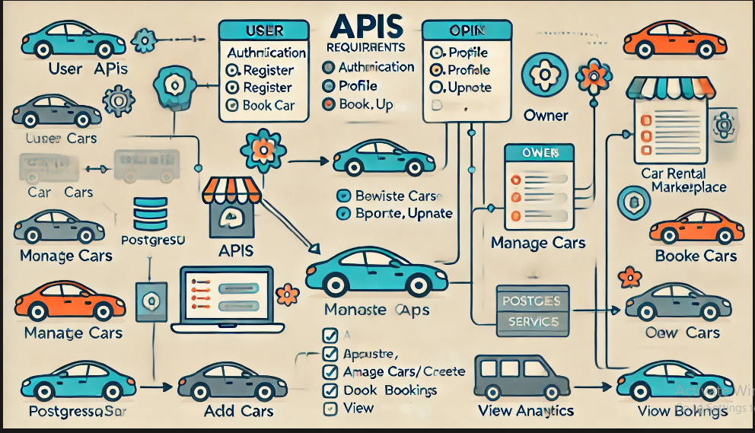

**5. Sanity Integration (CMS)**

Use **Sanity.io** to manage dynamic content like:

1. FAQs.
2. Promotional banners.
3. Blog posts for SEO.
4. Car details (if needed).

**6. Key Rules**

1. **Authentication**: Use JWT tokens for secure API access.
2. **Data Validation**: Validate all inputs using tools like Joi or Yup.
3. **Rate Limiting**: Apply rate limiting to prevent abuse (e.g., login attempts).
4. **Payment Security**: Use PCI-compliant payment gateways.
5. **Car Verification**: Admin approval is mandatory for listing cars.
6. **Availability Checks**: Prevent double bookings with real-time availability validation.

**7. User Interaction**

1. **Homepage**: Simple search and browse interface.
2. **Login/Register**: User-friendly forms with social login options.
3. **Booking Flow**: Intuitive and seamless (3-5 steps max).
4. **Feedback**: Post-booking feedback/review system