TASK 4 : FINAL BIOINFORMATICS REPORT
Name: Shafaque Naushad
Course: B.Sc. Life Science (Pursuing)
Internship: Bioinformatics Internship
Intern Id: SWX-2026-001799
Task: Final Bioinformatics Report
Date: 15 October 2026
Dataset: Single-cell barcode quality summary

1. Research Question and Objective
The broader research questions recorded in Task 1 concern ductal carcinoma in situ (DCIS), its surrounding tumour microenvironment, and molecular or spatial features that may help explain differences between preinvasive and invasive breast cancer. The exploratory analysis completed in Tasks 2 and 3 focuses more narrowly on barcode-level expression summaries: how total counts and the number of detected genes vary across barcodes/spots.
Objective: to load a sparse gene-expression matrix and its feature and barcode tables, calculate basic summary statistics for each barcode, and visualize the distributions of total counts and detected genes without making unsupported biological or causal claims.

2. Dataset and Data Provenance
Task 1 records the dataset as “A single cell and spatial atlas of preinvasive breast cancer [Visium ST]” with GEO accession GSE348919, organism Homo sapiens, and 14 samples. The Task 2 code, however, searches for files named *matrix.mtx.gz, *features.tsv.gz, and *barcodes.tsv.gz. The supplied barcode filename begins GSM10083696_ECIS41T2, which is not enough by itself to confirm that the files belong to GSE348919.
Data provenance check required before submission: confirm the source/accession of the exact matrix, features, and barcode files used in Tasks 2 and 3. Until this is checked, this report treats the cancer research questions from Task 1 and the barcode summary analysis as related internship work, but does not claim that the analyzed matrix is definitively from GSE348919.

3. Methods
- Python was used with pandas to read the feature and barcode tables.
- The expression matrix was read from a compressed Matrix Market file using SciPy’s mmread function.
- The code checked that matrix dimensions matched the number of features and barcodes.
- Total counts per barcode were calculated by summing matrix values across features for each barcode.
- Detected genes per barcode were calculated by counting entries greater than zero for each barcode.
- Mean, median, minimum, and maximum values were calculated for the barcode-level summaries.
- Matplotlib histograms were generated to visualize the distributions of total counts and detected genes.

4. Results

4.1 Barcode summary
The Task 3 report states that the dataset used for the summary contained 3,585 barcodes. For total counts per barcode, the reported mean was 4,154.33 and the median was 1,792. For detected genes per barcode, the reported mean was 1,483.16 and the median was 1,015. These values are reproduced from the Task 3 report and should be rechecked against the saved quality_summary.csv or the original analysis output if available.

4.2 Distribution of detected genes per barcode
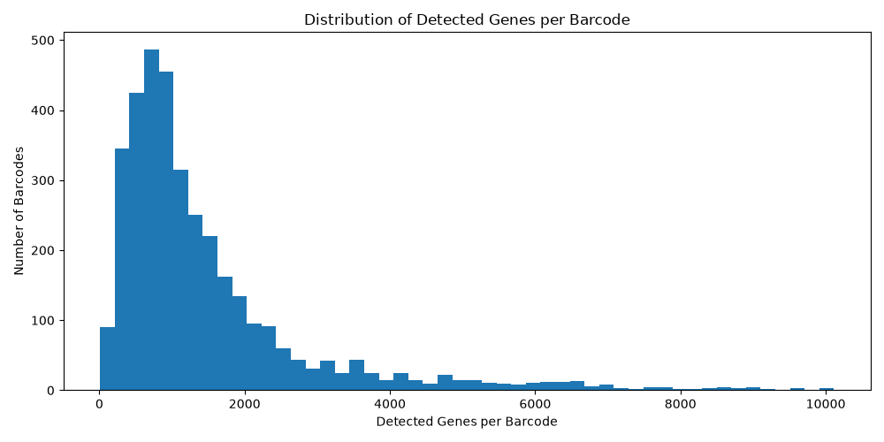
Figure 1. Distribution of detected genes per barcode.
Interpretation: the histogram is right-skewed. Most barcodes are concentrated at lower detected-gene values, while a smaller number have much higher values, extending to around 10,000 in the plotted range. This indicates variation in the number of genes detected across barcodes.
What this shows: the distribution and spread of detected-gene counts among barcodes.
What this does not prove: by itself, the histogram does not establish that a barcode with more detected genes is biologically better, that a low value necessarily indicates poor quality, or that a particular biological process caused the observed differences.

4.3 Distribution of total counts per barcode
The Task 3 report describes the total-count distribution as right-skewed, with most barcodes having lower total counts and a smaller number having much higher counts. The reported mean (4,154.33) is greater than the median (1,792), which is consistent with a right-skewed distribution. The chart image for this measure should be included in the final submission if it is available.

5. Limitations
- Histograms describe distributions but do not identify the cause of differences between barcodes.
- Higher total counts or more detected genes do not automatically mean that a barcode is biologically superior.
- No cell/spot filtering thresholds, normalization, differential expression, or statistical testing are reported in this basic summary.
- The exact link between the Task 1 GEO accession and the Task 2 matrix files remains to be confirmed.
- The numerical summaries in this report are taken from the Task 3 document; the original saved output should be checked before final submission.

6. Conclusion
The exploratory analysis demonstrates a basic bioinformatics workflow: loading a sparse expression matrix, checking its dimensions against feature and barcode tables, calculating barcode-level summaries, and visualizing the results. The reported distributions are right-skewed, with many barcodes at lower values and fewer barcodes at higher values. These plots are useful for understanding variation, but further quality control and biological analysis would be needed to interpret the underlying causes. Dataset provenance should be verified before the report is submitted as a single analysis of the Task 1 dataset.

7. References and Tools
1. NCBI Gene Expression Omnibus (GEO), GSE348919: https://www.ncbi.nlm.nih.gov/geo/query/acc.cgi?acc=GSE348919
2. Python libraries used in the supplied analysis code: pandas, SciPy, and Matplotlib.
3. Internship materials: Task 1 dataset-selection document; Task 2 Python analysis script; Task 3 visualization and interpretation report.

Pre-submission checklist
☐ Confirm that the Task 2 matrix, features, and barcode files came from the intended dataset.
☐ Check the reported summary values against the original analysis output.
☐ Add the total-count histogram if available.
☐ Save the final report and analysis files in a clearly named Google Drive folder or GitHub repository.
☐ Create the required LinkedIn explanation post and paste both URLs into the Swynex Task 4 form.

