**Question 1: Create a Dashboard displaying the following data and differentiating Indian billionaires and other world billionaires [Using an appropriate visualization]**

|  |  |
| --- | --- |
| ADAV Mini project | **Group members**   1. Sangeetha Sankar 2. G R Priyavarshini 3. Shafeena Farheen   **Dataset:** Billionaire detailed.csv  **BI Tool:** Tableau |

1. **Industry**

**Description:**

The stacked bar chart (aka stacked bar graph) extends the standard [bar chart](https://chartio.com/learn/charts/bar-chart-complete-guide/) from looking at numeric values across one categorical variable to two. Each bar in a standard bar chart is divided into a number of sub-bars stacked end to end, each one corresponding to a level of the second categorical variable.

Calculated fields allow you to create new data from data that already exists in your data source. When you create a calculated field, you are essentially creating a new field (or column) in your data source, the values or members of which are determined by a calculation that you control.

In Tableau, grouping is the process of combining multiple members from a singledimension into a higher category, whereas creating a set is the process of combining members from multi-dimensions and/or conditions into a dynamic or constant Group.

**Steps:**

1. From the Data Source pane, Right click on “Country” field and select ‘Create Group…’
2. Provide Field name as “country differentiate”
3. Select the india country and create a group name as ”India” and group the remaining countries as “Other”
4. Save changes by clicking ‘OK’.
5. Create a calculative field for the count of Billionaire
6. Drag and drop the “Industry” column to Rows and the “Count of Billionaire” measure to column
7. Add the “country differentiate” field to color marks
8. Choose stacked bar chart from the show me section .

**Inference:**

The stacked Bar chart shows the count of indian billionaire and other country billionaire for each industry. The Finace&Investment has more number of Billionaire as compared to other industry on overall i.e.., there are 8 indian Billionaire and 363 other country billionaire. More Indian billionaire are found in manufacturing industry(27). There is no indian billionaire present in the following industry -‘gaming&casino’,’Logistics’ and ‘sports’.

**Output:**

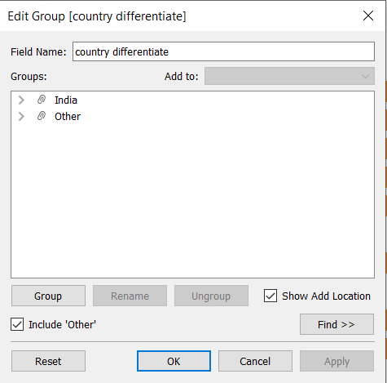

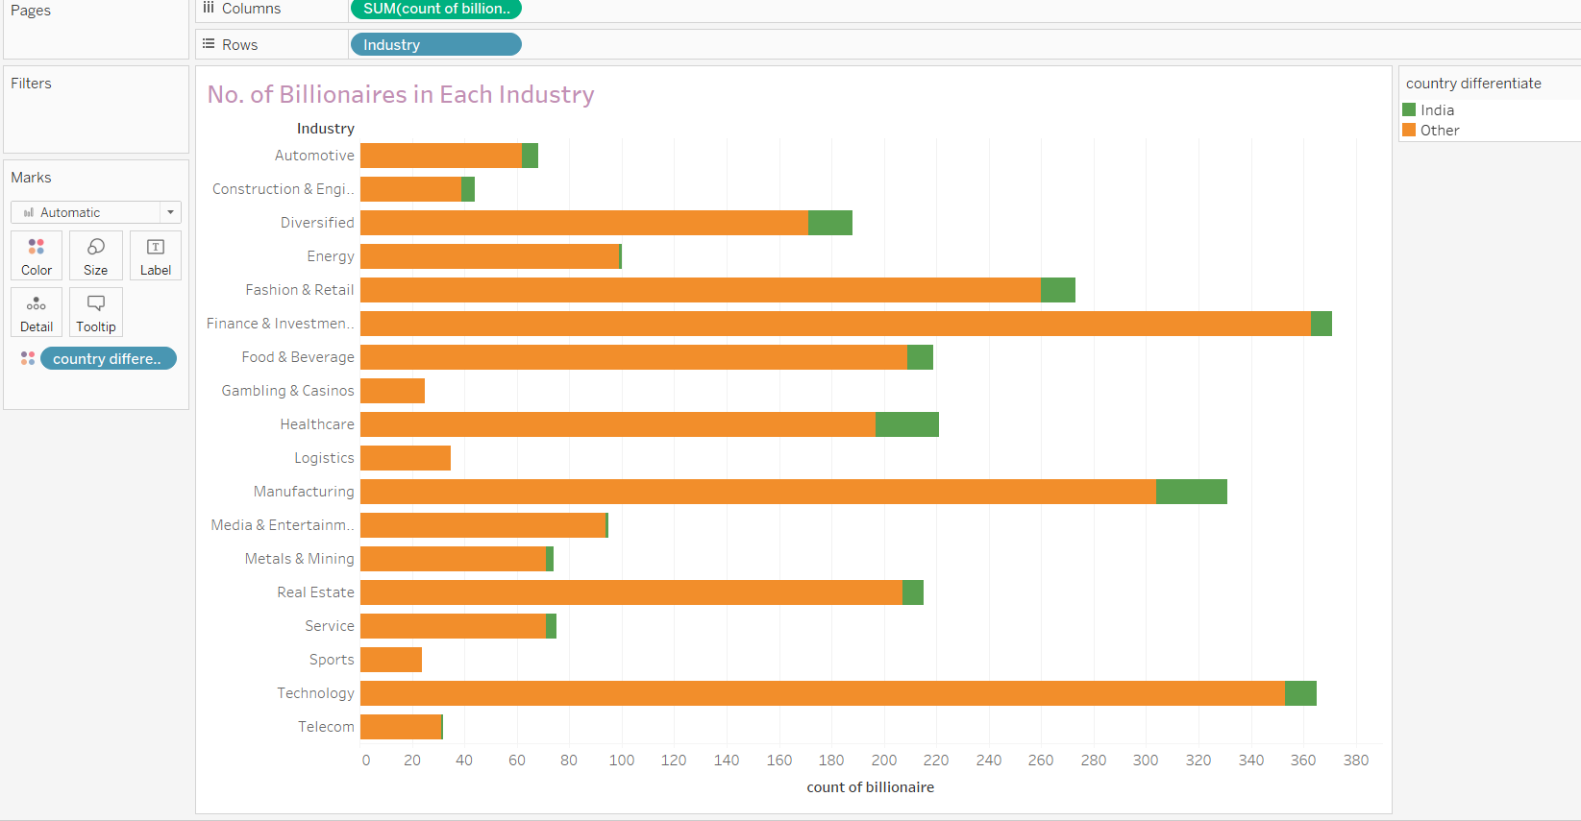

**Note 1.1:** In order to get rid of null values in the data, a new calculated field ‘count of billionaire’ is included with value 1 in each row. Even in a performance standpoint Sum() works better than Count() function which acts as a dual purpose here. Going forward we will be using Sum(count of billionaire) wherever possible.

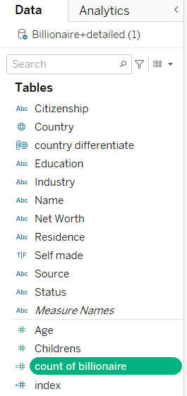

1. **Wealth**

**Description:**

A bar chart or bar graph is a chart or graph that presents [categorical data](https://en.wikipedia.org/wiki/Categorical_variable) with rectangular bars with [heights](https://en.wikipedia.org/wiki/Height) or [lengths](https://en.wikipedia.org/wiki/Length) proportional to the values that they represent. The bars can be plotted vertically or horizontally. A vertical bar chart is sometimes called a column chart.

Calculated fields allow you to create new data from data that already exists in your data source. It is used for “Net Wealth “ field

“country differentiate” field is created based on the grouping concept in table to show differentiate the india vs other country in the visualisation

**Steps:**

1. From the Data Source pane, Right click on table and select ‘Create Calculated Field…’
2. Provide Name for the new field: ‘Net Wealth’
3. Feed required calculation to the Calculation area:

REPLACE(REPLACE([Net Worth],'$',''),'B','')

1. Save changes by clicking ‘OK’
2. Right click on “Country” field and select ‘Create Group…’
3. Provide Field name as “country differentiate”
4. Select the india country and create a group name as ”India” and group the remaining countries as “Other”
5. Save changes by clicking ‘OK’.
6. Drag and drop the “sum(Net Wealth )” to Rows and “country differentiate” field to columns
7. Add the “country differentiate” to the color under marks and “sum(Net Wealth)” to Label under marks.
8. Select Bar chart under show me section , to create visualisation for the given data.

**Output:**

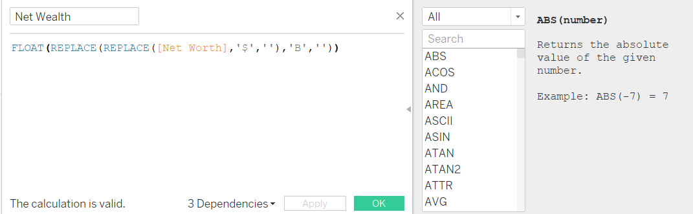



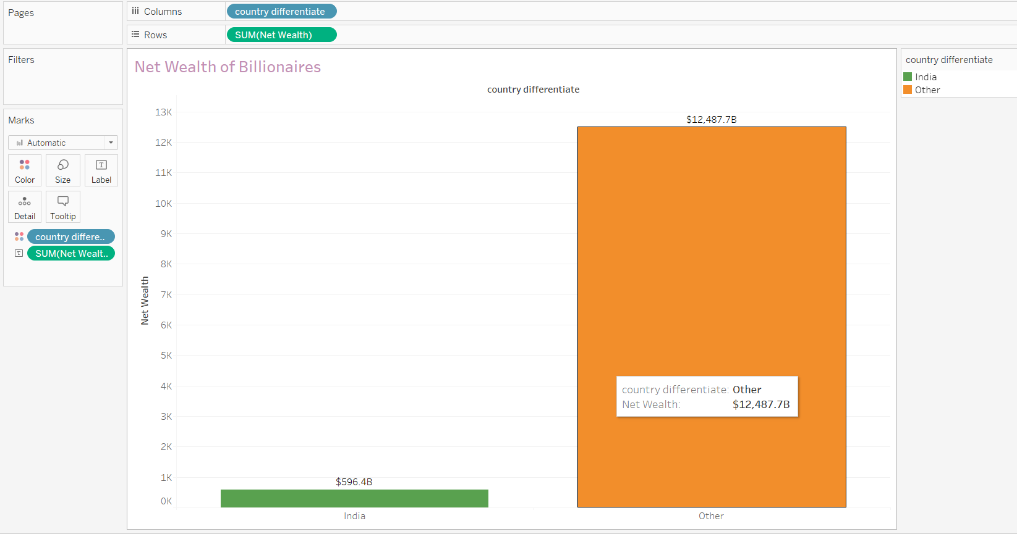

**Inference:**

Using this view where the user can compare the Net Wealth of the indian billionaire with other countries billionaire net wealth. As you see here, The net wealth of indian billionaire is $596.48 which comparatively lower than other countries billionaire net wealth.

1. **Self Made Billionaire**

**Description:**

Packed Bubble chart is used to display data in a cluster of circles. Dimensions define the individual bubbles, and measures define the size and color of the individual circles. Bubble Chart is used to illustrate the relationship between numerical variables visually. Like Scatter Plot, bubble charts can help understand social, economical, and other scientific relationships.

In order to get rid of null values in the data, a new calculated field ‘count of billionaire’ is included with value 1 in each row. Even in a performance standpoint Sum() works better than Count() function which acts as a dual purpose here. Going forward we will be using Sum(count of billionaire) wherever possible.

“country differentiate” field is created based on the grouping concept in table to show differentiate the india vs other country in the visualisation

**Steps:**

1. Add “country differentiate” field to the color under marks
2. Add the sum(count of billionaire) to the size under marks
3. Select “packed bubble chart” from the show me section to create the visualisation for the selected field.
4. Add the “Self Made” to the filter and enable the “True” option.
5. Add the “country differentiate” and “sum(count of billionaire)” to the Label to show the values in the visualisation.

**Output:**

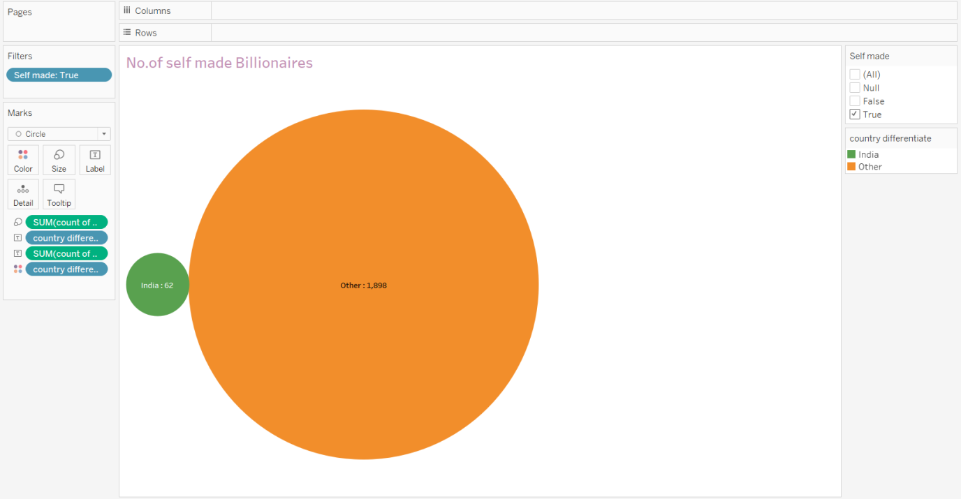

**Inference:**

This dynamic view helps the user understand the count of self-made billionaire in India and other countries. As you can see, the self-made billionaires are more in other countries as compared to India. India has only 62 self-made billionaire whereas; other countries have 1898 self-made billionaire.

1. **Top 5 Billionaires**

**Description:** It helps understanding data across different categories where one can play around adding multiple measures and make it either Grouped or Stacked Bar chart. The exact measure value can also be viewed in the Bars making it useful to compare across categories sorting them in the way the Business User needs it.

**Steps:**

1. Add dimension “Name” to the Sheet
2. Add the Measure Sum([Net Wealth])
3. Select view – Bar Chart (Horizontal)
4. Create a calculative field “index” to create a unique numbers down the pane which partitioned by the “country differentiate”
5. Add the “index” and “country differentiate” fields to Rows
6. Sort the index based descending order of sum(Net Wealth) along each “country differentiate”.
7. Add index to the filer pane and Select Top filter type By field and choose 5 to display top5 billionaire in each country differentiate
8. Add “country differentiate” to colors under marks.

**Output:**

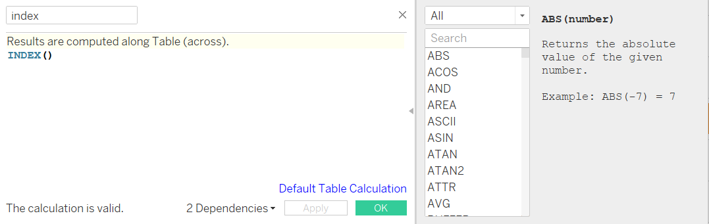

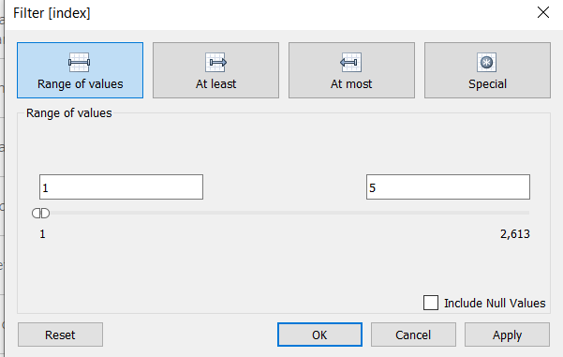

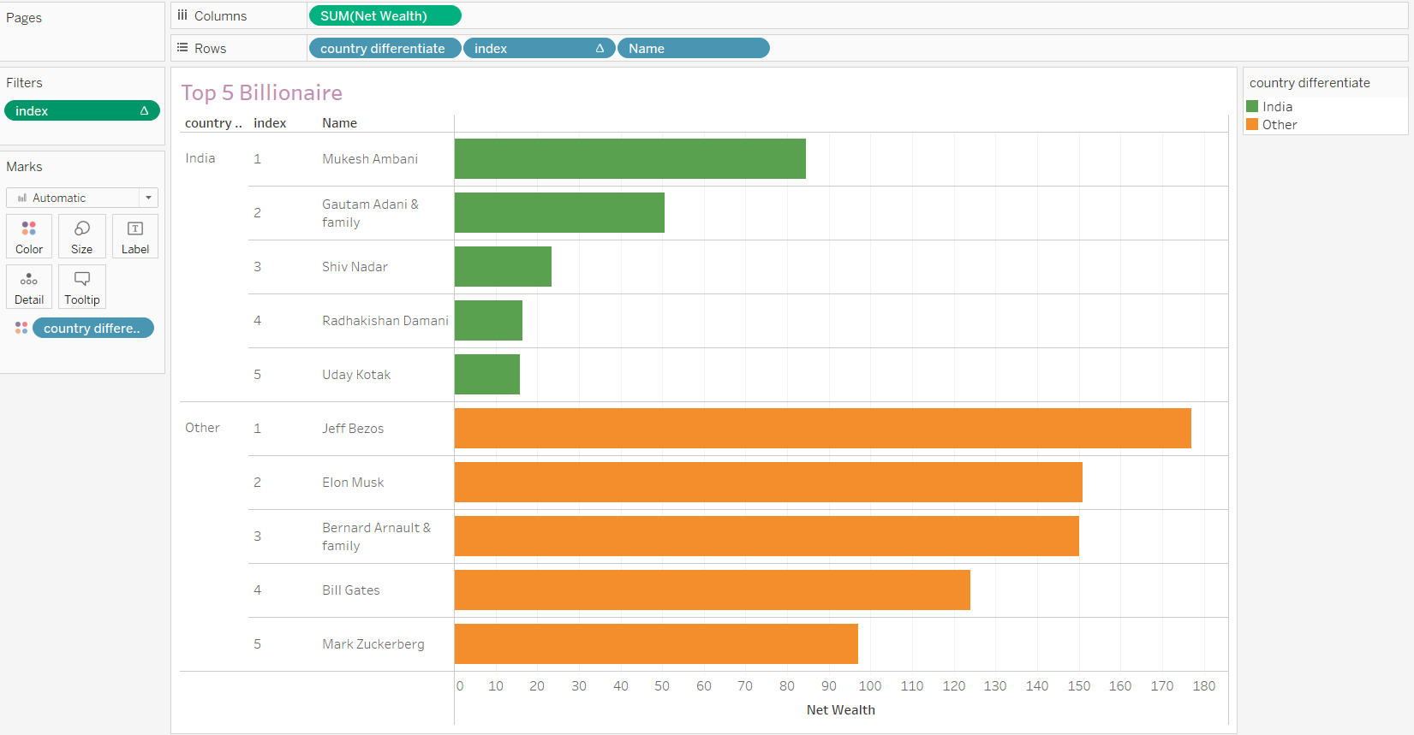

**Inference:**

This view helps the user understand the Top 5 Billionaire with their respective Net Wealth against the name for india and other country. From thisbar graph, we can find the top 5 billionaires by their net wealth. As you can see , In India, The person “**Mukesh Ambani**” is **top 1** billionaire followed by “Gautam Adani”,” Shiv Nadar” , “Radhakishan damani” and “uday kotak”and other. Mukesh Ambani has overall net wealth of $84.50B.

In other countries, The person “**Jeff Bezos**” is **top 1** billionaire followed by “Elon Musk”,” Bernard Arnault” , “Bill Gates” ,”Mark Zukerberg”and others. JeffBezzos has netwealth of $177.00B.

**Dashboard:**

A dashboard is a collection of several views, letting you compare a variety of data simultaneously. For example, if you have a set of views that you review every day, you can create a dashboard that displays all the views at once, rather than navigate to separate worksheets.

Like worksheets, you access dashboards from tabs at the bottom of a workbook. Data in sheets and dashboards is connected; when you modify a sheet, any dashboards containing it change, and vice versa. Both sheets and dashboards update with the latest available data from the data source.

**Steps:**

* **Build your worksheets**: Create individual worksheets that represent different aspects of your data analysis or visualizations. Each worksheet should focus on a specific question or key insight you want to convey. In this Question, we have created 4 worksheets namely “industry”,”wealth”,”self made”,”top 5 billionaire”.
* **Arrange your worksheets**: Drag and drop the worksheets onto the dashboard canvas. You can rearrange them, resize them, and add additional elements such as text boxes, images, or web objects to enhance the overall dashboard layout.
* **Add interactivity and filters**: Enhance the user experience by adding interactivity to your dashboard. You can add filters, parameters, and actions to allow users to explore and interact with the data dynamically. Here, We used selfmade filter to add user interactivity in the Billionaire dashboard.
* **Format and customize**: Fine-tune the formatting of your dashboard to make it visually appealing and intuitive. Adjust colors, fonts, borders, and gridlines to ensure consistency and clarity across the dashboard.
* **Test and refine**: Preview and test your dashboard to ensure that it displays the desired information accurately and that interactivity and filters work as intended. Make adjustments as needed to improve usability and functionality.
* **Publish and share**: Once you are satisfied with your dashboard, publish it to Tableau Server or Tableau Public (if available) to share it with others. You can also save it as a Tableau packaged workbook (.twbx) for sharing with users who have Tableau Desktop.

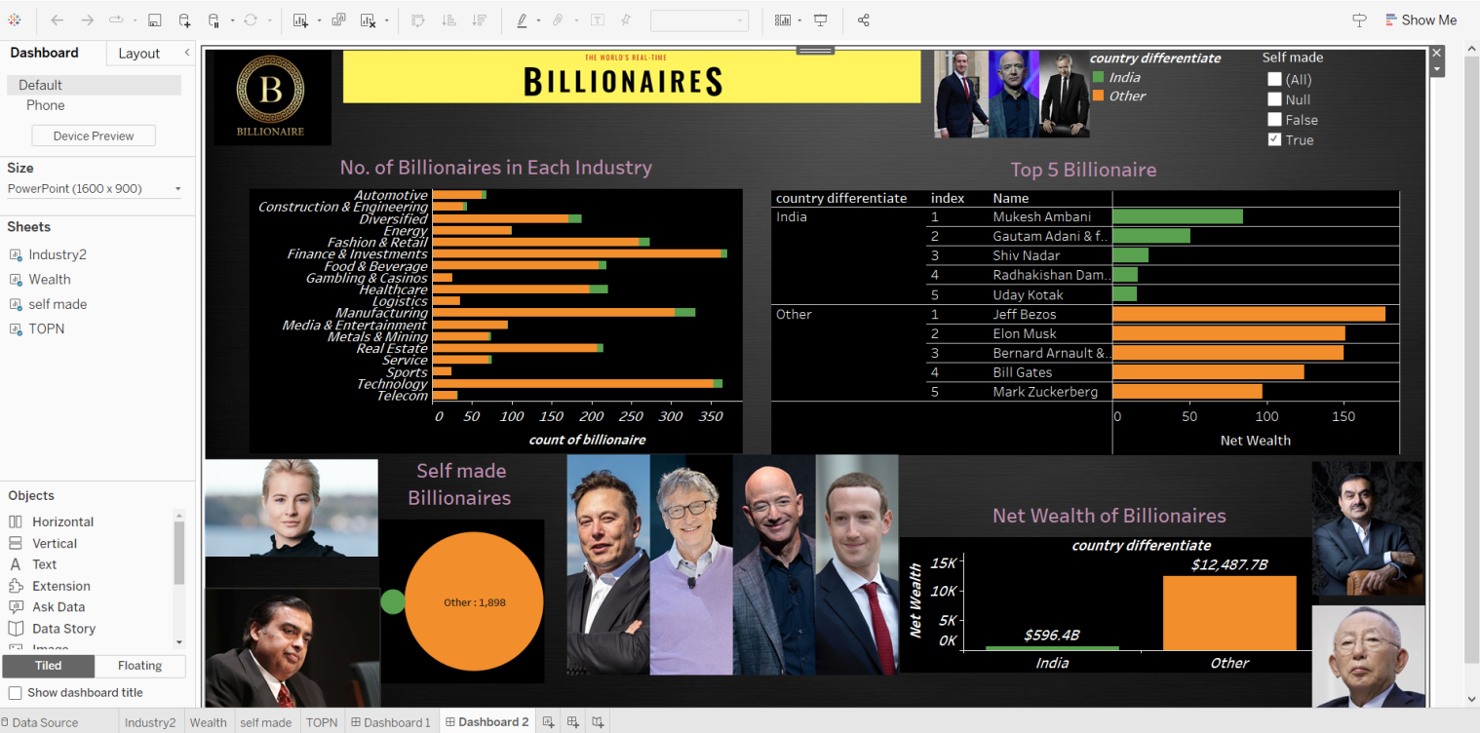

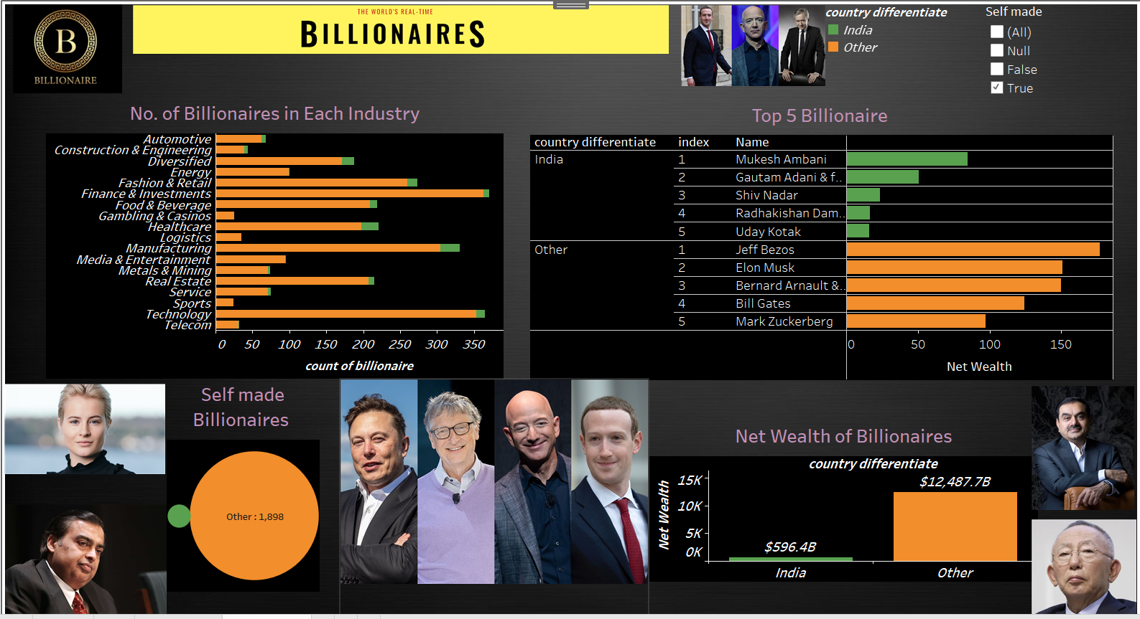

**Question 2: Create a Dashboard containing the following data details**

1. **Create a calculated field to differentiate the marital status as Married or not Married. Create a donut chart display on marital status. Use country and industry filters to customize the view**

**Note 1.2:** In a performance perspective “Case” statements are more effective compared to “if” statements and makes it easy to read when written against complex nested “if” statements

**Description:** Users can display multiple data sets with a donut chart. Users can place additional information about the total value or data labels in the hole of the doughnut chart. The percentage values are automatically calculated when the donut chart in Tableau is drawn.

**Steps:**

1. Create a calculated field ‘Marital Status’ with below expression:

CASE [Status]

WHEN IN ('Engaged','Single','In Relationship')

THEN 'Not Married'

WHEN NULL THEN 'Unknown'

ELSE 'Married' END

1. Add avg(1) in Rows twice.
2. Two new additions will be displayed under Marks: Agg(Avg(1)
3. Select Pie Chart in drop down menu
4. In the first aggregation drop Marital Status column in Label and colour and Measure Sum(count of billionaire) to Label (Refer Note 1.1)
5. Right click measure and Select Percentage to Total under Quick Table calculation
6. In Second aggregation add measure Sum(count of billionaire) alone
7. Update the label with ‘Total Billionaires’ followed by value
8. Change the colour of this chart to White and adjust size to make the Primary chart to be in a donut shape
9. Right click second Agg(Avg(1)) and select “Dual axis” to merge two pie chart to create donut chart.
10. Add Filters Country and Industry and show them in the sheet with Selecting all values by default

**Output:**

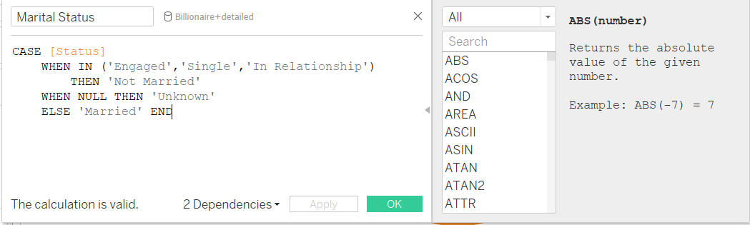

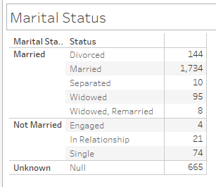

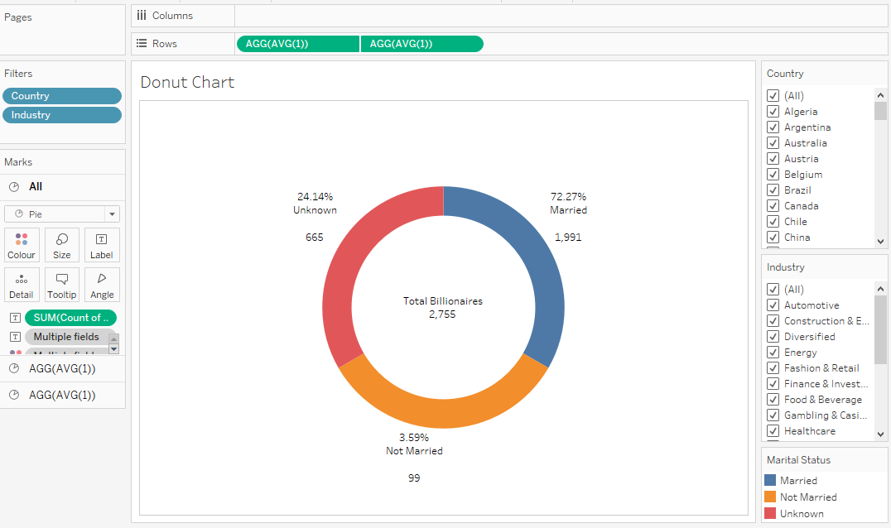

**Inference:** Coupling two pie chart is giving a clear idea to user the Total value and percentage split of values across each attributes. Filters give the convenience of playing around with different attributes of Country and Industry Dimensions. From this Donut chart, we can infer that **72.27%** of Billionaires are **married** across all countries and only **3.59%** of Billionaires are **unmarried.** We can apply filter across country and industry to get the marital status percentage.

1. **Create a box plot chart displaying their children count.**

**Description:**

The box plots are also known as a box-and-whisker plots. They show the distribution of values along an axis. Boxes indicate the middle 50 percent of the data which is, the middle two quartiles of the data's distribution. The remaining 50 percent of data on both sides is represented by lines also called whiskers, to display all points within 1.5 times the interquartile range, which is all points within 1.5 times the width of the adjoining box, or all points at the maximum extent of the data.

The Box Plots take one or more measures with zero or more dimensions.

**Steps:**

1. Drag and drop “childrens” field to Rows in the sheet
2. Click on the “Analysis” menu and uncheck the Aggregation measure.
3. To create a box-and-whisker plot, right-click on the Y-Axis, and choose “Add Reference Line”. When the add reference line dialog box appears, click on the choice for Box Plot. There are some formatting options available, but the default settings are usually best and add annote for more understanding.

**Output:**

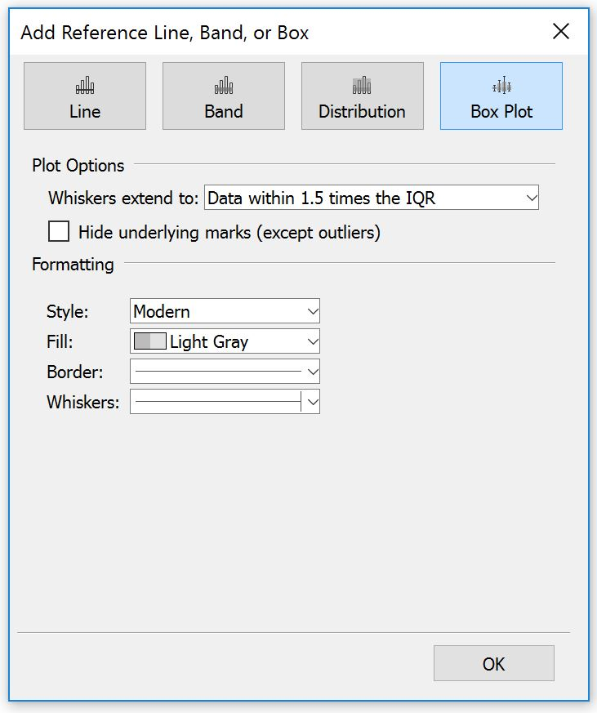

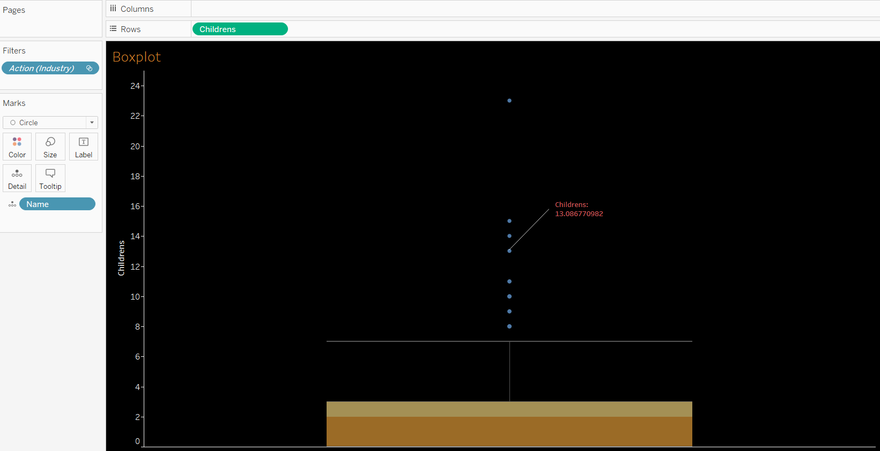

**Inference:**

The Box plot depicts the distribution or spread of Childrens count. As you see, The middle 50% of data or median for childrens count is 2 which means most of billionaire have 2 childrens. The upper and lower whiskers of box plot fit the data into 1.5 times of IQR . For childrens count the upper whisker value is 7 and Lower whisker is 0. We could see the presence of outliers in the “childrens” data. The children datapoint above the upperbound whiskers shows the outliers. i.e., the children count above 7 is considered as outliers .

1. **Display the average age and net worth.**

**Description:**

A bubble chart is a two-dimensional graph where plotted discs graphically represent data. The plotted discs resemble bubbles, hence the name bubble chart. It combines a scatter plot with a proportional area chart. It's used to visualize and analyze data in 3-4 dimensions**.** Each of the values in the dimension field represents a circle whereas the values of measure represent the size of those circles.

Create a calculative field for Martial status and networth. Calculated fields allow you to create new data from data that already exists in your data source.

**Steps:**

1. Create a calculated field ‘Marital Status’ with below expression:

CASE [Status]

WHEN IN ('Engaged','Single','In Relationship')

THEN 'Not Married'

WHEN NULL THEN 'Unknown'

ELSE 'Married' END

1. Add the “Martial Status” field to Label and color marks.
2. Add avg(net worth) to size marks.
3. Add avg(age) to label marks.
4. Choose the bubble chart from show me section to visualise the avg age and net worth of billionaires based on the marital status
5. Right click on bubble chart and select annote 🡪 point and give the description for more understanding

**Output:**

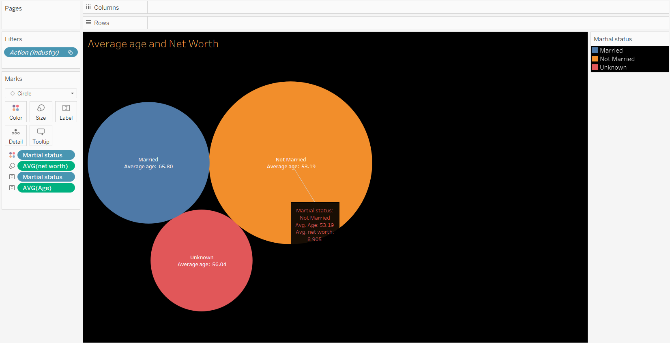

**Inference:**

The Bubble chart show the average age of the Billionaire and net worth based on the marital status. The net worth is high for the billionaires who are not married and belongs to the average age of 53.19. The average age of Married billionaire is 65.80.

1. **Create a bubble chart with Top 5 Industry with net worth which is self-made. Keep the Bubble chart as the master filter for Dashboard.**

**Description:** Bubble charts display data as a cluster of circles. Each of the values in the dimension field represents a circle whereas the values of measure represent the size of those circles. As the values are not going to be presented in any row or column, you can drag the required fields to different shelves under the marks card

**Steps:**

1. From the Data Source pane, Right click on table and select ‘Create Calculated Field…’
2. Provide Name for the new field: ‘net worth’
3. Feed required calculation to the Calculation area:

REPLACE(REPLACE([Net Worth],'$',''),'B','')

1. Save changes by clicking ‘OK’
2. Add the “sum(net worth)” field to size under marks.
3. Add the “Industry” field to label and color marks
4. Add “Industry” and “self made” fields to filter pane and choose “True” option to filter the self made billionaire for each industry. For Industry filter choose top 5 in configuration window.
5. Select the packed bubble chart from the show me section.
6. While adding this sheet to dashboard. Select the sheet and choose “use as filter” to keep this bubble chart as a master filter for other sheets in the Dashboard.

**Output:**

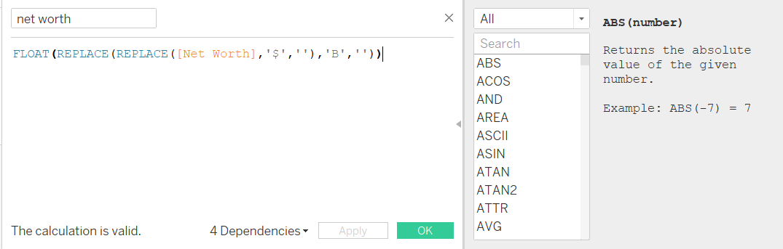

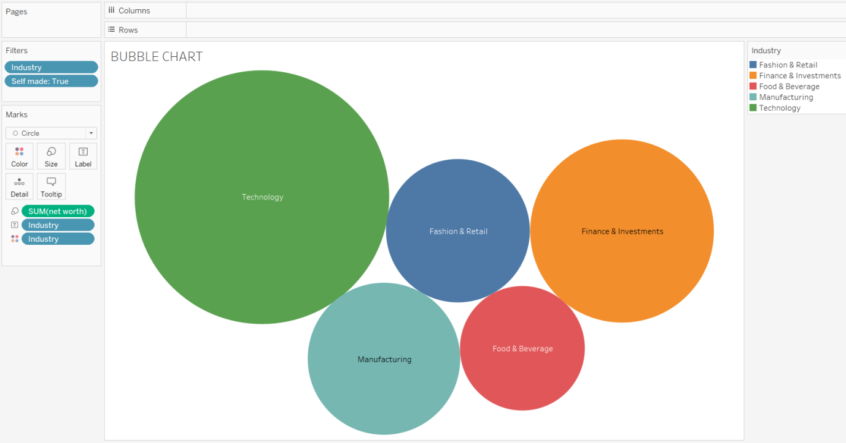

**Inference:**

From the Bubble chart, we can see the top 5 industry based on the net worth of the self-made billionaire. Technology is Top 1 industry which has net worth of $2309B as compared to other industries. Food Beverage industry is in 5th position with net worth of $556B . The size of the Bubble represents the “Net worth” value and it is packed by the “Industry” dimension. Hence, the Top 5 industry of self-made billionaire are **Industry,Finance&Investment,Manufacturing,Fashion&Retail and Food&Beverages .**

1. **Find a relation between the top 5 Industry and Age using an appropriate visualization. Compute the age into following groups:**

**Age: 0-20, 21-45, 46-60, 61-80 and 80+**

**Description:**

Bar charts enable us to compare numerical values like integers and percentages. They use the length of each bar to represent the value of each variable. For example, bar charts show variations in categories or subcategories scaling width or height across simple, spaced bars, or rectangles.

It is a chart or graph that presents categorical data with rectangular bars with heights or lengths proportional to the values that they represent. The bars can be plotted vertically or horizontally. A vertical bar chart is sometimes called a column chart.

Calculated fields allow you to create new data from data that already exists in your data source. We created two calculative field for Age bins and networth which is used to visualise the top 5 industry for each age group or bins.

**Steps:**

1. From the Data Source pane, Right click on table and select ‘Create Calculated Field…’
2. Provide Name for the new field: ‘net worth’
3. Feed required calculation to the Calculation area:

REPLACE(REPLACE([Net Worth],'$',''),'B','')

1. Save changes by clicking ‘OK’
2. Similarly, create a calculative field “Age bins” using the below expression

IF[Age (copy)]>0 and [Age (copy)]<=20 THEN "0-20"

ELSEIF [Age (copy)]>20 and [Age (copy)]<=45 THEN "21-45"

ELSEIF [Age (copy)]>45 and [Age (copy)]<=60 THEN "46-60"

ELSEIF [Age (copy)]>60 and [Age (copy)]<=80 THEN "61-80"

ELSE "80+"

END

1. Drag and drop the “Industry” and “Age bins” to column shelves .
2. Add sum(net worth) to rows shelves..
3. Add “Industry” to color marks.
4. Add “Industry” to filter and choose top 5 and click “ok” and save the changes.
5. Select Bar chart from the show me section to visualise the top 5 industry for each age bins.

**Output:**

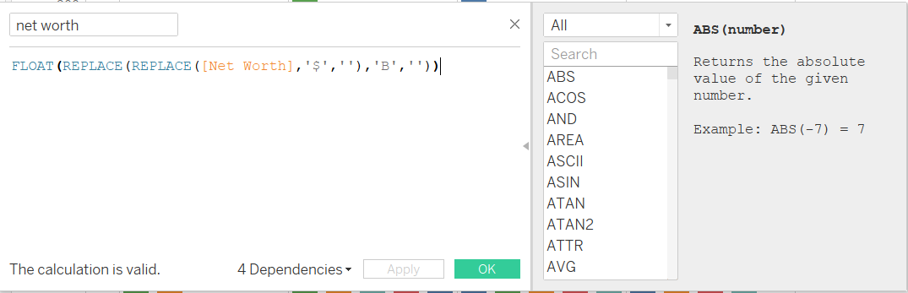

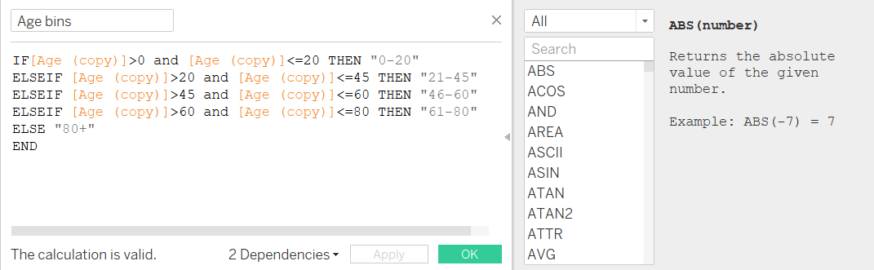

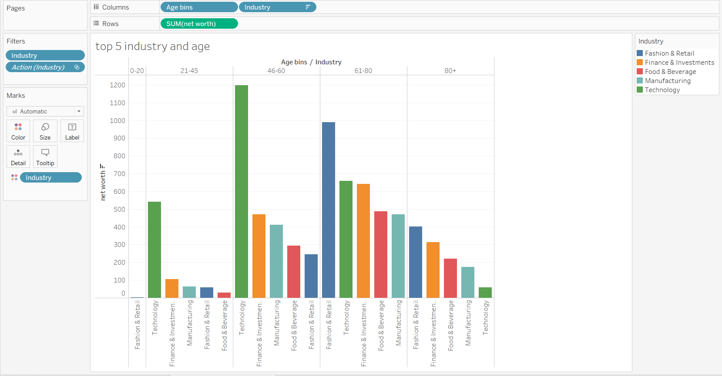

**Inference:**

The Bar chart shows the top 5 industry based on the networth of billionaire in each age group or bins. Here, we have 5 age group such as 0-20,21-45,46-60,61-80,80+. Below are the top 5 industry for different age bins

**0-20 :** Fashion &Retail.

**21-45:** Technology, Finance&investment, manufacturing, Fashion&Retail, Food&Beverages.

**46-60 :** Technology, Finance&investment, manufacturing, Food&Beverages, Fashion&Retail..

**61-80:** Fashion&Retail, Technology, Finance&investment, Food&Beverages, manufacturing.

**80+ :** Fashion&Retail, Finance&investment, Food&Beverages, manufacturing, Technology.

From the above chart, we came to know that the billionaires of age group 21-60 has more networth in “Technology” industry and the billionaires of age group 61- 80+ has more networth in “Fashion &Retail” industry.

**Dashboard:**

A dashboard is a collection of several views, letting you compare a variety of data simultaneously. For example, if you have a set of views that you review every day, you can create a dashboard that displays all the views at once, rather than navigate to separate worksheets**.**

**Steps:**

**• Build your worksheets:** In this Question, we have created 5 worksheets namely “martial status”,”boxplot”,”average age and networth”,”bubble chart”,”top5 industry and age”.

• **Arrange your worksheets**: Drag and drop the worksheets onto the dashboard canvas. You can rearrange them, resize them, and add additional elements such as text boxes, images, or web objects to enhance the overall dashboard layout.

• **Add interactivity and filters**: Enhance the user experience by adding interactivity to your dashboard. . Here, we added “country” and “Industry” filters to allow users to explore and interact with the data dynamically. The Bubble chart sheet is kept as a master filter for other sheets in the dashboard. If we filter the industry in the bubble chart then the values will change in all the sheets or chart as per your selection.

• **Format and customize:** Fine-tune the formatting of your dashboard to make it visually appealing and intuitive. Adjust colors, fonts, borders, and gridlines to ensure consistency and clarity across the dashboard.

• **Test and refine**: Preview and test your dashboard to ensure that it displays the desired information accurately and that interactivity and filters work as intended. Make adjustments as needed to improve usability and functionality.

• **Publish and share:** Once you are satisfied with your dashboard, publish it to Tableau Server or Tableau Public (if available) to share it with others. You can also save it as a Tableau packaged workbook (.twbx) for sharing with users who have Tableau Desktop.

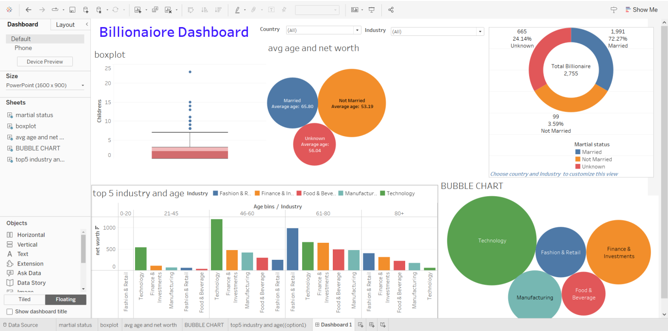

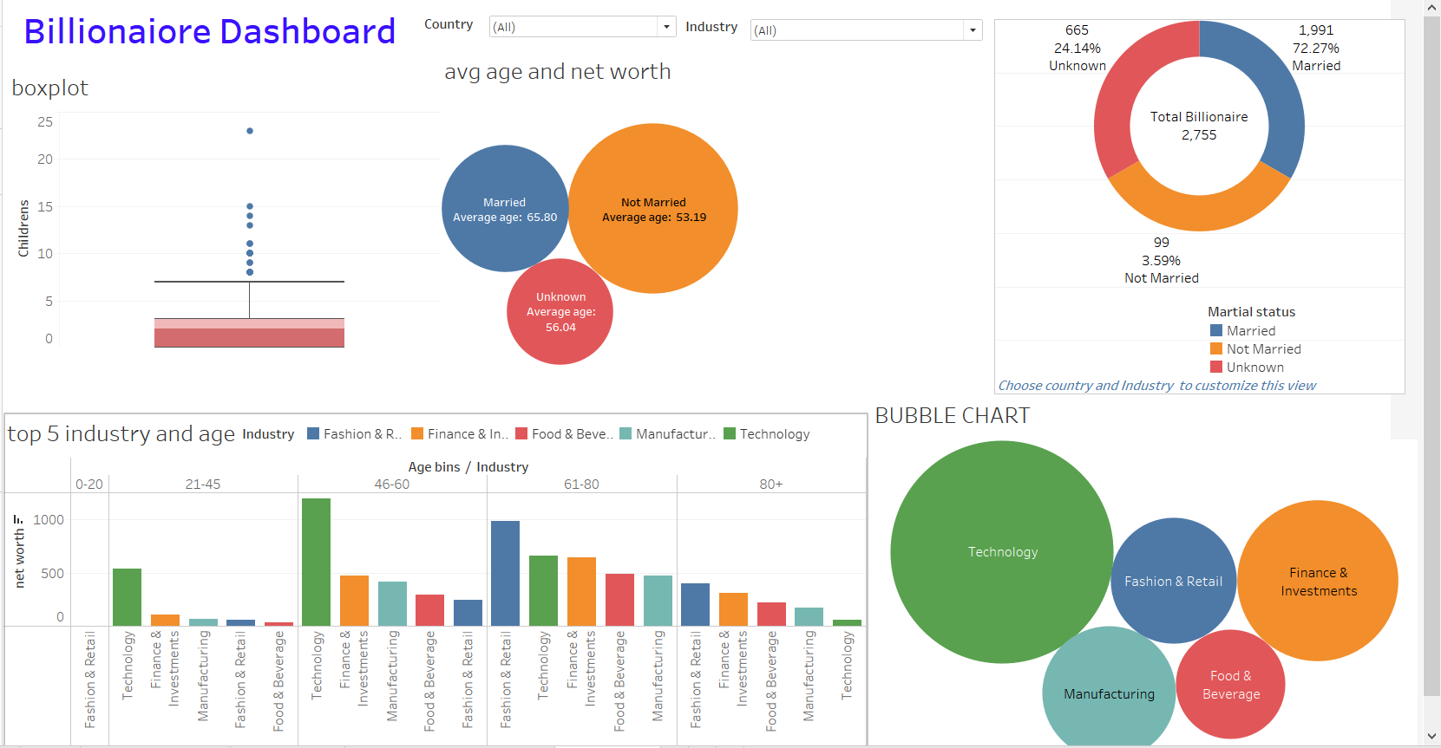

**Dark Theme based Dashboard**

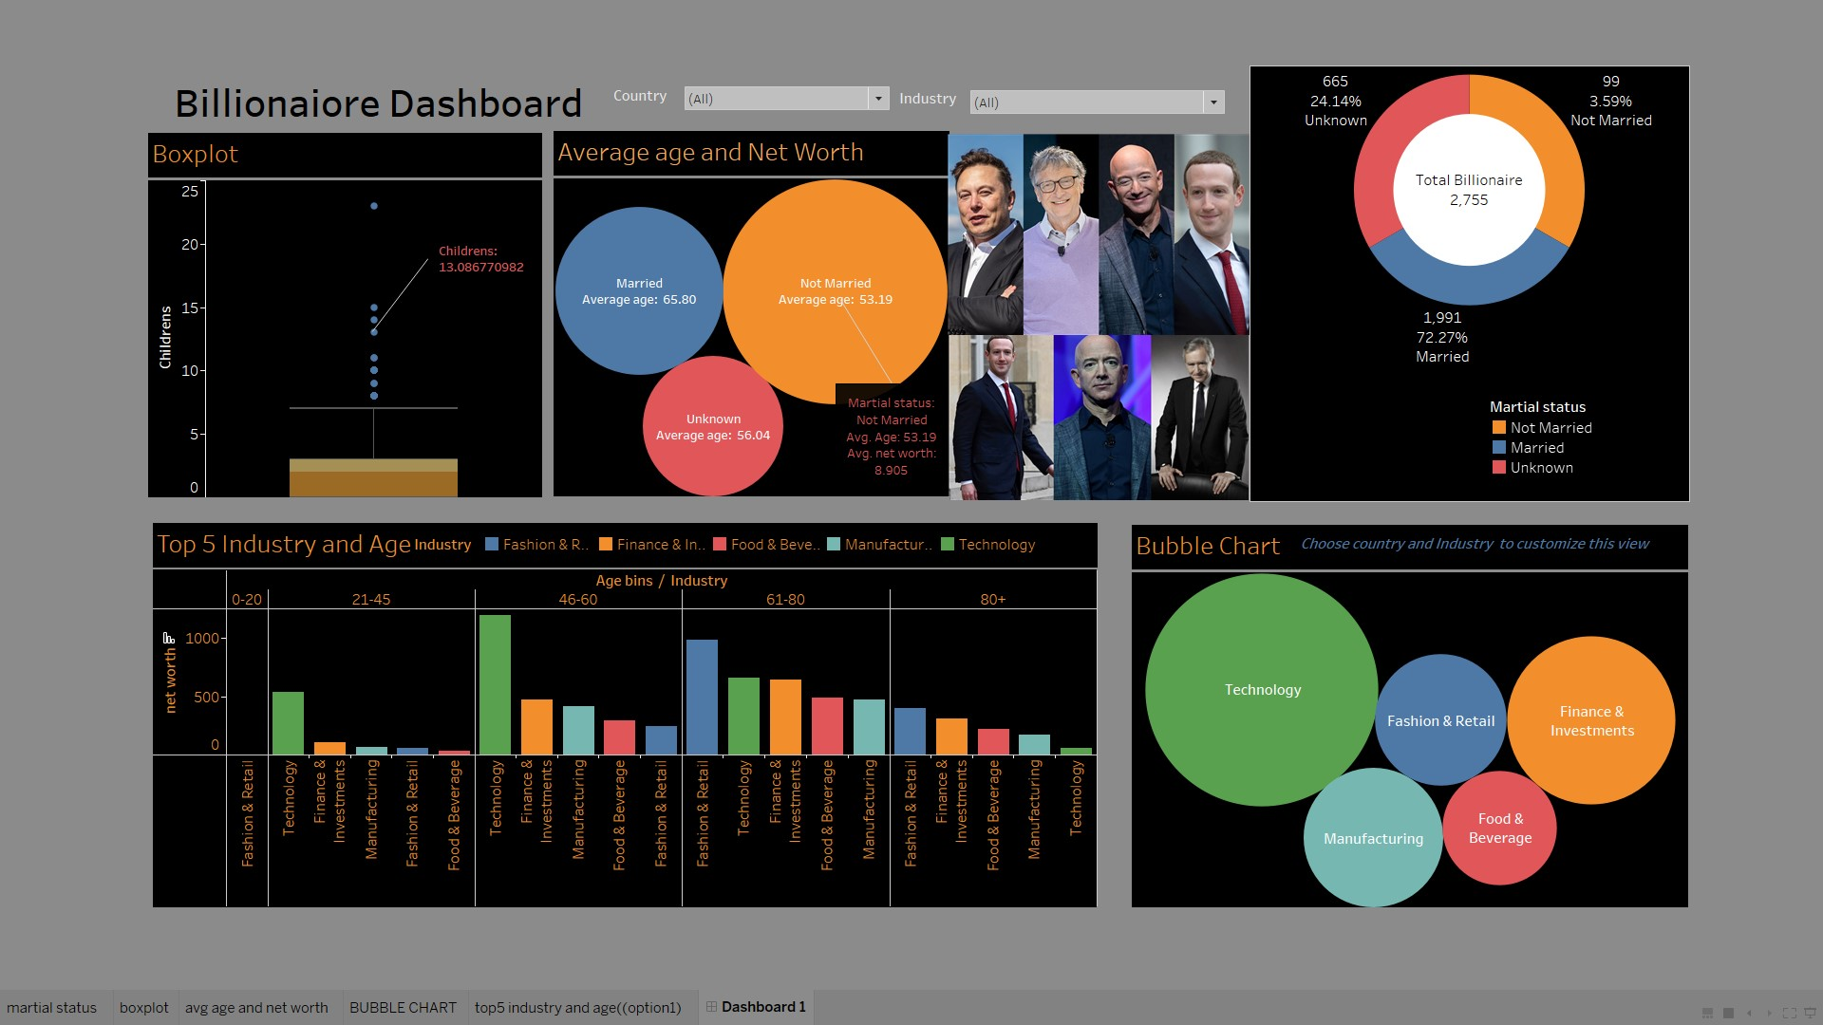

**Using the Bubble chart “Industry” has master filter**

