Educational Ludo
System Report – Iteration 1
Team Sharks
Shafeek Saif · Rakan Ziyan · Mohamed Zereny
Software Engineering and Software Quality Assurance in Information Systems
Assignment 4 – Iteration 1 · November 2026
https://github.com/shafeekseef81-svg/Sharks

Contents
1. About this iteration 3
2. How to run the system 3
2.1 Requirements 3
2.2 Running the submitted JAR 3
2.3 Building from source and running the tests 3
3. Inputs 4
4. What the player can do 4
4.1 Main Menu 4
4.2 Setting up a game 5
4.3 Playing 6
4.4 End of the game 8
5. Expected results in different scenarios 9
6. How we tested the system 9
6.1 Automated tests 9
6.2 Our testing method 10
7. Known limitations of Iteration 1 10
8. GitHub repository 10

1. About this iteration
Iteration 1 delivers a playable basic Ludo game on the Easy level, from the Main Menu to the results screen (SDP 5.2.1, user stories US-1.1 to US-1.5). The application is a Java Swing desktop program built with the MVC architecture required by the course: the packages are Model, View and Controller.
What is in Iteration 1:
- Main Menu, New Game setup with full input validation, the Easy board, turns with the Regular die, legal-move highlighting, square-by-square movement, capture, protected squares, the home path and exact finish, the Rule of 6, the finishing order and ranking, the game clock and the results screen.
What comes in later iterations (by the SDP plan):
- Iteration 2: Medium and Hard boards, special dice (Boost, UltraBoost), Double Blocks, question and surprise squares.
- Iteration 3: game history saved to the course CSV file, administrator login and question management.

2. How to run the system

2.1 Requirements
- Java 17 or later (JRE to run, JDK to build). Tested with Java 23 on Windows 11.
- No internet connection and no installation are needed.

2.2 Running the submitted JAR
The submitted ZIP contains the folder Iteration1 with the runnable EducationalLudo.jar.
System | How to start
Windows | Double-click run.bat in the Iteration1 folder, or run java -jar EducationalLudo.jar from inside that folder.
macOS / Linux | Run ./run.sh in the Iteration1 folder, or java -jar EducationalLudo.jar.

Important (Windows): if the full path of the folder contains Hebrew letters, java -jar "C:\...\<Hebrew folder>\EducationalLudo.jar" can fail with "Unable to access jarfile". run.bat avoids this because it changes to its own folder first, so please start the game with run.bat.

2.3 Building from source and running the tests
Action | Windows | macOS / Linux / Git Bash
Build the JAR | build.bat | ./build.sh
Build and run all tests | test.bat | ./test.sh
Start the game | run.bat | ./run.sh

The tests use JUnit 5 through lib/junit-platform-console-standalone-1.10.2.jar, which is included in the folder; it is used only for the tests and is not packed into the game JAR.

3. Inputs
All input is entered on the New Game screen. The game itself is played only with mouse clicks (Roll Dice, then a highlighted piece).
Input | Allowed values | What happens with a wrong value
Number of players | 2, 3 or 4 | Cannot be wrong: chosen with buttons.
Difficulty | Easy (Medium and Hard are shown with an "Iteration 2" tag and cannot be selected) | Cannot be wrong: only Easy can be chosen.
Player name | 1–12 characters; spaces and invisible characters at the ends are removed; must be unique (not case-sensitive); any language, including Hebrew | The field is marked in red with a message: "Enter a name (1-12 characters)." or "Player N already uses this name."
Player colour | Red, Green, Yellow, Blue; each colour once | A colour already taken by another player is shown crossed out and cannot be chosen.

While any field is invalid, pressing Start Game does not start the game; a line at the bottom says how many fields must be fixed. The settings cannot change once the game has started.

4. What the player can do
The screenshots below were taken from the real application (the integrated Iteration 1 build) at 1280×720.

4.1 Main Menu
The player can start a new game or exit. Game History and Question Management are marked "Soon"; clicking them shows a message that they are part of Iteration 3.
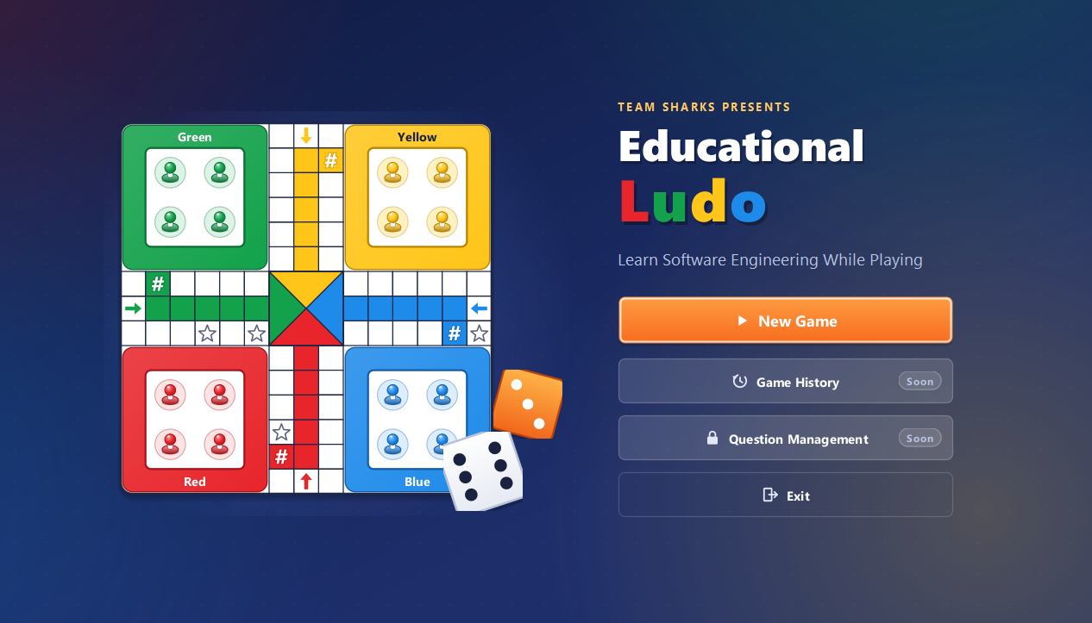
Figure 1 – Main Menu

4.2 Setting up a game
The player chooses the number of players and the difficulty, then enters a name and picks a colour for each player. The order of the list is the turn order.
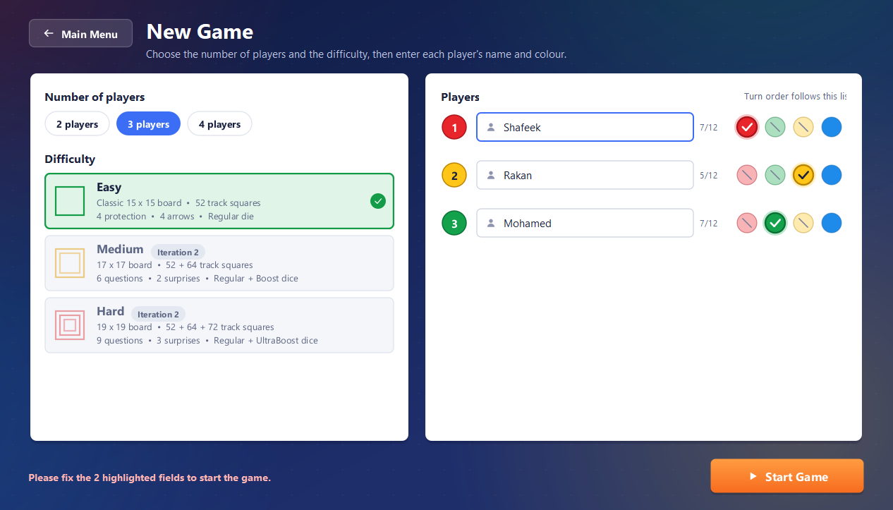
Figure 2 – New Game screen, filled in correctly for three players
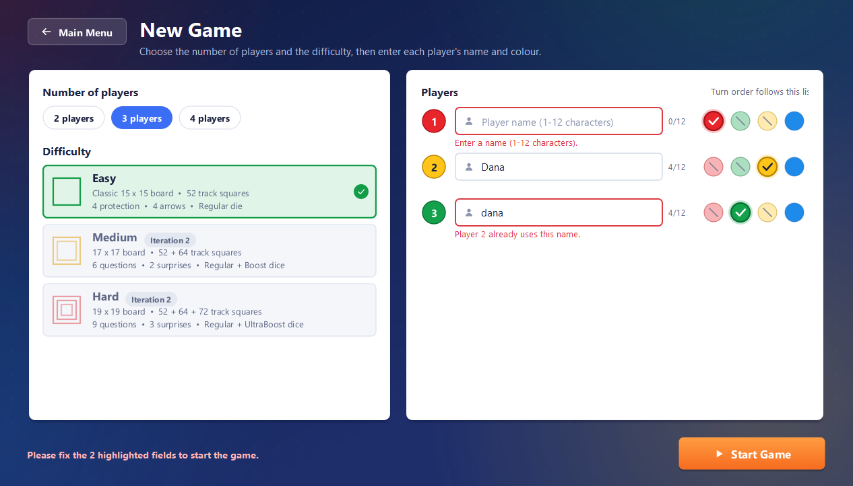
Figure 3 – Validation: an empty name and a duplicate name ("Dana" / "dana") are marked

4.3 Playing
The board shows each player's castle (home base) with four pieces, the shared track, the coloured home paths and the special squares: start squares (#), protection squares (star) and arrows where a piece turns into its home path. The left panel shows the level, the game clock, the players with the number of finished pieces, and the board legend. The right panel shows whose turn it is, the die and a message that tells the player what to do.
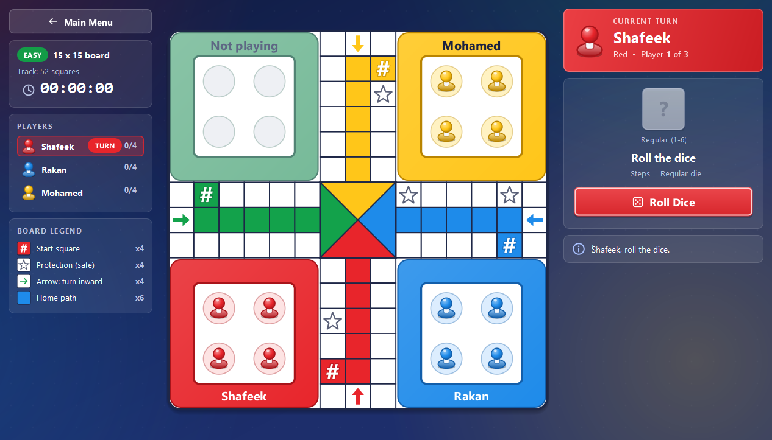
Figure 4 – A new three-player Easy game; the first player is to roll
The active player presses Roll Dice. Every piece that may legally move glows; the player clicks one of them. With a 6, a piece can leave the castle to its start square.
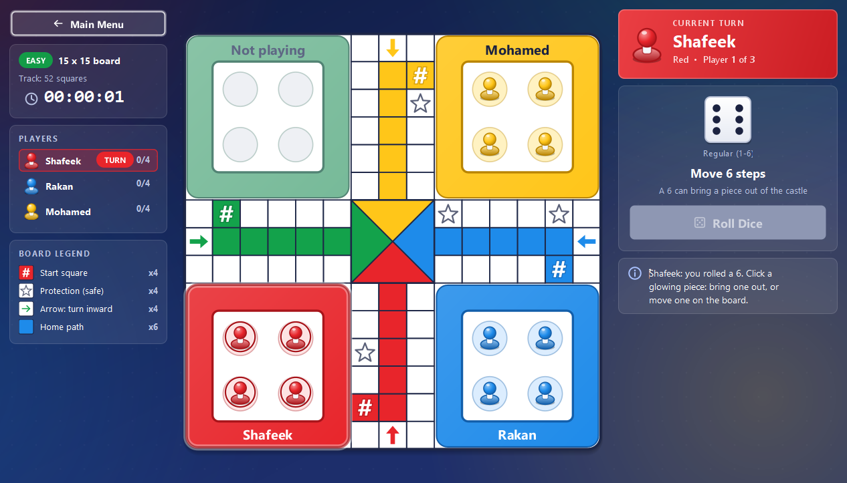
Figure 5 – Shafeek rolled a 6: the four castle pieces are highlighted
The piece moves square by square. Because the roll was a 6, the same player rolls again.
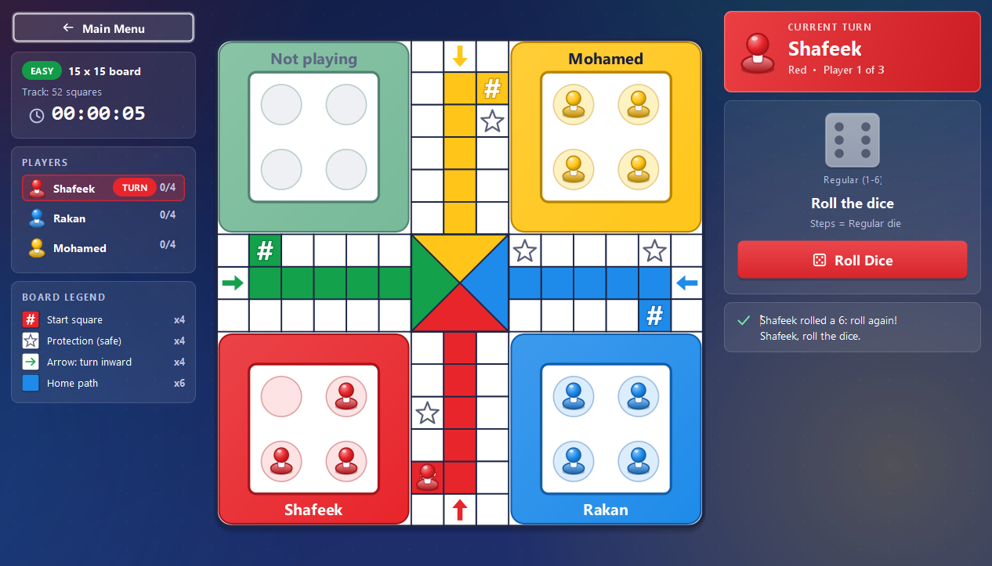
Figure 6 – The red piece is on its start square and Shafeek rolls again
Main Menu during a game asks for confirmation, because a game that is left is not saved.
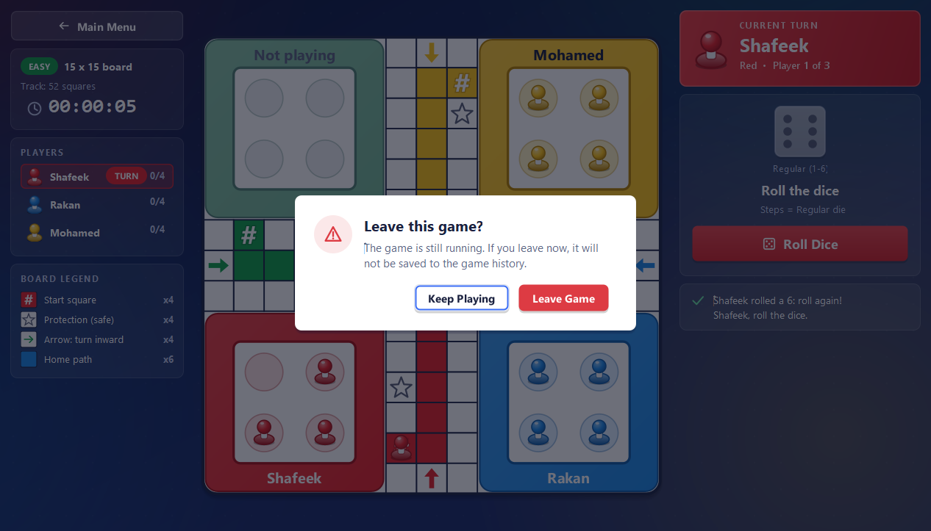
Figure 7 – Leaving a running game needs confirmation

4.4 End of the game
A player who brings all four pieces to the finish leaves the turn order. The game ends when only one player is left; the results screen shows the ranking, the difficulty and the game duration (HH:MM:SS). From here the player can play again with the same settings or go back to the Main Menu.
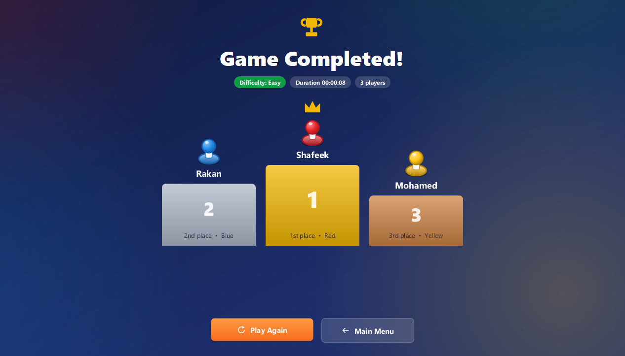
Figure 8 – Results screen (this game was played automatically by a test driver, so its duration is only a few seconds)

5. Expected results in different scenarios
# | Scenario | Expected result
1 | Start a game with 2–4 valid, unique names and colours | The board opens; the first player in the list has the turn; the clock starts at 00:00:00.
2 | Leave a name empty, enter more than 12 characters, or repeat a name (also with different capital letters) | The field is marked in red with a message and the game does not start.
3 | Roll anything but 6 while all pieces are in the castle | No piece can move; the message says the turn passes, and the next player gets the turn.
4 | Roll a 6 | The castle pieces and the pieces on the board that can move are highlighted. After the move the same player rolls again.
5 | Roll a 6 three times in a row | The third 6 is cancelled: no piece moves and the turn passes to the next player.
6 | A roll with a legal move | The player must move one of the highlighted pieces; the turn cannot be skipped. Pieces that cannot move are not highlighted.
7 | A piece ends on a plain square with a single opponent piece | The opponent piece is captured and returns to its castle.
8 | A piece ends on a start square or a protection square (star) with an opponent | No capture: both pieces stay.
9 | A piece reaches its arrow | It turns into its own coloured home path; other colours never enter it.
10 | A roll larger than the steps left to the finish | That piece is not highlighted; the finish needs the exact number.
11 | A player finishes all four pieces | The player gets the next place in the ranking and takes no more turns.
12 | Only one player has pieces left | The game ends and the results screen shows all places and the duration.
13 | Main Menu during a game, then "Leave Game" | The game ends without results and the Main Menu opens. "Keep Playing" returns to the game unchanged.

6. How we tested the system

6.1 Automated tests
The project has 375 automated JUnit 5 tests; on the integrated Iteration 1 build all of them pass (375 passed, 0 failed, 0 skipped; run with test.bat / test.sh). Every test name carries the SRS requirement it verifies.
Package | Tests | What they check
Model | 282 | Setup validation, Easy board and protection squares, dice and turn order, Rule of 6, move engine, capture and protection, home path and exact finish, ranking, game clock, full games.
View | 73 | Main Menu and setup screen, board drawing and scaling, legal-move highlighting, square-by-square animation, screen navigation.
Controller | 16 | Navigation between screens and the GameController with the real screens and model, including a complete game to the results screen.
Architecture | 4 | MVC dependency rules: the Model has no Swing, View or Controller imports.

6.2 Our testing method
- Unit tests by the author for every class (Definition of Done, SDP 5.3.4).
- Independent tests: each game rule was tested again by a team member who did not write it (for example T14, T20, T21, T25).
- Acceptance tests by the Product Owner for every user story US-1.1 to US-1.5 (T06, T10, T15, T22, T26). The full-game acceptance test plays 120 complete games with the real dice and rules and checks that each one ends with a correct ranking.
- Fixed dice sequences make turn and Rule of 6 scenarios repeatable; seeded random numbers make the board and full games repeatable.
- Fault seeding: for the engine and turn tests we planted faults in a copy of the code to check that the tests catch them.
- Code review on GitHub: every change was made on a feature branch and merged through a pull request after review. Rule classes had a deep review by both other members.
- Manual checks: the game was played by hand on Windows 11 (menu, setup errors, a game, leaving a game, results) and the screenshots in section 4 come from the real application.

7. Known limitations of Iteration 1
- Only the Easy level can be played; Medium and Hard are visible but disabled until Iteration 2.
- No Double Blocks, special dice, question squares or surprise squares yet (Iteration 2).
- Game history (the course CSV file), Game History screen and administrator functions are planned for Iteration 3.
- On Windows, starting the JAR by its full path from a folder with Hebrew letters can fail; use run.bat (section 2.2).

8. GitHub repository
Repository: https://github.com/shafeekseef81-svg/Sharks
The repository name contains the team name (Sharks). The Iteration 1 code is on the branch iteration-1, in the folder Iteration1.

