NAME : JAWAD AHMED
ROLL NO : 20P-0165
SECTION : BCS-4A
________________________________________________________________________________
CODE:
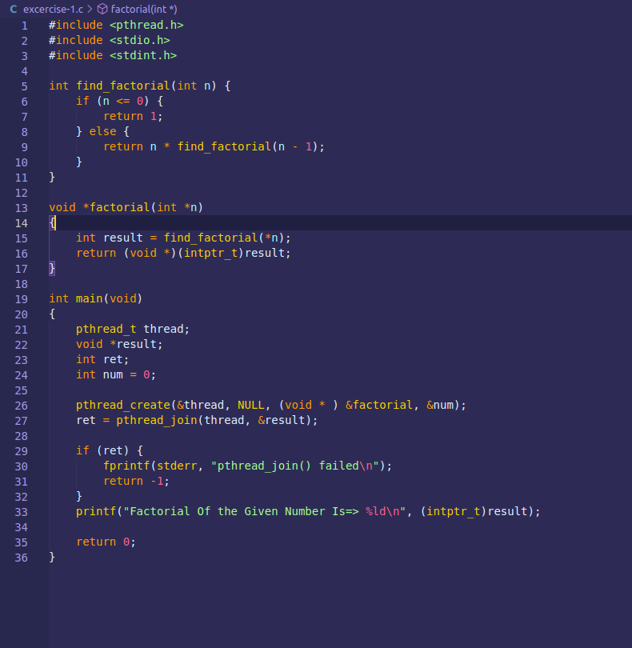
OUTPUT
