**Findings**

**Case I** – Using an Institution with “oauth”: true

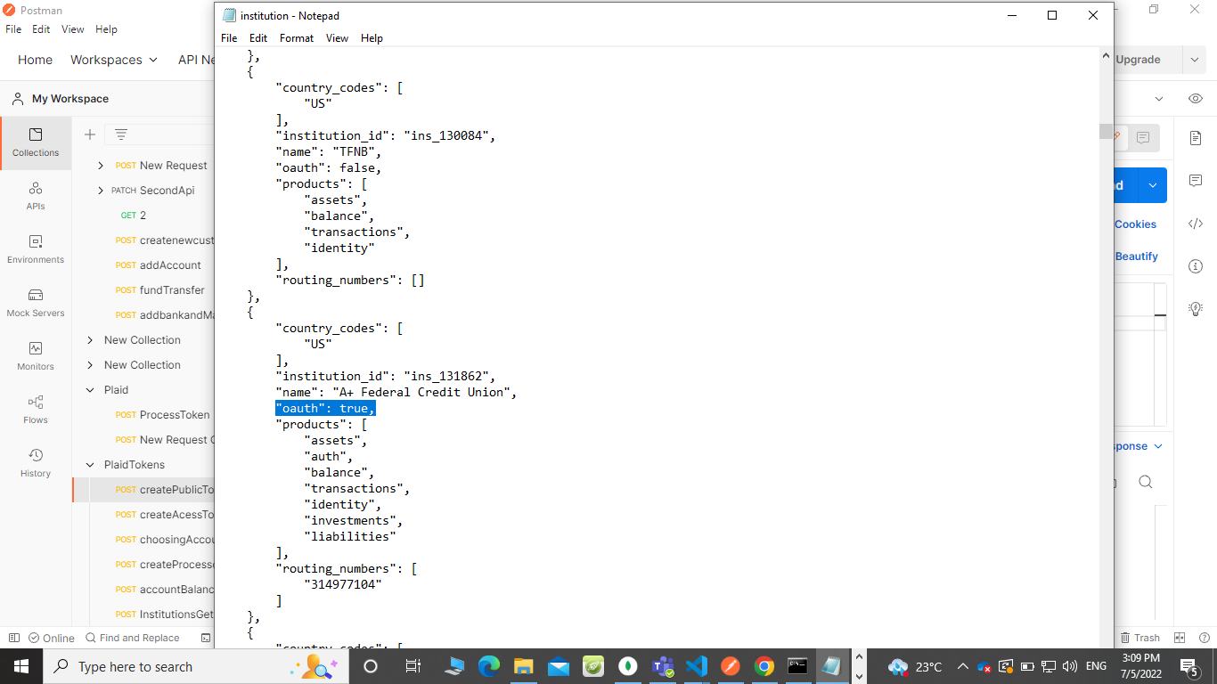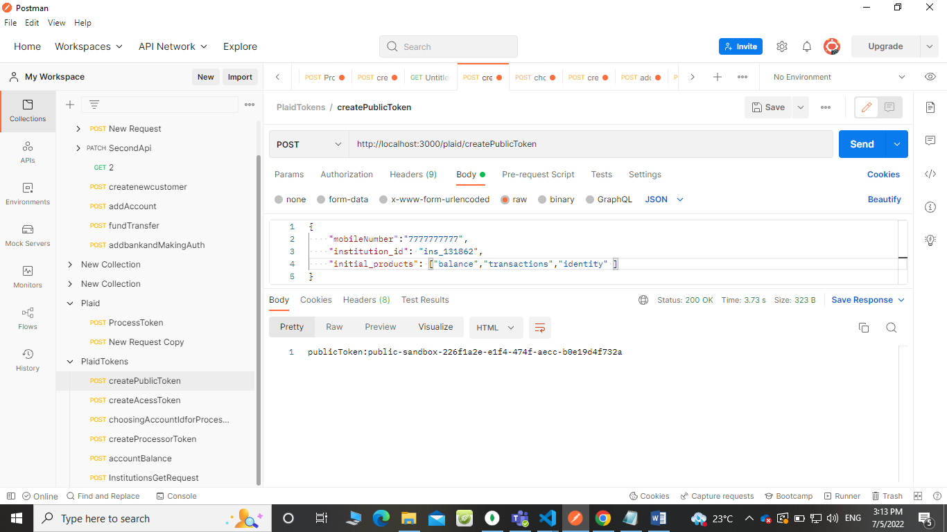

**Case II** – Using an Institution with “oauth”: false

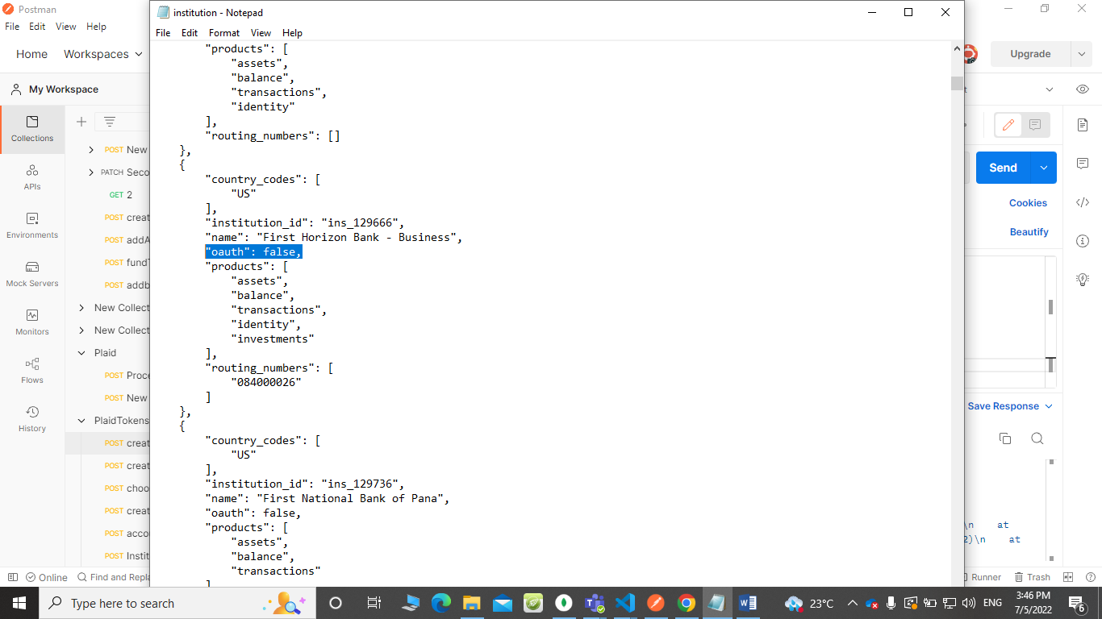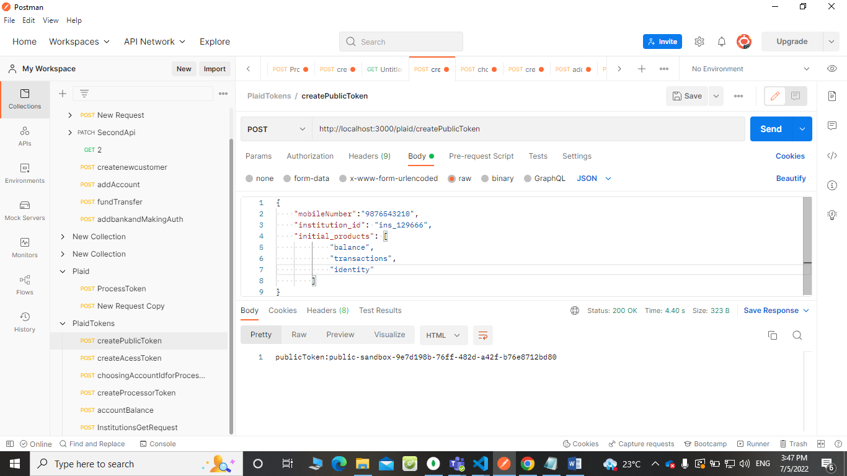

**Case II**I– Using an Institution with “oauth”: false

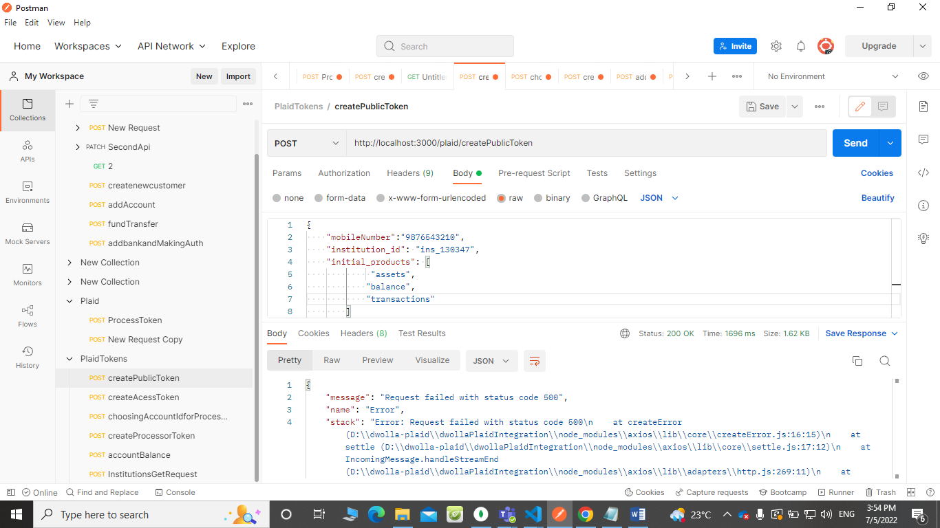

**Findings:**

1. When I filtered through 100 institutions, I found that results having {“oauth”: true } case have product [“ identity”], So we can pass it with other products to create a Public Token.
2. In some cases {“oauth”: false }, It also has product[“ identity”], So we can pass it with other products to create a Public Token.
3. In some cases {“oauth”: false }, it does not have a product[“ identity”], so we cannot generate Public Token by passing it with all products, for creating Public Token we pass individual products at a time.