Azure Identity and RBAC
Overview
This task is performed to understand and demonstrate identity and access management in Azure using Azure Intra ID, Azure RBAC and Managed Identity.
Here the main goal is to clearly understand who can access what, why that access is required and how Azure enforces security and least privilege.
This task focused on:
- Understanding how identities are created and managed using Azure Entra ID.
- To understand how does IAM and RBAC control access to Azure resources.
- To learn how permissions are enforced internally based in scope.
- Understand the difference between human identities and service identities.

Task:
Step 1: Created Users in Azure Entra ID
Five users created in Azure Entra ID:
- User1
- User2
- User3
- User4
- User5
Did not assign any roles at this stage.
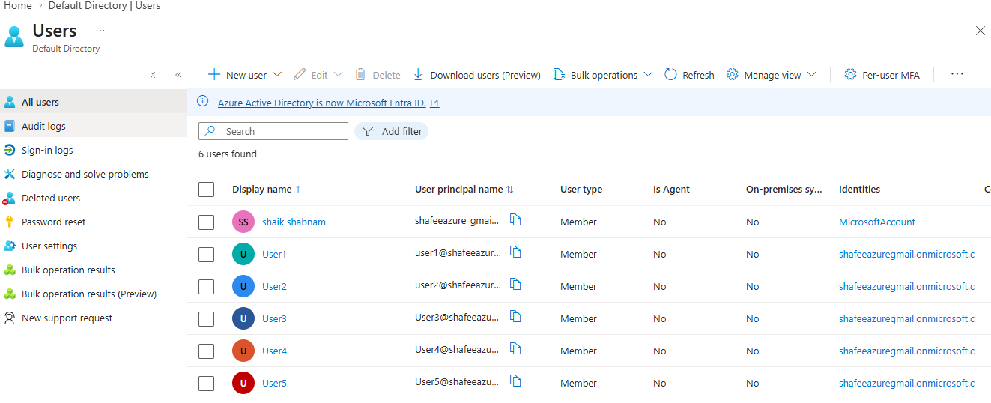
Step 2: Create a resource group.
Step 3: Create resources
- Three storage accounts
- Six Virtual Machine
These resources are used to test isolated access.

Step 4: Assign RBAC at Resource level
Assigned roles at resource level
RBAC assignments
- User1→ Storage Blob Data Contributor → Storage Account
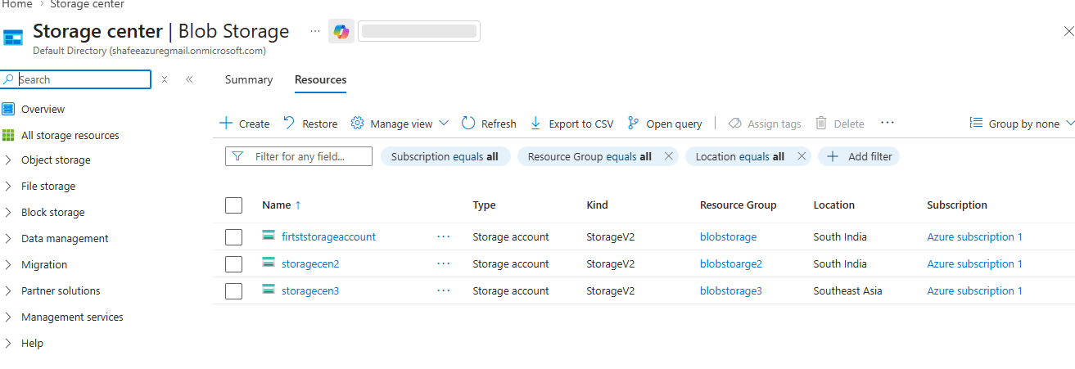

- User1 → Virtual Machine Contributor → VM
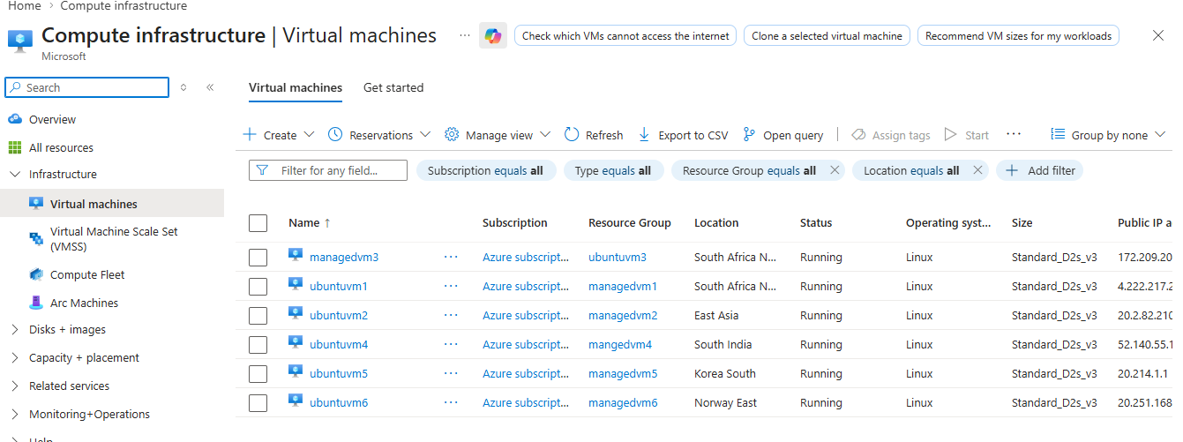

Step 5: Verify access by logging in as users.
Roles were assigned to the created groups to control access to resources effectively. Group 1 and Group 2 were given full access permissions, allowing users in these groups to create, modify, and manage resources. Group 3 was assigned read-only access, which allows users to view resources but not make any changes. This setup demonstrates role-based access control, ensuring that users have permissions according to their responsibilities while maintaining security.
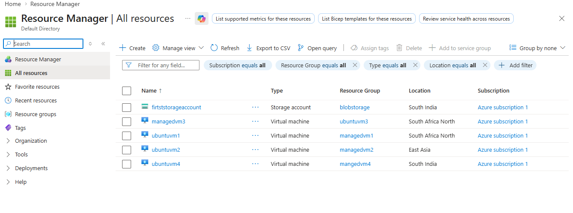

STEP 6: Enable Managed Identity on the VM
Enabled System-assigned Managed identity on the VM.
- Here Azure created a service identity in Entra ID.
- Managed credentials automatically.
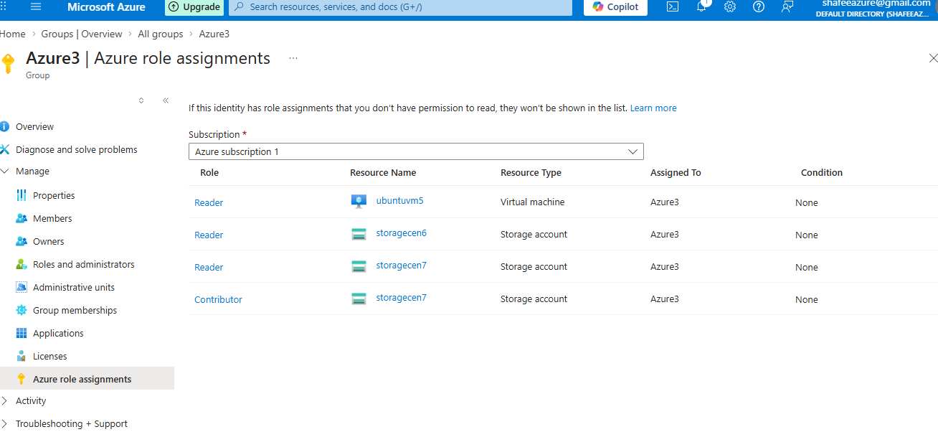

Third group were created and different resources were assigned with specific access permissions. A storage account, a data lake storage, and two virtual machines were created. The storage account was given read-only access, allowing users to view data but not modify it. The data lake storage was assigned both read and write permissions, enabling users to access and update the data. For the virtual machines, one VM was configured with read-only access, while the other VM was given both read and write access. This setup demonstrates how role-based access control (RBAC) can be used to provide different levels of access to different resources, ensuring proper security and efficient resource management.

STEP 7: Connected to GIT Bash
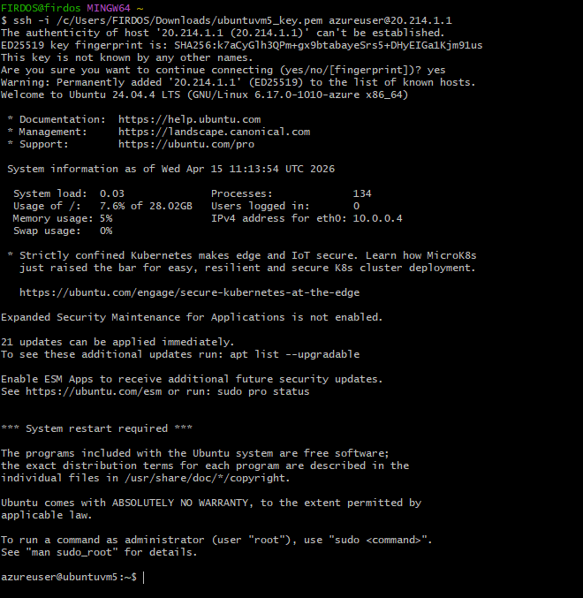
Observation:
The system was successfully connected to Git Bash to manage and interact with resources using command-line operations. Git Bash provides a Unix-like environment that allows users to execute commands efficiently. Through this connection, users can perform tasks such as managing files, accessing repositories, and automating operations. This integration helps in simplifying workflows, improving productivity, and enabling better control over development and deployment processes.

Conclusion:
This task helped understand how IAM works in Azure. It showed how users and resources are managed, how access is controlled using RBAC, and how security is maintained using managed identities.

