**JIRA - Project Management Tool**

**EPIC**

**List of Epics**

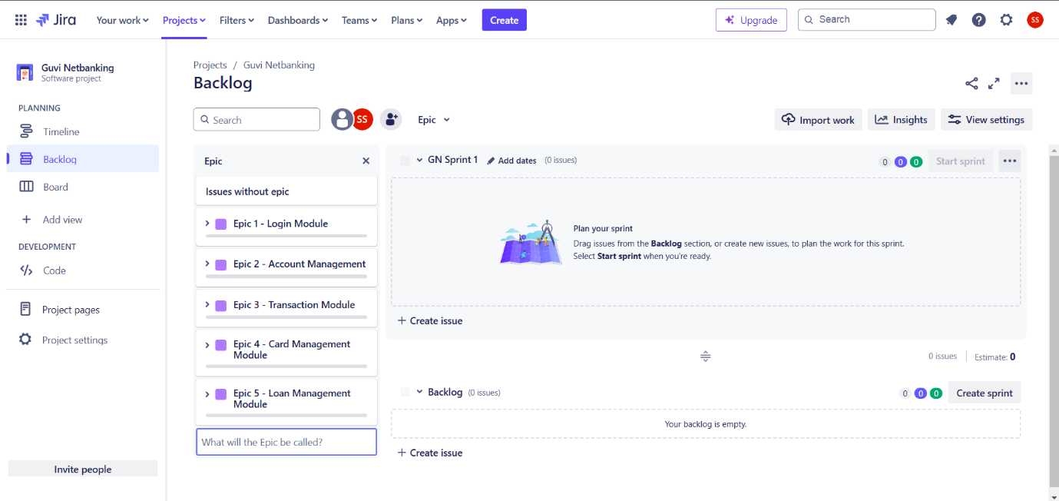

**Detailed Epic**

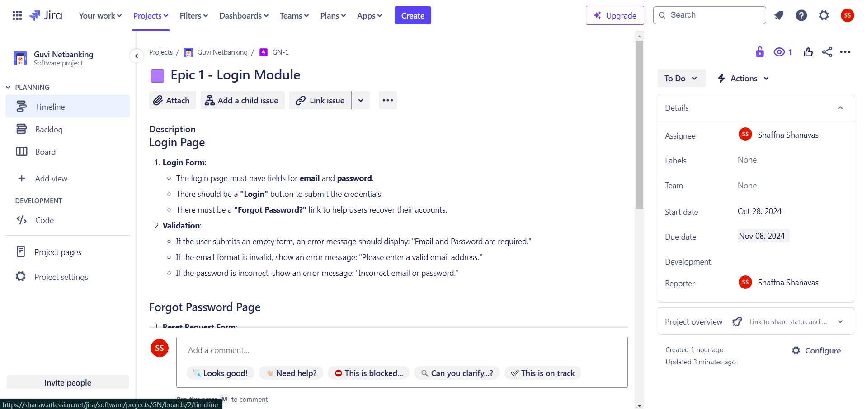

**SPRINT**

**List of Sprints**

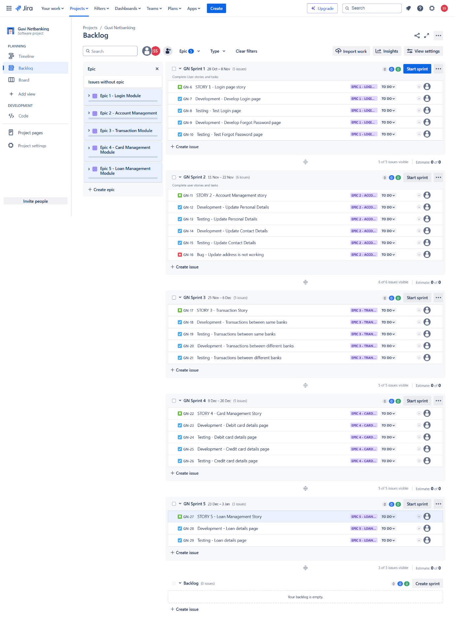

**Start Sprint**

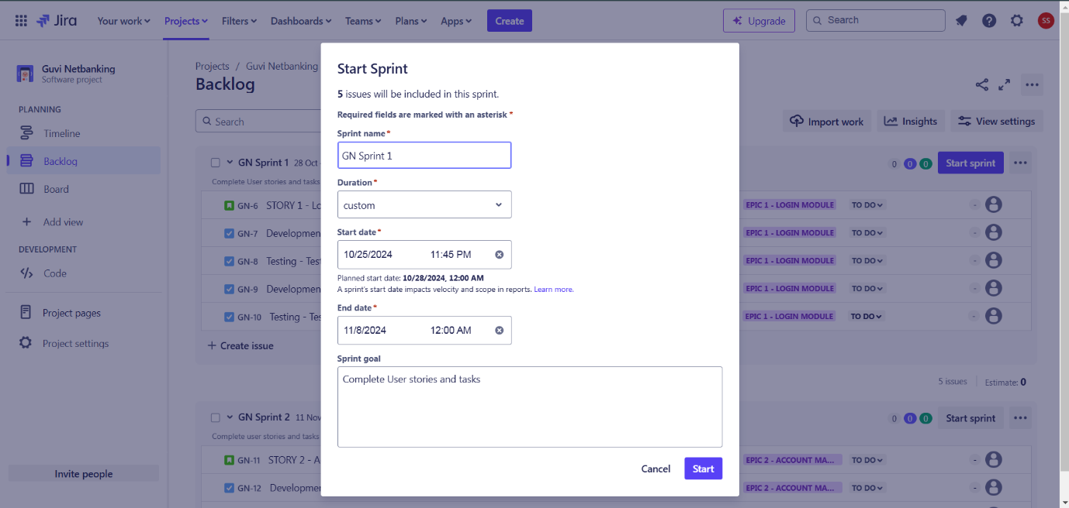

**Edit Sprint**

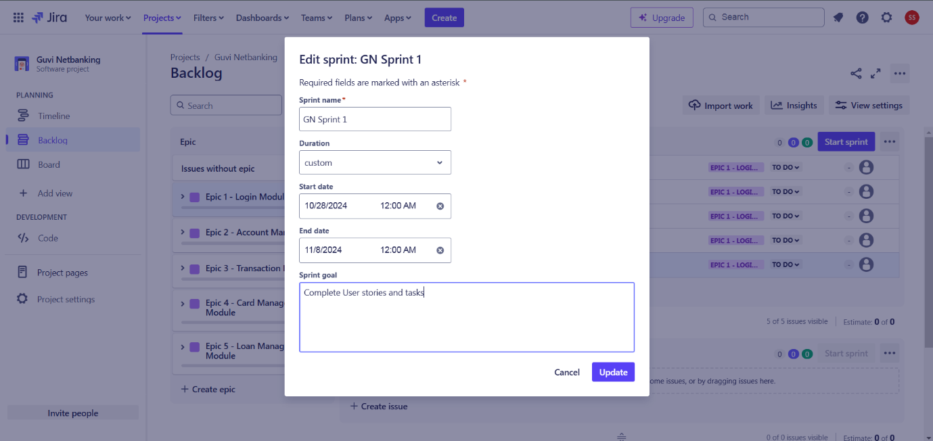

**USER STORIES**

**List of Stories**

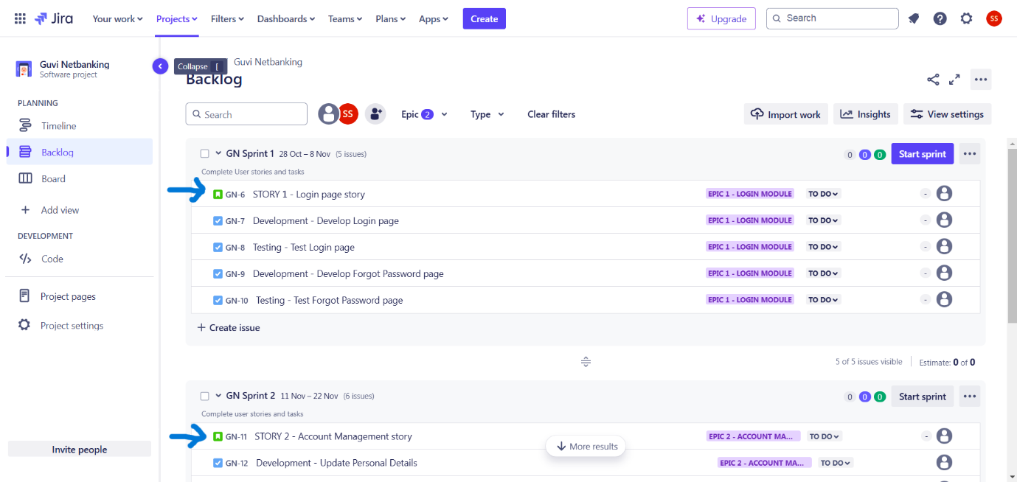

**Detailed Story**

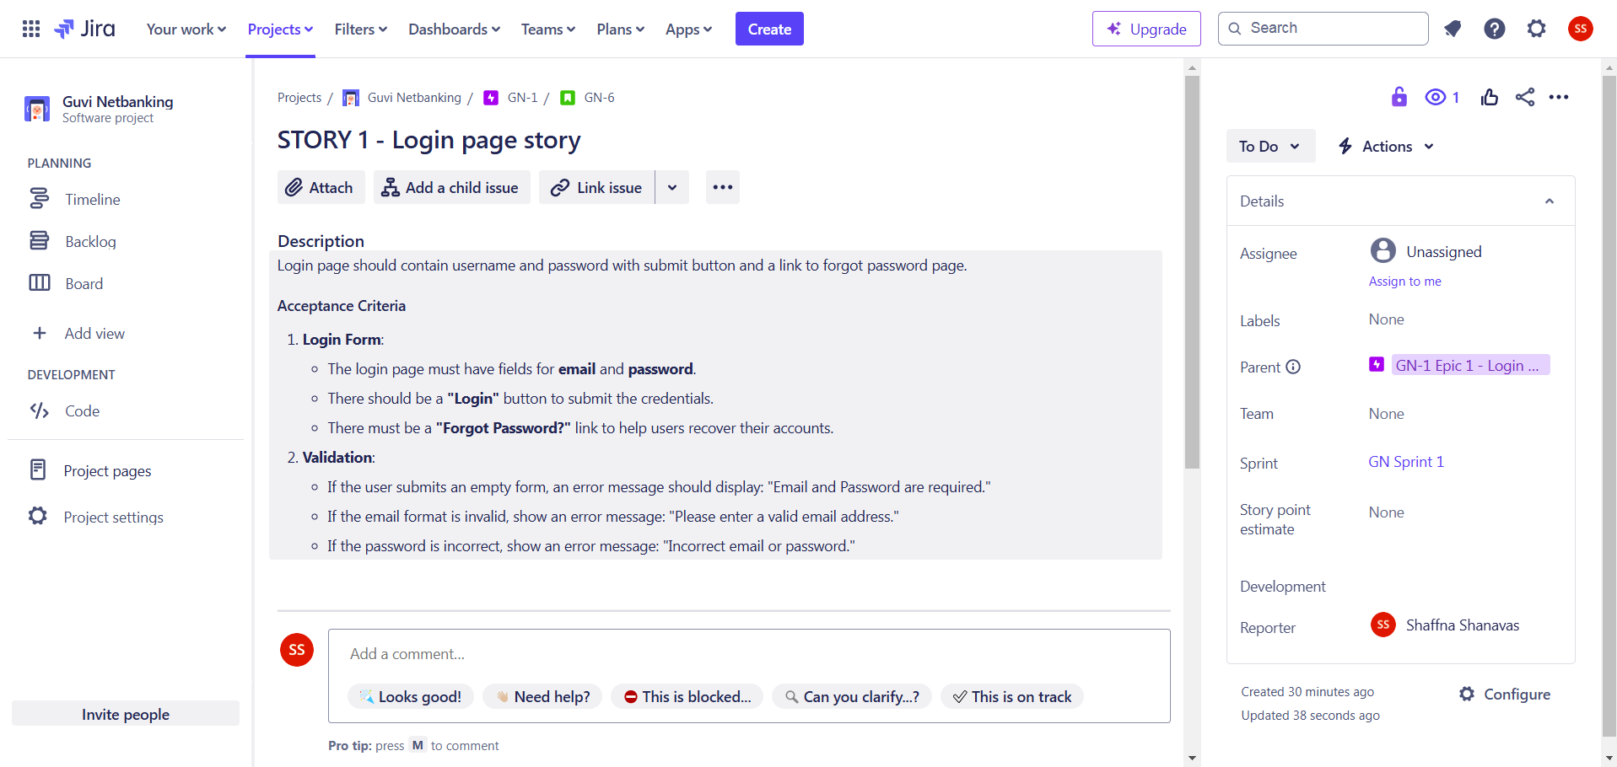

**BUGS**

**Bug in a Sprint**

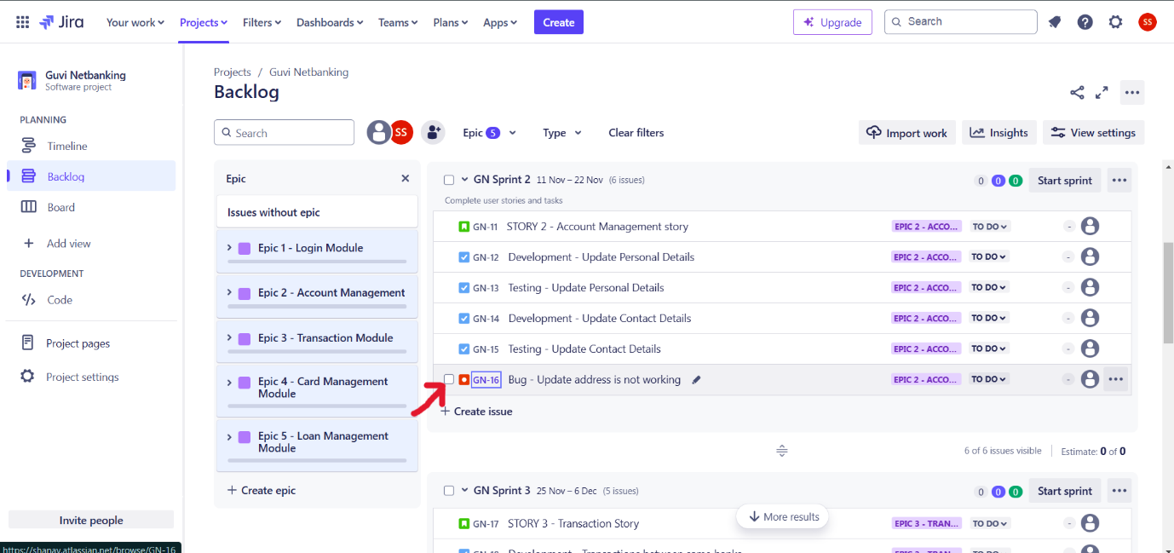

**Detailed Bug**

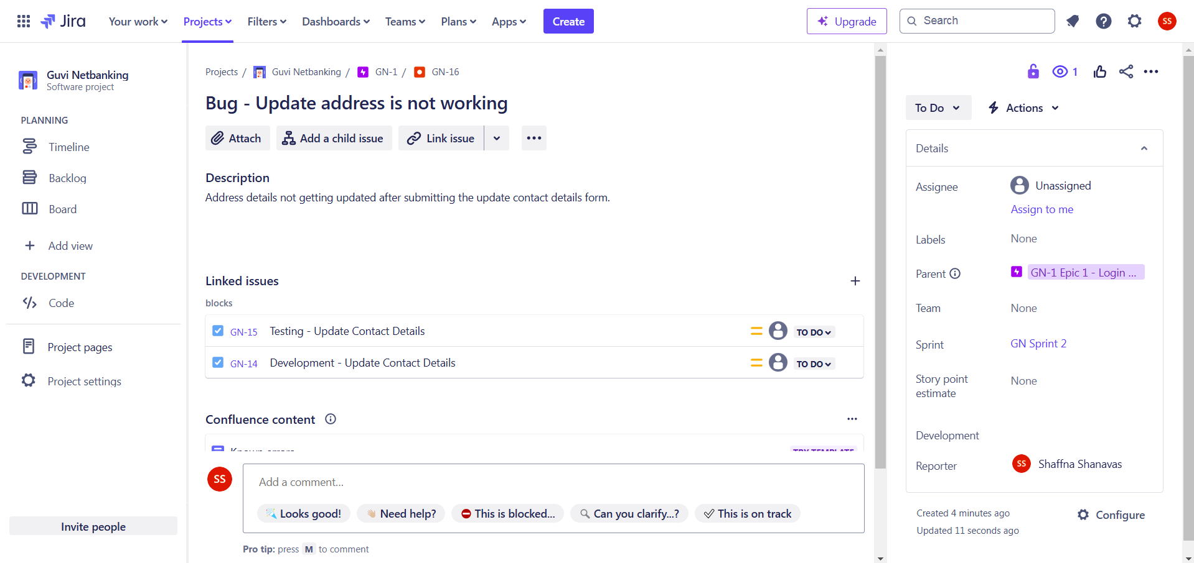

**SPRINT EXECUTION**

**To Do**

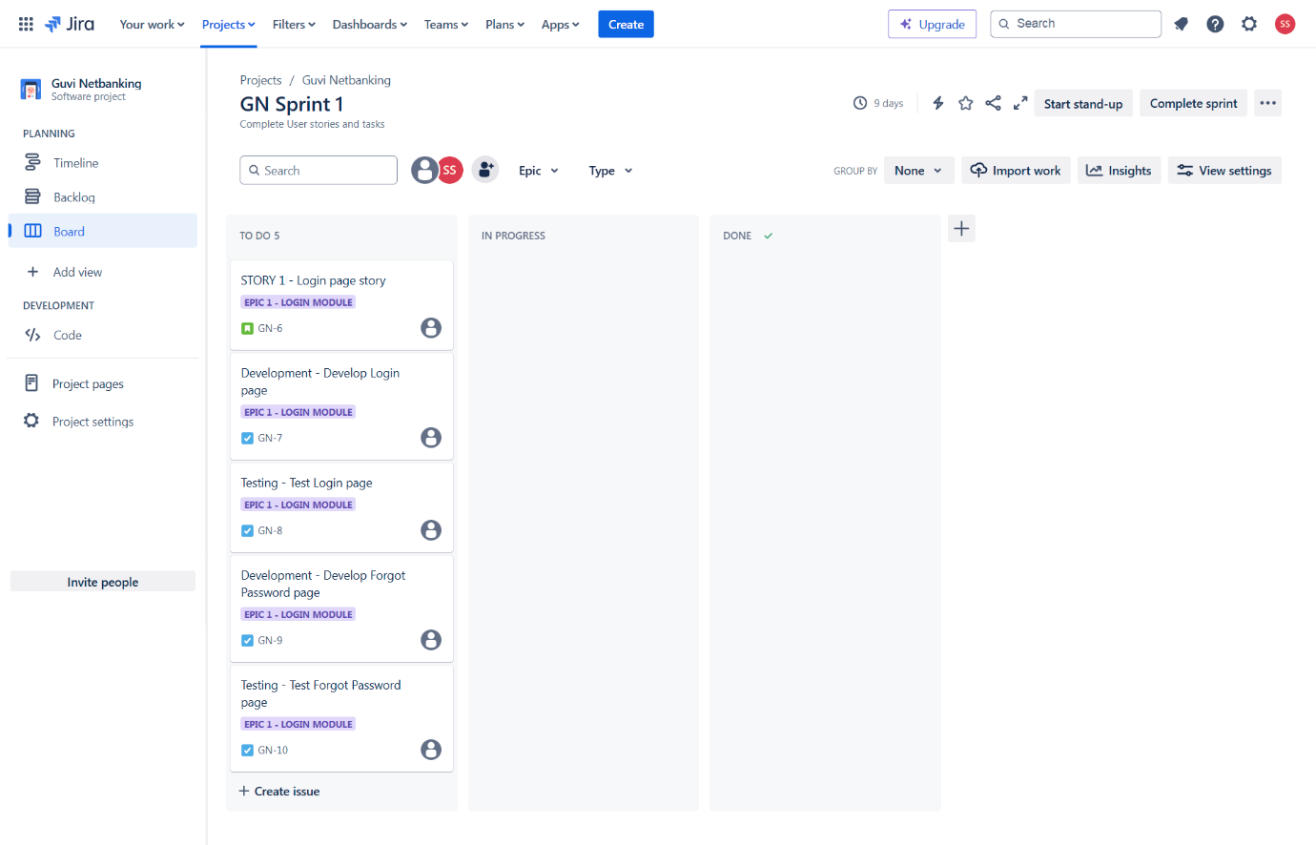

**In Progress**

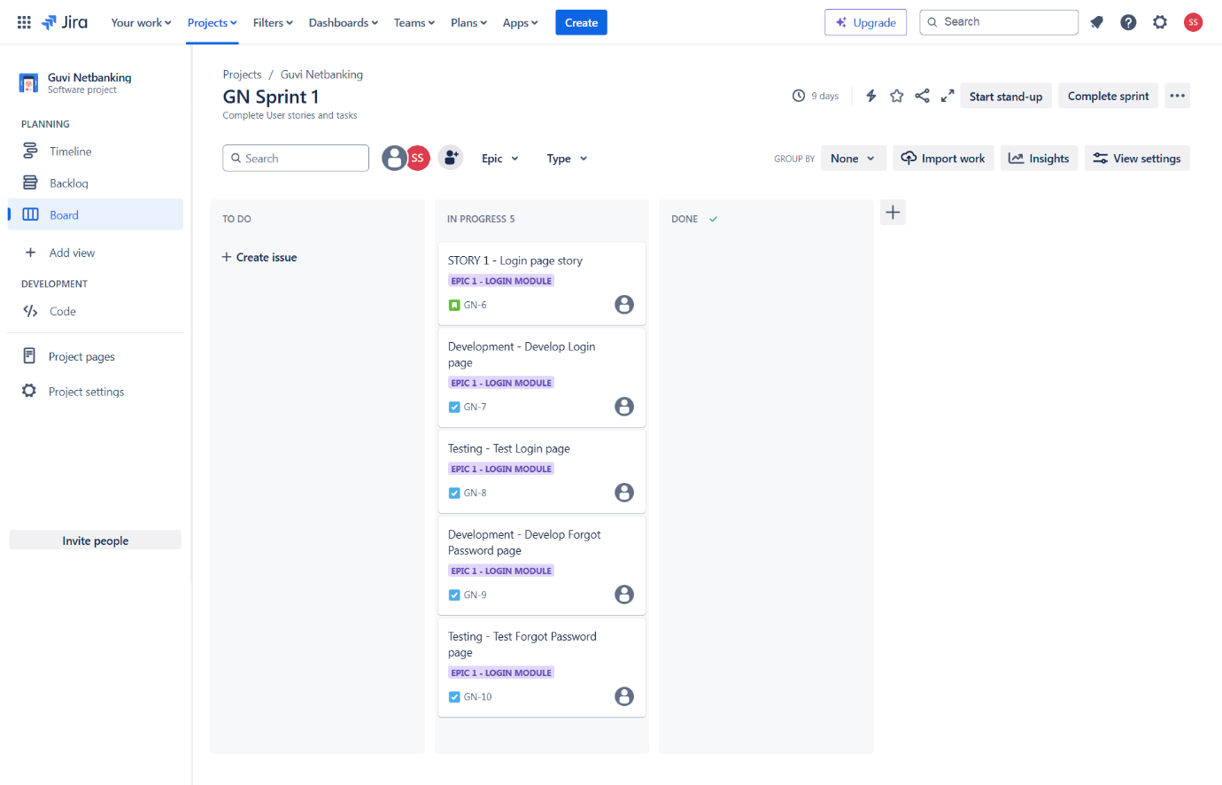

**Done**

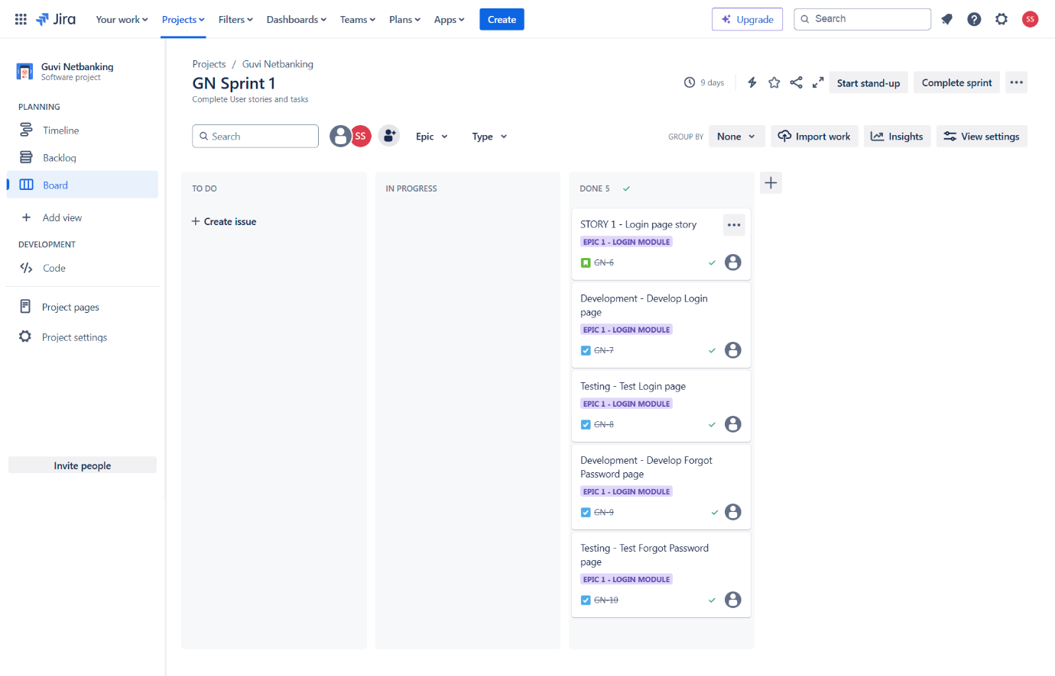

**Sprint Completion**

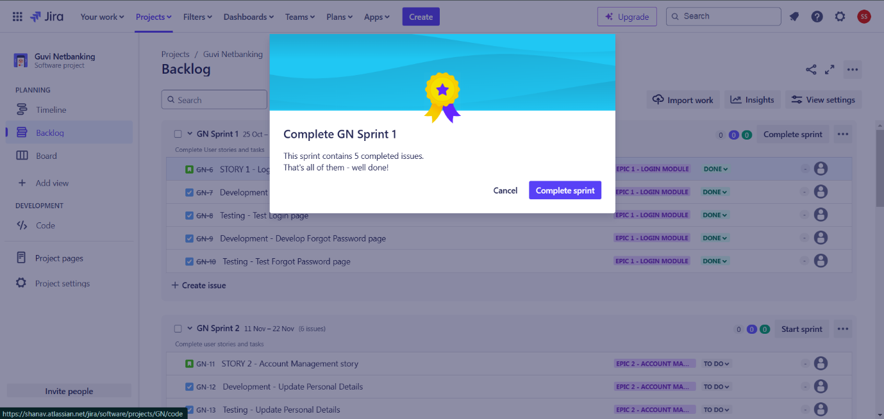

**Sprint Timeline**

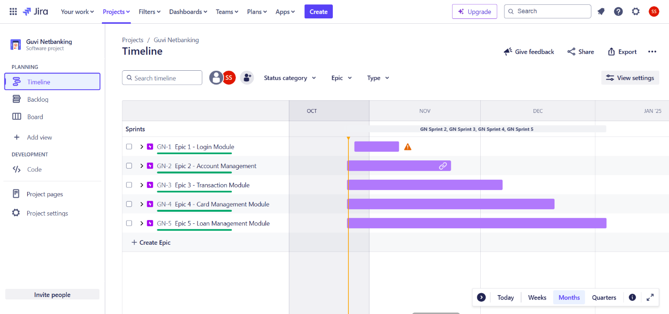

**SPRINT REVIEW**

A Sprint Review is a key Scrum event held at the end of each sprint. Its purpose is to inspect the product increment, discuss what was completed during the sprint.

Here each sprint (sprint1, sprint2, sprint3, sprint4, sprint 5) must be reviewed at the end of the respective sprints.

**SCRUM**

Scrum is an Agile framework used for developing, delivering, and sustaining complex products through an iterative process.

Daily scrum meetings must happen between stakeholders in order to discuss about the sprint tasks or blockers.

**SPRINT RETROSPECTIVE**

A Sprint retrospective meeting should comprise “What went well?”, “What didn’t go well?”, “Areas of improvement”.

Example:

What went well? – All tasks are completed on time.

What didn’t go well? – No proper communication between teammates.

Area of Improvement – Team should interact with others for queries while development.

**RELEASE PLANNING**

**Login Module (08 Nov 24)**

User can able to login the Net banking app seamlessly

**Account Management Module (22 Nov 24)**

Users can able to access and update the account details.

**Transaction Module (06 Dec 24)**

Users can able to do the transaction between same & different banks.

**Card Management Module (20 Dec 24)**

User can able to access the card details.

**Loan Management Module (03 Jan 25)**

User can able to access the loan details.

**ROLES INVOLVED IN SCRUM**

**Product Owner**

Represents the customer and stakeholders. They define what needs to be built and prioritize the features or tasks (user stories) in the product backlog.

**Business Analyst**

Works closely with the Product Owner and the team to clarify requirements and ensure that the needs of the stakeholders are understood and met.

**Managers**

Provide support and resources to the team. They may also help in removing obstacles that hinder the team's progress and ensure that the team stays aligned with organizational goals.

**Tech Architect**

Designs the overall structure of the product. They make technical decisions and ensure that the architecture supports future growth and maintenance.

**Development Team**

Composed of developers who build the product. They work collaboratively to implement features and deliver increments of the product during each sprint.

**Testing Team**

Focuses on ensuring the quality of the product. They test the features developed by the development team to identify any bugs or issues before release.

**Operations**

Handles the deployment and maintenance of the product in a live environment. They ensure that the product runs smoothly and is available to users.