United International University (UIU)
Department of Computer Science and Engineering
Project Proposal Report
Course: Microprocessors and Microcontrollers Laboratory (CSE 4326)
Group No: _______

AgriScan 360:
An AI-Assisted 360° Multi-Spectral Produce Quality Inspection Station
Group Members
No. | Student Name | Student ID
1
2
3

1. Motivation and Problem Statement
Post-harvest food loss represents a staggering economic and food-security challenge across South Asia. In Bangladesh, an estimated 25% to 40% of fresh fruits and vegetables spoil between farm harvest and consumer consumption. A major driver of this loss is the inability of manual inspection to detect early-stage fungal contamination and hidden internal rot prior to bulk packaging and distribution.
Human visual inspection suffers from inherent subjectivity, fatigue, and critical optical limitations. First, human operators cannot see mould spores or fungal toxins (such as aflatoxins) in their early formation. Second, internal rot—such as the devastating Eggplant Fruit and Shoot Borer (Leucinodes orbonalis) or anaerobic core fermentation in mangoes and apples—frequently leaves the outer waxy skin appearing completely intact while the interior pulp is severely compromised. Destructive testing (cutting produce open) renders the product unsellable.
AgriScan 360 solves this critical challenge by engineering an embedded, non-destructive inspection station that interrogates produce across three complementary physical domains: 360-degree visible surface vision, ultraviolet fungal fluorescence, and electrochemical headspace gas sensing. By combining these signals with an on-device multi-modal AI classifier running on a Raspberry Pi 5, the system delivers objective, repeatable quality grading in real-time.
2. System Architecture & Two-Stage Implementation Roadmap
To ensure rigorous academic execution and physical feasibility within the timeframe of CSE 4326, the project is structured into two distinct engineering phases: an active core implementation (Stage 1) and an industrial scale-up architecture (Stage 2):
- Stage 1 — The Enclosed Multi-Modal Inspection Station (Active Build): Stage 1 represents the fully engineered, physical prototype currently built and evaluated. It features a sealed, light-controlled inspection chamber (17" L × 11" W × 9" H, ~27.6 L volume, matte-black interior) with a precision NEMA 17 stepper turntable. A single overhead/side-mounted Raspberry Pi Camera Module 2 captures synchronized frames under dual illumination (diffused White LED and 365 nm UV-A LED), while a ceiling-mounted Bosch BME688 AI sensor measures accumulated volatile organic compound (VOC) emissions. Results are rendered on an on-device SSD1306 OLED screen and broadcast wirelessly via a Flask IoT web dashboard.
- Stage 2 — Automated Conveyor & Sorting Line (Future Industrial Roadmap): Stage 2 outlines the roadmap for commercial / industrial assembly-line deployment. It transitions the batch inspection station into an in-line sorting plant by adding a motorized PVC conveyor belt, light-tight silicone entry/exit flaps, optical break-beam indexing sensors (E18-D80NK), an automated 40 mm 5V chamber exhaust blower fan for continuous air purging, and a high-torque MG996R servo-actuated diverter gate for automatic sorting into ACCEPTED and REJECTED bins.
3. The Three Pillars of Non-Destructive Detection
AgriScan 360 achieves complete quality assessment by inspecting through three distinct physical phenomena:
Pillar 1: 360° Multi-Angle Surface Vision (RGB + Diffused White Light)
A NEMA 17 stepper motor indexes the fruit through 8 distinct 45-degree stops (0° to 315°). Under uniform, diffused white illumination, the camera captures full circumferential surface detail. This eliminates blind spots and inspects skin color, browning necrosis, bruising, surface wrinkling (turgidity loss), and stem/calyx freshness.
Pillar 2: Fungal & Mould Fluorescence (365 nm UV-A Illumination)
Under 365 nm ultraviolet excitation, fungal metabolites and aflatoxins exhibit optical fluorescence, emitting a distinct neon yellow-green glow. The RGB camera captures this glow in complete darkness, detecting early mould colonies hidden in skin crevices or beneath leafy calyx crowns long before visible necrosis appears.
Pillar 3: Electrochemical Internal Rot Sensing (Bosch BME688 MOX Sensor)
When internal tissue rots due to bacterial soft rot or fruit borer larvae (Leucinodes orbonalis), it releases ethanol, ethylene, and volatile organic compounds (VOCs). The heated metal-oxide semiconductor (MOX) plate of the BME688 reacts with these gases inside the sealed 27.6 L chamber, causing a sharp drop in electrical resistance (ΔGas). This catches deep internal decay completely invisible to optical cameras.
4. System Architecture Diagram
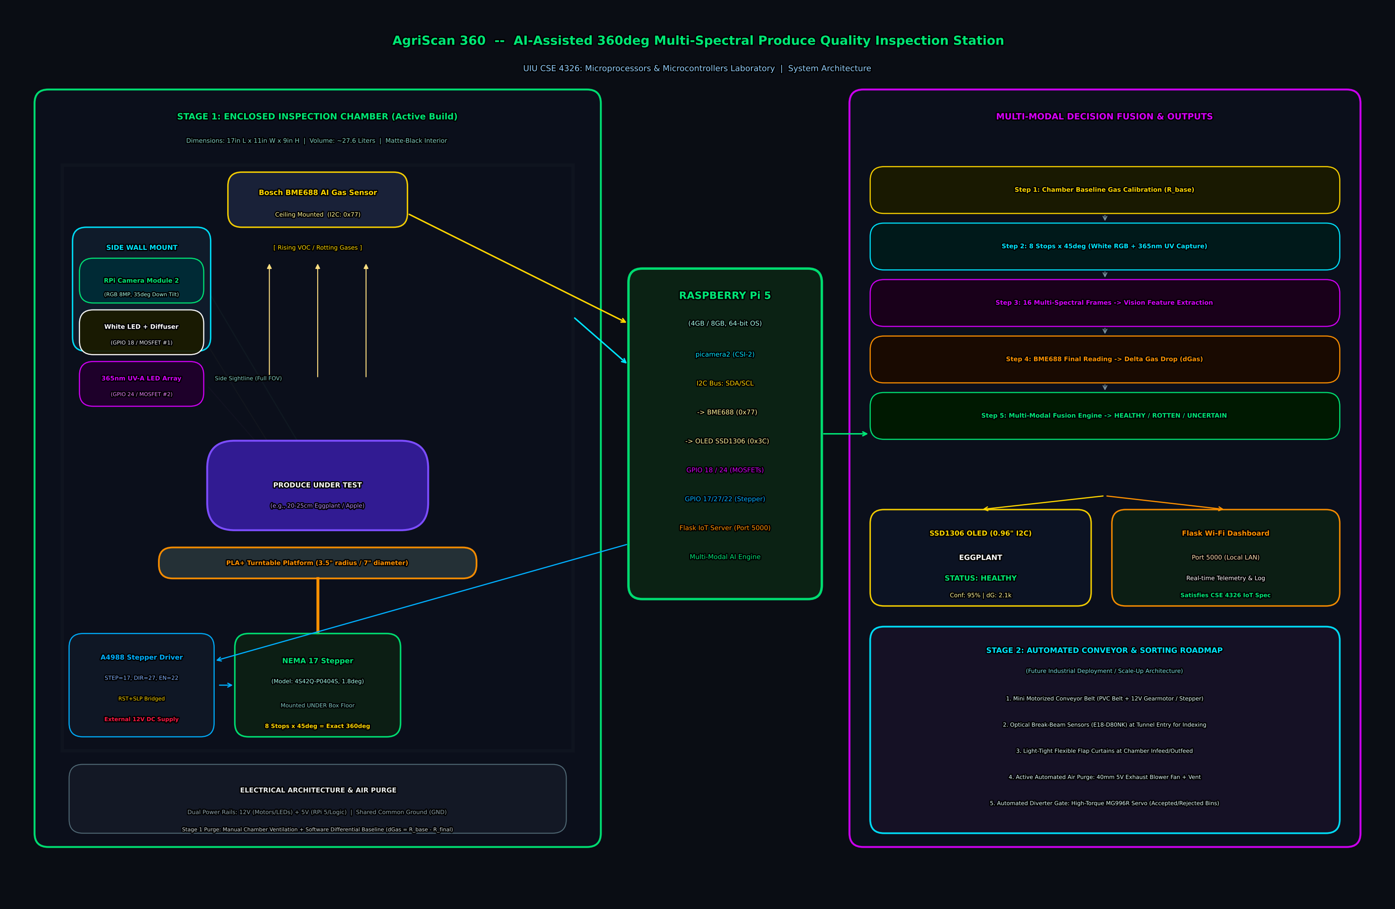
Figure 1: AgriScan 360 System Architecture Diagram — Illustrating the Stage 1 Enclosed Inspection Chamber (Side-wall camera, ceiling BME688, dual lighting arrays, under-floor NEMA 17 stepper), Raspberry Pi 5 master interfacing, Multi-Modal AI decision fusion pipeline, and the Stage 2 Automated Conveyor & Sorting Roadmap.
5. Project Features & CSE 4326 Requirements Coverage
Feature 1 — Precision Motor Actuation (NEMA 17 Stepper + A4988 Driver)
- Driven by a bipolar NEMA 17 stepper motor (model 4S42Q-P0404S, 1.8° step angle, 200 full steps/rev).
- Controlled via an A4988 microstepping driver with STEP (GPIO 17), DIR (GPIO 27), and ENABLE (GPIO 22).
- Software open-loop step-counting: Sends exact 25-step pulses per 45° rotation (8 stops = exact 360° circle).
- Soft acceleration ramp-up prevents mechanical jerk, fruit slippage, or motor stalling on start.
- Coil De-energize Safety: The ENABLE pin is pulled HIGH immediately upon scan completion to cut holding current, guaranteeing the 0.4A motor remains completely cool during idle standby.
Feature 2 — Multi-Sensor & Multi-Protocol Hardware Interfacing
- High-Speed MIPI CSI-2: Dedicated 2-lane camera ribbon interface for Picamera2 frame capture.
- I2C Bus Communication (GPIO 2/SDA, GPIO 3/SCL): Shared bus interfacing the Bosch BME688 AI gas sensor (0x77) and the SSD1306 0.96" OLED display (0x3C).
- Logic-Level MOSFET Switching: GPIO 18 and GPIO 24 independently drive the gates of two IRLZ44N N-channel MOSFETs to provide isolated low-side power switching for the White and 365 nm UV LED arrays.
Feature 3 — IoT & Wireless Communication (Flask Telemetry Server)
- A lightweight Flask HTTP server runs in a background daemon thread on the Raspberry Pi 5 on port 5000.
- Accessible over local Wi-Fi from any browser on a smartphone, tablet, or PC on the same network.
- Displays real-time classification status badge (HEALTHY, ROTTEN, UNCERTAIN), AI confidence percentage, chamber VOC resistance drop (ΔGas), and timestamped historical logs.
- Fully satisfies the IoT / Wireless Communication requirement of CSE 4326 with zero external cloud dependency.
Feature 4 — Embedded Multi-Modal AI Decision Fusion
- On-device inference pipeline running directly on Raspberry Pi 5 64-bit OS.
- Evaluates 16 multi-spectral frames (8 RGB surface frames + 8 UV fluorescence frames) for color necrosis and fungal glow.
- Fuses visual metrics with the BME688 electrochemical gas resistance delta (ΔGas = R_baseline - R_final).
- Solves the 'Clean Skin / Rotten Core' paradox: Flags produce as ROTTEN if a heavy internal VOC spike is detected, even if the visual camera reports clear skin.
6. Hardware Bill of Materials (BOM)
Table 6.1: Stage 1 Implemented Components (Inspection Station)
No. | Component | Specification | Qty | Role in System
1 | Raspberry Pi 5 | Broadcom BCM2712, 4GB/8GB RAM, 64-bit OS | 1 | Master compute, GPIO control, AI inference, Flask server
2 | RPi Camera Module 2 | Sony IMX219, 8 MP RGB, CSI-2 interface | 1 | Multi-spectral surface and UV fluorescence imaging
3 | Bosch BME688 AI Sensor | MOX Gas / VOC, Temp, Humidity, I2C interface | 1 | Headspace gas sensing for internal rot & borer detection
4 | NEMA 17 Stepper Motor | 4S42Q-P0404S, 1.8 deg/step, 200 steps/rev, 0.4A | 1 | Precision 45-degree incremental turntable rotation
5 | A4988 Stepper Driver | Microstepping driver, 8-35V, 2A peak per phase | 1 | Drives NEMA 17 coils via STEP/DIR/ENABLE control
6 | IRLZ44N MOSFETs (2x) | Logic-Level N-Channel MOSFET (Vth < 2V, 55V/47A) | 2 | Low-side electronic switching for White & UV LED arrays
7 | White LED Array + Diffuser | High-CRI 5V/12V LED chunk with butter paper diffuser | 1 | Shadow-free visible surface lighting (anti-glare)
8 | 365 nm UV-A LED Array | 365 nm narrow-band Ultraviolet LEDs | 1 | Optical excitation for fungal/mould fluorescence
9 | SSD1306 OLED Display | 0.96", 128x64 pixels, I2C interface (0x3C) | 1 | On-device standalone physical status display
10 | PLA+ Turntable Platform | 3.5" radius (7" diameter), 3D printed with 5mm hub | 1 | Rotating produce platform (under-floor shaft mount)
11 | Enclosure Box | 17" L x 11" W x 9" H, matte-black interior (~27.6 L) | 1 | Light-isolated and gas-controlled scanning chamber
12 | 12V DC Power Supply | 12V, 2A-3A regulated switching adapter | 1 | Dedicated power for NEMA 17 motor and LED arrays
13 | Official 27W USB-C PSU | 5V, 5A DC official Raspberry Pi power supply | 1 | Clean, isolated power for RPi 5 and logic sensors
14 | Pull-Down Resistors | 10 kOhm 1/4W resistors on MOSFET gates | 2 | Prevents LED flickering during Raspberry Pi boot-up

Table 6.2: Stage 2 Future Components (Automated Conveyor & Sorting Line)
No. | Component | Specification | Qty | Role in System
1 | Motorized Conveyor Belt | Food-grade mini PVC belt (15-20cm wide, 80-100cm long) | 1 | Continuous automated transport of produce into chamber
2 | Conveyor Drive Motor | 12V High-Torque DC Worm Gear Motor (30-60 RPM) | 1 | Drives conveyor belt rollers with high holding torque
3 | L298N / TB6600 Driver | Dual H-Bridge Motor Driver Module | 1 | Direction and speed control for conveyor drive motor
4 | Optical Break-Beam Sensors | E18-D80NK Infrared Photoelectric Obstacle Sensor | 2 | Detects fruit arrival at tunnel entry to trigger belt stop
5 | Automated Diverter Servo | MG996R High-Torque Metal Gear Servo (11 kg-cm) | 1 | Actuates sorting flipper gate (0° Rejected / 90° Accepted)
6 | Chamber Exhaust Blower | 40 mm 5V DC Mini Blower Fan (GPIO/MOSFET switched) | 1 | Flushes chamber VOCs in 5s between consecutive fruits
7 | Light-Tight Silicone Flaps | Flexible slitted black rubber curtain flaps | 2 sets | Blocks ambient room light at tunnel infeed and outfeed

7. Software Architecture & Module Tree
The codebase is organized modularly under `AgriScan360/` for maintainability and testing:
Module / Script | Functional Responsibility
config.py | Central registry defining GPIO pins, motor step counts, thresholds, and paths.
motor.py | NEMA 17 step-pulse generation, 45° step increments, and coil de-energize routine.
lights.py | Dual-spectrum control; manages White and UV illumination via IRLZ44N MOSFET gates.
gas_sensor.py | Bosch BME688 driver: Baseline calibration, VOC sampling, and ΔGas calculation.
camera.py | Picamera2 capture interface: Synchronized frame acquisition into `captured_scans/`.
display.py | SSD1306 0.96" OLED driver: Formats and renders live status, result, and gas readings.
ai_classifier.py | Multi-modal fusion engine: Synthesizes 16 vision frames with electrochemical gas delta.
web_server.py | Flask HTTP server (Port 5000): Serves real-time telemetry dashboard over local Wi-Fi.
main.py | Master orchestrator: Coordinates the automated 8-stop scan and classification pipeline.
test_bme688.py | Unit test script for continuous BME688 environmental and VOC monitoring.
test_dual_lights.py | Unit test script for alternating White and UV illumination verification.
run_stepper_continuous.py | Unit test script for continuous NEMA 17 stepper rotation.

8. Step-by-Step Inspection Cycle Sequence
- 1. Initialization: Raspberry Pi 5 boots, Flask IoT server launches on port 5000, and OLED displays 'SYSTEM READY'.
- 2. Produce Placement: Operator places produce (e.g., Eggplant, Mango) on the turntable and closes the chamber lid.
- 3. Baseline Calibration: BME688 records initial clean chamber air baseline resistance (R_baseline).
- 4. 8-Stop Multi-Spectral Scan (Repeated across 0°, 45°, 90°, 135°, 180°, 225°, 270°, 315°):
- a. White LED ON --> Camera captures RGB surface frame --> White LED OFF.
- b. 365 nm UV LED ON --> Camera captures UV fluorescence frame --> UV LED OFF.
- c. Stepper advances +45 degrees (25 pulses) to next position.
- 5. Final Alignment: Stepper executes final 25-step pulse, returning turntable to exact 0° reference position.
- 6. Gas Scent Measurement: BME688 samples accumulated chamber VOCs; software computes ΔGas = R_baseline - R_final.
- 7. AI Decision Fusion: Vision features + ΔGas are evaluated against thresholds to classify HEALTHY, ROTTEN, or UNCERTAIN.
- 8. Telemetry Display: OLED screen and Flask Web Dashboard update simultaneously with status, confidence %, and ΔGas.
- 9. Safe Coils De-energize: Stepper motor ENABLE line is set HIGH, completely cutting coil current so motor remains cool.
- 10. Purge: Operator opens lid to air chamber, ready for next sample.

9. Expected Performance, Accuracy and Limitations
Inspection Task | Expected Accuracy | Confidence Level
Visible Surface Rot (RGB 360° Multi-View) | 93–97% | High — 8-angle coverage eliminates hidden surface blind spots
Early-Stage Mould & Aflatoxins (365 nm UV-A) | 88–94% | High — Fluorescent optical emission isolates fungal colonies
Deep Internal Rot / Borer Decay (BME688 Gas) | 75–85% | Moderate/High — Chemical VOC detection catches hidden core decay
Overall Multi-Modal Combined Accuracy | 89–94% | Target — Validated against multi-sensor fusion matrix

Design Justifications & Handled Limitations:
- Elimination of NoIR Camera & Optical Spectrometer: Near-infrared at 850 nm only achieves 1–2 mm penetration and lacks public rotten fruit training datasets. Internal rot detection was deliberately reassigned to the BME688 electrochemical sensor, which detects chemical VOCs through the entire pulp depth.
- Elimination of Hall Sensor / Magnet: Open-loop digital step counting (200 steps = 360°) completely eliminates sensor alignment drift and reduces physical failure points.
- Stage 1 Gas Purge: In Stage 1, chamber ventilation is performed manually between scans. Stage 2 eliminates this through an automated 40 mm 5V exhaust blower fan and tunnel flaps.
- Electrochemical Gas Sensing Evolution & Advanced ML (Bosch BME AI-Studio & BSEC Integration): In Stage 1, gas sensing utilizes direct baseline resistance drop (ΔR_gas in kΩ at a fixed 320°C heater step) to provide a deterministic, immediate rot indicator without external software toolchain dependencies. This deliberately avoided the extensive data-collection bottleneck (requiring 50+ multi-day chamber sessions per produce type) and closed-source C library (libalgobsec.a) linking challenges on 64-bit Raspberry Pi OS Bookworm during physical system validation. As future work for Stage 2, headspace sensing will advance to high-selectivity chemical fingerprinting using Bosch BME AI-Studio and the BSEC 2.x embedded library. The sensor will be configured with a 10-step cyclic thermal profile (modulating hotplate temperatures from 200°C to 320°C in 150 ms intervals). Because decomposition volatiles (ethylene, ethanol, acetic acid) exhibit distinct reaction kinetics at different activation temperatures, the resulting 10-point resistance response curve generates a unique molecular signature. Using BME AI-Studio, custom neural networks will be trained on logged .bmerawdata chamber datasets and compiled into optimized BSEC profiles, enabling multi-class probabilistic freshness inference (e.g., Fresh %, Rotten %, Early Decay %) alongside autonomous temperature and humidity drift compensation.

Report finalized: 13 September 2026 | United International University | Department of Computer Science & Engineering

