**Lecture#2**

**URL of Repository on your account**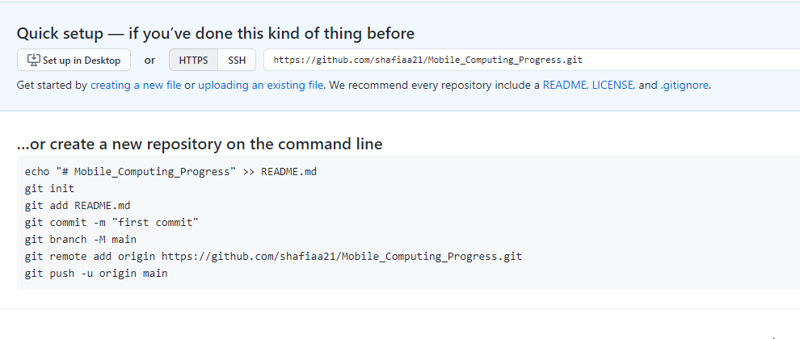

**Cloning a repository:**

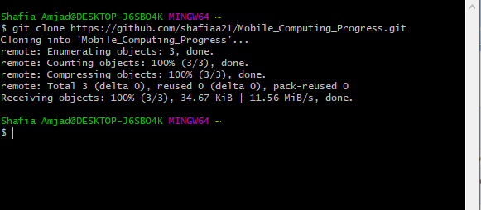

**Signing In and Commit Command:**

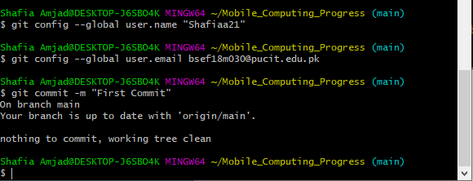

**Lecture#04**

**After making project and adding configuration:**

