DEPARTMENT OF COMPUTER & INFORMATION SYSTEMS ENGINEERING
BACHELORS IN COMPUTER SYSTEMS ENGINEERING
Course Code: CS-324
Course Title: Machine Learning
Complex Engineering Problem
TE Batch 2023, Spring Semester 2026
Grading Rubric 1: Dataset Collection and Preprocessing (Milestone 2)
TERM PROJECT Group Members:
Student No. | Name | Roll No.
S1 | Shafia Arif | CS-23107
S2 | Sania Shakeel | CS-23108
S3 | Muneeba | CS-23109
S4

CRITERIA AND SCALES |  |  |  | Marks Obtained
 |  |  |  | S1 | S2 | S3 | S4
Criterion 1: Data collection, labeling, and dataset quality.
(CPA-1, CPA-3) [4 marks]
1 | 2 | 3 | 4
Data collection or labeling is incomplete, incorrect, or poorly justified. | Data collection and labeling are partially completed with quality issues. | Data collection and labeling are complete and mostly correct. | Data collection and labeling are complete, accurate, and well justified, resulting in a high-quality dataset.
Criterion 2: Preprocessing pipeline and exploratory data analysis (EDA).
(CPA-1, CPA-2) [4 marks]
1 | 2 | 3 | 4
Preprocessing and EDA  are missing or incorrectly applied. | Preprocessing or EDA is applied partially or superficially. | Preprocessing and EDA are applied correctly with minor gaps. | Preprocessing and EDA are comprehensive, correct, and well documented.
Criterion 3: Report quality and adherence to format.
[2 marks]
1 | 2 | 3 | 4
The report is poorly written and does not follow the given format. | The report partially follows the format and lacks clarity. | The report follows the format with minor formatting or clarity issues. | The report is clear, well written, and fully adheres to the given format and requirements.

Final Score = (Criteria_1_score ) + (Criteria_2_score) + (Criteria_3_score) = ______________

____________________ Teacher’s Signature

Introduction:
This project focuses on developing a supervised machine learning system for detecting defects in consumer product packaging. The dataset consists of real-world images categorized into different levels of packaging quality. The objective of this milestone is to perform dataset collection, labeling, preprocessing, and exploratory data analysis (EDA) to prepare the data for model training.
Dataset Description:
The dataset consists of RGB images of consumer product packaging collected from real-world environments such as retail stores and home settings. The images include various types of packaging such as bottles, cartons, and packets.
The dataset captures real-world variations including:
- Different lighting conditions
- Diverse backgrounds
- Multiple viewing angles
Each image represents one of the following classes:
- Good Packaging
- Minor Defect
- Major Defect
Data Collection Method and Sources:
The dataset was collected through visits to multiple real-world retail environments, including local stores such as Al-Jadeed Store, Imtiaz Supermarket, and various neighborhood general stores. In addition, some images were captured in home environments to increase diversity. Images were captured using mobile phone cameras under different lighting conditions, backgrounds, and viewing angles to simulate realistic scenarios. Various types of packaging, including bottles, cartons, and packets, were included in the dataset. Packaging defects were either naturally occurring or lightly induced to represent real-world damage conditions such as dents, tears, wrinkles, and broken seals. All collected images were manually reviewed and labeled into three classes: Good Packaging, Minor Defect, and Major Defect, based on the severity of visible damage.
Dataset Statistics:
The dataset contains a total of 837 images, distributed across three classes as follows:
Statistic | Good Packaging (Class 0) | Minor Defect (Class 1) | Major Defect (Class 2) | Total / Overall
Number of Images | 323 | 279 | 235 | 837
Mean Brightness | 0.4798 | 0.4818 | 0.4551 | 0.4722 (approx)
Pixel Value Variance | 0.0691 | 0.0664 | 0.0524 | 0.0626
Edge Density | 24.52 | 24.47 | 23.80 | 24.26
Image Dimensions | 224 × 224 | 224 × 224 | 224 × 224 | 224 × 224
Augmentation Applied | Flip, Brightness, Zoom | Flip, Brightness, Zoom | Flip, Brightness, Zoom | Yes
Defect Severity Score (0–2) | 0 | 1 | 2 | —

The dataset is relatively balanced, although the Good Packaging class contains slightly more samples.
Labeling Methodology:
All images were manually labeled based on visual inspection of packaging condition:
Good Packaging (Label = 0):
No visible defects; packaging is intact and undamaged.
Minor Defect (Label = 1):
Small defects such as slight dents, wrinkles, or minor scratches.
Major Defect (Label = 2):
Significant damage such as broken packaging, leakage, crushed areas, or large deformations.
This labeling ensures a clear distinction between different levels of defect severity.
Preprocessing Pipeline:
To prepare the dataset for machine learning, a systematic preprocessing pipeline was implemented using Python libraries such as OpenCV, NumPy, and TensorFlow.

- Image Loading:
The dataset was organized into three folders corresponding to each class good_packaging, minor_defect, and major_defect.
A loop was used to iterate through each folder and read images using the OpenCV library.

- Color Space Conversion:
Images loaded using OpenCV are in BGR format by default. Therefore, each image was converted to RGB format using cv2.cvtColor(image, cv2.COLOR_BGR2RGB)
This ensures compatibility with visualization tools and deep learning frameworks.

- Image Resizing:
All images were resized to a fixed dimension of 224 × 224 pixels using cv2.resize(image, (224, 224)).
This step ensures uniform input size, which is required for neural network models.

- Data Cleaning:
A try-except block was used during image loading to handle corrupted or unreadable images. Any image that caused an error was skipped, ensuring that only valid data was included in the dataset.

- Data Structuring:
All processed images were stored in a NumPy array:
X → image data
y → corresponding labels
Final dataset shape:
X.shape = (837, 224, 224, 3)
y.shape = (837,)

- Label Encoding:
Each class was assigned a numerical label using a dictionary mapping:
good_packaging → 0
minor_defect → 1
major_defect → 2
This encoding allows machine learning models to process categorical data efficiently.

- Pixel Normalization:
To improve training stability, pixel values were normalized from the range [0,255] to [0,1] using:
X = X.astype('float32') / 255.0
Normalization ensures faster convergence and prevents large gradient updates during training.

- Dataset Splitting:
The dataset was split into training, validation, and test sets using stratified sampling:

- 70% Training Set
- 15% Validation Set
- 15% Test Set

The splitting was performed in two steps using the train_test_split function:

First split: Training (70%) and temporary set (30%)

Second split: Temporary set divided into validation (15%) and test (15%)

Stratified sampling was used to maintain equal class distribution across all subsets.

- Data Augmentation:
To improve model generalization, data augmentation was applied to the training dataset using TensorFlow.
The following augmentation techniques were used:

- Horizontal flipping
- Brightness variation
- Random Zoom
Augmentation was applied dynamically using the TensorFlow tf.data.Dataset pipeline:
train_ds = train_ds.map(lambda x, y: (tf.image.random_flip_left_right(x), y))

This generates new variations of images during training without increasing dataset size.

- Batch Processing:
The training dataset was converted into batches of size 32 using:
train_ds = train_ds.batch(32)
Batch processing improves computational efficiency and stabilizes model training.

- Final Prepared Dataset:
After preprocessing, the dataset is:

- Cleaned and free from corrupted image
- Resized to uniform dimensions
- Properly labeled and encoded
- Normalized for neural network training
- Split into training, validation, and test sets
- Augmented to improve generalization

Exploratory Data Analysis (EDA):

Exploratory Data Analysis (EDA) was performed to understand the dataset characteristics, identify patterns, and analyze variations across different classes before model training.

- Dataset Overview
A DataFrame was created from the dataset directory structure to organize image paths and corresponding class labels.

The dataset consists of:

Total Images: 837
Total Classes: 3
Class Distribution:
Class | Number of Images
Good Packaging | 323
Minor Defect | 279
Major Defect | 235

The dataset is relatively balanced, with slightly more samples in the Good Packaging class.

- Class Distribution Visualization:
A bar chart was plotted to visualize the number of images in each class.
The visualization confirms that the dataset does not suffer from severe class imbalance, which is important for unbiased model training.
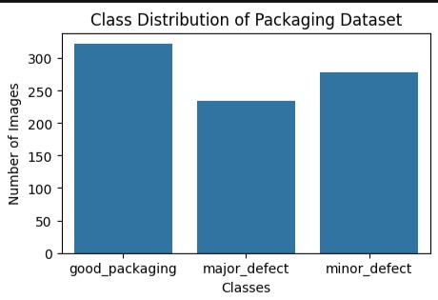

- Sample Image Visualization:
Random sample images from each class were displayed to:
- Verify correctness of labeling
- Observe visual differences between classes
- Understand real-world variations in packaging conditions
Good packaging images appear intact, while minor and major defects show increasing levels of damage
such as dents, wrinkles, and deformation.
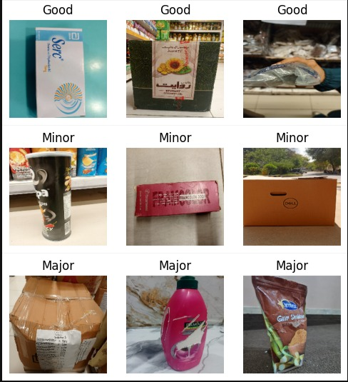

- Image Size Analysis:
The original images were analyzed to determine their dimensions.
The images had varying sizes due to differences in capture conditions. This justified resizing all images to a fixed dimension of 224×224 pixels during preprocessing.

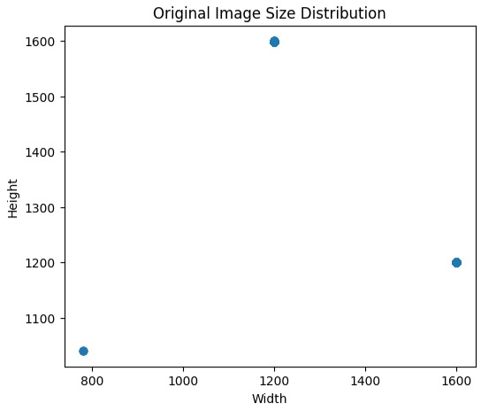

- Dataset Shape After Preprocessing:
After preprocessing, the dataset shape is (837, 224, 224, 3).
This confirms that all images have been successfully resized to a uniform shape with three color channels (RGB).

- Pixel Value Distribution:
A histogram of pixel values was plotted to analyze intensity distribution.
The pixel values are normalized in the range [0,1], ensuring consistency and stability during neural network training.
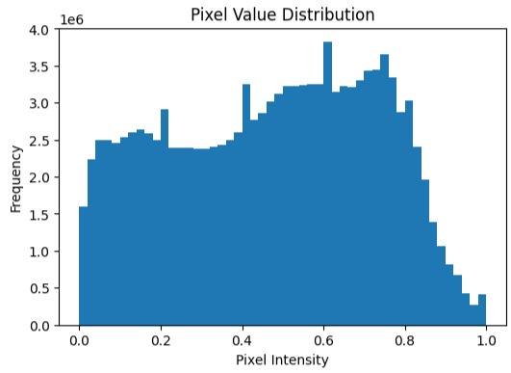

- Defect Severity Analysis:
A numerical severity score was assigned to each class:
- Good → 0
- Minor → 1
- Major → 2
Statistical analysis showed:
Mean Severity: 0.89
Range: 0 to 2
This representation allows the dataset to be analyzed on a continuous scale of defect severity.
- Difficulty Ranking of Classes:
Class distribution analysis showed:
- Good Packaging: 323
- Minor Defect: 279
- Major Defect: 235
Classes with fewer samples and subtle visual differences (especially Minor vs Major defects) are
expected to be more difficult for the model to classify.
- Brightness Analysis:
Average brightness of images was calculated for each class:
- Good Packaging: 0.48
- Minor Defect: 0.48
- Major Defect: 0.45
The Major Defect class shows slightly lower brightness, possibly due to damaged surfaces or shadows
caused by deformation.
- Color Distribution Analysis:
Histograms of RGB channels were plotted for each class.The analysis shows variation in color intensity across classes, reflecting differences in product types, packaging colors, and environmental conditions.
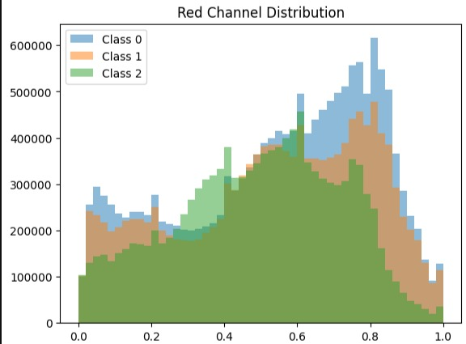

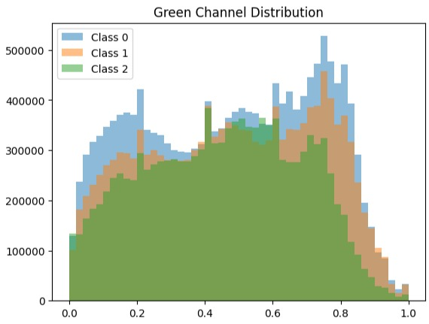

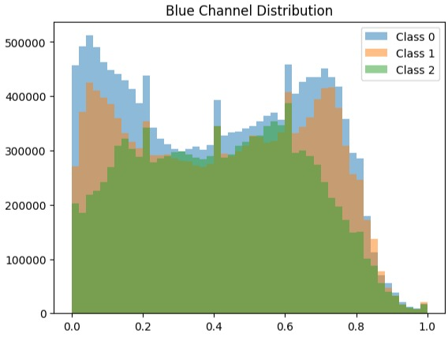

- Edge Density Analysis:
Edge density was calculated using edge detection techniques:
- Good Packaging: 24.51
- Minor Defect: 24.47
- Major Defect: 23.80
Good packaging images show slightly higher edge density due to textures, printed labels, and
patterns. Major defect images have slightly lower edge density, possibly due to smoother
damaged regions.
This suggests that distinguishing between Minor and Major defects may be challenging, while
Good vs Major classification is relatively easier.

- Variability Analysis:
Pixel variance was calculated for each class:
- Good Packaging: 0.069
- Minor Defect: 0.066
- Major Defect: 0.052
Good packaging images show higher variability due to diverse colors and patterns, while Major defect
images are relatively less variable, possibly due to damaged and uniform surfaces.
- Key Observations:

- The dataset is reasonably balanced across classes.
- Significant variation exists in lighting, background, and product types.
- Minor and Major defects exhibit similar visual characteristics, making classification more challenging.
- Good packaging is visually distinct, making it easier for the model to classify.
- Structural and color-based differences provide useful features for model learning.
Conclusion of EDA:
The exploratory analysis confirms that the dataset is diverse, well-structured, and suitable for supervised machine learning. The insights obtained from EDA will help guide model selection and improve understanding of potential classification challenges.

